Comparative Analysis of Mechanical Power Transmission Systems and Fastener Selection Methodologies

Abstract-Mechanical system design depends fundamentally on two core domains: transmitting power efficiently between dynamic shafts, and joining structural members reliably under complex operational loads. This paper synthesizes the operational mechanics, kinematic principles, and functional boundaries of primary power transmission drives (belt, chain, rope, and gear drives), provides an analytical breakdown of gear nomenclature and epicyclic kinematics, and establishes an engineering selection framework for permanent versus non-permanent fasteners under vibration, shear, and fatigue environments.
[ Name:Piyanshi Sinha / Student Registration Number: 261090050740]
RoboManipal Research Taskphase, Department of Mechatronics / Electronics
Manipal Institute of Technology, MAHE, Manipal, India
Email: priyanshi1.mitmpl2026@learner.manipal.edu
I. Introduction
Mechanical power transmission systems transfer energy, motion, and torque from a primary mover (e.g., electric motor, engine) to driven elements. Fasteners mechanically assemble distinct structural and functional components into cohesive assemblies. Selecting optimal transmission and fastening methods requires balancing torque capacity, operational speed, center-to-center distance, maintenance constraints, and disassembly requirements.

II. MECHANICAL POWER TRANSMISSION METHODS
Mechanical drives are broadly classified into flexible drives (belts, ropes, chains) and rigid drives (gears).

A. Belt Drives
- Operating Principle: Transmits power between shafts via frictional grip (flat and V-belts) or positive meshing teeth (timing belts) over pulleys.
- Key Characteristics:
  - Absorbs mechanical shocks and dampens vibration due to belt elasticity.
  - Accommodates moderate center distances.
  - Friction-based types experience slip and creep, resulting in non-exact velocity ratios. Timing belts eliminate slip.
- Primary Applications: Automotive engine alternator and accessory drives, conveyor belts, HVAC fans, and 3D printer gantry positioning (timing belts).

B. Rope Drives
- Operating Principle: Utilizes wire ropes or synthetic fiber ropes running over grooved sheaves/drums, relying on groove friction or direct spooling.
- Key Characteristics:
  - Capable of long center-to-center transmission distances (exceeding tens of meters).
  - Handles very high tensile loads with high shock absorption.
- Primary Applications: Elevators, cranes, mine hoists, winches, and suspension systems.

C. Chain Drives
- Operating Principle: Employs an endless articulate chain consisting of rigid links meshing with toothed sprockets, providing positive drive without slip.
- Key Characteristics:
  - Constant, exact velocity ratio over medium center distances.
  - High transmission efficiency (up to 98%).
  - Requires regular lubrication; subject to chordal action (polygon effect) and operational noise at high speeds.

- Primary Applications: Bicycles, motorcycles, tracked vehicle drivetrains, and heavy-duty industrial chain conveyors.

D. Gear Drives
- Operating Principle: Direct positive engagement between conjugate toothed wheels on rigid rotating shafts.
- Key Characteristics:
  - Exact, positive velocity ratio with zero slippage.
  - Extremely compact footprint and high load capacity.
  - Requires precise shaft alignment and continuous lubrication; limited to short center distances.
- Primary Applications: Automotive transmissions, differential gearboxes, industrial reduction boxes, and precision robotic actuators. 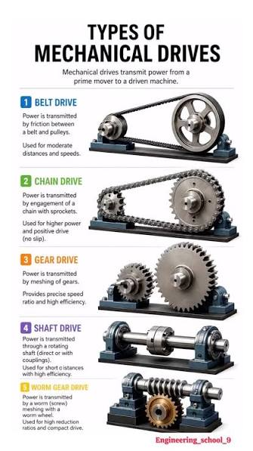

E. Comparative Analysis of Transmission Drives
Drive Type | Torque Capacity | Speed Capability | Center Distance | Cost Metric | Operational Characteristics
Belt Drive | Moderate | High | Medium | Lowest | Quiet, absorbs shock, slip present (except timing)
Rope Drive | Very High | Low to Moderate | Large | Low to Moderate | High tension, shock-resistant, long reach
Chain Drive | High | Moderate | Medium | Moderate | Positive drive (no slip), noisier, requires lube
Gear Drive | Very High | Low to High | Small (Compact) | Higher | Exact velocity ratio, rigid, highly compact

III. GEAR BASICS, NOMENCLATURE, AND GEAR TRAINS

A. Fundamental Gear Terminology

Pitch Circle & Pitch Diameter (d): The imaginary circle where two meshing gears effectively roll against each other. All gear size calculations start here.

Module (m): The unit of gear tooth size in millimeters:
m=d/Z​
where d is the pitch diameter and Z is the number of teeth. Two gears must have the exact same module to mesh properly.

Circular Pitch (p): The distance along the pitch circle from the start of one tooth to the start of the next:
p=π⋅m
- $p_{c}=\frac{πd}{T}$
M = d/T

Diametral Pitch (P): The imperial version of tooth size, measuring teeth per inch of pitch diameter (P=d/Z​). A higher number means smaller teeth.

Addendum (a): The height of the tooth sticking out above the pitch circle (a=m).

Dedendum (b): The depth of the tooth space below the pitch circle (b=1.25⋅m). It is slightly deeper than the addendum so teeth don't collide. [Addendum ($h_{a}$) & Dedendum ($h_{f}$): Radial height of the tooth above the pitch line ($h_{a}≈1.0m$) and radial depth below it ($h_{f}≈1.25m$)]

Clearance (c): The small gap left between the top of one tooth and the bottom of the mating gear's groove (c=0.25⋅m) to prevent jamming.($c=h_{f}-h_{a}$).

Pressure Angle (ϕ): The angle at which the teeth push against one another (most modern gears use 20∘).(standard values: $20^{∘}$ or $14.5^{∘}$).

Gear Ratio (i): How speed, teeth, and turning power (torque) trade off with each other:
i=Speed OutSpeed In​=Teeth InTeeth Out​=Torque InTorque Out​
If the output gear has twice as many teeth as the input gear, it spins at half the speed but delivers twice the torque.
Where $N$ is rotational speed (RPM), $d$ is pitch diameter, and $T$ is tooth count.

B. Gear Classifications and Applications

Spur Gears: Straight-cut teeth on parallel shafts. Simple, cheap, and reliable, but they click loudly at high speeds (common in electric hand drills and simple gearboxes).

Trade-off: High load capacity; produces high acoustic impact noise at elevated pitch-line velocities.

Helical Gears: Curved teeth cut at an angle on parallel shafts. Because the teeth slide together gradually, they run much smoother and quieter under heavy loads (standard in car transmissions).

Trade-off: Smooth and quiet high-speed operation; induces undesirable axial end-thrust forces requiring thrust bearings or herringbone (double-helical) arrangements.

Bevel Gears: Cone-shaped gears that turn power around a corner (usually at a 90∘ angle), such as in a car's rear differential.
Conical tooth layout. Shafts intersect, typically at $90^{∘}$ (termed miter gears if speed ratio is 1:1). Transmits torque between perpendicular shafts in differentials and hand drills.

Worm and Worm Wheel: A threaded screw (worm) turning a gear (wheel). They fit huge speed reductions into a tiny space and are usually one-way only—the screw can turn the gear, but the gear cannot turn the screw back (ideal for elevator

Trade-off: Delivers extreme reduction ratios in a single stage ($10:1$ to $>60:1$) with inherent self-locking prevention of back-driving; high sliding friction yields lower mechanical efficiency and heat generation.safety lifts and winches).

Rack and Pinion: A round gear (pinion) rolling along a flat toothed bar (rack). This converts rotation directly into back-and-forth straight-line movement (used in car steering systems).
In definitive terms its more like a spur gear (pinion) meshing with a linear flat bar (rack, representing an infinite pitch radius gear). Directly converts rotary motion into linear displacement in steering columns and CNC linear axes.

Gear Train Setups
Gear trains adjust output torque and angular velocity between drive input and output shafts.
- Simple Gear Train: Each shaft carries only one gear. Direction alternates with each successive mesh. Idle gears alter rotational direction without modifying the overall velocity ratio.
- Each shaft supports exactly one gear wheel. Intermediate gears act strictly as idlers: they alter the rotational direction of the output shaft without affecting the overall gear ratio:
- $VR=\frac{N_{driven}}{N_{driver}}=\frac{T_{driver}}{T_{driven}}$
- Compound Gear Train: At least one intermediate shaft carries two gears of different tooth counts rotating at identical angular velocity. Achieves high gear ratios in a compact footprint.
- At least one intermediate shaft carries two fixed, co-rotating gears. Allows large step-down speed reductions in a compact envelope:
- $VR=\frac{\prod{}TeethofDrivingGears}{\prod{}TeethofDrivenGears}$
- Reverted Gear Train: The input and output shafts are axially collinear, frequently used in industrial clock mechanisms and manual vehicle gearboxes.
- Driving and driven shafts share a common geometric centerline (coaxial). Common in manual automotive transmissions, clock escapements, and industrial inline gearboxes.

- Epicyclic (Planetary) Gear Train: Contains a sun gear, planet gears mounted to a rotating carrier arm, and an outer ring (annulus) gear. Compact layout capable of delivering variable speed ratios, differential distribution, and high torque density within automatic transmissions and hub motors.

IV. MECHANICAL FASTENERS AND PRACTICAL APPLICATIONS
Mechanical fasteners mechanically join two or more components and are categorized according to whether joint disassembly causes non-destructive component release or permanent joint destruction
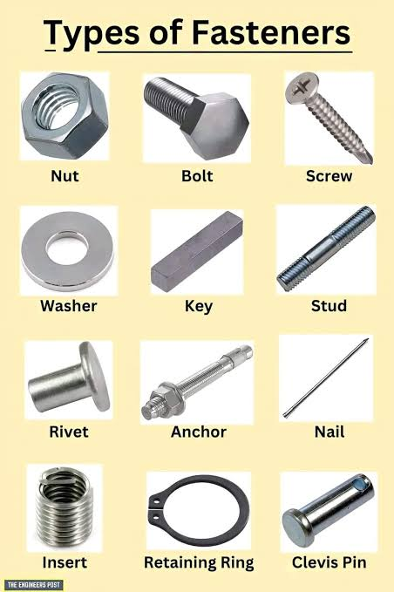

A. Temporary Fasteners (Removable / Reusable)

- Bolts and Nuts:
  - Mechanism: Through-bolt passing through unthreaded clearance holes, clamped by tightening a matching threaded nut.
  - Key Engineering Application: Structural steel framing, chassis assemblies, engine cylinder head mounting. Chosen when parts require periodic service, overhaul, or high clamping preload.
- Machine Screws and Cap Screws:
  - Mechanism: Fastened directly into pre-threaded blind or through-holes in one of the mating parts without requiring a nut.
  - Key Engineering Application: Engine blocks, gearbox covers, robot casing closures, electronic enclosures.

- Studs:
  - Mechanism: Headless cylindrical rods threaded on both ends; one end threads into a housing casting while the other receives a nut.
  - Key Engineering Application: Cylinder heads and pipe flanges subjected to high pressures, preventing repeated wear on expensive casting female threads during maintenance.
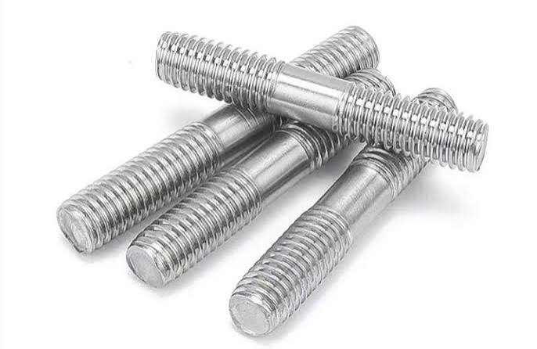

- Washers (Flat & Spring / Lock):
  - Mechanism: Flat washers distribute clamping load across wider surface areas; spring, split-lock, and Belleville washers maintain tension and resist loosening caused by operational vibration.
  - Key Engineering Application: Automotive suspension, dynamic rotating machinery mounts.

- Keys, Splines, and Pins:
  - Mechanism: Cotter pins, dowel pins, and shaft keys resist shear forces rather than axial clamping.
  - Key Engineering Application: Locking pulleys/gears onto rotating drive shafts (keys/splines); exact alignment doweling between engine casing halves.

B. Permanent Fasteners (Non-Removable without Joint Destruction)
- Rivets (Solid and Blind/Pop Rivets):
  - Mechanism: Cylindrical pin with a pre-formed head, inserted through aligned holes; the tail end is deformed plastically (bucked or drawn) to create a second head.
  - Key Engineering Application: Aircraft skins and wings (aerodynamic flush rivets), bridge trusses, and thin sheet-metal enclosures where access is restricted to one side. Rivets resist dynamic fatigue and vibration loosening superiorly to standard threaded joints.

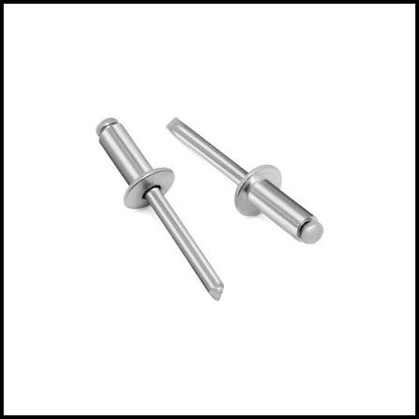

- Welded Joints:
  - Mechanism: Thermal fusion melting base metals together, with or without filler material, creating homogeneous continuous joint metallurgical structures.
  - Key Engineering Application: Automotive spaceframes, pressure vessels, pipelines, structural building columns. Used when maximum structural strength, hermetic sealing, and minimum joint weight are required.

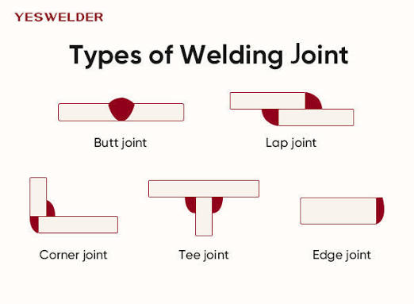

- Brazing and Soldering:
  - Mechanism: Capillary flow of molten filler metal with melting point below that of base metals.
  - Key Engineering Application: Refrigeration HVAC copper tubing, heat exchangers, PCB electronics.
- Structural Adhesives:
  - Mechanism: Chemical bonding agents (epoxies, polyurethanes, cyanoacrylates) distributing stress uniformly across entire contact surface areas.
  - Key Engineering Application: Carbon-fiber composite aerospace joints, vehicle body panels, smartphone display assemblies. Eliminates stress concentrations and galvanic corrosion between dissimilar materials.

C. Fastener Selection Criteria Summary
Selection Parameter | Temporary Fasteners (Bolts, Screws) | Permanent Fasteners (Rivets, Welds, Adhesives)
Disassembly Need | High (Non-destructive removal) | None (Requires joint destruction)
Vibration Resistance | Requires locking devices or threadlockers | Inherently resistant to vibration loosening
Weight & Profile | Higher mass, protruding heads/nuts | Low profile, lightweight, option for flush joints
Stress Distribution | Concentrated at bolt holes | Uniform (adhesives) or integrated (welds)
Thermal Limit | Limited by bolt grade and material | High (welds/brazing); Low to Moderate (adhesives)

V. CONCLUSION
Power transmission systems and fasteners dictate the mechanical efficiency, structural integrity, and service life of engineering assemblies. While gear drives and chain drives deliver positive non-slip kinematic power transmission, flexible belt and rope systems provide long-distance and shock-absorbent transmission capabilities. In fastening design, matching the operational demands (vibration, load, service cycles) to either temporary threaded connections or permanent metallurgical/mechanical bonds is fundamental for reliable mechanical design.

