Comparative Study, Kinematic Analysis, and Selection Framework for Mobile Robotic Drive Systems
[ Name:Piyanshi Sinha / Registration Number: 261090050740]
RoboManipal Research Taskphase, Department of Mechatronics / Electronics
Manipal Institute of Technology, MAHE, Manipal, India
Email: priyanshi1.mitmpl2026@learner.manipal.edu

Abstract—Locomotion system design directly governs a mobile robot's maneuverability, payload capacity, and control complexity. Rather than merely cataloging configurations, this paper provides an analytical framework to evaluate how application requirements dictate drivetrain selection. We examine eight foundational drive systems—Differential, Omnidirectional, Mecanum, Ackermann, Swerve, Tracked, 4WD, and Skid-Steer—analyzing their kinematics, operational trade-offs, and deployment criteria across varied terrains.

I. Introduction & The Engineering Selection Rationale
In mobile robotic design, selecting a locomotion mechanism is an optimization problem governed by conflicting parameters: agility versus traction, kinematic flexibility versus mechanical durability, and software simplicity versus dynamic control capability.
Drivetrains fall into two kinematic classifications:
- Holonomic platforms: The controllable degrees of freedom equal the total degrees of freedom in the plane ($3DOF:x,y,θ$). The robot can translate instantaneously in any lateral vector without reorienting its chassis.
- Non-holonomic platforms: Path constraints restrict instantaneous sideways motion without an orientation change, requiring trajectory planning and curvature management.

II. Drive System Architectures: Mechanics, Kinematics & Selection Logic

1. Differential Drive
- Definition: A system utilizing two independently actuated coaxial wheels mounted on opposite sides of the chassis centerline, with one or two passive caster wheels providing vertical balance.
- Working Principle:
  - Translation: Equal forward speed ($ω_{L}=ω_{R}$).
  - Turning: Differential wheel speeds ($ω_{L}≠ω_{R}$).
  - Zero-Radius Pivot: Identical speed in opposite directions ($ω_{L}=-ω_{R}$).
- Advantages: Minimal parts, lowest cost, straightforward forward / inverse kinematics, zero-radius turning.
- Disadvantages: Non-holonomic; prone to caster flutter and drift on uneven surfaces; low high-speed stability.
- Selection Logic (Why & When to Choose):
  - When we usually prefer this is when operational environment is flat, low cost micro mobility is critical, and software simplicity is prioritized over high-speed agility.
  - Applications: Domestic vacuum cleaners (Roomba) Introductory education platforms (TurtleBot), standard indoor automated guided vehicles (AGVs).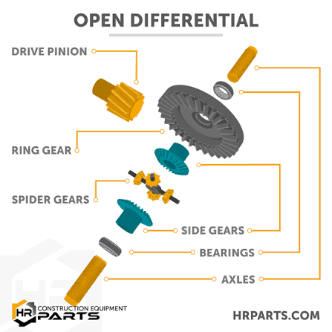

2. Omnidirectional Drive (Omni Wheels)
- Definition: A multi-wheel setup (typically 3 wheels at $120^{∘}$ or 4 wheels at $90^{∘}$) using omni wheels equipped with passive rollers oriented perpendicular ($90^{∘}$) to the wheel’s main drive axis.
- Working Principle: Each motor drives along its wheel plane while the perpendicular passive barrel rollers allow free sliding transversely. Combining the independent force vectors allows simultaneous planar translation and yaw rotation.
- Advantages: Fully holonomic (3-DOF); instantaneous sideways strafing and agile trajectory tracking.
- Disadvantages: Significant traction loss; rollers collect debris; poor efficiency due to continuous roller drag.
- Selection Logic :
  - Choose when: Instantaneous, high-frequency vector repositioning is required in a tightly constrained, highly clean indoor environment where high pushing force is not required.
  - Applications:Widely used in RoboCup Small Size League (SSL) and Middle Size League (MSL) soccer robots where dodging opponents, tracking a ball instantly in any direction, and executing omnidirectional kicking maneuvers at high speeds are critical.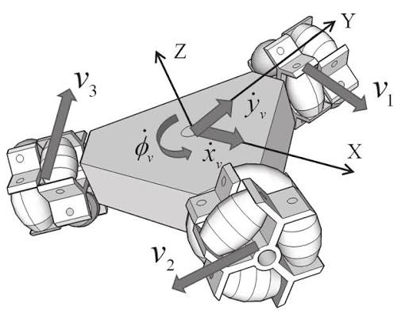

3. Mecanum Drive
- Definition: A four-wheel drive configuration where each wheel is lined with passive rollers angled at $45^{∘}$ to the wheel's circumference.
- Working Principle: Rotating a Mecanum wheel generates a ground reaction vector containing both longitudinal and transverse components. By modulating the forward and reverse velocities of all four wheels, transverse components either cancel (driving straight) or combine (strafing sideways or turning).
- Advantages: True holonomic capability on a standard rectangular chassis without requiring complex steering linkages.
- Disadvantages: Lower power efficiency (~65% traction efficiency); micro-vibrations from roller transitions; highly sensitive to uneven floors.
- Selection Logic :
  - Choose when:Mecanum drive is chosen when a heavy, box-shaped machine needs to slide directly sideways into tight spots (like narrow warehouse aisles or cramped factory rooms) without building a complex car-style steering system. but mechanical steering linkages are impractical.
  - Applications: Precision warehouse forklifts, compact industrial manufacturing cells, competitive robotics . 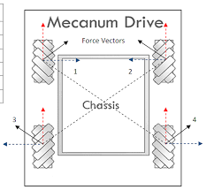

4. Ackermann Steering Drive
- Definition: The classic automotive steering geometry where the two front steerable wheels pivot about separate kingpins via mechanical linkages, while the rear axle delivers propulsion.The Ackermann steering geometry is a mechanical arrangement of linkages designed so that when a vehicle turns, the inside wheel steers at a sharper angle than the outside wheel. This prevents the tires from slipping or scrubbing, because the inner wheel naturally follows a tighter turning radius than the outer wheel
- Working Principle: During cornering, the linkage pivots the inner front wheel to a sharper angle than the outer wheel ($θ_{inner}>θ_{outer}$). This aligns all four wheel centerlines so their perpendicular lines meet at a single Instantaneous Center of Curvature (ICC), preventing lateral tire scrub.
- Advantages: Maximum tire life, zero tire scrub during turning, high energy efficiency, and superior dynamic stability at high speeds.
- Disadvantages: Cannot rotate in place (finite turning radius); complex path planning in reverse gear; difficult parallel maneuvering.
- Selection Logic :
  - We can choose it when the platform must operate outdoors or on roadways at moderate to high speeds, where energy efficiency, payload capacity, and tire wear dominate over zero-radius agility.
  - Applications: Autonomous cars, outdoor delivery buggies, long-range agricultural field scouts.
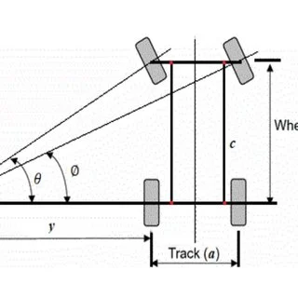

5. Swerve Drive
- Definition: An advanced drivetrain composed of modular wheel pods, each featuring two independent motors: one for continuous propulsion and one for continuous $360^{∘}$ azimuth steering.
- Working Principle: Each wheel can steer 360∘360^\circ360∘ and drive independently with grippy rubber tires, allowing the robot to slide in any direction without turning its body.
- Advantages: Combines full multi-directional agility with maximum tire grip, pushing force, and fast acceleration.
- Disadvantages: Very complex and expensive—requires 8 motors and precise feedback sensors for 4 wheels, complex software, and high maintenance.
- Selection Logic:
  - Choose when: You need both maximum agility and high pushing power simultaneously, and budget or software complexity are not limiting factors.
  - Applications: Advanced competition robotics (like FRC), military robotic arms, and planetary exploration rovers.

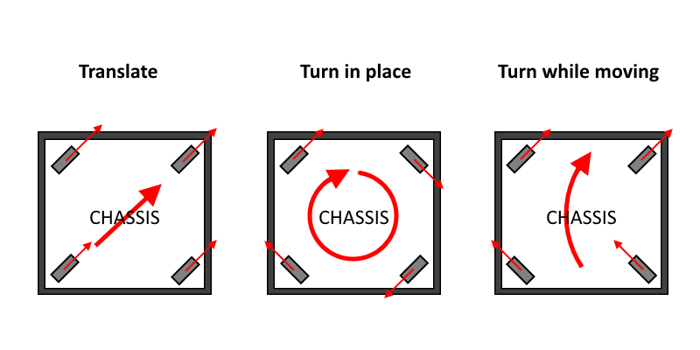

6. Tracked Drive (Continuous Tracks / Tank Treads)
- Definition: Locomotion utilizing continuous reinforced rubber or metal track belts driven by sprockets around idler wheels and support rollers.
- Working Principle: Relies on differential velocity between the left and right continuous tracks. The large ground contact footprint distributes vehicle mass evenly over a large surface area.
- Advantages: Extremely low ground pressure (prevents sinking into mud, snow, or sand); superior obstacle climbing, trench crossing, and terrain bridging.
- Disadvantages: Severe ground scrub during turns; high powertrain frictional drag; lower top speeds; risk of track slippage on steep side slopes.
- Selection Logic :
  - Choose when: The robot must traverse unstructured, soft, muddy, or obstacle-strewn terrain where wheeled robots would get stuck or tip over.
  - Applications: Search-and-rescue disaster robots, defense vehicles, deep-mud agricultural crawlers.
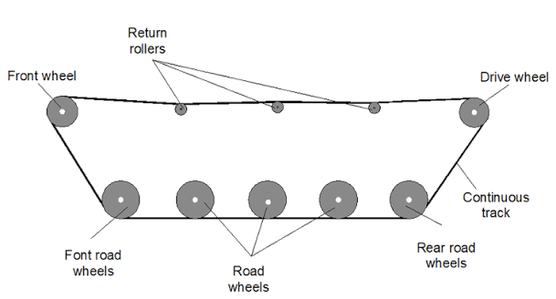

7. Four-Wheel Drive (4WD)
- Definition: A wheeled system where all four wheels receive active drive torque, either via individual hub motors or a centralized motor with Differentials (Splits power side-to-side (between the left wheel and the right wheel on an axle).) and Transfer cases(Splits power front-to-back between the front axle and the rear axle )
- Working Principle: Delivers traction torque across four distinct contact points. Steering is achieved either via a front Ackermann axle or through skid steering between the left and right pairs.
- Advantages: High traction on slopes, redundancy if one wheel loses grip, and balanced weight distribution.
- Disadvantages: Adds extra weight and gear friction, which reduces efficiency; without a center differential, the front and rear axles fight each other during turns on grippy ground, causing drivetrain jamming (binding) .
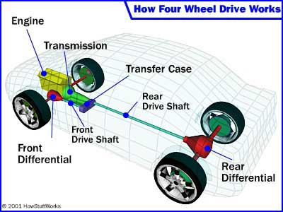
- Selection Logic :
  - Choosen when: The platform must traverse moderate outdoor terrain, climb moderate inclines, or carry distributed payloads reliably with mechanical resilience.
  - Applications: Outdoor security patrol rovers, environmental field-monitoring robots.

8. Skid-Steer Drive
- Definition: A rigid-wheel architecture (typically 4 or 6 non-steering wheels) where the left bank of wheels and right bank of wheels are driven independently.
- Working Principle: Steering is achieved by creating a velocity differential between the left and right wheel banks. Turning forces the tires to slip and skid sideways across the ground surface, pivoting the robot around its central footprint.
- Advantages: Mechanically rugged with no delicate steering linkages; zero turning radius; high payload capacity.
- Disadvantages: High tire wear from constant lateral friction scrub; severe wheel encoder odometry drift; large power spikes during zero-radius turns on high-traction surfaces.
- Selection Logic :
  - Choose when: A rugged, mechanically indestructible outdoor vehicle is required that can pivot in place on dirt, gravel, or grass without fragile steering components.
  - Applications: Construction skid-steer loaders (Bobcat), outdoor exploration robots (like Clearpath Jackal/Husky), all-terrain military ground robots.
