Store Manager - Inventory Management Documentation

# 1. Introduction

Project Title: Store Manager - Keep Track of Inventory Management

Team Members:

Team Leader: K. Priyanka

B. Kirthika

R. Dhivya Dharshini

R. Lakshmi

R. Bhavani

This Inventory Management application is a web-based tool designed to help users efficiently keep track of inventory items, sales, and product details. It acts as a digital store manager that simplifies inventory handling and provides real-time updates on stock levels. Built using modern web technologies, it supports smooth product management and sales recording.

# 2. Project Overview

Purpose: To streamline inventory control and management for retail or business environments by allowing users to maintain up-to-date inventory records, manage sales, and monitor stock levels efficiently.

Features:

* Add, update, and delete products in inventory
* Record and manage sales transactions
* Automatic inventory updates after sales
* Monitor stock levels to avoid overstocking or stockouts
* Generate reports on inventory and sales performance
* Responsive and interactive user interface
* Real-time synchronization of data across the app

# 3. Architecture

Component Structure: The app consists of UI components for product management, sales recording, inventory tracking, and sales records display.

State Management: Uses local and global state management to maintain inventory and sales data consistently throughout the app.

Routing: Implements client-side routing to navigate between product management, sales, and report views seamlessly.

# 4. Setup Instructions

Prerequisites:

* Windows or macOS operating system
* Node.js LTS version installed (https://nodejs.org/en/download/)
* Internet connection for dependency downloads
* Code editor such as Visual Studio Code
* Modern web browser (Chrome, Firefox, Edge, Safari)

Installation:

1. Download and install Node.js LTS version suitable for your OS.
2. Download the project zip folder from the source provided.
3. Extract and open the folder in VS Code.
4. Open the terminal in VS Code and run `npm install` to install dependencies.

# 5. Folder Structure

Client: Contains frontend code including components, styles, and UI logic.

Utilities: Includes helper functions and modules for state management, API calls, and data processing.

# 6. Running the Application

Frontend: After dependencies are installed, start the application by running the command `npm start`. This will open the app in the default browser at http://localhost:3000.

# 7. Component Documentation

Key Components:

* Product Management: Interface to add, edit, or delete products.
* Sales Recording: For entering product sales data.
* Sales Records: Displays list of past sales transactions.

Reusable Components: UI elements like buttons, input forms, and data tables that are used across multiple sections.

# 8. State Management

Global State: Manages the inventory and sales data accessible by multiple components.

Local State: Handles temporary UI states like form input and dialog visibility.

# 9. User Interface

The UI is responsive and interactive, allowing easy navigation through the app on various devices. It provides clear forms for data entry and tables for inventory and sales information.

# 10. Styling

Theming: The application uses consistent styling with predefined colors, fonts, and spacing for a professional look and feel.

# 11. Testing

Testing Strategy: Focus on unit testing key components and integration testing of inventory and sales workflows.

Code Coverage: Ensures major functionalities including product management and sales recording are covered by tests.

# 12. Screenshots or Demo

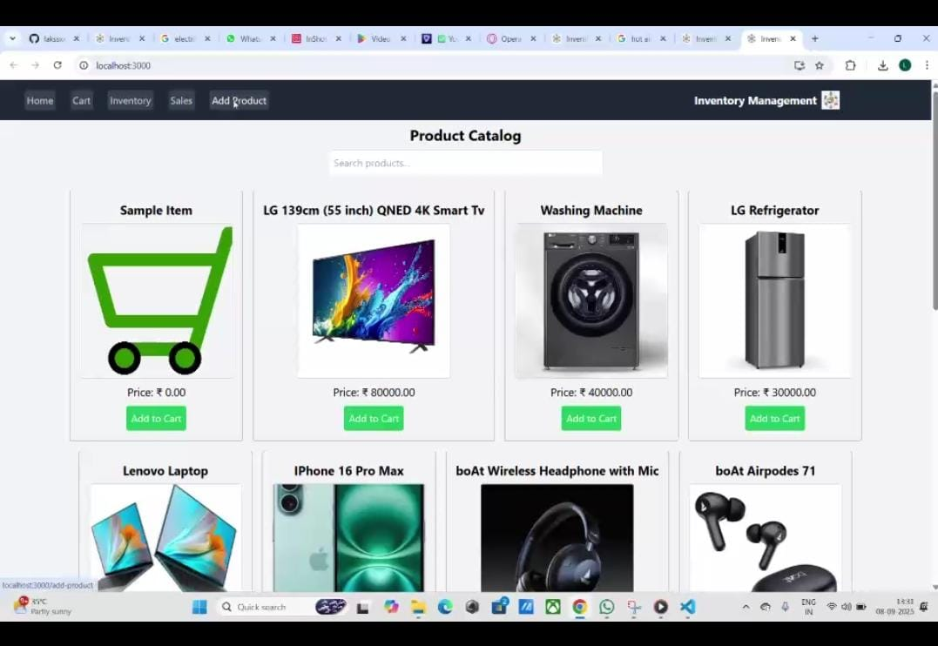

# 13. Known Issues

(Current known bugs or limitations can be listed here, if any.)

# 14. Future Enhancements

* Adding user authentication and role-based access
* Detailed sales analytics and charts
* Alerts for low stock notifications
* Mobile app version for on-the-go inventory management

# Conclusion

The Store Manager application is an effective solution for managing inventory in a streamlined, organized manner. It helps businesses avoid stockouts and overstocking, optimize sales management, and improve operational efficiency with real-time updates and a user-friendly interface.