**GROUP 5 - Fake News Detection Using NLP**

**Phase 2: Innovation**

**INTRODUCTION**

The research initiative begins with an initial phase involving library research and the creation of a literature review, aimed at cultivating a deeper comprehension of the subject matter and the pertinent ongoing debates. Subsequently, a preliminary project plan is formulated, outlining the utilization of machine learning algorithms for the purpose of conducting simulations. Throughout the project's progression, various challenges are encountered, including unforeseen obstacles and the inherent complexity associated with the selection of optimal algorithms for the project's objectives. However, the project team exhibits unwavering perseverance, diligently persisting in their efforts to advance the project. Their approach centers on employing simulation techniques to conduct experiments and enhance their understanding.

The primary objective of the article is to delineate a methodology for the identification of fake news, leveraging a multi-source news dataset in conjunction with the social contexts of users on social media platforms. The problem statement for the detection of fake news is formally articulated as follows:

- Input: Comprising news articles, social contexts, and pertinent site data.

- Output: The outcome is characterized as either the classification label "fake" or "real," contingent upon the attributes of the input data.

The proposed framework for the identification of fake news commences with the acquisition of news data from authentic real-world sources, referred to as the dataset (input). In the preprocessing phase, the content of news articles is meticulously processed, and each individual news item is systematically categorized as either "real" or "fake." As shown below

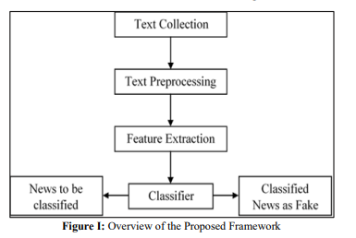

The methodology encompasses several key steps:

**1. Dataset and Text Preprocessing:** The researchers utilize an open-source ISOT Fake News dataset, containing both fake and real news CSV files gathered from various sources. To enhance dataset performance, they perform data cleansing, removing null, noisy, or incomplete data. Additionally, they employ techniques such as stop words removal, tokenization (breaking text into smaller units), and stemming (reducing words to their root form).

**2. Tools Selection:** Python 3.10.5 serves as the primary programming language, supported by libraries like Numpy, Pandas, and Sklearn. The researchers also employ machine learning classification methods.

**3. Machine Learning:** Machine learning methods are used to create a fake news classifier. The process comprises two stages: training and testing. During training, the algorithm learns from categorized data to predict or classify new data. In the testing stage, a portion of the dataset is used to evaluate the classifier's performance, typically with 20% reserved for testing and 80% for training.

**4. Classifiers Description:** Multiple classifiers are implemented in the study, including Naïve Bayes (NB), Support Vector Machine (SVM), and Random Forest (RF). Each classifier is trained using a designated training dataset and evaluated based on accuracy, precision, recall, and F1 score metrics.

The proposed framework aims to discern fake news by analyzing news articles, social contexts, and related site data. It assigns a label of either "fake" or "real" based on the input. The methodology relies on iterative processes and simulations to experiment and enhance learning, even in the face of challenges such as unexpected issues and algorithm selection difficulties.

Regarding data preprocessing, the researchers employ the ISOT Fake News dataset, which includes both fake and real news CSV files from diverse domains. Preprocessing involves data cleansing to eliminate irrelevant or incomplete data. This step also encompasses the removal of stop words, tokenization for breaking text into smaller units, and stemming to reduce words to their root forms.

Notably, the use of preprocessing is critical as it prepares raw text for machine learning by translating it into numerical data, a necessary format for training models. Data cleansing ensures data quality, stop words removal eliminates commonly used but non-informative words, tokenization simplifies text understanding, and stemming reduces words to their original roots. These preprocessing steps collectively improve the overall performance of the dataset in subsequent machine learning tasks.

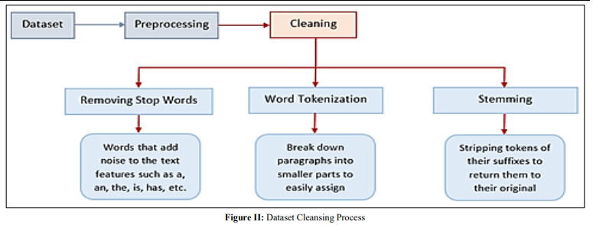

**PROPOSED MODEL DESIGN**

The described method for identifying fake news using Natural Language Processing (NLP) techniques involves several key steps. These steps include data collection, text data cleaning and preprocessing, data division into training and testing sets, and the application of Naïve Bayes (NB), Support Vector Machine (SVM), and Random Forest (RF) classifiers for data analysis. The accuracy of the models is evaluated through experiments, ultimately leading to the creation of a fake news detection model. The methodology is visually depicted in Figure III.

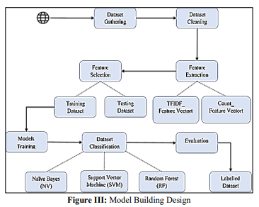

Figure III illustrates the design of the framework for fake news detection, consisting of three primary modules: data collection [22], preprocessing, and clustering. Data is gathered from reputable news websites using a custom web crawler and subsequently processed using text-processing algorithms to extract topics and events. The classification module then categorizes the news articles as either fake or real, integrating both the training and testing processes.

A. Framework Design:

The project's design encompasses an overview structure that elucidates the various components employed in the project, including objects, methods, functions, classifiers, and algorithms.

B. Data Exploration:

The classification dataset utilized for the project is sourced from the public domain and comprises a collection of both real and fake news articles [6].

C. Natural Language Processing for Text Preprocessing:

NLP, a subset of Artificial Intelligence (AI), is employed to make sense of unstructured data, such as electronic conversations. NLP dissects language into smaller units, comprehends the relationships between these units, and amalgamates them to derive meaning. NLP encompasses various methodologies, spanning from statistical and machine learning to rules-based and algorithmic approaches. The utilization of deep learning and algorithms is crucial for NLP in analyzing and understanding human language and, at times, predicting human intent. By transforming unstructured text data into structured and meaningful insights, NLP enables accurate data indexing and categorization into distinct groups.

• Cleaning: Data cleaning refers to the process of correcting or removing any inaccurate, incomplete, irrelevant, duplicate, or improperly formatted data in preparation for analysis.

• Tokenization: This divides the text into single phrases or semantic units.

• Stop Word Removal: Eliminating words that don't offer any initial data, including prepositions and articles.

• Lemmatization and Stemming: Reducing words to their most basic forms while analyzing word context.

D. Feature Extraction:

The research endeavor focuses on implementing a fake news detection system based on the textual content of news articles. Initially, the process entails text feature extraction to reduce redundant data and expedite the machine learning process. Three distinct feature extraction techniques are employed, namely Word Embedding, Count Vectorizer, and TF-IDF Vectorizer.

E. Dataset Classifiers:

The author opted to employ NB, SVM, and RF algorithms as text classifiers for the purpose of categorizing the dataset into fake or real news articles, primarily due to their commendable accuracy rates.

F. Coding:

The coding phase entails several essential steps, which encompass library importation, the ingestion of news datasets in CSV format, data cleansing involving the identification and removal of null values and superfluous columns, analysis of the distribution of fake and real news, amalgamation of title and text columns, visualization of news data through word clouds, NLP-based text preprocessing, the implementation of feature extractors, dataset division into training and testing sets, execution of classifiers (NB, SVM, Random Forest) on the training dataset, prediction generation on the test dataset, and the creation of a data frame for comprehensive performance comparison among all classifiers.

G. Simulation:

A simulation is carried out by the author to assess the accuracy and efficacy of the proposed methods for classifying news articles as fake or real. The simulation commences with data collection and preprocessing, followed by feature extraction implementation and the execution of multiple classifiers. Subsequently, the author conducts a comparative analysis of the results to ascertain the project's success. The outcome of the simulation underscores its success and alignment with the outlined objectives, as depicted in the study's strategic approach illustrated in Figure IV.

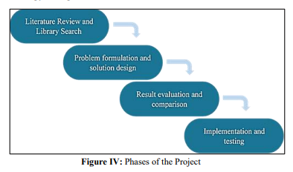

**H. NLP Models:**

To enhance the classifier's accuracy and performance, feature reduction is implemented, aiming to eliminate irrelevant and redundant features within the dataset. This optimization is achieved by constraining the size of text features and focusing exclusively on words that occur a specific number of times. Machine learning methods such as CountVectorizer and TF-IDF are employed to streamline this process.

The pre-processing steps integral to feature reduction include:

- Limiting the number 'n' of used words.

- Converting text to lowercase.

- Removing stop words.

Two primary techniques are employed for feature reduction:

**1. CountVectorizer:** This method calculates the frequency of each word in the text, organizes the results, and selects the most frequent features based on the "max features" hyperparameter. While convenient, this approach may exhibit bias by potentially overlooking significant yet less common features.

**2. TFIDFVectorizer:** Term Frequency Inverse Document Frequency (TFIDF) is utilized to transform text documents into vectors, with a focus on the relevance of words. The resulting matrix provides information on the least and most relevant terms within the document and is rooted in the bag of words model.

-----------------------------------------------------------------------------------------------------------------------