 | crop estimates committee
 | oesskattingskomitee
From/Van: Mr Baldwin Netshifhefhe  Tel: 012 319 8043/32  Fax/Faks: 012 319 8031  E-mail/E-pos: BaldwinN@dalrrd.gov.za  Web page/Webblad: www.dalrrd.gov.za/old website/statistics and economic reports or  www.sagis.org.za/CEC: Crop Estimates EMBARGO: 14:30 |  |  | 

The area planted estimate and fourth production forecast for summer crops for 2024 is hereby released.
Hiermee word die oppervlakte- en vierde produksieskatting vir somergewasse vir 2024 vrygestel.

SUMMER CROPS – AREA PLANTED AND FOURTH PRODUCTION FORECAST: 2024
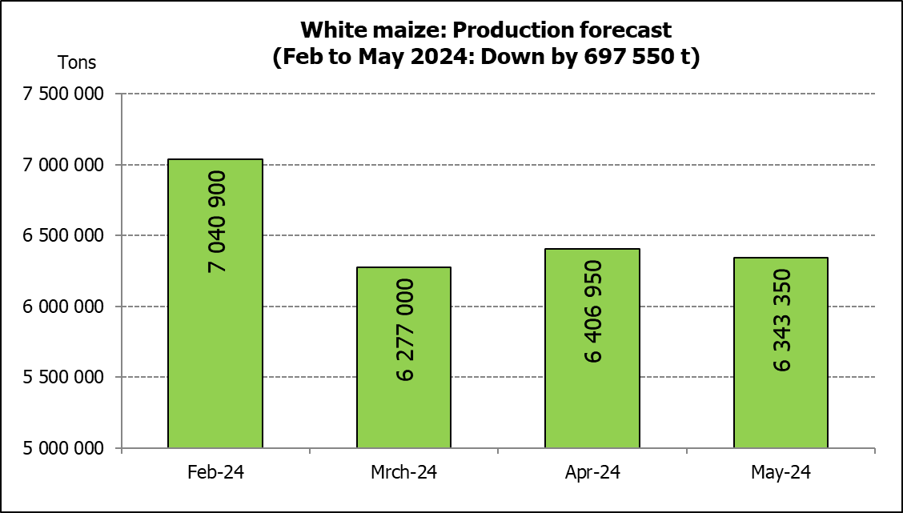
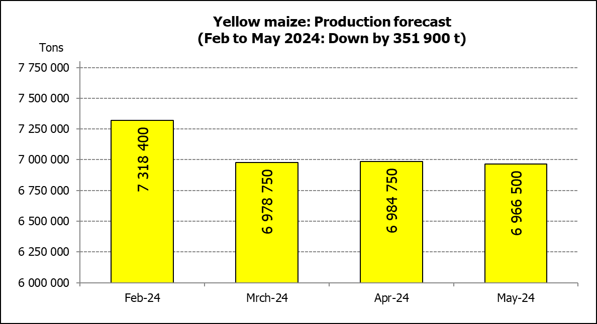
SOMERGEWASSE – OPPERVLAKTE- EN VIERDE PRODUKSIESKATTING: 2024
CROP/GEWAS | Area planted/ | 4th forecast/ | 3rd forecast/ | Area planted/ | Final crop/ | Change/
CROP/GEWAS | Opp beplant | 4de skatting | 3de skatting | Opp beplant | Finale oes | Verandering
CROP/GEWAS | 2024 | 2024 | 2024 | 2023 | 2023
CROP/GEWAS | Ha | Tons | Tons | Ha | Tons | %
CROP/GEWAS | (A) | (B) | (C) | (D) | (E) | (B) ÷ (C)
Commercial/Kommersieël:
White maize/Witmielies | 1 554 750 | 6 343 350 | 6 406 950 | 1 521 300 | 8 505 000 | -0,99%
Yellow maize/Geelmielies | 1 081 500 | 6 966 500 | 6 984 750 | 1 064 800 | 7 925 000 | -0,26%
Total Maize/Totale Mielies | 2 636 250 | 13 309 850 | 13 391 700 | 2 586 100 | 16 430 000 | -0,61%
Sunflower seed/Sonneblomsaad | 529 000 | 649 250 | 615 000 | 555 700 | 720 000 | 5,57%
Soybeans/Sojabone | 1 150 500 | 1 778 790 | 1 813 790 | 1 148 300 | 2 770 000 | -1,93%
Groundnuts/Grondbone | 41 200 | 54 440 | 54 960 | 31 300 | 53 000 | -0,95%
Sorghum | 42 100 | 95 830 | 94 105 | 34 000 | 94 360 | 1,83%
Dry beans/Droëbone | 39 550 | 52 190 | 54 120 | 36 650 | 50 260 | -3,57%
TOTAL/TOTAAL | 4 438 600 | 15 940 350 | 16 023 675 | 4 392 050 | 20 117 620 | -0,52%
Non-Commercial Maize/Nie-Kommersiële Mielies
Total Maize/Totale Mielies | 347 000 | 575 000 | 575 000 | 358 620 | 664 040 | 0,00%
Maize/Mielies: Commercial/Kommersieël + Non-Commercial/Nie-Kommersieël
Total Maize RSA/Totaal Mielies RSA | 2 983 250 | 13 884 850 | 13 966 700 | 2 944 720 | 17 094 040 | -0,59%
Note: Estimate is for calendar year, e.g. production season 2023/24 = 2024
Nota: Skatting is vir kalenderjaar, bv. produksie-seisoen 2023/24 = 2024
The Crop Estimates Committee comprises officials of the following institutions:
Department of Agriculture, Land Reform and Rural Development; Provincial Departments of Agriculture; various ARC-Institutes (Soil, Climate and Water; Small Grains Institute; and
Grain Crops Institute); BFAP and Statistics SA.
28 May / Mei 2024
The Crop Estimates Committee comprises officials of the following institutions:
Department of Agriculture, Land Reform and Rural Development; Provincial Departments of Agriculture; various ARC-Institutes (Soil, Climate and Water; Small Grains Institute; and Grain Crops Institute); BFAP and Statistics SA.

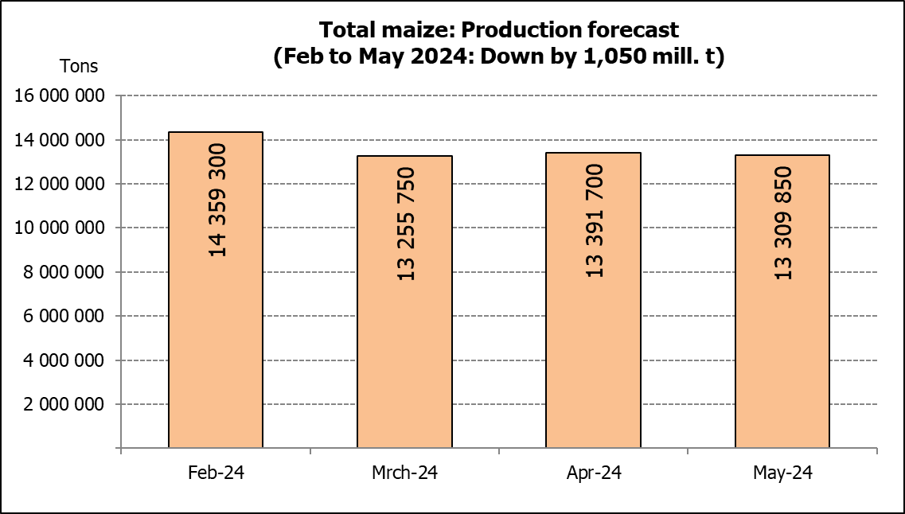

WHITE AND YELLOW MAIZE – AREA PLANTED AND FOURTH PRODUCTION FORECAST: 2024
WIT- EN GEELMIELIES – OPPERVLAKTE EN VIERDE PRODUKSIESKATTING: 2024

Provinsie/ | Area planted/ |  |  | 4th forecast/ |  |  | Area planted/ |  |  |  | Final crop/
Province | Oppervlakte beplant |  |  | 4de skatting |  |  | Oppervlakte beplant |  |  |  | Finale oes
 | 2024 |  |  | 2024 |  |  | 2023 |  |  |  | 2023
 | White/ | Yellow/ | Total/ | White/ | Yellow/ | Total/ | White/ | Yellow/ | Total/ | White/ |  | Yellow/ | Total/
 | Wit | Geel | Totaal | Wit | Geel | Totaal | Wit | Geel | Totaal | Wit |  | Geel | Totaal
 | Ha | Ha | Ha | Tons | Tons | Tons | Ha | Ha | Ha | Tons |  | Tons | Tons
Western Cape/Wes-Kaap | 250 | 3 500 | 3 750 | 2 300 | 32 200 | 34 500 | 250 | 3 500 | 3 750 | 2 375 |  | 33 000 | 35 375
Northern Cape/Noord-Kaap | 1 500 | 42 000 | 43 500 | 18 300 | 672 000 | 690 300 | 1 000 | 43 500 | 44 500 | 12 500 |  | 696 000 | 708 500
Free State/Vrystaat | 835 000 | 415 000 | 1 250 000 | 3 507 000 | 2 158 000 | 5 665 000 | 780 000 | 401 000 | 1 181 000 | 4 446 000 |  | 2 696 000 | 7 142 000
Eastern Cape/Oos-Kaap | 6 000 | 27 000 | 33 000 | 39 600 | 191 700 | 231 300 | 5 750 | 25 000 | 30 750 | 40 250 |  | 192 500 | 232 750
KwaZulu-Natal | 47 000 | 67 000 | 114 000 | 291 400 | 582 900 | 874 300 | 49 000 | 65 000 | 114 000 | 298 900 |  | 537 000 | 835 900
Mpumalanga | 160 000 | 360 000 | 520 000 | 1 000 000 | 2 448 000 | 3 448 000 | 156 500 | 352 000 | 508 500 | 1 032 900 |  | 2 596 000 | 3 628 900
Limpopo | 11 000 | 15 000 | 26 000 | 74 250 | 121 500 | 195 750 | 16 800 | 22 800 | 39 600 | 114 075 |  | 187 000 | 301 075
Gauteng | 54 000 | 62 000 | 116 000 | 310 500 | 409 200 | 719 700 | 56 000 | 52 000 | 108 000 | 364 000 |  | 392 500 | 756 500
North West/Noordwes | 440 000 | 90 000 | 530 000 | 1 100 000 | 351 000 | 1 451 000 | 456 000 | 100 000 | 556 000 | 2 194 000 |  | 595 000 | 2 789 000
Total/Totaal | 1 554 750 | 1 081 500 | 2 636 250 | 6 343 350 | 6 966 500 | 13 309 850 | 1 521 300 | 1 064 800 | 2 586 100 | 8 505 000 |  | 7 925 000 | 16 430 000

SUNFLOWER SEED – AREA PLANTED AND FOURTH PRODUCTION FORECAST: 2024
SONNEBLOMSAAD – OPPERVLAKTE EN VIERDE PRODUKSIESKATTING: 2024

Province/ | Area planted/ | 4th forecast/ | Area planted/ | Final crop/
Provinsie | Opp beplant | 4de skatting | Opp beplant | Finale oes
 | Ha | Tons | Ha | Tons
 | 2024 | 2024 | 2023 | 2023
Western Cape/Wes-Kaap | 0 | 0 | 0 | 0
Northern Cape/Noord-Kaap | 2 000 | 4 600 | 2 500 | 6 250
Free State/Vrystaat | 255 000 | 357 000 | 290 000 | 402 000
Eastern Cape/Oos-Kaap | 700 | 1 400 | 700 | 1 400
KwaZulu-Natal | 300 | 600 | 300 | 600
Mpumalanga | 3 500 | 4 900 | 5 000 | 7 140
Limpopo | 90 000 | 76 500 | 100 000 | 75 000
Gauteng | 2 500 | 3 000 | 2 200 | 2 860
North West/Noordwes | 175 000 | 201 250 | 155 000 | 224 750
Total/Totaal | 529 000 | 649 250 | 555 700 | 720 000
SOYBEANS – AREA PLANTED AND FOURTH PRODUCTION FORECAST: 2024
SOJABONE – OPPERVLAKTE EN VIERDE PRODUKSIESKATTING: 2024
Province/ | Area planted/ | 4th forecast/ | Area planted/ | Final crop/
Provinsie | Opp beplant | 4de skatting | Opp beplant | Finale oes
 | Ha | Tons | Ha | Tons
 | 2024 | 2024 | 2023 | 2023
Western Cape/Wes-Kaap | 0 | 0 | 0 | 0
Northern Cape/Noord-Kaap | 1 200 | 4 380 | 1 000 | 3 750
Free State/Vrystaat | 545 000 | 681 250 | 565 000 | 1 330 000
Eastern Cape/Oos-Kaap | 5 300 | 14 310 | 4 300 | 12 900
KwaZulu-Natal | 47 000 | 169 200 | 44 000 | 163 000
Mpumalanga | 320 000 | 576 000 | 305 000 | 671 000
Limpopo | 21 000 | 71 400 | 26 000 | 88 500
Gauteng | 56 000 | 84 000 | 48 000 | 105 600
North West/Noordwes | 155 000 | 178 250 | 155 000 | 395 250
Total/Totaal | 1 150 500 | 1 778 790 | 1 148 300 | 2 770 000

GROUNDNUTS – AREA PLANTED AND FOURTH PRODUCTION FORECAST: 2024
GRONDBONE – OPPERVLAKTE EN VIERDE PRODUKSIESKATTING: 2024

Province/ | Area planted/ | 4th forecast/ | Area planted/ | Final crop/
Provinsie | Opp beplant | 4de skatting | Opp beplant | Finale oes
 | Ha | Tons | Ha | Tons
 | 2024 | 2024 | 2023 | 2023
Western Cape/Wes-Kaap | 0 | 0 | 0 | 0
Northern Cape/Noord-Kaap | 4 200 | 9 450 | 2 000 | 5 300
Free State/Vrystaat | 17 000 | 25 500 | 12 300 | 21 000
Eastern Cape/Oos-Kaap | 0 | 0 | 0 | 0
KwaZulu-Natal | 300 | 840 | 0 | 0
Mpumalanga | 0 | 0 | 0 | 0
Limpopo | 1 700 | 4 250 | 2 000 | 4 700
Gauteng | 0 | 0 | 0 | 0
North West/Noordwes | 18 000 | 14 400 | 15 000 | 22 000
Total/Totaal | 41 200 | 54 440 | 31 300 | 53 000

SORGHUM – AREA PLANTED AND FOURTH PRODUCTION FORECAST: 2024
SORGHUM – OPPERVLAKTE EN VIERDE PRODUKSIESKATTING: 2024

Province/ | Area planted/ | 4th forecast/ | Area planted/ | Final crop/
Provinsie | Opp beplant | 4de skatting | Opp beplant | Finale oes
 | Ha | Tons | Ha | Tons
 | 2024 | 2024 | 2023 | 2023
Western Cape/Wes-Kaap | 0 | 0 | 0 | 0
Northern Cape/Noord-Kaap | 0 | 0 | 0 | 0
Free State/Vrystaat | 11 500 | 18 400 | 5 200 | 14 820
Eastern Cape/Oos-Kaap | 100 | 300 | 0 | 0
KwaZulu-Natal | 100 | 350 | 100 | 400
Mpumalanga | 8 300 | 35 690 | 8 500 | 35 275
Limpopo | 18 000 | 35 100 | 15 500 | 33 325
Gauteng | 100 | 390 | 100 | 420
North West/Noordwes | 4 000 | 5 600 | 4 600 | 10 120
Total/Totaal | 42 100 | 95 830 | 34 000 | 94 360

DRY BEANS – AREA PLANTED AND FOURTH PRODUCTION FORECAST: 2024
DROëBONE – OPPERVLAKTE EN VIERDE PRODUKSIESKATTING: 2024

Province/ | Area planted/ | 4th forecast/ | Area planted/ | Final crop/
Provinsie | Opp beplant | 4de skatting | Opp beplant | Finale oes
 | Ha | Tons | Ha | Tons
 | 2024 | 2024 | 2023 | 2023
Western Cape/Wes-Kaap | 100 | 200 | 100 | 180
Northern Cape/Noord-Kaap | 500 | 1 050 | 450 | 990
Free State/Vrystaat | 13 500 | 11 475 | 14 000 | 13 300
Eastern Cape/Oos-Kaap | 200 | 440 | 200 | 360
KwaZulu-Natal | 2 100 | 2 520 | 2 100 | 3 150
Mpumalanga | 2 600 | 4 420 | 5 000 | 7 000
Limpopo | 12 200 | 24 400 | 8 000 | 16 000
Gauteng | 850 | 935 | 800 | 880
North West/Noordwes | 7 500 | 6 750 | 6 000 | 8 400
Total/Totaal | 39 550 | 52 190 | 36 650 | 50 260

CONFIDENTIALITY ISSUES that CEC members are committed to adhere to on the day of the meeting
- Personal items such as laptops, handbags, cell phones, etc. are not allowed in the venue during the meeting
- No member is allowed to leave the meeting before 12:00 in order to prevent disclosure of the information
- The embargo time for the release of crop estimates information is 14:30
- No member is allowed to discuss crop estimates information with anyone other than a member of the Committee before the embargo time
- Only the Chairperson, or a member appointed by the Chairperson, may release the figures to the media
- Members must regard the detail of any information that was collected for and/or discussed during the meeting, as confidential
- Individual information received for crop estimate purposes is treated strictly confidential, and is not divulged for any other purposes

AREA ESTIMATE AND FOURTH PRODUCTION FORECAST OF SUMMER CROPS (2024 PRODUCTION SEASON)/
OPPERVLAKTE- EN VIERDE PRODUKSIESKATTING VIR SOMERGEWASSE (2024 PRODUKSIE-SEISOEN)
28 MAY / MEI 2024

Summer field crops – 2024  Commercial maize: The size of the expected commercial maize crop has been set at 13,310 mill. tons, which is 0,61% or 81 850 tons less than the previous forecast of 13,392 mill. tons. The expected yield for maize is 5,05 t/ha.  The estimated maize crop is 18,99% or 3,120 mill. tons smaller than the 2023 crop. The three main maize producing areas, namely the Free State, Mpumalanga and North West provinces are expected to produce 79% of the 2024 crop.  The production forecast of white maize is 6,343 mill. tons, which is 0,99% or 63 600 tons less than the 6,407 mill. tons of the previous forecast. The area estimate for white maize is 1,555 mill. ha and the expected yield is 4,08 t/ha.  In the case of yellow maize, the production forecast is 6,967 mill. tons, which is 0,26% or 18 250 tons less than the 6,985 mill. tons of the previous forecast. The area estimate for yellow maize is 1,082 mill. ha and the yield is 6,44 t/ha.  The yield per ha for the Free State and North West provinces were mainly based on scientific and objective results provided by the ARC.  Other summer crops:  Sunflower seed: The production forecast for sunflower seed is 649 250 tons, which is 5,57% or 34 250 tons more than the previous forecast of 615 000 tons. The area estimate for sunflower seed is 529 000 ha, while the expected yield is 1,23 t/ha.  Other crops: The production forecast for soybeans is 1,779 mill. tons, which is 1,93% or 35 000 tons less than the previous forecast of 1,814 mill. tons. The estimated area planted to soybeans is 1,151 mill. ha, with an expected yield of 1,55 t/ha.  The expected groundnut crop has been set at 54 440 tons, which is 0,95% or 520 tons less than the previous forecast of 54 960 tons. For groundnuts, the area estimate is 41 200 ha, with an expected yield of 1,32 t/ha.  The production forecast for sorghum is 95 830 tons, which is 1,83% or 1 725 tons more than the 94 105 tons of the previous forecast. The area estimate for sorghum is 42 100 ha and the expected yield is 2,28 t/ha.  In the case of dry beans, the production forecast decreased by 3,57% or 1 930 tons, from 54 120 tons to 52 190 tons. The area estimate of dry beans is 39 550 ha, with an expected yield of 1,32 t/ha.  Please note that the fifth production forecast for summer field crops for 2024 will be released on 27 June 2024. |  | Somergewasse – 2024  Kommersiële mielies: Die grootte van die verwagte kommersiële mielie-oes is op 13,310 milj. ton gestel, wat 0,61% of 81 850 ton minder is as die vorige skatting van 13,392 milj. ton. Die verwagte opbrengs van mielies is 5,05 t/ha.  Die geskatte mielie-oes is 18,99% of 3,120 milj. ton minder as die 2023-oes. Die drie belangrikste mielieproduserende gebiede, nl. die Vrystaat, Mpumalanga en Noordwes provinsies, gaan na verwagting 79% van die 2024-oes produseer.  Die produksieskatting van witmielies is 6,343 milj. ton, wat 0,99% of 63 600 ton minder is as die 6,407 milj. ton van die vorige skatting. Die oppervlakteskatting vir witmielies is 1,555 milj. ha en die verwagte opbrengs is 4,08 t/ha.  In die geval van geelmielies is die produksieskatting 6,967 milj. ton, wat 0,26% of 18 250 ton minder is as die 6,985 milj. ton van die vorige skatting. Die oppervlakteskatting vir geelmielies is 1,082 milj. ha en die opbrengs is 6,44 t/ha.  Die opbrengs-bepaling per ha vir die Vrystaat en Noordwes provinsies is hoofsaaklik gebaseer op wetenskaplike en objektiewe resultate verstrek deur die LNR.  Ander somergewasse:  Sonneblomsaad: Die produksieskatting vir sonneblomsaad is 649 250 ton, wat 5,57% of 34 250 ton meer is as die vorige skatting van 615 000 ton. Die oppervlakteskatting vir sonneblomsaad is 529 000 ha, terwyl die verwagte opbrengs 1,23 t/ha is.  Ander gewasse: Die produksieskatting van sojabone is 1,779 milj. ton, wat 1,93% of 35 000 ton minder as die vorige skatting van 1,814 milj. ton. Die geskatte oppervlakte beplant van sojabone is 1,151 milj. ha, met ‘n verwagte opbrengs van 1,55 t/ha.  Die verwagte grondbone-oes is op 54 440 ton gestel, wat 0,95% of 520 ton minder is as die vorige skatting van 54 960 ton. Vir grondbone is die oppervlakteskatting 41 200 ha, terwyl the verwagte opbrengs 1,32 t/ha is.  Die produksieskatting van sorghum is 95 830 ton, wat 1,83% of 1 725 ton meer is as die 94 105 ton van die vorige skatting. Die oppervlakteskatting vir sorghum is 42 100 ha, en die verwagte opbrengs is 2,28 t/ha.  In die geval van droëbone het die produksieskatting afgeneem met 3,57% of 1 930 ton, vanaf 54 120 ton tot 52 190 ton. Die oppervlakte beplant met droëbone is 39 550 ha, en die verwagte opbrengs is 1,32 t/ha.  Neem asseblief kennis dat die vyfde produksieskatting vir somergewasse vir 2024, op 27 Junie 2024 vrygestel sal word.
Information is available on the internet at http:// www.dalrrd.gov.za/old website/statistics or http://www.sagis.org.za, as from 14:30 on the date of the relevant meeting of the Crop Estimates Committee. |  | Inligting is beskikbaar op die internet by http://www.dalrrd.gov.za/old website/statistics of by http://www.sagis.org.za, vanaf 14:30 op die dag van die toepaslike vergadering van die Oesskattingskomitee.

The non-commercial agricultural sectors’ production estimate for maize for 2024 is hereby released. /
Hiermee word die nie-kommersiële landbou-sektor se produksieskatting vir mielies vir 2024 vrygestel.

NON-COMMERCIAL MAIZE – PRELIMINARY AREA PLANTED AND PRODUCTION ESTIMATE: 2024
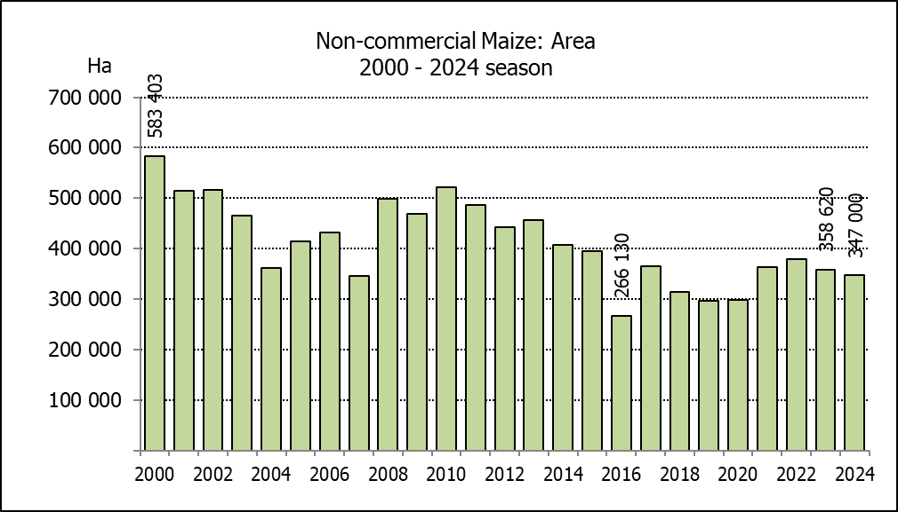
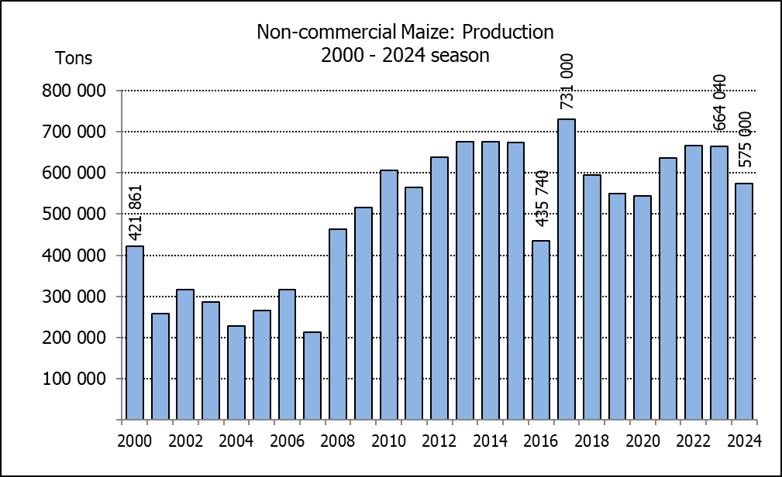
NIE-KOMMERSIëLE MIELIES – VOORLOPIGE OPPERVLAKTE- EN PRODUKSIESKATTING: 2024
CROP/GEWAS | Area planted/  Opp beplant  2024 | Production/  Produksie  2024 | Area planted/  Opp beplant  2023 | Final crop/  Finale oes  2023 | Change/  Verandering
CROP/GEWAS | Ha | Tons | Ha | Tons | %
CROP/GEWAS | (A) | (B) | (C) | (D) | (B) ÷ (D)
Non-commercial agriculture/Nie-kommersiële landbou:
White maize/Witmielies | 267 570 | 407 500 | 278 655 | 472 765 | -13,80
Yellow maize/Geelmielies | 79 430 | 167 500 | 79 965 | 191 275 | -12,43
Maize/Mielies | 347 000 | 575 000 | 358 620 | 664 040 | -13,41
The area planted to maize in the non-commercial agricultural sector is estimated at 347 000 ha, which represents a decrease of 3,24%, compared to the 358 620 ha of the previous season. The expected maize crop for this sector is 575 000 tons, which is 13,41% less than the 664 040 tons of last season. It is important to note that about 46% of the maize produced in the non-commercial sector, is planted in the Eastern Cape, followed by KwaZulu-Natal with 22%.
Die voorlopige oppervlakte beplant met mielies in die nie-kommersiële landbou-sektor word geskat op 347 000 ha, wat ’n afname van 3,24% verteenwoordig in vergelyking met die 358 620 ha van die vorige seisoen. Die verwagte mielie-oes van dié sektor is 575 000 ton, wat 13,41% minder is as die 664 040 ton van die vorige seisoen. Dit is belangrik om daarop te let dat ongeveer 46% van die mielies wat geproduseer word in die nie-kommersiële sektor, in die Oos-Kaap geplant word, gevolg deur KwaZulu-Natal met 22%.

