ARMOR

OVERVIEW
The armor is an item that gives the player armor points that protect them from incoming shots.

BREAKDOWN
The point of the armor is to act as a first line of defense for the player’s health. If the player possesses armor and gets shot, the armor will take the damage first until it’s fully depleted.

ART
A rusty old Kevlar armor that has very clear been worn by multiple people for an extended amount of time. It has holes dug into it with some pieces even sticking out as chunks.

SOUND
When picking it up, a loud KSSSHH BLIMM, TUM TUM can be heard across the map. While a player has armor, there’s a noise that’s periodically coming from the player, like an electricity spark sound Tzzzzshhht. When the player’s armor breaks from damage, a loud ZZSHHHPBRREOK noise happens.

ANIMATION
While the armor is on the floor, it has electrical zaps surrounding it that visualize sparks periodically. When the player picks up the armor, a brown hue flashes for a second around the player’s POV. When the armor breaks, 2 sparks come out of the player from the other player’s POV.

PROGRAMMING
When the armor is on the floor, an animation plays on loop for the sparks. When the player picks up the armor, it will give him 25 armor points. When the armor reaches 0, it will no longer protect the player’s health bar. If the damage that the player takes from a shot is bigger than the amount of armor that they have left, the remaining damage will carry over to the health.

ILLUSTRATIONS
Bloody Suit (Dead Space 1 2023)
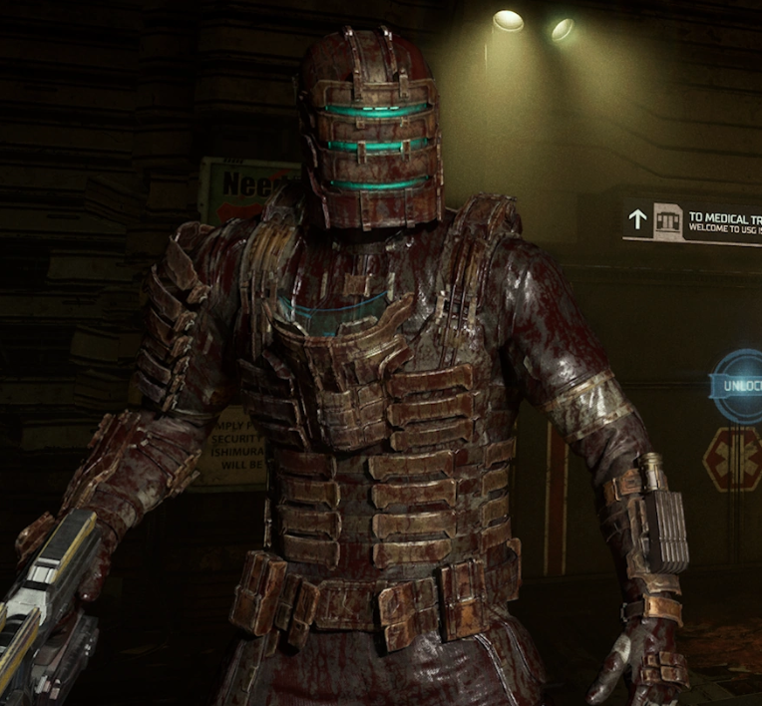
Rusted Junkyard Power Armor (Fallout 76)
