Nosebreaker

OVERVIEW
The Nosebreaker is a rocket launcher that depends on the surface that it hits.

BREAKDOWN
The Nosebreaker will only deal damage to the enemy when the rocket hits them on direct impact. When hitting anything else but the player, it produces a shockwave that knocks back any player that’s located by the explosion radius.

ART
An industrial look to it using yellow, black and orange as the main colors with some steel to it.

SOUND
When shooting, it produces a THHWOOOMPP kind of sound. After a shot, the player cocks back the back half of the launcher in order to load in the next projectile into place. This will do a “tongue clicking” kind of noise twice with some delay in-between.

ANIMATION
When shooting, the barrel of the launcher will cock back slightly and back forward into place. After a shot, the character will cock the back half of the weapon fully in and back out in order to load the next bullet into it.

PROGRAMMING
When the player fires the weapon, it will send out a projectile that will determine what happens on impact. If it collides with an enemy, it will explode. Else, it will create multiple spherical collisions over a short period of time to calculate and determine where in the explosion the player was hit and the direction that they should be launched. After the bullet is shot, there is a small 1 second delay to load the next one in.

BEHAVIOUR
The launcher should have 5 bullets. On a direct hit, it will deal 80 damage, the perfect amount to 1 shot unless the enemy has armor. This will leave them at 25 health. The rocket will have a moderate amount of speed when travelling.

TTK
1 rocket = 80 DMG
1 seconds cooldown between rockets
2 rockets (kill) = 1 seconds cooldown in total
Moderate travel time, travel from fireplace room to portal of main area in about 0.6 seconds.
TTK ~1.4 seconds (counting shooting)

ILLUSTRATIONS
Rocket Launcher (ULTRAKILL)
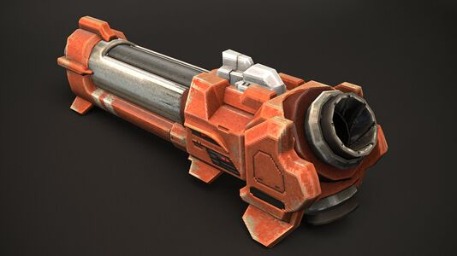

Pharah gun
