Pulse CRVR

OVERVIEW
The Pulse CRVR is a semi-automatic rifle. It’s use is ideal for mid to long range combat with its high damage, but ultimately excels at all.

BREAKDOWN
The Pulse CRVR works like any semi-automatic rifle. It has good long range performance while still being good and reliable in close quarters situations.

ART
A rusty, thin rifle with a big rounded double barrel with holes while having a normal extended barrel after it.

SOUND
When shooting, it produces a TUM with a certain amount of reverb to mimic the big barrel.

ANIMATION
When shooting, slight puffs of steam come out the barrel holes. The cases also fly out like any regular gun.

PROGRAMMING
When the player fires the weapon, it will have a delay of about 0.4 seconds in which the player isn’t able to shoot. The shooting is made using line tracing in order to have it instantly hit the surface that the player is aiming at.

BEHAVIOUR
The gun should have a little delay on the shooting and requires the player to click in order to shoot. It’s supposed to be a gun that the player has to hit their shots with good accuracy and tempo in order to not lose against the opponent. The weapon has 12 bullets and each one hits for 35 damage.

TTK
1 bullet = 20 DMG
0.3 seconds cooldown between shots
5 bullets (kill) = 1.5 seconds cooldown in total
TTK ~1.6 seconds (counting shooting)

ILLUSTRATIONS
FN FAL
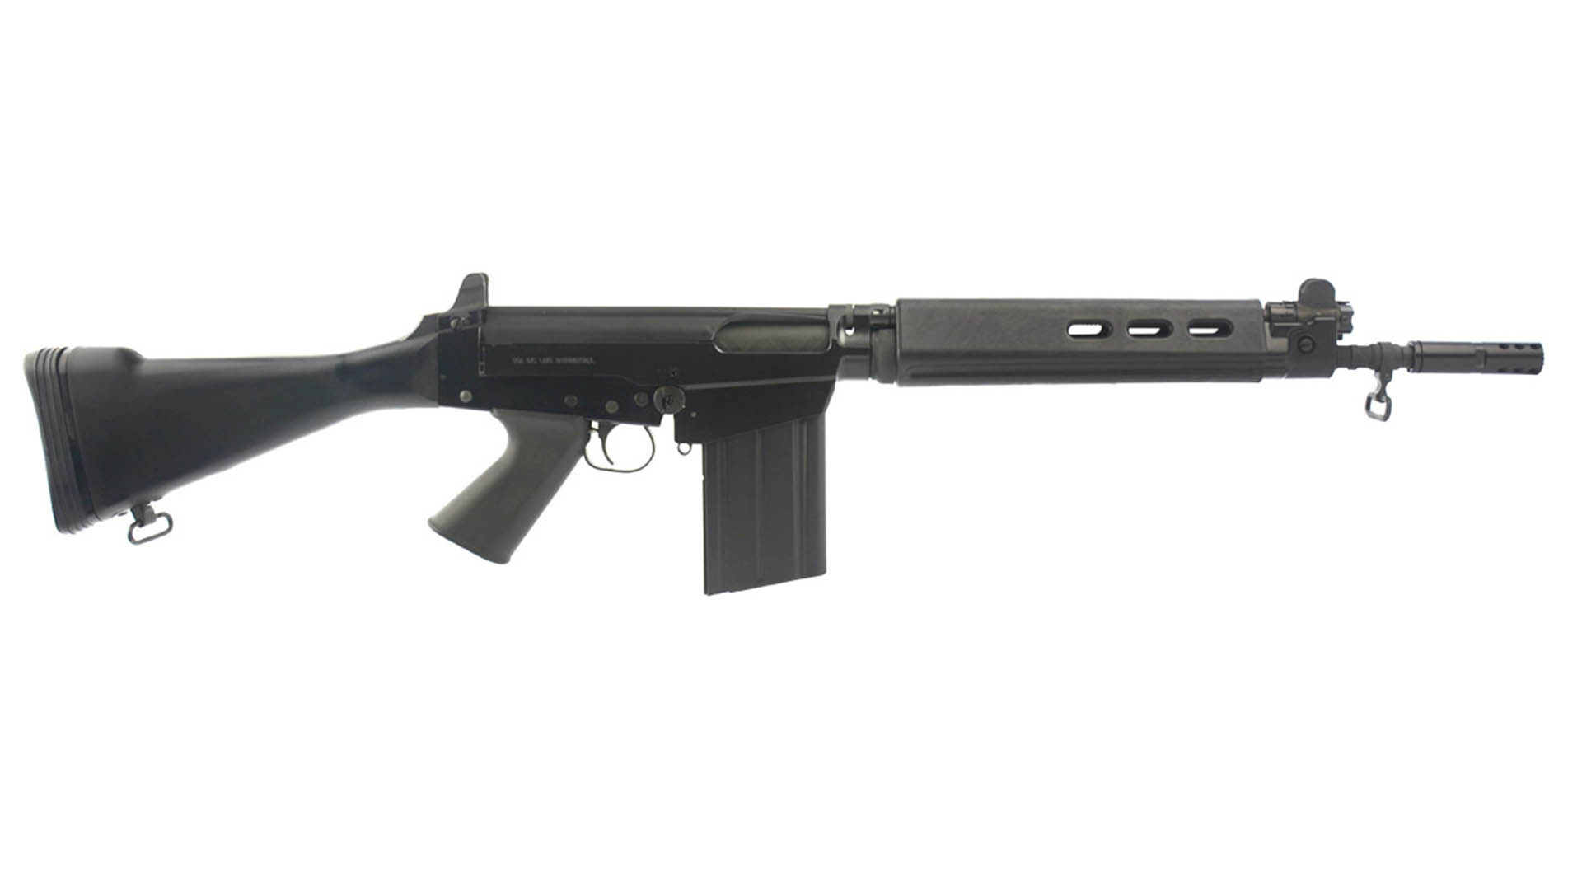

M1 Garand
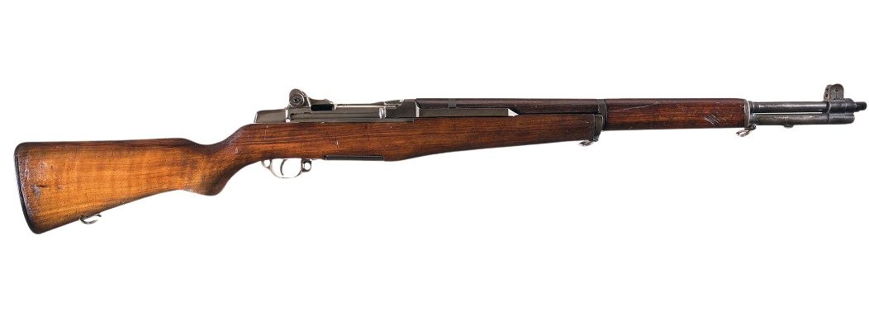

Zweihänder (COD BO4)
