XRED-R

OVERVIEW
The XRED-R is a gun that shoots 3 projectile-based bullets that travel overtime to the player’s aimed location during the trigger pull.

BREAKDOWN
The point of the weapon is for the player to track the opponent’s movement while they themselves have to be on the move. This makes it more challenging while having the reward of landing a two full bursts to kill the enemy. Having this kind of burst mechanic will also prompt the player into swapping between weapons while using them to try and get the most out of their arsenal.

ART
A rusty old steam-powered gun that shoots .45 cal bullets. The gun looks used with some levers and more attached to it. Like a 5-minute crafts weapon.

SOUND
Something like a controller vibration, Brrrrt Brrrrt. After a burst, the steam that leaves the weapon can do a steam/vaporization kind of sound. Bsshhhhhh

ANIMATION
When firing, the back of the weapon has a curved metal stick, kind of like a caulk gun, that will go back and forth on each bullet that gets released. At the end of a burst shot, the gun lets some steam out from the sides from having powered off 3 bullets in quick succession.

PROGRAMMING
When the player fires the weapon, it will have a little delay between the 3 bullets. Then at the end of those, it will have another delay to keep the player from spamming burst shots and so that the weapon can resume its state.

BEHAVIOUR
The gun should ideally have 15 bullets and deal 9 damage per bullet hit on a player.

TTK
3 bullets = 27 DMG
0.3 seconds cooldown between bursts
12 bullets (kill) = 1.2 seconds cooldown in total
TTK ~1.3 seconds (counting shooting)

ILLUSTRATIONS
Caulk gun
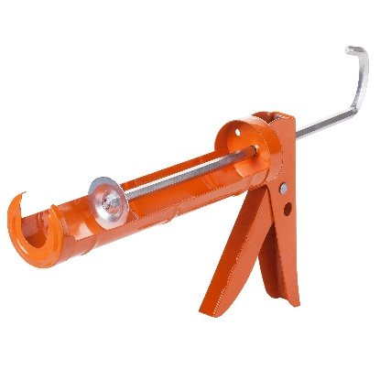
LWRC SMG-45
