**REPORT**

Team No - 19

* **Project Title**

Database System for a Music Company

* **Team Members(TEAM-19)**

Lebaka Kullayi Swamy Reddy – CSE20085

N.N.V.Siva Sai Raghu – CSE20109

Pusapati Ramakrishna Raju – CSE20134

Tripuramallu Pramodh – CSE20183

**Brief Description**

**ER Diagram**

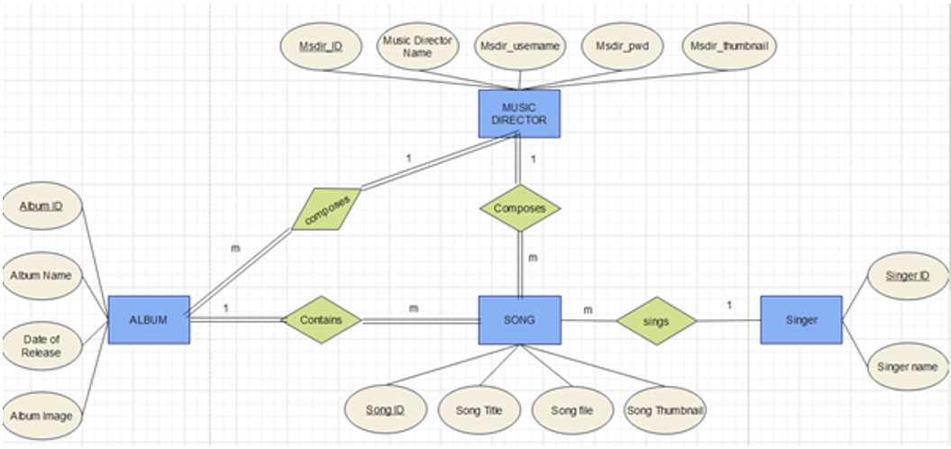

Album (Album name, Album ID, Date of release, Album Image)