1. Familiarize with the File Operations in Java. Develop a program to read the content of one file and copy the content to other file.

* The **canRead()** method is used to check whether we can read the data of the file or not.
* The **canWrite()** method is used to check whether we can write the data into the file or not.
* The **createNewFile()** method returns true when it successfully creates a new file and returns false when the file already exists.
* FileWriter(File file) – Constructs a FileWriter object given a File object.
* FileWriter (File file, boolean append) – constructs a FileWriter object given a File object.
* FileWriter (FileDescriptor fd) – constructs a FileWriter object associated with a file

descriptor.

* FileWriter (String fileName) – constructs a FileWriter object given a file name.
* FileWriter (String fileName, Boolean append) – Constructs a FileWriter object given a filename with a Boolean indicating whether or not to append the data written.

Source Code:

**package** Pranav221047001;

**import** java.io.File;

**import** java.io.IOException;

**import** java.io.FileWriter;

**import** java.util.Scanner;

**import** java.io.FileNotFoundException;

**import** java.io.FileReader;

**public** **class** FileHandling {

**public** **static** **void** main(String[] args) {

**try** {

File myObj1 = **new** File("C:\\Users\\MSIS\\Documents\\Java\\Input.txt");

**if** (myObj1.createNewFile()) {

System.***out***.println("File created: " + myObj1.getName());

} **else** {

System.***out***.println("File already exists.");

}

} **catch** (IOException e) {

System.***out***.println("An error occurred.");

e.printStackTrace();

}

**try** {

FileWriter myWriter = **new** FileWriter("C:\\Users\\MSIS\\Documents\\Java\\Input.txt");

myWriter.write("Pranav Ravindra Khedekar \n 221047001 \n Cloud computing");

myWriter.close();

System.***out***.println("Input given and inserted successfully.");

} **catch** (IOException e) {

System.***out***.println("An error occurred.");

e.printStackTrace();

}

**try** {

File myObj2 = **new** File("C:\\Users\\MSIS\\Documents\\Java\\Output.txt");

**if** (myObj2.createNewFile()) {

System.***out***.println("File created: " + myObj2.getName());

} **else** {

System.***out***.println("File already exists.");

}

} **catch** (IOException e) {

System.***out***.println("An error occurred.");

e.printStackTrace();

}

**try** {

FileReader f1 = **new** FileReader("Input.txt");

File myObj = **new** File("C:\\Users\\MSIS\\Documents\\Java\\Input.txt");

FileWriter myWriter = **new** FileWriter("C:\\Users\\MSIS\\Documents\\Java\\Output.txt");

Scanner myReader = **new** Scanner(myObj);

**int** i; String s="";

**while** ((i=f1.read())!=-1)

s+=(**char**)i;

myWriter.write(s);

myWriter.close();

System.***out***.println("Input given and inserted successfully.");

myReader.close();

f1.close();

} **catch** (FileNotFoundException e) {

System.***out***.println("An error occurred.");

e.printStackTrace();

} **catch** (IOException e) {

System.***out***.println("An error occurred.");

e.printStackTrace();

}

}

}

Output

Input.txt

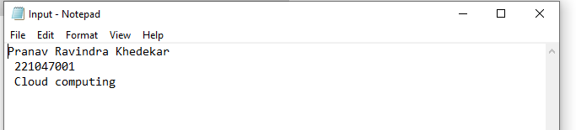

Output.txt

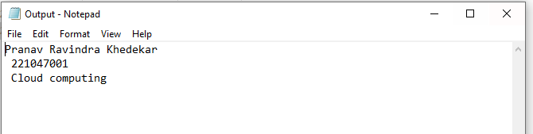

2.Write a Calculator Utility that does the that performs the set of operations defined in an interface called MyOperations. Develop the Application Program to utilize the  operations defined in MyOperations. Your Application should have proper Exception Handling and your operation should utilize at least two Custom Exceptions. Record of your operations should be recorded in a file

Source Code:

**package** Pranav221047001;

**import** java.util.InputMismatchException;

**import** java.util.Scanner;

**import** java.io.FileReader;

**import** java.io.FileWriter;

**interface** MyOperations{

**public** String add(**int** a, **int** b);

**public** String subtract(**int** a, **int** b);

**public** String multiply(**int** a, **int** b);

**public** String division(**int** a, **int** b);

**public** String min(**int** a, **int** b);

}

**public** **class** Cal_File **implements** MyOperations{

**public** **static** **void** main(String[] args) **throws** InputMismatchException{

Cal_File cal = **new** Cal_File();

**try** {

**var** sc1 = **new** Scanner(System.***in***);

System.***out***.println("For addition : 1");

System.***out***.println("For subtraction : 2");

System.***out***.println("For multiply : 3");

System.***out***.println("For division : 4");

System.***out***.println("For minimum of number : 5");

System.***out***.println("Enter your choice here : ");

**int** c = sc1.nextInt();

System.***out***.println("Enter first number : ");

**char** x = (**char**) sc1.nextInt();

System.***out***.println("Enter second number: ");

**char** y = (**char**) sc1.nextInt();

String data = **null**;

**switch**(c) {

**case** 1:

data = cal.add(x, y);

**break**;

**case** 2:

data = cal.subtract(x, y);

**break**;

**case** 3:

data = cal.multiply(x, y);

**break**;

**case** 4:

data = cal.division(x, y);

**break**;

**case** 5:

data = cal.min(x, y);

**break**;

**default** : System.***out***.println("Invalid input");

}

**try**{

/**Creating Data file

File file = new File("data.txt");*/

**int** i; String s = **null**;

//Saving user data with file without loosing old data

FileWriter wr = **new** FileWriter("data.txt", **true**);

wr.write("\n");

wr.write(data);

wr.write("\n");

wr.close();

FileReader f2r = **new** FileReader("data.txt");

**while**((i=f2r.read())!=-1) {

s += (**char**)i;

}

System.***out***.println(s);

f2r.close();

}

**catch**(Exception e){

System.***out***.println("File dosnt exist ");

}

//System.out.println(data);

}

**catch**(InputMismatchException e){

// show if value is invalid.

System.***out***.println("Invalid Input...");}

**catch**(ArithmeticException e){

// show when number is divided by 0.

System.***out***.println("Error:Divide By ZERO");

}

}

**public** **int** a;

**public** **int** b;

**public** String data;

**public** String add(**int** a, **int** b) {

**try** {

data = "MyOperations - add " + a + " and " + b + " = " + (a+b)+"\n";

System.***out***.println(data);

}**catch**(Exception e) {

System.***out***.println("Error Occuured");

**return** "Error";

}

**return** data;

}

**public** String subtract(**int** a, **int** b) {

data = "MyOperations - subtract " + a + " and " + b + " = " + (a-b)+"\n";

System.***out***.println(data);

**return** data;

}

**public** String multiply(**int** a, **int** b) {

data ="MyOperations - multiply " + a + " and " + b+ " = " + (a*b)+"\n";

System.***out***.println(data);

**return** data;

}

**public** String division(**int** a, **int** b) {

data ="MyOperations - multiply " + a + " and " + b+ " = " + (a/b)+"\n";

System.***out***.println(data);

**return** data;

}

**public** String min(**int** a, **int** b) {

**int** x;

**if** (a < b) {

x = a;

}

**else**

x = b;

data = "MyOperations - min " + a + " and " + b+" is "+x+"\n";

System.***out***.println(data);

**return** data;

}

}

Output

1. Exception 1- Divided by zero

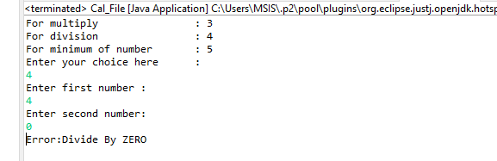

2. Exception 2-Input mismatch Exception

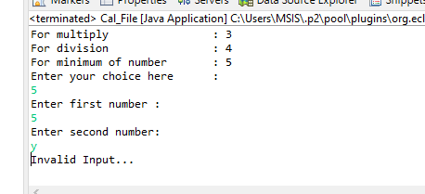

3. Performing the task

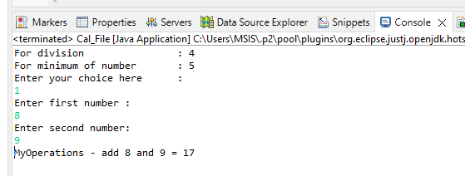

4. Data.txt file

