CIRCUIT DIAGRAM:

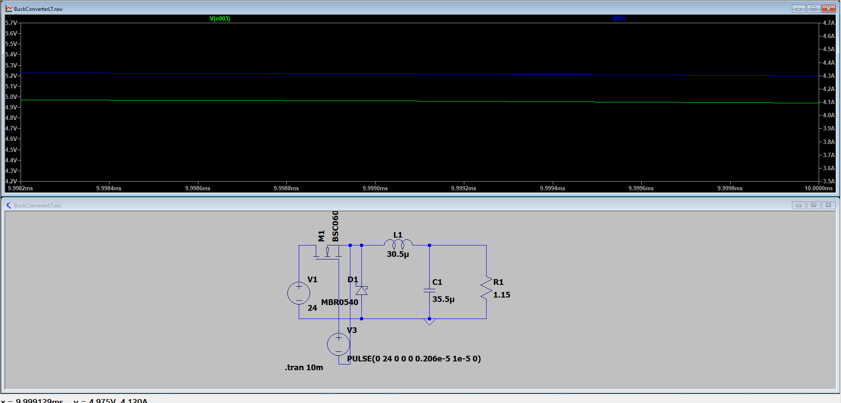

OUTPUT VOLTAGE

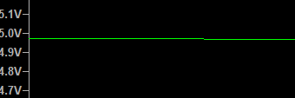

OUTPUT CURRENT

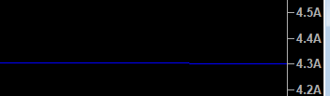

CALCULATIONS:

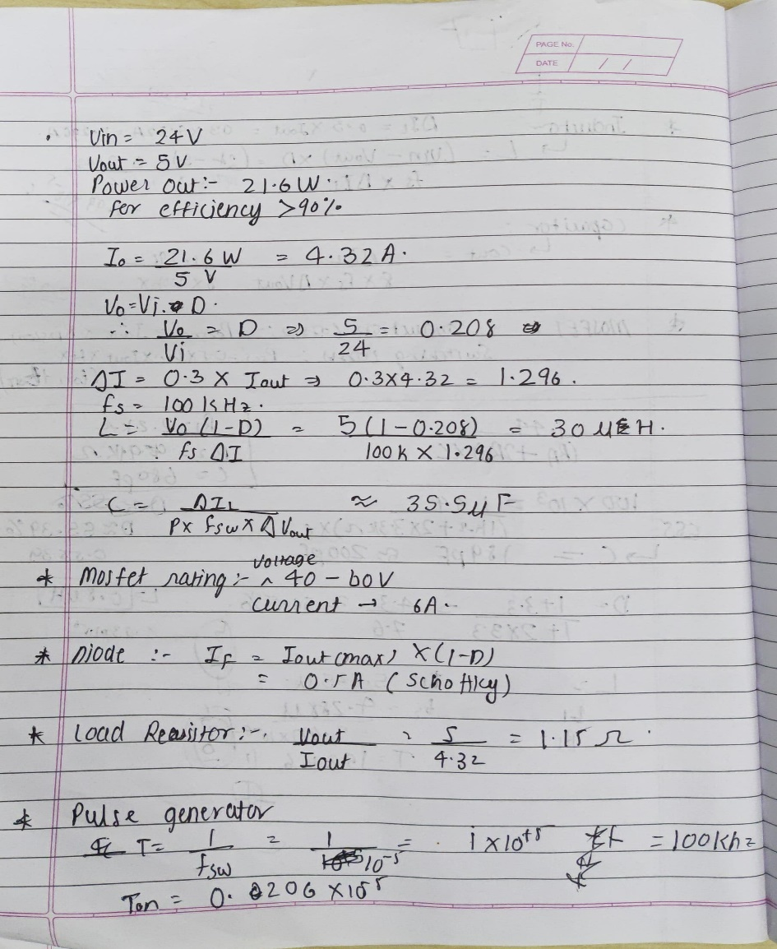

EFFICIENCY:

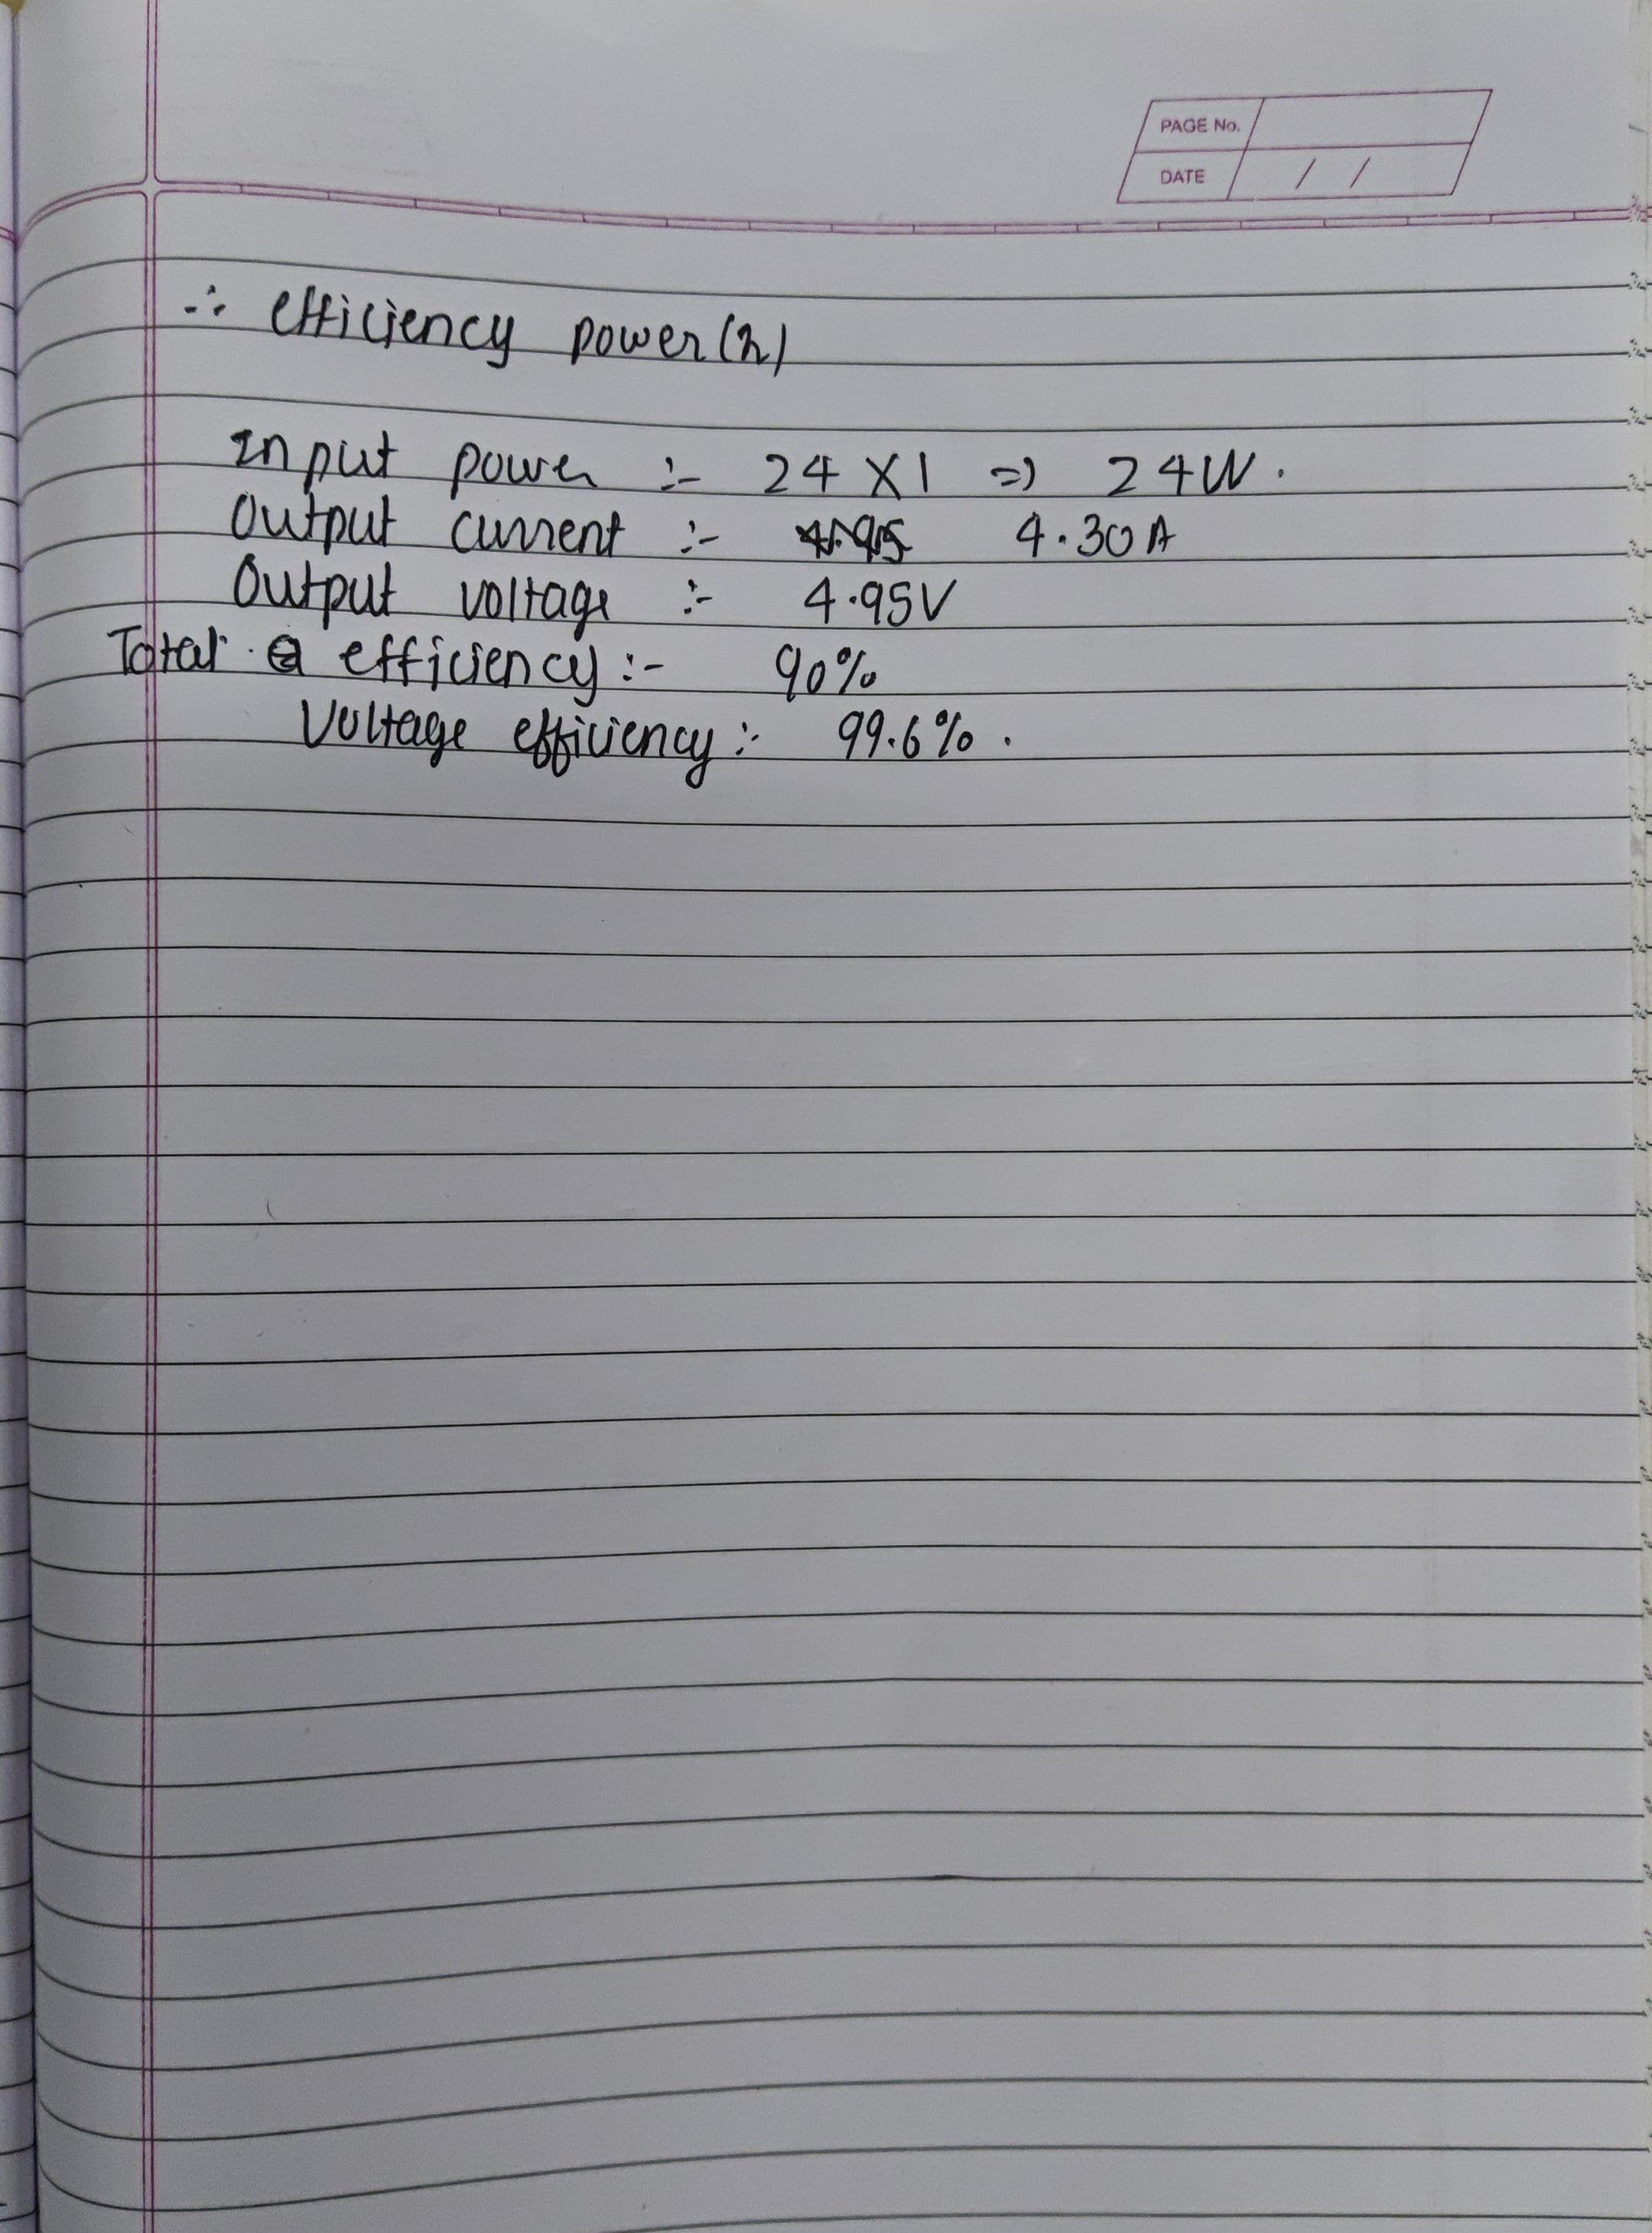

SCHEMATIC DIAGRAM:

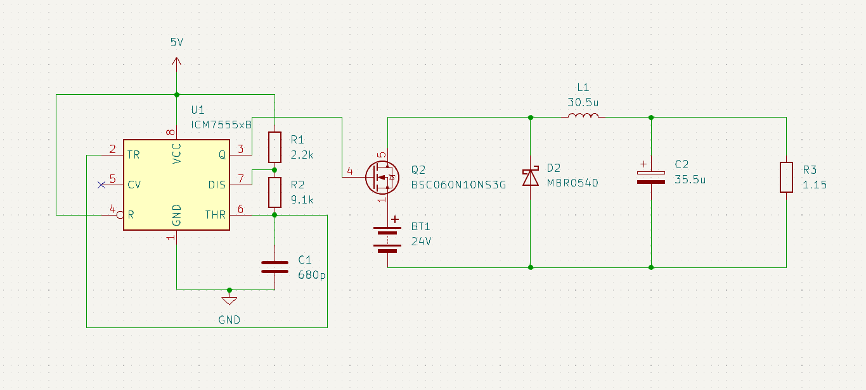

FOOTPRINT:

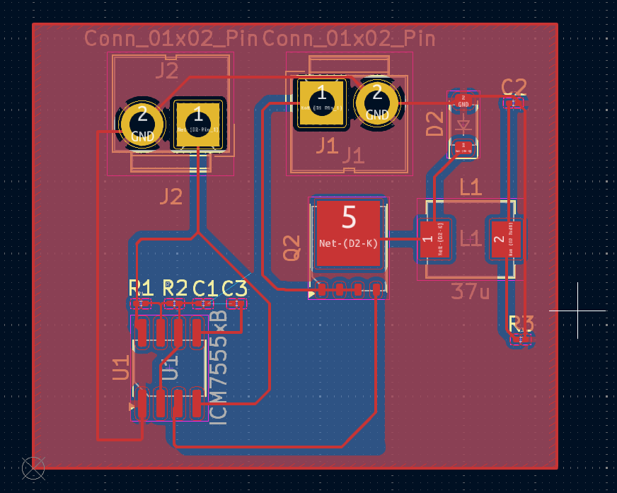

PCB:

