***Assumptions and Limitations:***

1. The program is limited to a given knowledge of words. In this case, ‘words.txt’.
2. If the limit of missed words is not set to 6, the program will work for all the test cases without missing any. Right now, we see it is missing for 3 words out of 4507

***Approach***

1. Given the length of word to predict, we consider all the words in the dictionary for a given length.
2. We take the most occurred element in the corpus of words, make it as a prediction.
3. If the word exists, then we further consider the words with the letter as a particular place and continue, else we remove the words from the corpus which do not contain the letter. I’ve found this to be the best possible approach.

***Results***

1. Test case: inirritative. The number of missed characters in this case are 0 (zero).

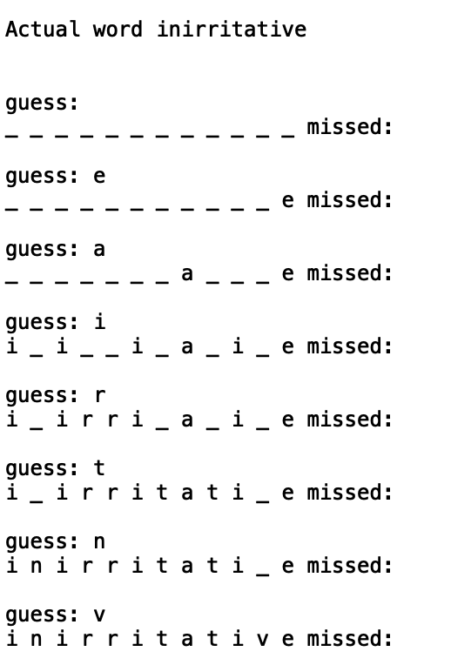

1. Test case: ﻿gawkier. The number of missed characters in this case are 1. 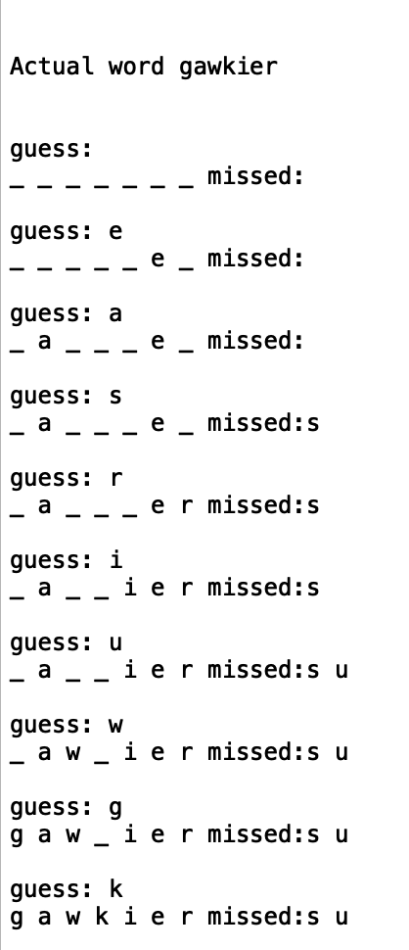
2. This testcase, illustrates all the given examples in the words.txt file. We can see that the accuracy for the word prediction is around ***99.93%***, where as the number of chances taken to predict are around***90.58%****.*

