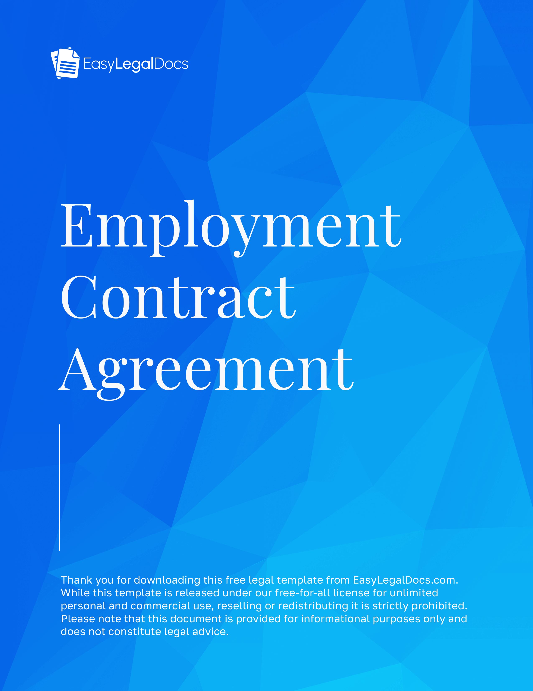
EMPLOYMENT CONTRACT AGREEMENT
This Employment Contract Agreement ("Agreement") is made and entered into as of __________________,
BY AND BETWEEN: | Employer: _______________________________, a corporation with its principal place of business at ____________________________________ ("Employer");
AND: | Employee: ____________________________________, residing at ____________________________________ ("Employee").

1. Employment Position & Duties
The employer agrees to hire the Employee in the position of _________________. The employee shall perform all duties and responsibilities customarily associated with this position and as directed by the Employer.

2. Term of Employment
This Agreement shall commence on __________________and continue unless terminated in accordance with this Agreement.

3. Compensation & Benefits
- Salary: Employee shall receive a salary of ____________ per __________________, payable in accordance with Employer’s standard payroll schedule.
- Benefits: As per the employer's policies, employees may be eligible for benefits, including, but not limited to, health insurance, paid time off, and retirement plans.

4. Work Schedule & Location
Employee shall work __________________ at __________________, with standard work hours of __________________.

5. Confidentiality & Non-Disclosure
Employee agrees to maintain the confidentiality of Employer’s proprietary information and not disclose or use such information for any purpose other than Employer’s business.

6. Non-Compete & Non-Solicitation
For a period of two (2) years following termination of employment, Employee agrees not to engage in direct competition with Employer or solicit Employer’s clients or employees.

7. Termination
Either party may terminate this Agreement __________________. Employer may also terminate for cause, including but not limited to misconduct, policy violations, or poor performance.

8. Dispute Resolution
Any disputes arising under this Agreement shall be resolved by __________________.
9. Governing Law
This Agreement shall be governed by the laws of the State of __________________.

10. Entire Agreement
This Agreement constitutes the entire understanding between the parties and supersedes any prior agreements or understandings.
IN WITNESS WHEREOF, the parties hereto have executed this Agreement as of the date first written above.
Employer:  Employer Representative Name: __________________  Company Name: __________________  Signature: ____________________________________  Date: __________________ | Employee:  Employee Name: __________________  Signature: __________________  Date: __________________

