Proposal for Reimagined Model for Community Association Regulation

An industry project to remodel regulation to incent directors’ education and community excellence

George Markle — the [MakeMyHOAok.org](https://www.makemyhoaok.org) project

Rev. November 30, 2022

Table of Contents

Abstract 4

1 Costly consequences of under-informed directors 5

1.1 Pool of willing, qualified candidates varies with community size 5

1.2 HOAs with underqualified directors are the rule — not the exception 5

1.3 Mere availability of director education hasn’t been sufficient 5

2 Mandated education or licensing could hobble recruitment 6

2.1 A flawed model 6

3 Rather than compel, we can incent education 7

3.1 Model legislation to be developed 7

3.2 Director certifications could earn benefits for their associations 9

3.2.1 Potential for lower dues 9

3.2.2 Potential for higher property values 9

4 Board of Certification for Community Associations and Directors (BCCAD) 10

4.1 The COMPETENCE training program 10

4.2 Multiple broad benefits 11

4.2.1 Benefits for community associations 11

4.2.2 Benefits for community association insurers 11

4.2.3 Benefits for candidates 12

4.2.4 Benefits for management companies 12

4.2.5 Increased membership for community association educators 12

4.3 Other benefits of the program 12

4.3.1 May help bootstrap volunteer recruitment 13

4.3.2 Would save time and help keep directors on the same page 13

4.3.3 May help freshen board composition 13

4.3.4 May help ensure incorporated associations retain corporate status 14

5 Becoming a Certified Community Association Director 14

5.1 Initial certification 14

5.1.1 Regarding stringency of requirements for director certification 14

5.2 Maintaining certification 15

5.3 Technology-centric to minimize costs and issues 15

5.4 Determination of credits 16

5.4.1 Approval of classes 16

5.4.2 Approval of online courses and published articles 16

5.4.3 Example credits earning scenarios 17

6 Determination of community association COMPETENCE star rating 18

6.1 RP: Reserves percent funded 18

6.1.1 FP: Foundational Partners credit 19

6.1.2 Formula may be amended 19

6.1.3 Rating calculation example 20

6.1.4 Displayed rating vs. precision rating 20

6.2 Effective date of rating 21

7 Summary of state legislation required to enable program 21

7.1.1 General Legislation for Community Associations 22

Appendix A – Example statute enabling creation of certification authority 23

Proposed new Civil Code Section 6200 23

Appendix B – Election materials must include certification info 26

Proposed amendment to identify certified candidates 26

Proposed amendment to include certification eligibility information 26

Conforming examples 27

Appendix C – Requirements for disclosures of board rating 30

Proposed amendment to Civil Code §5310 30

Footnotes 32

# Abstract

Figure 1: *Pool of willing, qualified candidates varies with community size*

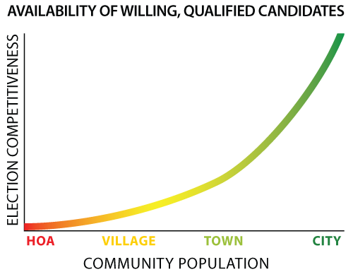

Community association (“CA”) directors can profoundly affect the value of homes and quality of living environment for over 74 million Americans residing in 358-thousand homeowners associations, condominium communities, cooperatives and other planned communities.[1] Damage to communities from lapses in oversight by well-meaning but untrained volunteer directors has spawned copius legislation to regulate homeowners associations. Though much-needed legislation has passed, intended effects and efforts to increase caliber of oversight may be compromised by inattention to factors particular to community associations.

Unlike directors of conventional asset management firms — or almost any other type of corporation — most CA directors have little or no experience or education in disciplines relevant to their duties. Attempts to *require* training and/or licensing backfire because directors are unpaid, often reluctant volunteers and such requirements exacerbate already notoriously difficult recruitment.

This proposal addresses this conundrum and posits a novel approach crafted expressly for this unique environment — one that proposes *incentives* to motivate directors and homeowners to attain education for successful CA governance. And unlike conventional legislative efforts that draw from the same familiar techniques to compel, this project begins with a novel *crowd-sourced* project — [“the MakeMyHOAok” project](https://makemyhoaok.org) — to draw from a vast experience base through participation by CA attorneys, managers, directors, accountants and other industry service providers with first-hand experience in what best motivates community association directors. The objective will be to create model legislation crafted to facilitate an environment wherein volunteer directors can be *incented,* rather than compelled, to acquire baseline education for competent community association governance.

Toward this effort, I submit the following proposal to seed discussion, drawing from my 40+ years of industry and director involvement. I invite your [comments, suggestions and participation](https://github.com/ProAccess/MakeMyHOAok/discussions) to further affect and shape model legislation we can then take to legislators in our respective states.



# Costly consequences of under-informed directors

How many corporations exist with directors responsible for protecting a large portion of stakeholders’ equity typically having so little applicable experience or knowledge of their duties or legal responsibilities?

We have all seen and read about consequences of failed governance of community associations — from petty irritations of hapless administration of architectural rules preventing a homeowner from flying a flag, to [devastation of a community](https://en.wikipedia.org/wiki/Surfside_condominium_collapse) and lost lives resulting from failure to conduct structural inspections and maintain adequate reserves.

HOA managers and attorneys too often witness the dearth of volunteers and the inordinate costs in time and funds wasted by HOA Boards attempting to navigate issues affected by laws and best practices about which directors are unaware — and time and costs for recovering from consequences of actions or inaction.

## Pool of willing, qualified candidates varies with community size

Populations of most towns and cities usually are sufficient to enable competitive elections and town- and city-councils with talents in disciplines applicable to operating their governments. However, the comparatively small population of most homeowners associations often means a dearth of board candidates, many without applicable qualifications. Often, HOA boards find themselves with directors with virtually *no experience* in business, finance, insurance, law, construction or many other applicable fields.

## HOAs with underqualified directors are the rule — not the exception

HOA boards with under-qualified directors can have profound, negative and costly effects on the lives of their members.

In my over forty-years of experience with HOAs I’ve found well-meaning volunteers in a neighborhood setting tend to conduct meetings within a social context wherein decisions are heavily influenced by uninformed sensibilities and impulses of neighbors present, without due diligence and investigation, consideration of state regulation or standards of governance intended to protect broader interests.

## Mere availability of director education hasn’t been sufficient

Even if a well-trained volunteer is elected and advocates for established best practices and legal compliance, such informed advice is often disregarded with deference given to an opposing director’s longevity or assertiveness, or to expedience or politics. Statutes and case law may as well not exist unless *multiple* directors are aware of them. Often, only when a *second* director reinforces and validates a director’s advice as deriving from an authoritative source, does the dynamic change; only then are directors apt to heed the advice.

To improve board performance in community associations, we must find a way to increase community association members’ participation on boards and ensure broader exposure of directors to best practices, statutes and case law.

Certification to an established baseline of knowledge and continuing education to maintain minimum standards is mandated in Business and Professions code for attorneys, physicians, real estate professionals and a myriad of other vocations with the potential to affect consumers’ welfare. HOA directors also may profoundly affect HOA members’ interests. Even so, while performance requirements exist, education requirements making directors aware of them are conspicuously absent.

# Mandated education or licensing could hobble recruitment

Consider this argument against making director education compulsory through legislation to require licensing:

“HOA directors are volunteers and many HOAs have difficulty recruiting sufficient volunteers for their boards. An increased burden of required education or certification may dissuade potential volunteers, further exacerbating recruitment.”

At least one state, Florida, did try a licensing model.

## A flawed model

We can learn from the Florida model, which loosely followed consumer protection licensing requirements, ostensibly requiring training of community association directors to minimum standards. However, presumably to address the objection that licensing would discourage potential volunteers, the legislature created what I believe to be a fatal loophole that effectively nullified the program’s purpose: A director could circumvent training or passing an exam simply by *certifying* in writing to the secretary he or she had read the governing documents and agreed to uphold them.

While this may have been a compromise to enable bill passage, it may have been fatal to the purpose of informed governance and the requirement for structural inspections and effective reserves maintenance. Resulting lapses may well have contributed to Florida’s [2021 Surfside condominium collapse](https://en.wikipedia.org/wiki/Surfside_condominium_collapse).

In May, 2022, Florida effected legislation, [SB 4-D](https://www.flsenate.gov/Committees/BillSummaries/2022D/html/2875), to address reserves studies and inspection requirements. However, it appears little was done to enhance community association directors’ education and it remains unclear if the certification requirement is essentially cosmetic as the loophole persists. To the extent it places increased burden upon community association directors, it may further exacerbate recruitment challenges.

# Rather than compel, we can incent education

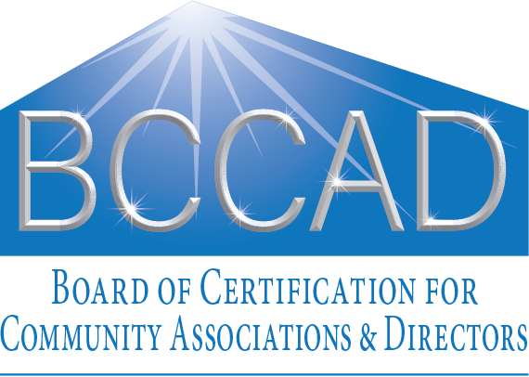

Figure 2: *Working logo*

I believe a *new* approach toward legislation is past-due, *with potential to vastly improve director’s education and competence—to incent directors and community associations to acquire needed education.*

I propose a framework be developed, as described below, that would enable creation of model legislation to help guide legislatures in each state to craft bills that would incent education. (See *Summary of state legislation required to enable program*.)

An organization would be created, modeled after the Community Association Manager International Certification Board, [CAMICBsm](https://www.camicb.org/?gclid=CjwKCAiAvK2bBhB8EiwAZUbP1LOAsflxRnOJ-jwwkyDVFapyA5m8FKkoE-55OsfeUPJtS-UYPiJHCxoC5NsQAvD_BwE), but directed toward the certification of both community association directors as well as their associations, as described herein. This governance board would oversee a program to incent (rather than *require*) directors to acquire education to enhance caliber of community governance.

Support for such an organization would be sought from educators like [CAI](https://www.caionline.org), [ECHO](https://www.echo-ca.org) (Educational Community of HOA Homeowners), [CACM](https://cacm.org) (California Association of Community Managers), and [FCAP](https://www.fcapgroup.com) (Florida Community Association Professionals). These educators could provide educational services to community association directors and members – some already do – and benefit by increased membership. A statement that would apply for homeowners might be modeled after that supporting managers’ education and certification in CAI’s [*Community Association Manager Licensing and Model Legislation*](https://www.caionline.org/Advocacy/PublicPolicies/Pages/Community-Association-Manager-Licensing-Policy.aspx).

Our model legislation would allow states to regulate community associations through an existing industry-sponsored self-regulatory organization, without having to budget for additional agency infrastructure.

I propose we work with these and other community association-oriented education institutions, such as ECHO (Educational Community of HOA Homeowners) and CACM and to advocate for passage of legislation based upon such model legislation.



## Model legislation to be developed

Legislation would create a new law (in the case of California, Civil Code Section 6200 to Division 4, Part 5, Chapter 12) that would

* enable recogniation of a public-facing non-profit governance board, in this example, the *Board of Certification for Community Associations and Directors* (BCCAD), to establish and administer the program described herein.
* create the credential for community association members, *Certified Community Association Director*.
* enable such an organization to administer tests and grant certifications to common interest community members who meet standards of knowledge of best practices and basic legal requirements for governance of state community associations.
* enable maintenance of certification records and making such records publicly accessible.
* authorize such organization to coordinate with the Secretary of State to enable key linkage with their community association database records to facilitate records maintenance and avoid unnecessary duplication.
* enable the organization to employ such records to create a community association COMPETENCE rating system derived principally by the proportion of its directors with current certifications, frequency of structural inspections and how well reserves are funded, and whether the board has committed to training and legal oversight. See a list of proposed parameters affecting successful governance.
* require an annual disclosure to members of the Board’s COMPETENCE rating.
* require adherence to a code of ethics and standards of practice for community association directors.
* require that any candidate certified under this program be identified as such on any election ballot or list of candidates. (See Conforming Examples.)

## Director certifications could earn benefits for their associations

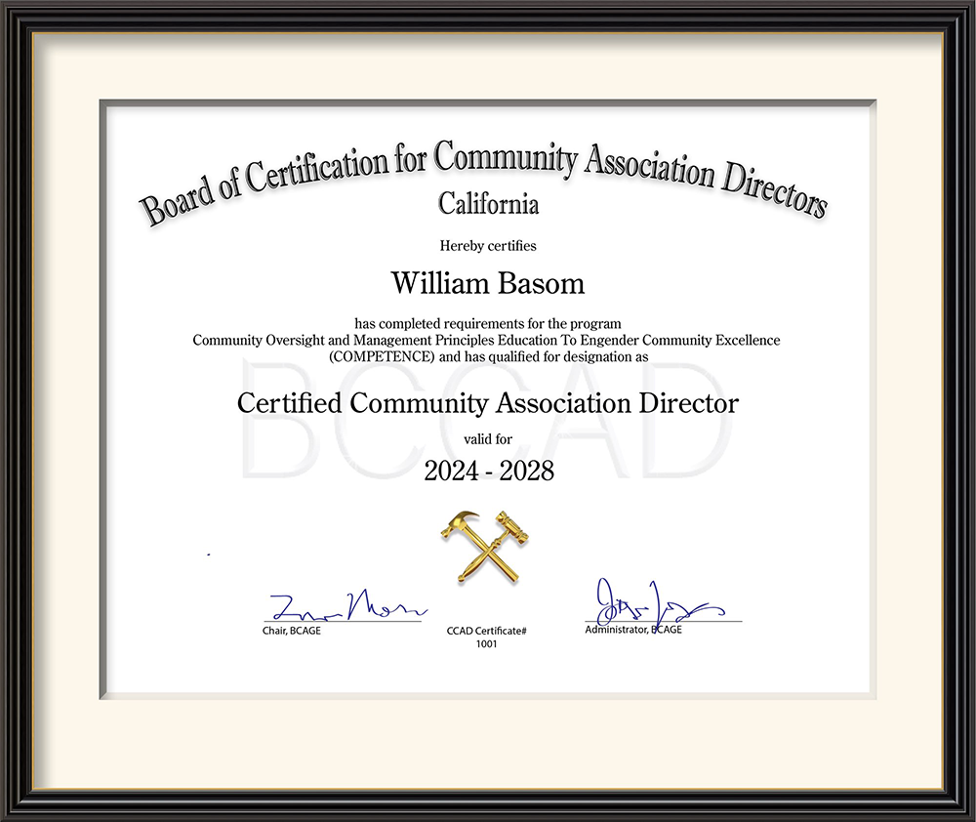

Figure 3: *Example certificate for a member and/or director who completes traiining and maintains continuing education requirements on rudiments of community association governance*

The BCCAD would calculate and publish *ratings* for community associations based generally upon the proportion of its directors with current certifications, frequency of structural inspections and how well reserves are funded, whether the board has committed to training and legal oversight, and whether it is actively managed by a manager certified as provided by the state. This would help foster an environment wherein communities with higher ratings may garner favored insurance premiums and prestige of being identified by the state as being, for example, in the top-10, top-100 or top-1000.

### Potential for lower dues

Insurance premiums typically are one of the largest budget items affecting monthly dues. Insurance companies would be incented to offer reduced premiums to those community associations that maintain a certain rating as risk management would be part of the BCCAD certification curriculum and exam. And reduced premiums translating into lower dues may be a powerful incentive for community associations to participate and members to support directors’ education.

### Potential for higher property values

Real estate values in communities that can boast such ratings may benefit and provide a strong incentive for members to keep electing candidates who are certified. Those that do not risk being at a disadvantage.

Other benefits may be fostered as well, such as discounts from services vendors, who may justify discounts as educated boards are easier and more profitable to work with. (See *Multiple broad benefits*.)

# Board of Certification for Community Associations and Directors (BCCAD)

## The COMPETENCE training program

The training program overseen by BCCAD would be known as the COMPETENCE program, an acronym for **C**ommunity **O**versight and **M**anagement **P**rinciples **E**ducation **T**o **E**ngender **C**ommunity **E**xcellence. (This acronym also complements the preferred means of attaining certification — through the *Competency Based Education* method[2].



The state would not *require* community association directors to participate in the COMPETENCE training or to be licensed; thus, community associations may continue to operate as they have without fear of a requirement that might discourage members from volunteering. However…

There would be incentives for those associations that encourage their directors to participate and become *certified*. (See *Multiple broad benefits*.)

The program would allow *any* association member of a residential common interest development to attain a *certification* as Certified Community Association Director by passing an examination on essential rudiments of CID oversight. Certification would be maintained by accumulating continuing education credits.

This would ensure consistency with legal requirements (for California, Civil Code § 5105-a-3) that any association member be eligible for candidacy and provides equal footing for non-directors to attain certification that may affect perceived qualifications as board candidates.

Any member’s certification status under this program would be verifiable via a website, as for verification of licenses and certifications for professionals and service providers (for California, those operating under Department of Consumer Affairs regulation).

## Multiple broad benefits

Benefits described below — particularly those involving reduced costs for the association affecting dues — may motivate CID boards to press directors to engage in the program and maintain their certifications and association ratings that would merit such benefits. Thus, association members may be motivated to vote for those candidates who are certified to maintain qualifying status and thus help control dues.

### Benefits for community associations



An overall board COMPETENCE score or *rating* would be calculated for each community association, derived primarily from the frequency of structural inspections, percentage of funding of reserves, proportion of directors who are certified, proportion of directors’ seats that are filled, whether they have engaged a manager who is certified, have engaged an attorney specialist and have committed to continuing education. (See *Determination of community association COMPETENCE star rating*.

The BCCAD would maintain a list of the top-10, top-100, top-1000 community associations by rating. Real estate values in communities who can boast such ratings may benefit and provide a strong incentive for members to keep electing candidates who are certified. This also should incent directors and members to keep their association’s rating high to enhance property values.

Disclosure of the board’s rating would be required in the annual policy statement provided to all members (in the case of California, pursuant to Civil Code §5310), also ensuring prospective purchasers would receive it. (See example candidate biographies document.

### Benefits for community association insurers

Insurance companies have long recognized the value of training of customers in improving risk management and reducing casualty costs. This program should result in more directors with demonstrated knowledge of best practices, current law and awareness of principles of risk management. An informed Board should be less likely to neglect structural inspections, under-fund reserves, fall askew of the law and incur unexpected legal expenses or special assessments. As such education could lower risk and insurance premiums — *typically one of the biggest budget items for CIDs* — this could provide a compelling motivation for boards to promote education among their directors and make certified candidates more attractive to the dues-paying members.

The BCCAD could work with insurance providers to demonstrate how such a program could reduce risks and encourage offers of discounts on premiums for those associations that can maintain a certain rating.

### Benefits for candidates

Indicating certification status on ballots and election materials with candidate lists — with a BCCAD designation or simple asterisk and footnote — would be an indicator of a candidate’s commitment to improve knowledge of best practices and legal requirements. For associations where elections are competitive, this could influence members in their voting and increase overall board competence.

### Benefits for management companies

The program should strongly incent management companies to ensure all of its managers are certified. This is because an association’s COMPETENCE rating will be affected by whether its manager — If it has one — is certified. (See the calculation for an Association’s rating under *Determination of board of directors COMPETENCE star rating*.)

Faced with competing bids from two management companies — one who will provide a CACM-certified manager that will increase the board’s rating, and one that cannot — which will they select?

Much of a manager’s time may be spent advising directors and dealing with issues that would not have surfaced had directors been better informed. This program should help with such education.

Management companies may discover such benefits sufficient to warrant offering a discount for boards that can maintain higher ratings or increasing management fees should the board’s rating drop below a certain number. Management fees usually are one of the largest budget items affecting dues.

### Increased membership for community association educators



Should we succeed in having legislation passed to create an organization such as the BCCAD, community association education organizations likely would see a substantial increase in membership. Those already at the forefront — CAI, ECHO, FCPP and CACM — particularly should benefit given their established prominence and reputations for excellence.

## Other benefits of the program

Community Association services providers may by convinced to offer discounts for those associations who maintain high ratings, as informed boards should be easier and more profitable to work with.

### May help bootstrap volunteer recruitment

As legislation would mandate publishing of the board’s rating and the certification status of candidates, association members should become increasingly aware of the potential cost of insufficient participation on the board by qualified directors and the effect of directors’ education on dues, likely to induce increased participation.

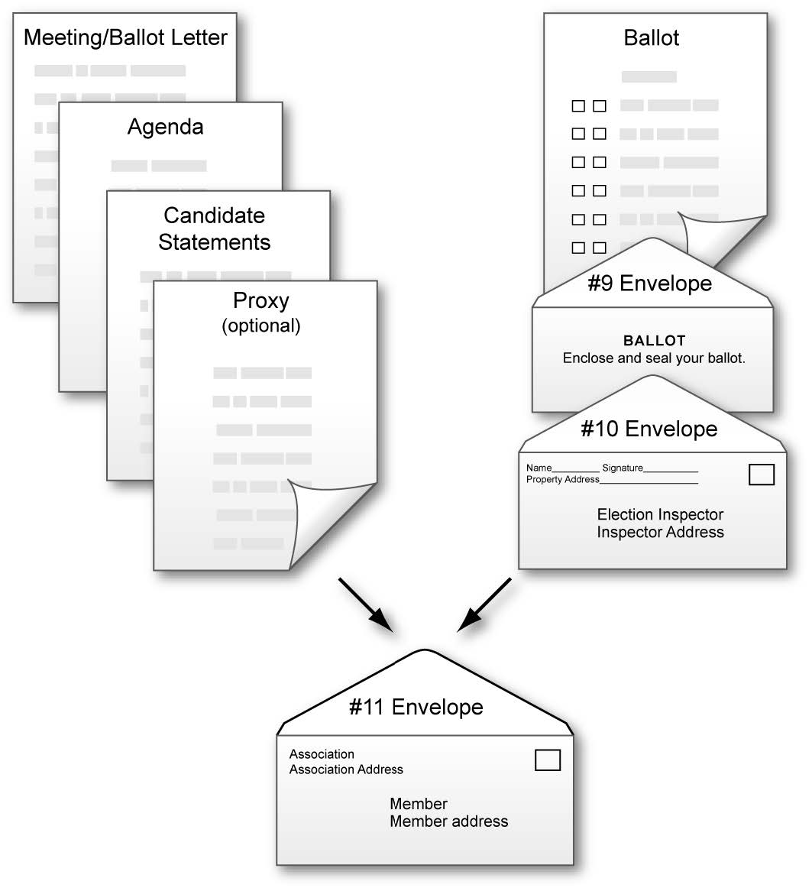

Also, the need and techniques for recruitment, training, motivation and retention of volunteers should be part of directors’ education within this program. Thus, while it may be naïve to anticipate director education will completely solve recruitment issues, my experience has shown that awareness of the need for such activities has made a difference in both quantity and qualifications of volunteers.

### Would save time and help keep directors on the same page

An inordinate amount of time in meetings is spent debating directors’ lay opinions regarding how issues should be treated, when applicable regulation and proven best practices already exist.

I suspect almost anyone who has attended association board meetings over time can relate anecdotes reflective of this. I attended a meeting where an influential senior director argued against seeking legal advice regarding a potential liability, rationalizing a consultation would be pointless because “there will always be another attorney with a different opinion.” She boasted that, while she had been president, “we *never* got legal advice” — as if that should be the board’s policy. Her argument prevailed, reinforced by a new board president who declined to heed a statute called to her attention, responding “I’m not an attorney and I won’t interpret the law.”

Had even a couple of directors been in exposed to rudiments of risk management, I believe this would not have occurred. Such exposure would be part of the training and certification process.

### May help freshen board composition

Many boards have one or more directors who have remained year-after-year having exhibited no effort to inform themselves regarding directors’ obligations. For no other reason beyond longevity, perceived seniority or force of personality, they continue to maintain strong, if under-informed, influence. If directors and members do invest in education under this program, theoretically, continued tenure of under-informed directors may become less likely, raising overall board competence.

### May help ensure incorporated associations retain corporate status

In order to participate, the applicant’s association must be registered with the state program. Associations will be required to enter their entity number assigned by the Secretary of State when incorporated or when registering pursuant to the law (in the case of California, Civil Code §5405). When checking for that number, any lapse in the association’s registration should be revealed so the association may take remedial action.

# Becoming a Certified Community Association Director

## Initial certification

An individual seeking initial certification must pass an exam to demonstrate knowledge of essential rudiments of CID law and governance best practices.

### Regarding stringency of requirements for director certification

Figure 4: *Example exam question*

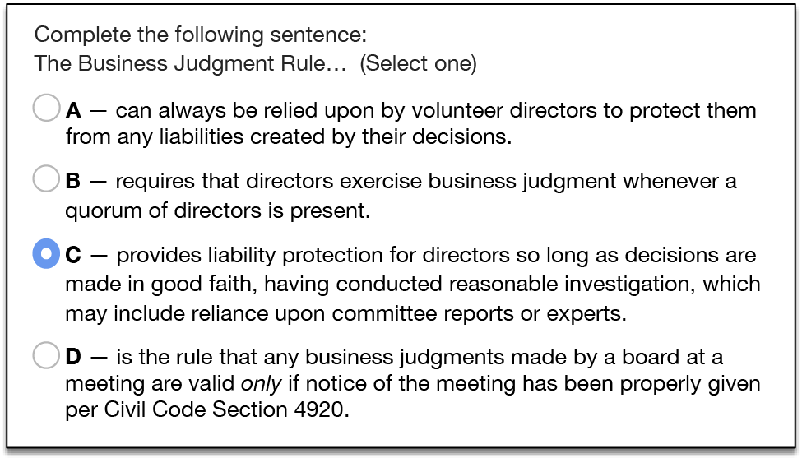

Director testing requirements are modeled somewhat after California Business and Professions Code §11502 — Certified Common Interest Development Manager Criteria. However, whereas testing for manager certification represents an opportunity for vocational and income advancement, testing for volunteers’ certification has the potential to be a barrier for essential director recruitment — already difficult for many community associations. Therefore, requirements for director certification are reduced from those for manager.

The number of questions and required percentage of correct answers would be determined by BCCAD, the objective being to ensure knowledge of fundamentals while not discouraging participation by unpaid volunteers. The policy may be adjusted over time as results are gauged and as required to meet this objective. An example policy might be the following:

* Initial certification would require correctly answering, for example, 40 of 50 questions in an exam, *open-book* to encourage review of any material about which the applicant may be uncertain. There might be a one-week time limit for completion.
* A failed exam may be taken over until successful, with a minimum 24-hour waiting period to encourage review of training materials. Multiple versions of the certification exam may be prepared and used to allow for repeat testing, discourage *teaching the test* and better ensure a fair assessment of knowledge.
* Classes and presentations may precede the online exam, however, a candidate also may learn through alternative means more accommodating for a working adult, such as articles, books and online courses.
* Upon successful completion, certification status would be recorded into the database, accessible online. The applicant would be notified by e-mail and a PDF certificate generated for optional download.

These example policies may be modified as experience is accumulated.

## Maintaining certification

An example policy for maintaining certification might be the following:

To maintain certification, one must accumulate a minimum of eight continuing education credits (CECs) every four years from date of initial certification. At least 50% of those credits must derive from material covering state law or legal topics, authored or approved by an attorney practicing CID law in the state.

Given that CID directors are unpaid volunteers, this program strives to achieve a balance of incenting meaningful education without overly burdensome requirements that may discourage volunteer recruitment. We also recognize individuals’ learning styles vary and allow for this in awarding certification and continuing education through these methods:

* Formal in-person classes — Attending in-person BCCAD-qualifying classes or presentations offered by institutions such as CAI and ECHO. No exam would be required for classes attended in-person although the instructor would be encouraged to distribute a written summary of key points.
* Online courses — Taking BCCAD-approved online courses and correctly answering a minimum of 75% of questions in an online quiz.
* Published articles — Reading articles in periodicals published by BCCAD-approved institutions such as CAI and ECHO and answering correctly a minimum of 75% of questions in an online quiz.

## Technology-centric to minimize costs and issues

Inasmuch as the program’s creation and existence may be predicated upon efficiency and minimal budget impact, emphasis will be given to applying technology for

* Testing — Certification examinations would be taken online to minimize impediments to certification and program administration costs and to ensure uniform, timely and reliable registration and management of certification and crediting. Reasonable allowances may be made to accommodate partner organizations’ testing methods.
* Courseware and continuing education materials — Courseware and industry article authors who wish their material to be available for training and continuing education credits would be provided instructions and means for formatting and placing their material online. Such material and CE *quizzes* would be subject to review by the BCCAD before being activated.

## Determination of credits

Each unit of continuing education credit would be equivalent to exposure to one of the following:

* 15-minutes of substantive class instruction of BCCAD-qualifying material.
* 1,000-words of substantive BCCAD-qualifying written material followed by correctly answering a minimum of 75% of questions on the material in an online quiz.

### Approval of classes

A detailed lesson plan or class outline should be submitted to BCCAD, nominally via its website.

### Approval of online courses and published articles

Writing style variation defies precise assignment of credits per given volume of material. However, an author or instructor should attempt to meet the following guidelines before submitting material via the BCCAD website for approval:

One credit may be awarded for each 1,000 words of *substantive material*[3] with a minimum of 75% correct answers to questions that follow. *The author should include approximately 1-question per each 200 words of substantive written material*. For example, a 1,000-word article would be followed by 4-to-6 questions. The minimum number is indicated in the table.

A variance for extraordinary circumstances may be applied for to BCCAD.

#### Table — Credit calculation examples

| **Method** | **Substantive** **length** | **Credits** | **Min. Quiz** **Questions** | **Number of** **Questions** |
| --- | --- | --- | --- | --- |
| In-person class or presentation | 10 min | 0 |  |  |
|  | 15 min | 1 |  |  |
|  | 20 min | 1 |  |  |
|  | 30 min | 2 |  |  |
|  | 40 min | 2 |  |  |
|  | 45 min | 3 |  |  |
|  | 50 min | 3 |  |  |
|  | 1 hr | 4 |  |  |
|  | 2 hr | 8 |  |  |
| … |  |  |  |  |
| Online courses, articles, written material | 1,000 words | 1 | 4 | 4-6 |
|  | 1,500 | 1 | 6 | 6-9 |
|  | 1,600 | 1 | 6 | 6-10 |
|  | 1,700 | 1 | 7 | 7-10 |
|  | 1,800 | 1 | 7 | 7-11 |
|  | 1,900 | 2 | 8 | 8-11 |
|  | 2,000 | 2 | 8 | 8-12 |
|  | 3,000 | 3 | 12 | 12-18 |
|  | 4,000 | 4 | 16 | 16-24 |
| … |  |  |  |  |

*A minimum of 75% correct answers is required for credit. Continuing education exams may be open-book, with full access to material, encouraging an applicant to review any material about which he or she may be uncertain. A failed exam may be taken over until successful.

### Example credits earning scenarios

The following include examples of how one may accumulate the required 8 credits to maintain certification for a 4-year certification period.

* Attending 4, 1-hour sessions at each of 2 annual CAI or ECHO conferences.
* Attending 4, 1-hour sessions at 1 annual CAI or ECHO conference, plus reading and successfully completing online exams for 4, 1,000-word articles.
* Taking an online 4,000-word course with exams, plus reading and successfully completing online exams for 4, 1,000-word articles.
* Reading and completing online exams for 4, 1,000-word articles plus reading and successfully completing online exams for 2, 2,000-word articles.
* …any other combination of activities in Table 1 may be employed to attain the minimum credits.

Credits in excess of those required for certification are laudable but cannot be applied to certification in *subsequent* periods inasmuch as current certification implies exposure to and knowledge of *current* legislation and developments in best practices. However, the total number of credits accumulated by an individual may be published in the online database as an incentive toward continuing education.

# Determination of community association COMPETENCE star rating

Whereas a calculated numeric score or rating may require interpretation, ratings based upon the popular and ubiquitous five-star model have come to be immediately and intuitively recognized. An eminently recognizable *star rating* next to the association’s name may incentivize an effort by its directors to increase its rating by ensuring all positions are filled and directors’ receive training — the primary objectives of this program. Directors informing association members how the rating may affect dues may heighten members’ awareness of the importance of volunteering for board participation.

The rating calculation includes normalization to a maximum of five for presentation in the five-star format, e.g., a rating of 2.9 would be presented as

Figure 5: *Example rating graphic*



A board’s COMPETENCE rating would be determined by a formula that may be adjusted by BCCAD from time to time as relevant factors become apparent. Factors to be integrated into the rating formula include those most heavily associated with a healthy community.

The initial proposed formula is as follows:

…where RP is Reserves Percent funded[4] and FP is the Foundational Partners credit. (See below.)

## RP: Reserves percent funded

Community Associations Institute (CAI) defines reserves percent funded as “The ratio, at a particular point in time related to the fiscal year end, of the actual (or projected) reserve balance to the fully funded balance, expressed as a percentage.” Generally, percent funded can be a useful gauge of how well the association has anticipated infrastructure repairs and replacement requirements and assessed members so as to accumulate amounts sufficient to cover such costs without additional funding or special assessments.

Regardless of the funding method chosen by an association, e.g., full funding, threshold funding, or baseline funding, and calculation methods of component/segregated/straight-line or cashflow/pooling, percent-funded must nonetheless also be calculated for purposes of the above calculation and rating uniformity.

Model legislation would urge the state pass legislation to require community associations to engage a professional engineering firm every three-to-five years to physically inspect physical infrastructure, determine estimated remaining life, projected repair and replacement costs, and specify a dollar amount that must be contributed on a regular basis in order for such funds to be available when needed. The topic is discussed more fully in the CAI publication, [National Reserve Study Standards](https://www.caionline.org/LearningCenter/credentials/Documents/RS%20Designation%20National%20Reserve%20Study%20Standards.pdf).

### FP: Foundational Partners credit

*FP* is the *foundational partners* credit and credits the association with having established the two key relationships essential to directors’ education and informed decision-making:

* membership in a community association educational institution approved by BCCAD, such as CAI (Community Associations Institute) or ECHO (Educational Community of Homeowners). A current membership in either organization is equal to one-half-point (0.5), the limit for this credit even with membership in more than one.
* A qualifying educational institution will periodically provide directors with published magazines and/or newsletters containing articles on community association law and best practices in management and oversight.
* an attorney specializing in state community association law. Certifying to BCCAD the association has established a client relationship with such an attorney will credit the association with one-half-point (0.5), the limit for this credit even if a relationship with more than one exists.

There is no minimum required number of consultations per year to retain this portion of the FP credit. However, communities are reminded to seek a consultation as circumstances warrent. Should a court or arbiter of binding arbitration issue a ruling against a community association on a liability issue, the association would lose the entire FP credit for a period of two years from the most recent adverse ruling.

Unsophisticated directors believing they were saving money by avoiding legal consultations is a common occurrence. Potential for substantial losses involving members’ interests mandates a continuing relationship with an attorney specialist and this is reflected within the rating system.

### Formula may be amended

The proposed formula may be amended from time to time to accommodate additional important factors identified.

### Rating calculation example

The COMPETENCE rating would be displayed as both stars and a number.

As an example, consider an association

* whose reserves are 74% funded, based upon a report by a professional engineering firm that examined physical infrastructure, estimated remaining useful life of components and calculated reserves percent funded.
* whose board or attorney has certified to BCCAD it has established a client relationship with an attorney specializing in state community association law (for one-half credit) and
* is a current member of an approved community association education organization, such as CAI or ECHO (for one-half credit).
* has six directors, where the Bylaws specifies a maximum of seven.
* that has four directors certified and the association has engaged a manager who is CCAM-certified.[5] The board rating would be

### Displayed rating vs. precision rating

#### Displayed rating

The above rating result would be rounded to, for example, 3.2 for the star-rating display on the BCCAD website and downloadable report in both stars and number format as in the following example. (See page 26.)

Figure 6: *Rating graphic would be limited to two significant digits*



#### Precision rating

While a rounded number would be displayed with the star rating, a full-precision floating point value would be used to further differentiate community associations when calculating ratings for Top 1,000, Top 500, Top 100, etc. placement. These ratings may further incent directors to maintain their education as such ratings might be used by insurance underwriters in evaluating risk factors and by real estate professionals when promoting property sales and values.

## Effective date of rating

The community association’s rating would be recalculated and effective immediately following any change of Board composition or certification or change of manager or foundational partnerships that would affect the rating. Thus, an association’s rating could not readily be manipulated by temporary director appointments or resignations.

# Summary of state legislation required to enable program

Success in incenting participation and education for informed governance is predicated upon universal applicability of COMPETENCE ratings. Were application of ratings merely elective, there would be little incentive for community associations to maintain ratings. Therefore, legislation would be required that would do *all of the following*:

* require community associations to engage a professional engineering firm every two-to-five years to physically inspect physical infrastructure, determine estimated remaining life, projected repair and replacement costs, and specify a dollar amount that must be contributed on a regular basis in order for such funds to be available when needed. The report also must calculate the percent funded. The topic is discussed more fully in the CAI publication, [*National Reserve Study Standards*](https://www.caionline.org/LearningCenter/credentials/Documents/NRSSClarificationArticles.pdf). (Also see Reserves *percent funded*.)  
  **Model legislation** governing community association structural inspections, reserves studies and funding has been in effect for many years and has been refined and proven. It is manifest as California Civil Code sections [5550](https://leginfo.legislature.ca.gov/faces/codes_displayText.xhtml?lawCode=CIV&division=4.&title=&part=5.&chapter=7.&article=3.), [5560](https://leginfo.legislature.ca.gov/faces/codes_displaySection.xhtml?lawCode=CIV&sectionNum=5560.) and [5300](https://leginfo.legislature.ca.gov/faces/codes_displaySection.xhtml?lawCode=CIV&sectionNum=5300).
* set standards for and recognize a qualifying organization whose purpose is to promote voluntary education of best practices and legal requirements for community association governance and to certify members who demonstrate such knowledge with designation as Certified Community Association Directors. (See *proposed California statute enabling creation of BCCAD*.)
* require an annual policy statement disclosure to members that includes the Board’s COMPETENCE rating. (In the case of California, this would mean amending Civil Code §5310 See proposed California amendment to Civil Code §5310.)
* require that any candidates certified under this program be identified as such in any election materials. (Example election materials illustrating this are in a proposed new California Civil Code §5105(a)(8) included in *Exhibit B — Election materials must include certification info*.
* require that information be provided regarding how *any* association member may apply for certification under this program. (Example documents illustrating compliance are included as new (California) Civil Code §5105(a)(9) in *Exhibit B — Election materials must include certification info*.
* require community associations to include the number of board seats indicated in their Bylaws to other information they are required to provide the Secretary of State annually (used to calculate the association board’s COMPETENCE rating). (For California, this would mean adding a sub-paragraph (12) to Civil Code §5405(a).)
* authorize such organization (BCCAD) to have a means for coordinating with the office of the Secretary of State to ensure existing CID records are accessible by the organization for purposes of this program and IT managers can integrate certification and other required information where sensible and appropriate so as to preclude unnecessary duplication of records and potential for confusion.
* authorize such organization (BCCAD) to contact CIDs to promote and administer the program.

### General Legislation for Community Associations

For states that have not yet passed extensive legislation, I suggest examining statutes passed by other]states in a reference index compiled by Community Associations Institute. Inasmuch as California was early to adopt comprehensive legislation for common interest developments in the early 1980’s, which has since been refined, restated and proven, I suggest reviewing that first. This code for Common Interest Developments is also known as the [Davis-Stirling Act](https://leginfo.legislature.ca.gov/faces/codes_displayexpandedbranch.xhtml?tocCode=CIV&division=4.&title=&part=5.). California also has substantial [Corporations Code](https://leginfo.legislature.ca.gov/faces/codes_displayexpandedbranch.xhtml?tocCode=CORP&division=2.&title=1.&part=3.) specifically for Non-profit Mutual Benefit Corporations, including community associations.

*This description and proposal for a voluntary state-sanctioned program to promote participation on and education for community association boards is being circulated within the industry for discussion. Comments and suggestions are requested.*

# Appendix A – Example statute enabling creation of certification authority

This example is numbered for California but should be readily adaptable for any state.

## Proposed new Civil Code Section 6200

A new Section 6200 would be added to Civil Code Division 4, Part 5, Chapter 12:

Chapter 12 — CERTIFIED COMMUNITY ASSOCIATION DIRECTOR

6200 For purposes of this chapter, the following definitions apply:

1. “Common interest development” has the same meaning as defined in Section 4100 of the Civil Code.
2. “Association” and “Community Association” have the same meaning as “Association” as defined in Section 4080 of the Civil Code.
3. “Board” has the same meaning as defined in Section 4085 of the Civil Code.
4. “Director” has the same meaning as defined in Section 4140 of the Civil Code.
5. “COMPETENCE program” is a program administered by an organization estblished to promote Community Association governance training and certification for members who are or may become directors. COMPETENCE is an acronym for Community Oversight and Management Principles Education To Engender Community Excellence.
6. “COMPETENCE rating” of a Community Association’s Board shall be determined by a formula created by a Director certification organization as defined below and such formula may be adjusted by such organization from time to time as experience may influence. It shall be determined by factors including but not limited to the following:
   1. the proportion of directors currently certified under this program.
   2. whether a manager it engages has qualified for certification under [state law authorizing certification for community association managers — in the case of California, Business and Professions Code §11502].
   3. reserves percent funded determined from a reserves study conducted by a credentialed reserves study professional that takes into account an inspection conducted by a licensed structural engineer.
   4. whether it maintains a current membership in an organization that provides training to residential common interest association members on legal requirements and best practices for community oversight.
   5. whether it maintains a retainer for an attorney specializing in residential common interest law.
7. “Director certification organization” means an organization that meets all of the following:
   1. Is chartered to administer tests and grant certifications to citizens of [state name] who meet their standards of knowledge of best practices and basic legal requirements for governance of California Community Associations.
   2. Operates pursuant to Section 501(c) of the Internal Revenue Code.
   3. Requires adherence to a code of ethics and standards of practice for Community Association directors.
   * 6205 — In order to be designated a “Certified Community Association Director,” a person must have passed an examination or examinations of no less than fifty (50) questions that test knowledge in common interest development oversight in the following areas:
8. The law that relates to the oversight of common interest developments, including, but not limited to, the following courses of study:
   1. Topics covered by the Davis-Stirling Common Interest Development Act, contained in Part 5 (commencing with Section 4000) of Division 4 of the Civil Code.
   2. Topics covered under Nonprofit Mutual Benefit Corporations, contained in Part 3 of Division 2 of Title 1 of the Corporations Code.
   3. Risk management, including, but not limited to, the business judgment rule, structural inspections, reserves studies and reserves funding,liability principles and insurance coverage.
   4. Personnel issues, including, but not limited to, general matters related to independent contractor or employee status, the laws on harassment, the Unruh Civil Rights Act, the California Fair Employment and Housing Act, and the Americans with Disabilities Act.
   5. Business affairs of associations and common interest developments, including, but not limited to, necessary compliance with federal, state, and local law.
   6. Basic understanding of governing documents, codes, and regulations relating to the activities and affairs of associations and common interest developments.
9. Instruction in general common interest development governance including, but not limited to, the following:
   1. Relationships with and communications with members, residents, employees and contractors.
   2. Types of meetings and notice requirements.
   3. Conduct of meetings and parliamentary procedures.
   4. Finance issues, including, but not limited to, understanding and working with budgets, income and balance sheets, structural inspections,reserves studies and funding requirements.
   5. Preparing project specifications, contractor bidding, qualifications and evaluation, awarding contracts.
   6. Board role in monitoring contractor and employee performance.
   7. Oversight of maintenance programs.
   8. Creation of rules and regulations, including architectural standards, and requirements for enforcement.
   9. Conflict avoidance and resolution mechanisms.
   10. Ethical conduct and standards of practice for common interest development directors.
   11. Current issues relating to common interest developments.

# Appendix B – Election materials must include certification info

This example is numbered for California but should be readily adaptable for any state.

## Proposed amendment to identify certified candidates

Add new Civil Code §5105(a)(8) to require that any candidate certified under this program be identified as such:

* “Ensure any ballot and list of board candidates identifies any candidate certified by an organization as provided under Civil Code §6200 as having a current certification by placement of an asterisk and/or other legend or footnote indicator next to the candidate’s name, and includes a legend or footnote containing substantially the following:
  + *Indicates candidate has met requirements set by the [state name] Board of Certification for Community Associations and Directors (BCCAD) for designation as a Certified Community Association Director (CCAD).’
* At the candidate’s option, any certified candidate may include the “CCAD” designation after their name.”

Example documents illustrating compliance are included below.

## Proposed amendment to include certification eligibility information

This example is numbered for California but should be readily adaptable for any state.

Add new Civil Code §5105(a)(9) to require that information be provided regarding how any association member may apply for certification under this program. The new paragraph regarding mandated Election Rules might read like the following:

* “Ensure any director ballot and list of board candidates include information regarding how any association member may apply for certification as provided under Civil Code §6200. Such information must include the association’s Secretary of State entity number so as to enable such application. The information shall contain substantially the following:
  + ‘Any association member may apply for certification as a Certified Community Association Director (CCAD) online at BCCAD.org using Secretary of State file number [include association’s SOS file number].’”

Example documents illustrating compliance appear below.

## Conforming examples

Examples that follow illustrate conforming election materials.

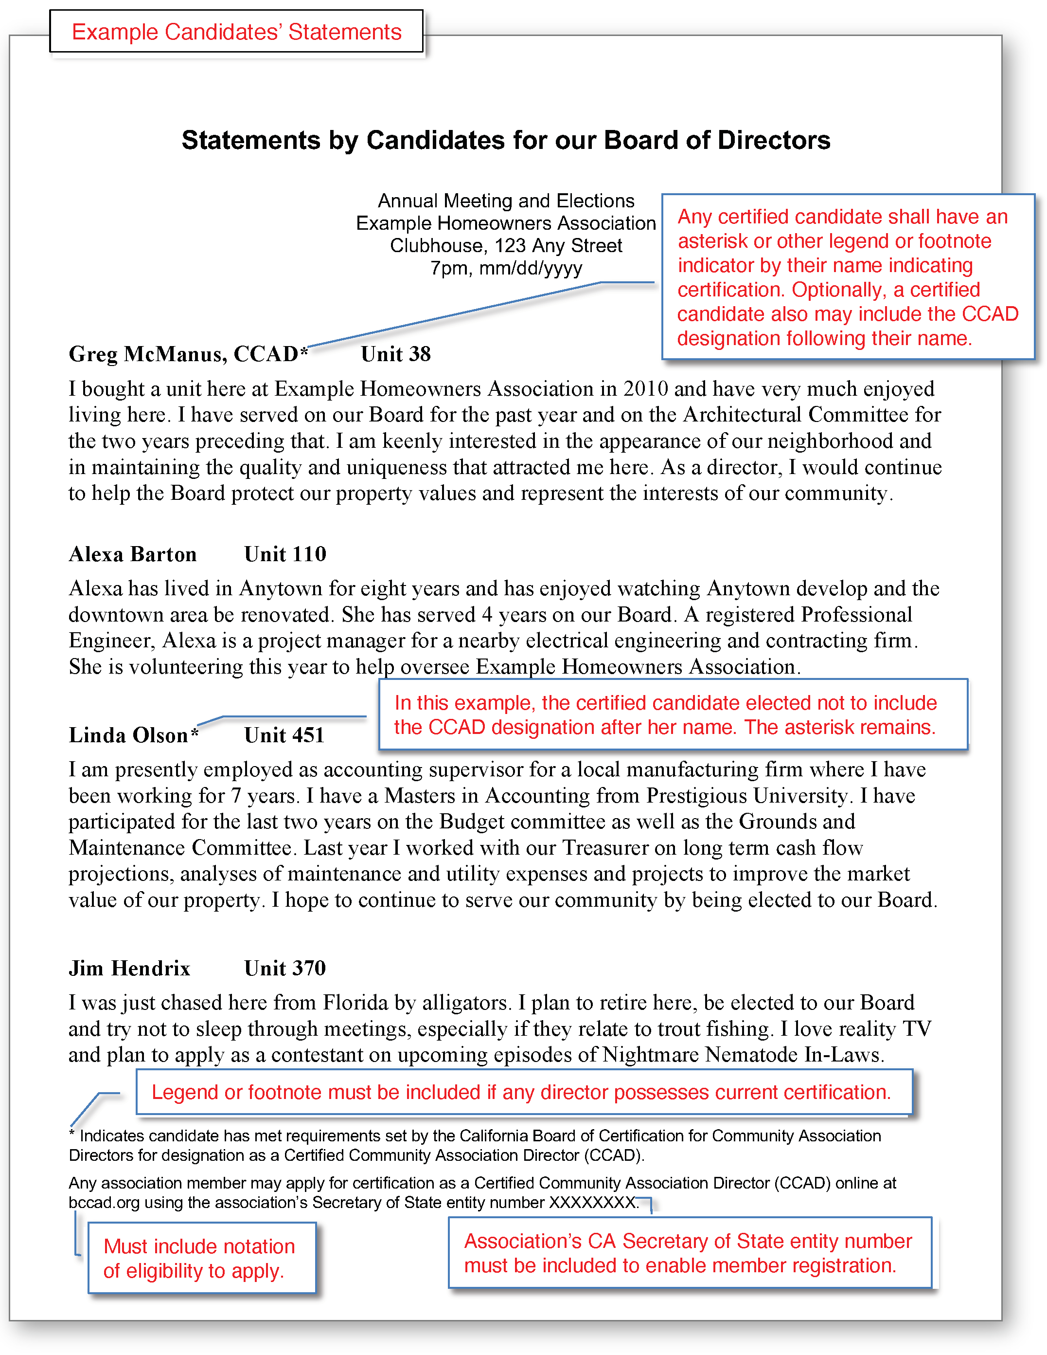

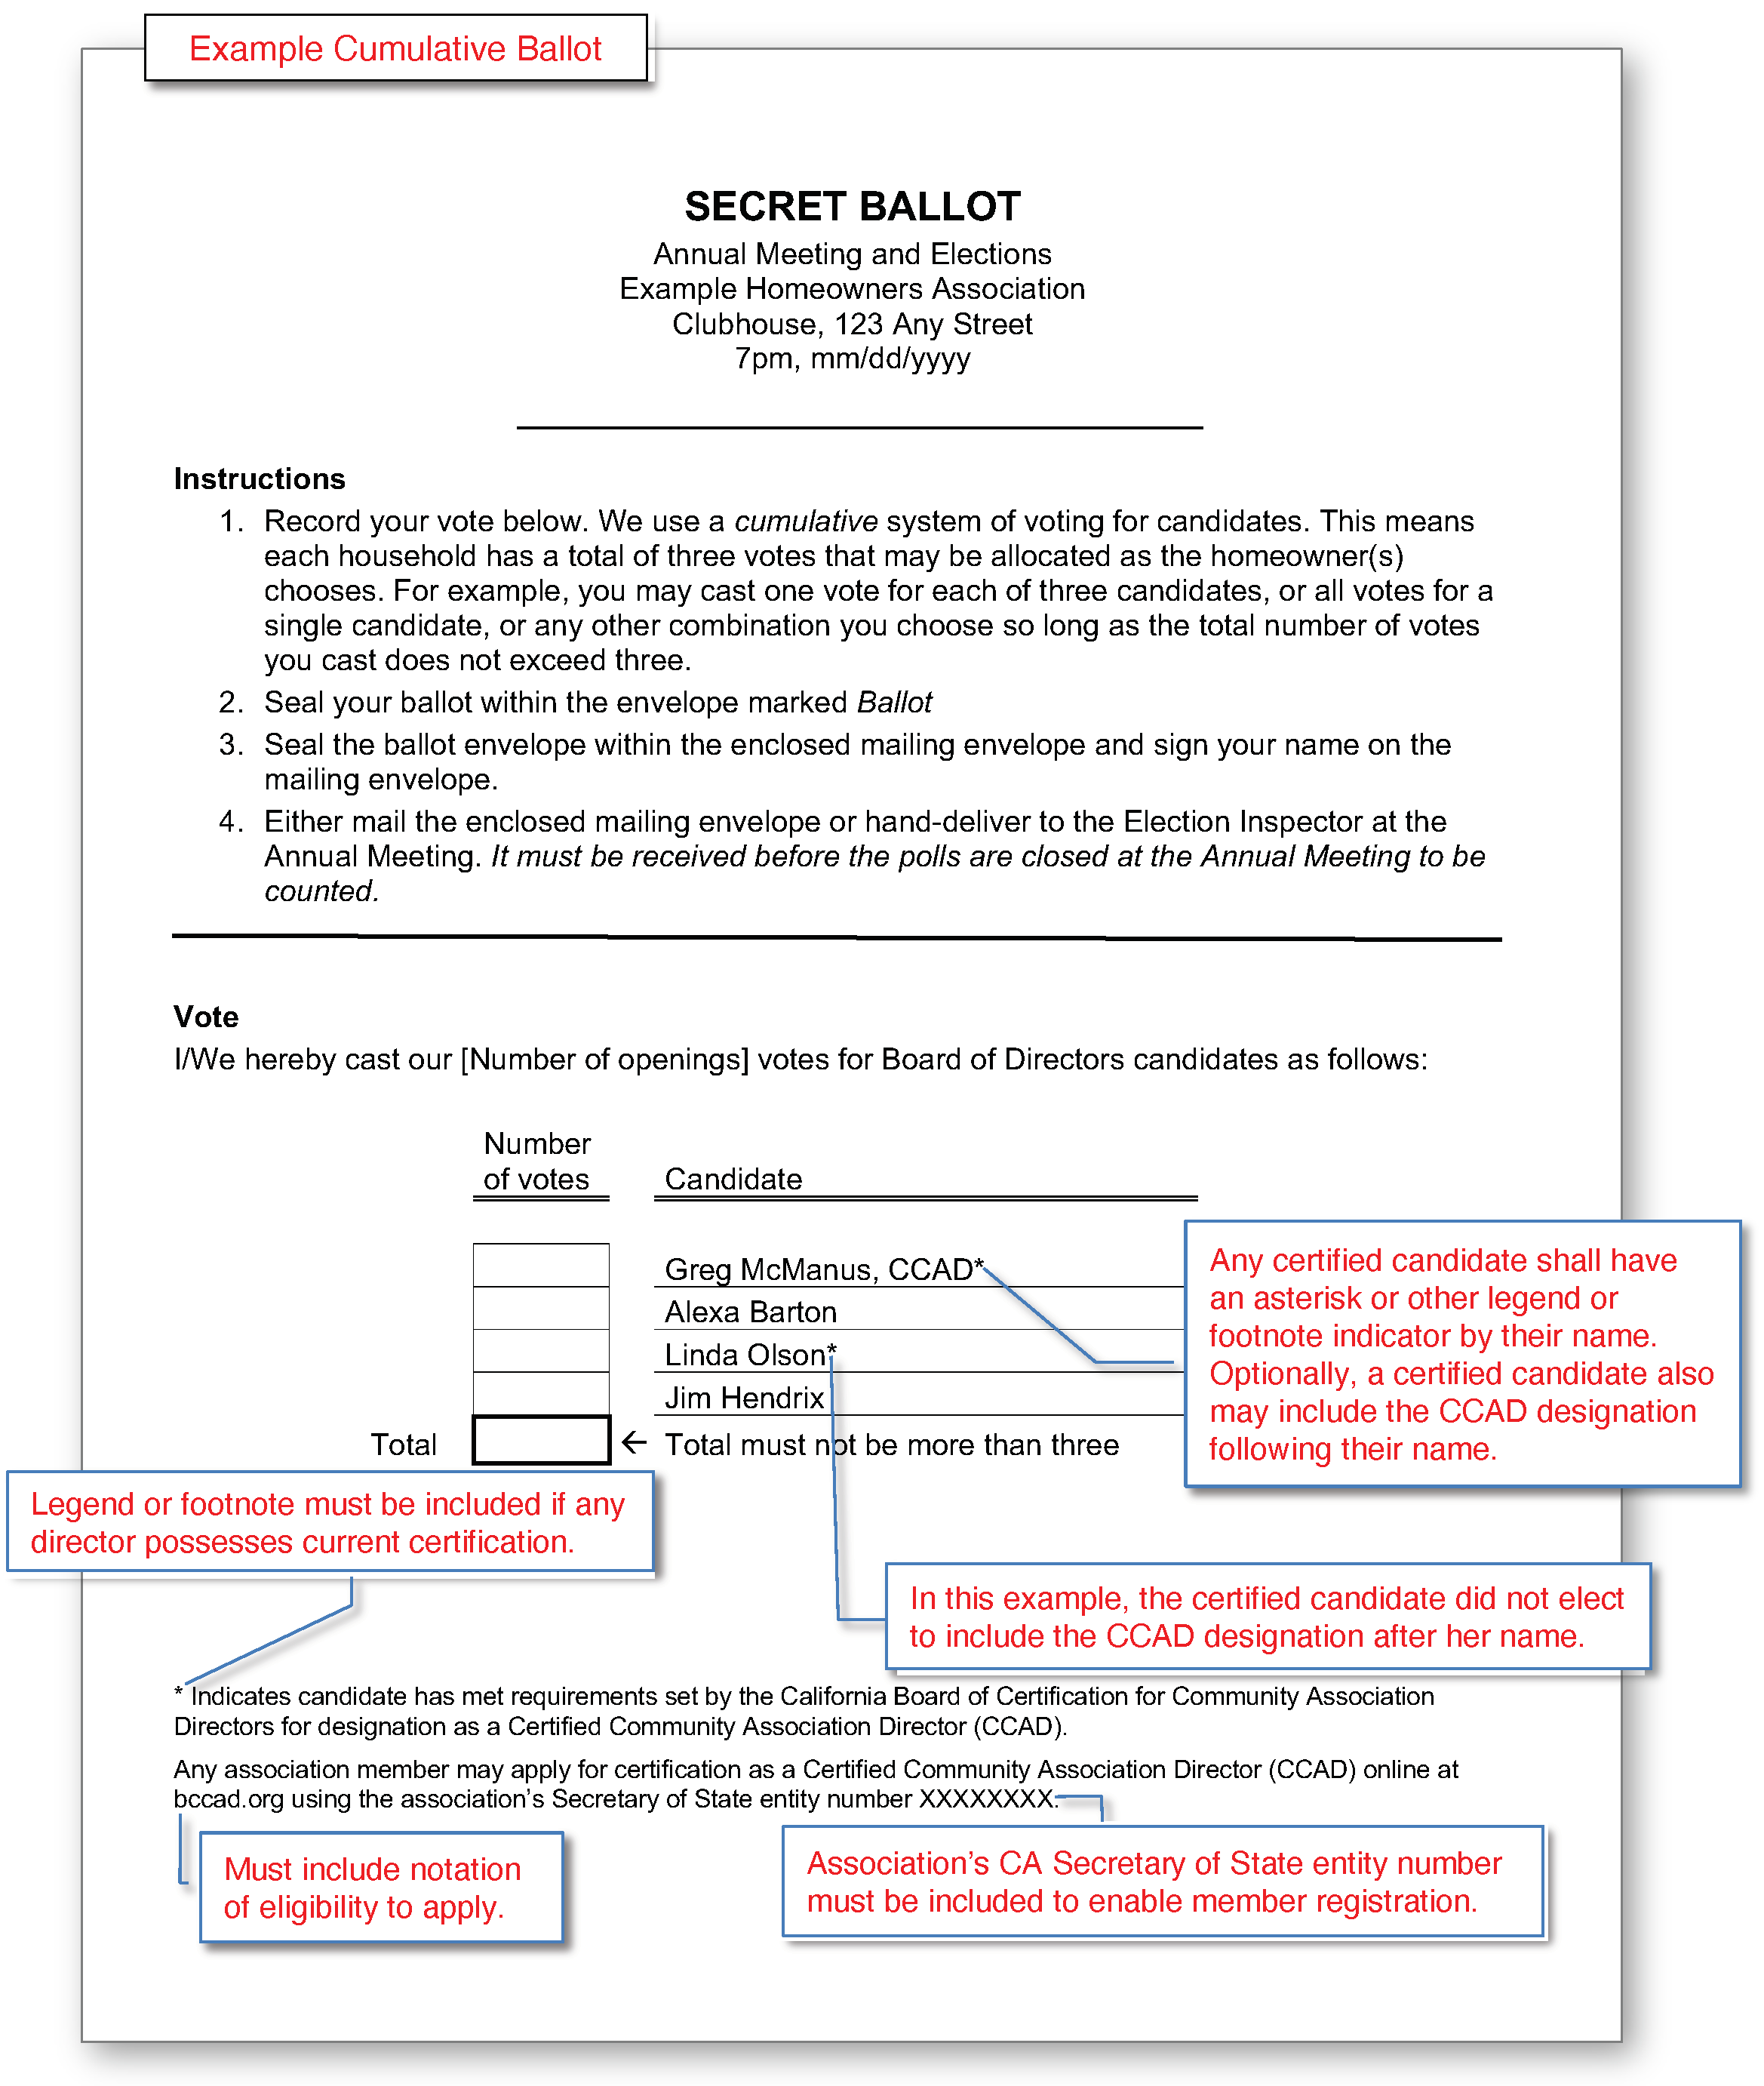

# Appendix C – Requirements for disclosures of board rating

This example is numbered for California but should be readily adaptable for any state.

Civil Code §5310 would be amended to require the annual policy statement include the Board’s certificate of rating disclosure. As a convenience, BCCAD may provide a webpage from which a certificate of rating disclosure may be generated and downloaded. (See specimen.)

## Proposed amendment to Civil Code §5310

Section 5310 (a)(12) would be renumbered as 5310 (a)(13) and new 5310(a)(12) would become the following:

1. The Board’s current COMPETENCE rating and explanation of its purpose and calculation formula, substantially as indicted in the following example specimen:

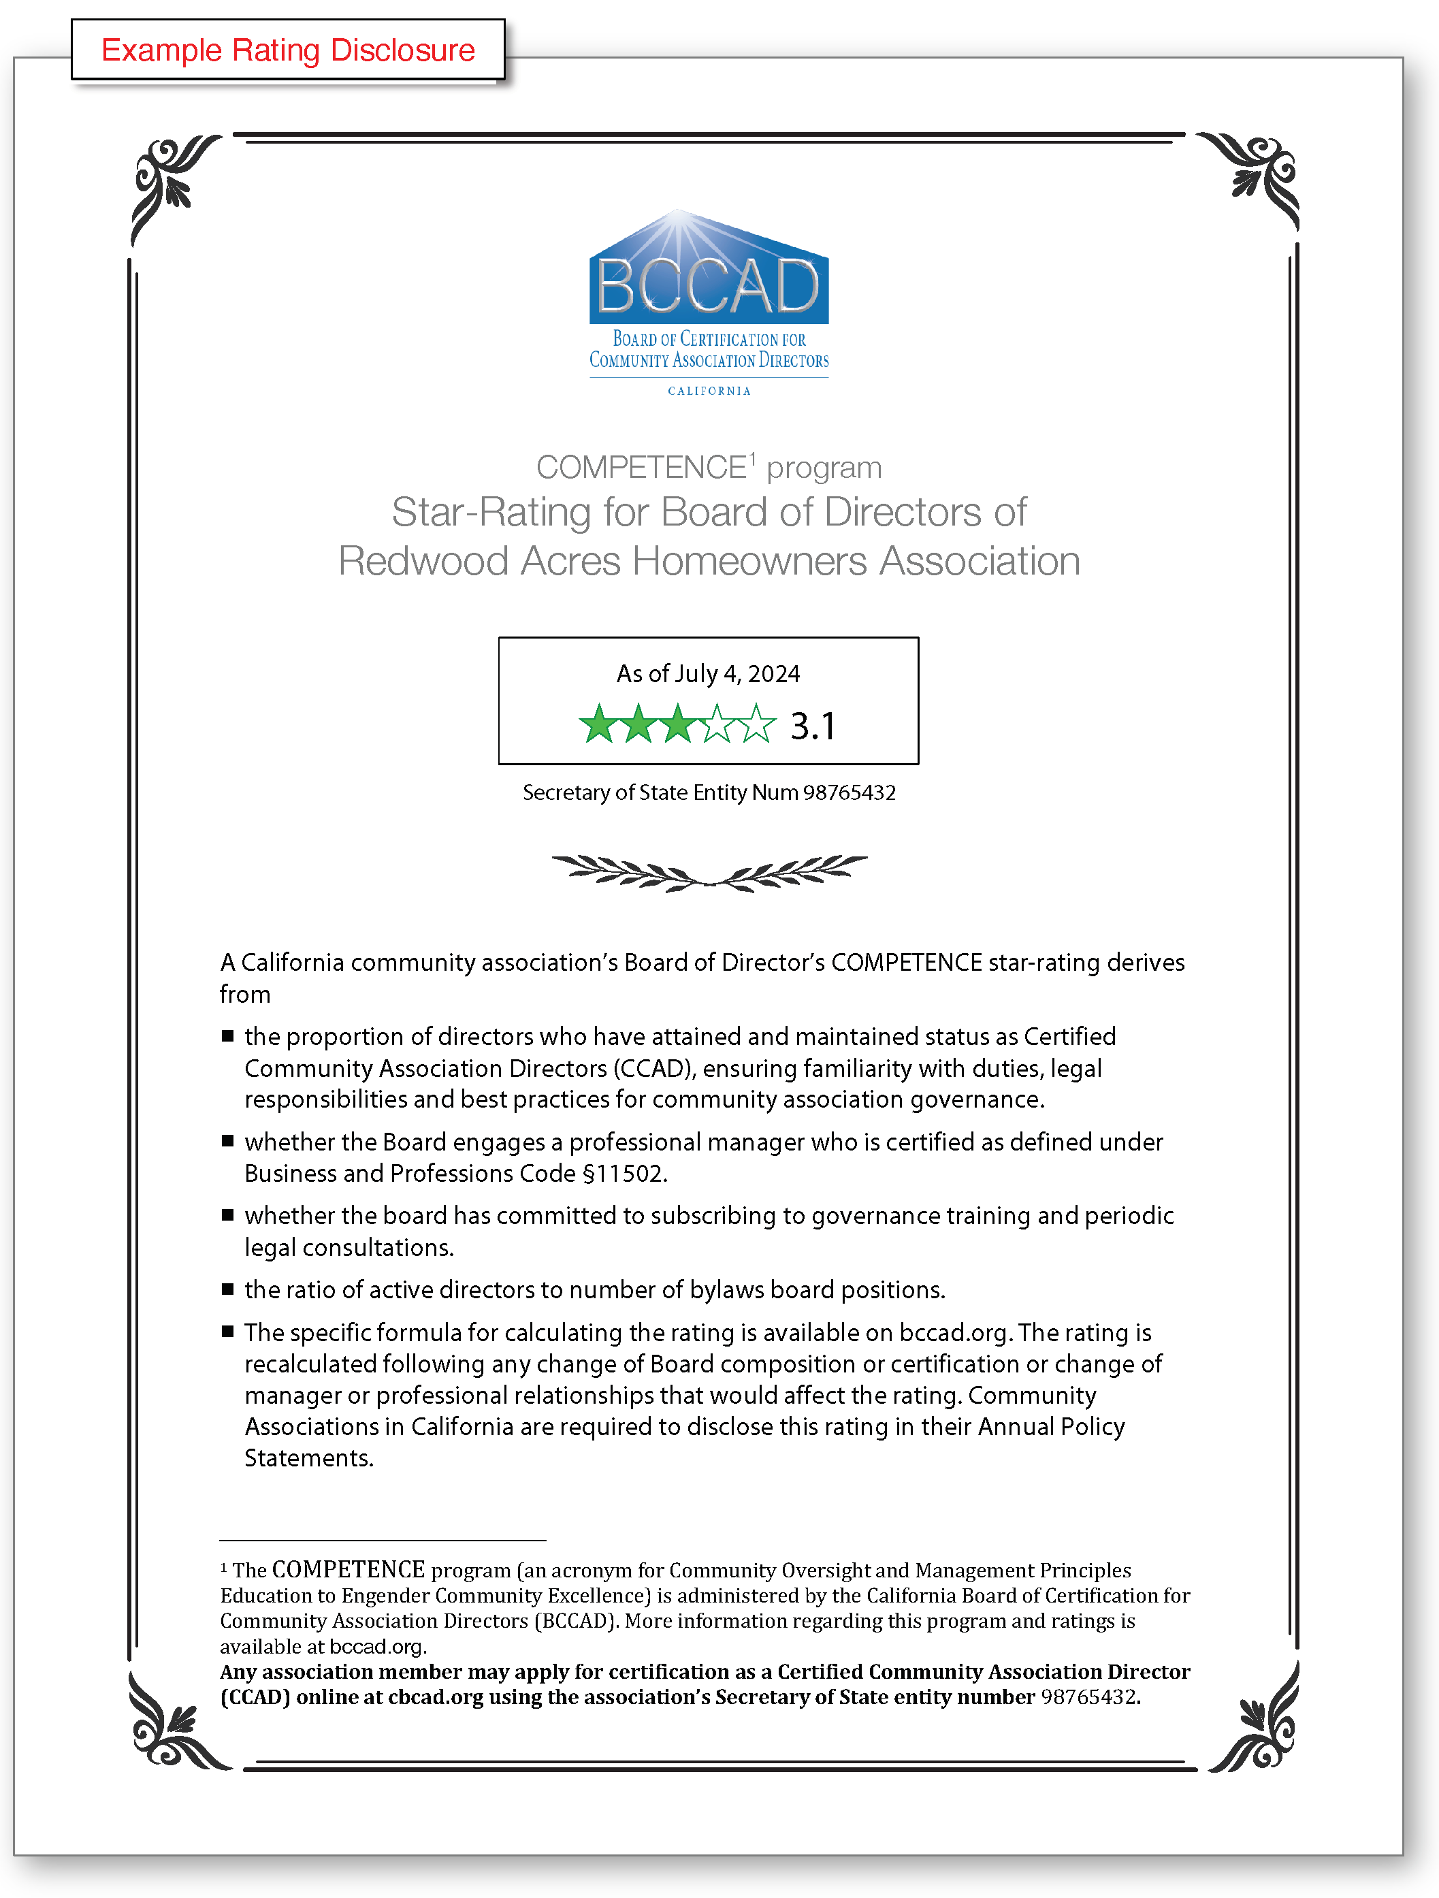

## Footnotes

1. Foundation for Community Association Research, Community Associations Institute; *FCAR Fact Book 2021,* Sec. 3.1;
2. The US Department of Education describes *Competency Based Education* as a preferred alternative to a traditional *Carnegie-Unit* based approach to learning in the modern age for a population already employed and without the flexibility of full-time student status. <https://www.ed.gov/oii-news/competency-based-learning-or-personalized-learning>. The program focuses less on accumulated hours in passive attendance or exposure to lectures and presentations, and more upon actual knowledge gleaned from experience and learning from any source, such as articles, classes, and online education programs.
3. *Substantive material* is that which conveys information essential for instruction and about which exam questions will be provided. Specifically, word count of coursework or an article would not include material employed primarily for introductory or stylistic purposes.
4. Robert Browning, RS; Mitch Frumkin, PE, RS; Peter B. Miller, RS; Robert Nordlund, PE, RS; John Poehlmann, RS; and Ted Salgado, RS; “An Explanation of Reserve Study Standards–Based on the National Reserve Study Standards (NRSS)” Nov. 2019; p. 9 <https://www.caionline.org/LearningCenter/credentials/Documents/NRSSClarificationArticles.pdf>
5. *CCAM-certified* is a certification awarded by the California Association of Community Managers to those community managers who meet its training and testing requirements.