ITRW 322

lEONARD WASSENAAR

25948083

PT5 Activity 6.7.5: Subnet and Router

**Task 1**: Subnet the Address Space.

Step 1: Examine the network requirements.

Step 2: Consider the following questions when creating your network design.

How many subnets are needed for this network? **3**

What is the subnet mask for this network in dotted decimal format? **255.255.255.224**

What is the subnet mask for the network in slash format? **/27**

How many usable hosts are there per subnet? **30**

Step 3: Assign subnetwork addresses to the Topology Diagram.

1. 192.168.1.32/27

2. 192.168.1.64/27

3. 192.168.1.96/27

**Task 2:** Determine Interface Addresses.

Step 1: Assign appropriate addresses to the device interfaces.

|  |  |  |  |  |
| --- | --- | --- | --- | --- |
| Device | Interface | IP Address | Subnet Mask | Default Gateway |
| R1 | Fa0/0 | 192.168.1.33 | 255.255.255.224 |  |
| S0/0/0 | 192.168.1.65 | 255.255.255.224 |  |
| R2 | Fa0/0 | 192.168.1.97 | 255.255.255.224 |  |
| S0/0/0 | 192.168.1.94 | 255.255.255.224 |  |
| PC1 | NIC | 192.168.1.62 | 255.255.255.224 | 192.168.1.33 |
| PC2 | NIC | 192.168.1.126 | 255.255.255.224 | 192.168.1.97 |

**Task 3: Configure the Serial and FastEthernet Addresses**

**Step 1: Configure the router interface**

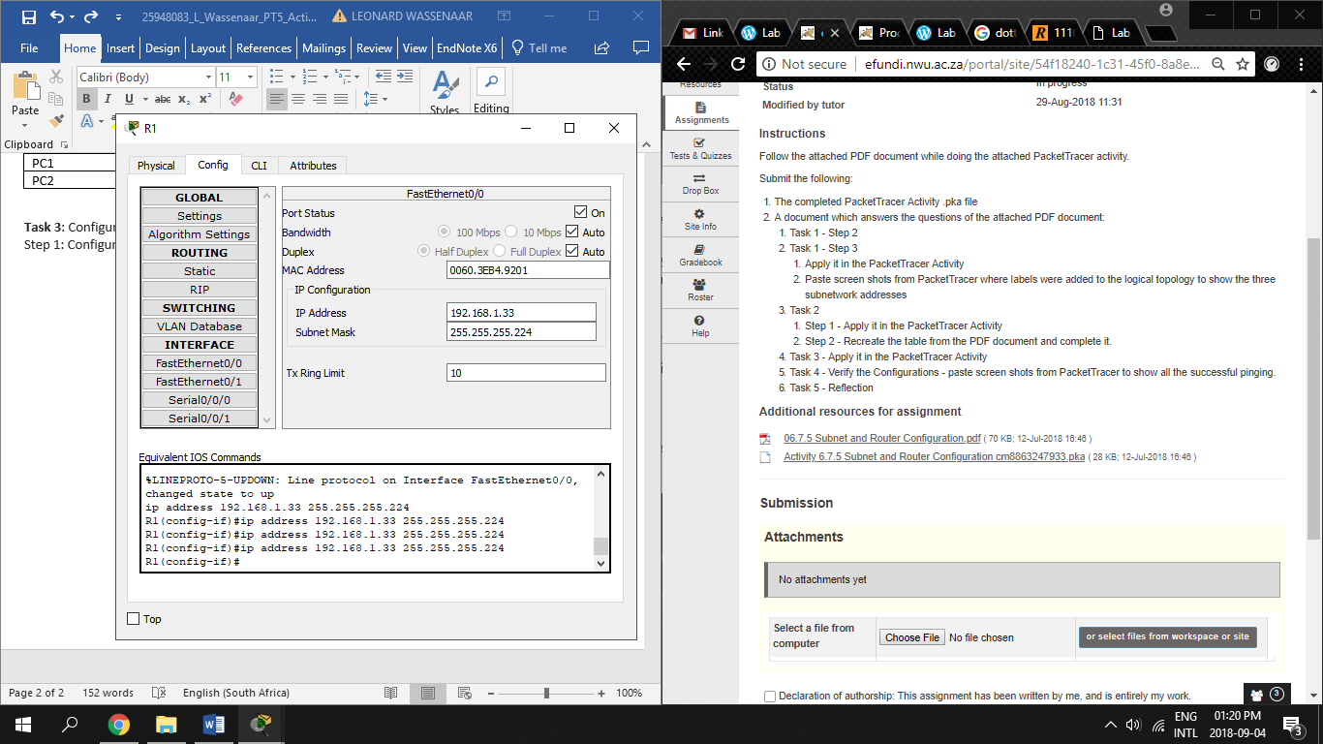

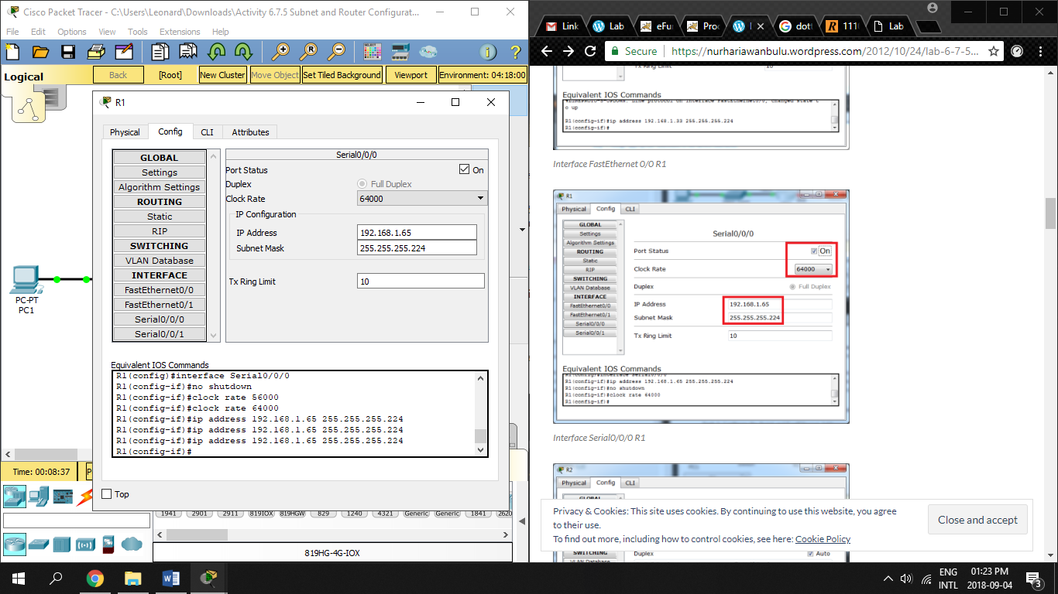

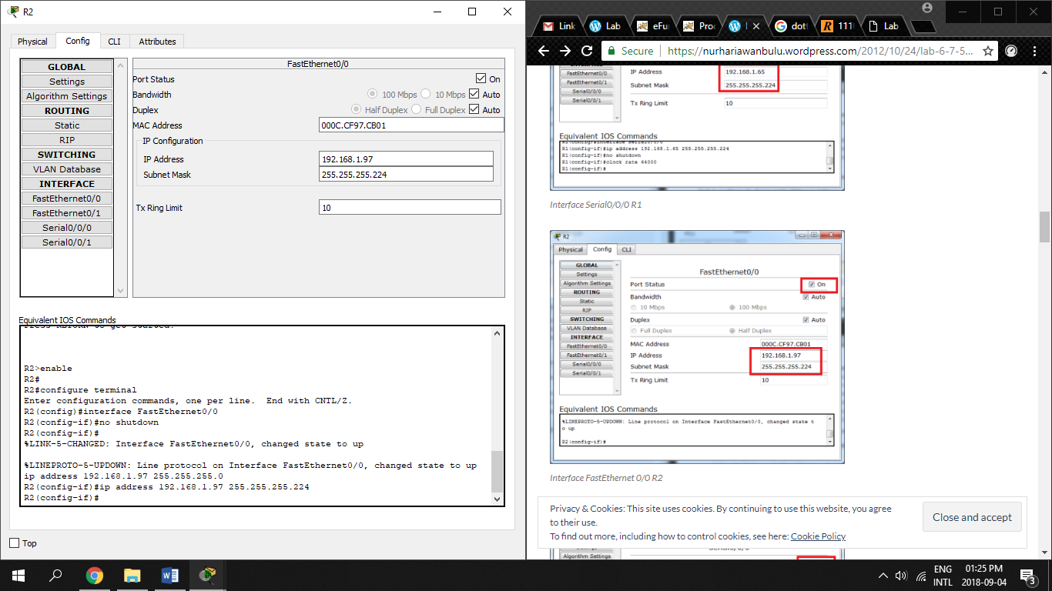

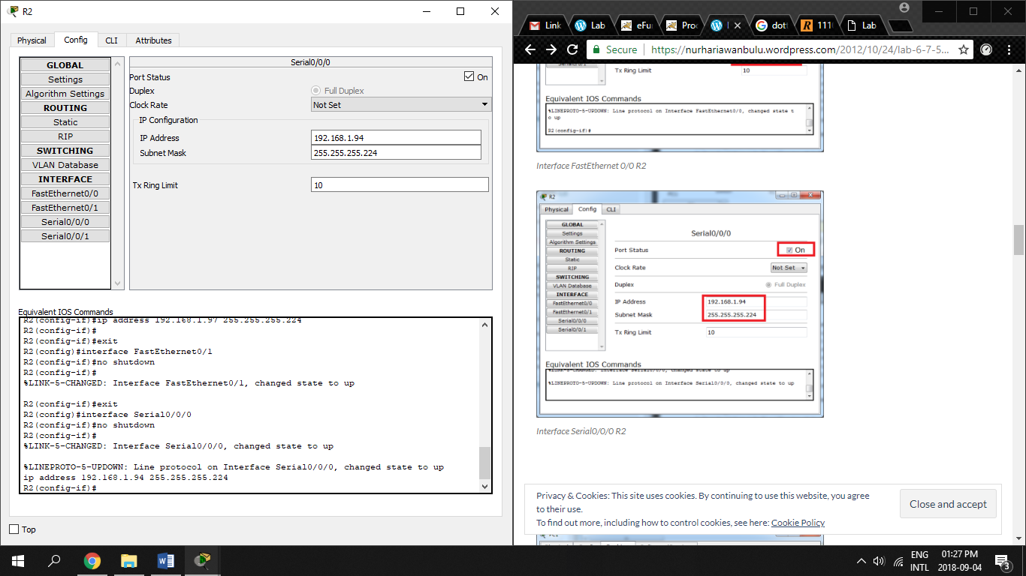

Step 2: Configure the PC interfaces.

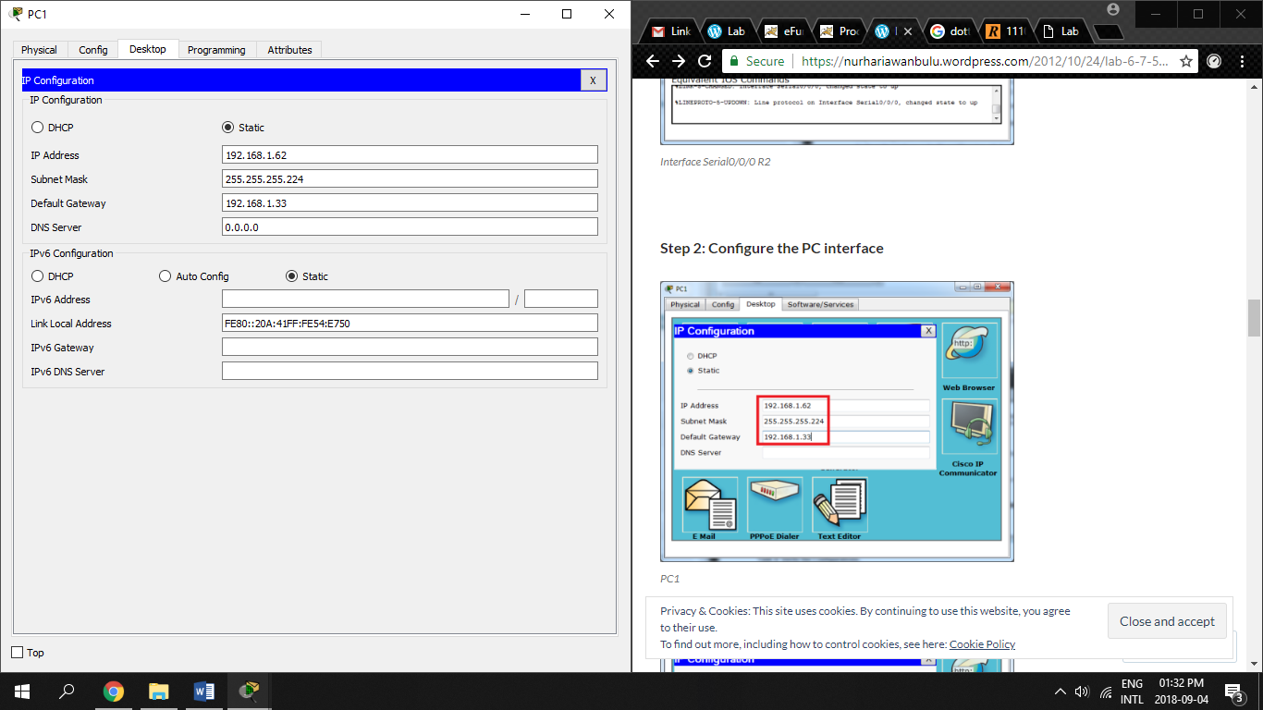

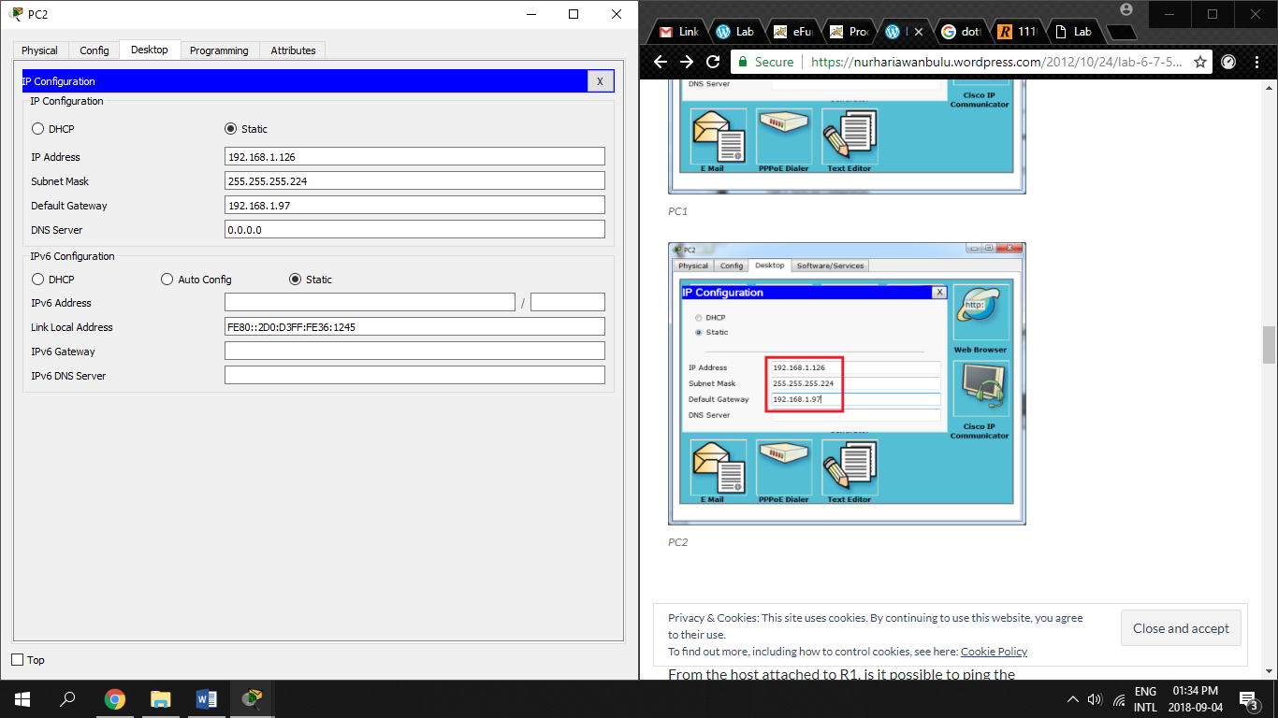

**Task 4: Verify the Configurations**

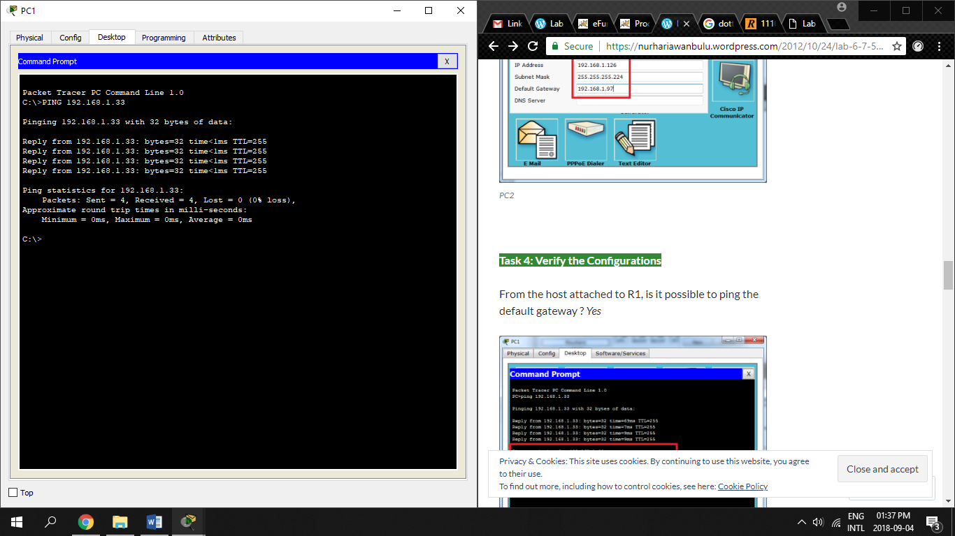

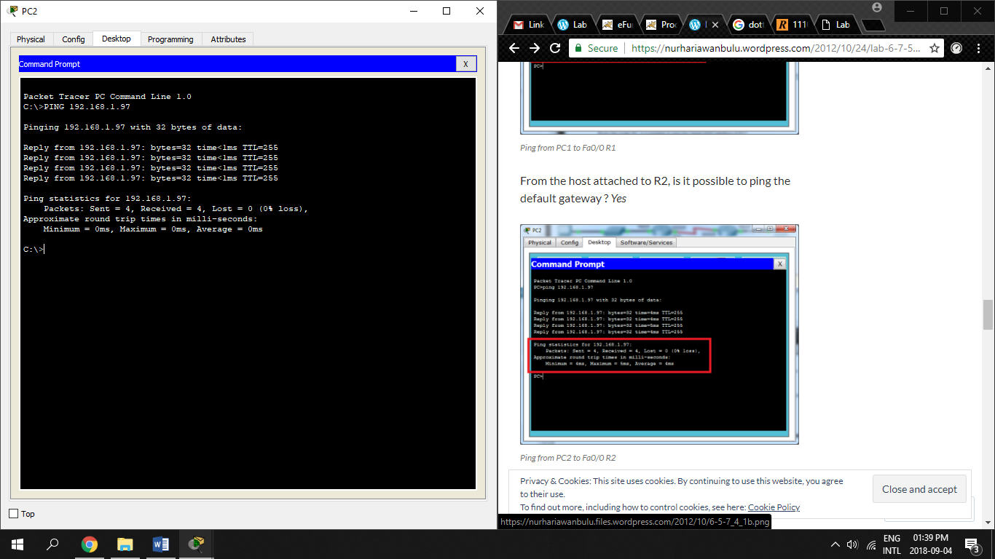

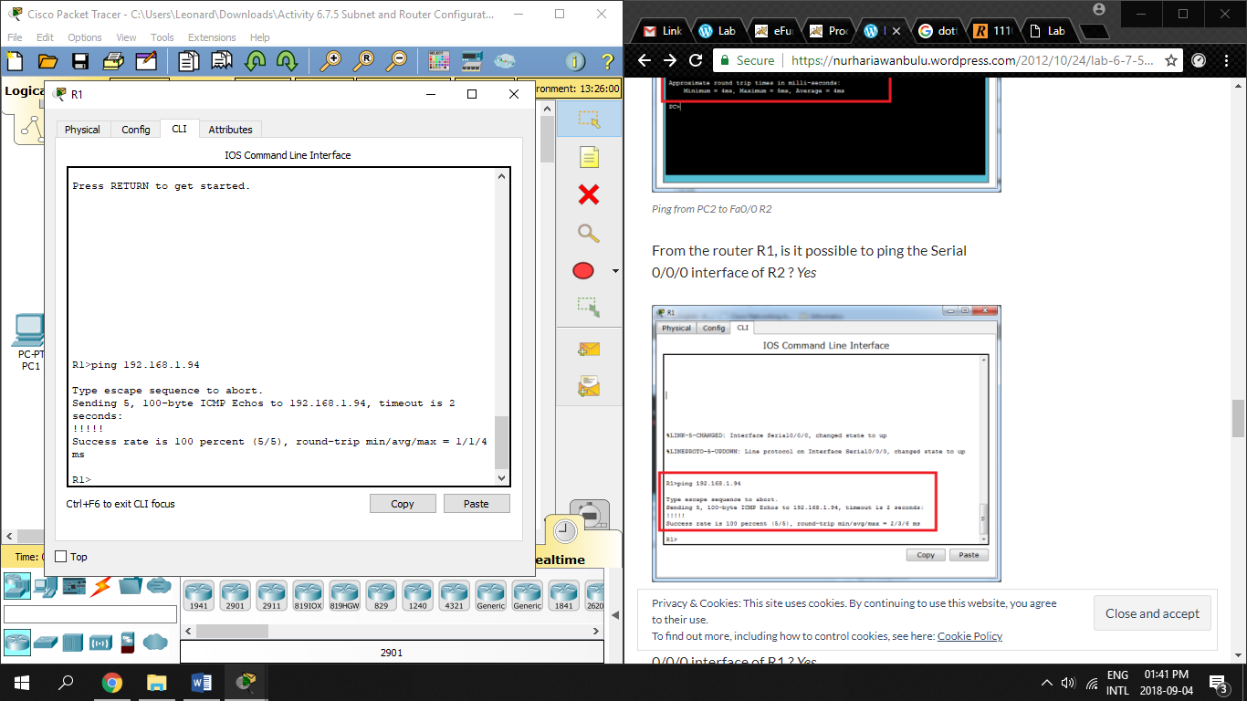

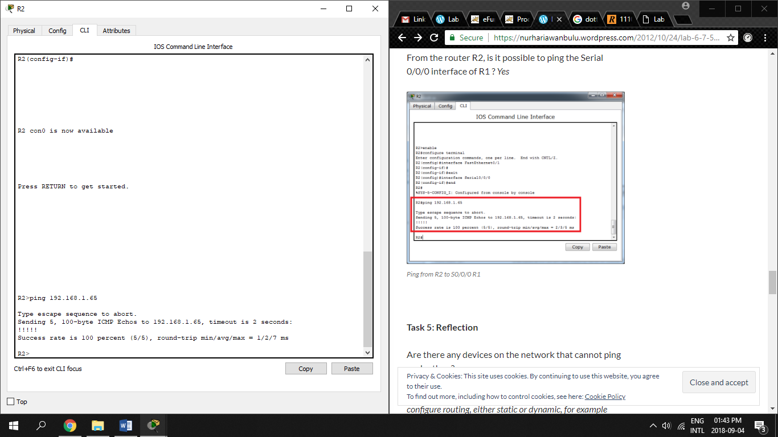

1. From the host attached to R1, is it possible to ping the default gateway? **Yes**
2. From the host attached to R2, is it possible to ping the default gateway? **Yes**
3. From the router R1, is it possible to ping the Serial 0/0/0 interface of R2? **Yes**
4. From the router R2, is it possible to ping the Serial 0/0/0 interface of R1? **Yes**

**Task5:** Reflection

The router must be configured fist, either static or dynamic before we can ping, example between PC1 and PC2