# **Cybertronix**

# **Project 2**

ITRW 324

Design document

L.Wassenaar: 25948083

B.Lubbe: 24928410

N.Hefer: 26098903

D.Pieterse: 27740757

Table of Contents

Cybertronix Project 2 1

WebApp design document 3

Interface design 3

Login 3

Admin 4

Manager 8

Employee 9

Validation 11

Aesthetic design 11

Content design 12

Navigation design component-level design 15

# **WebApp design document**

## **Interface design**

### **Login**

1. Admin login:

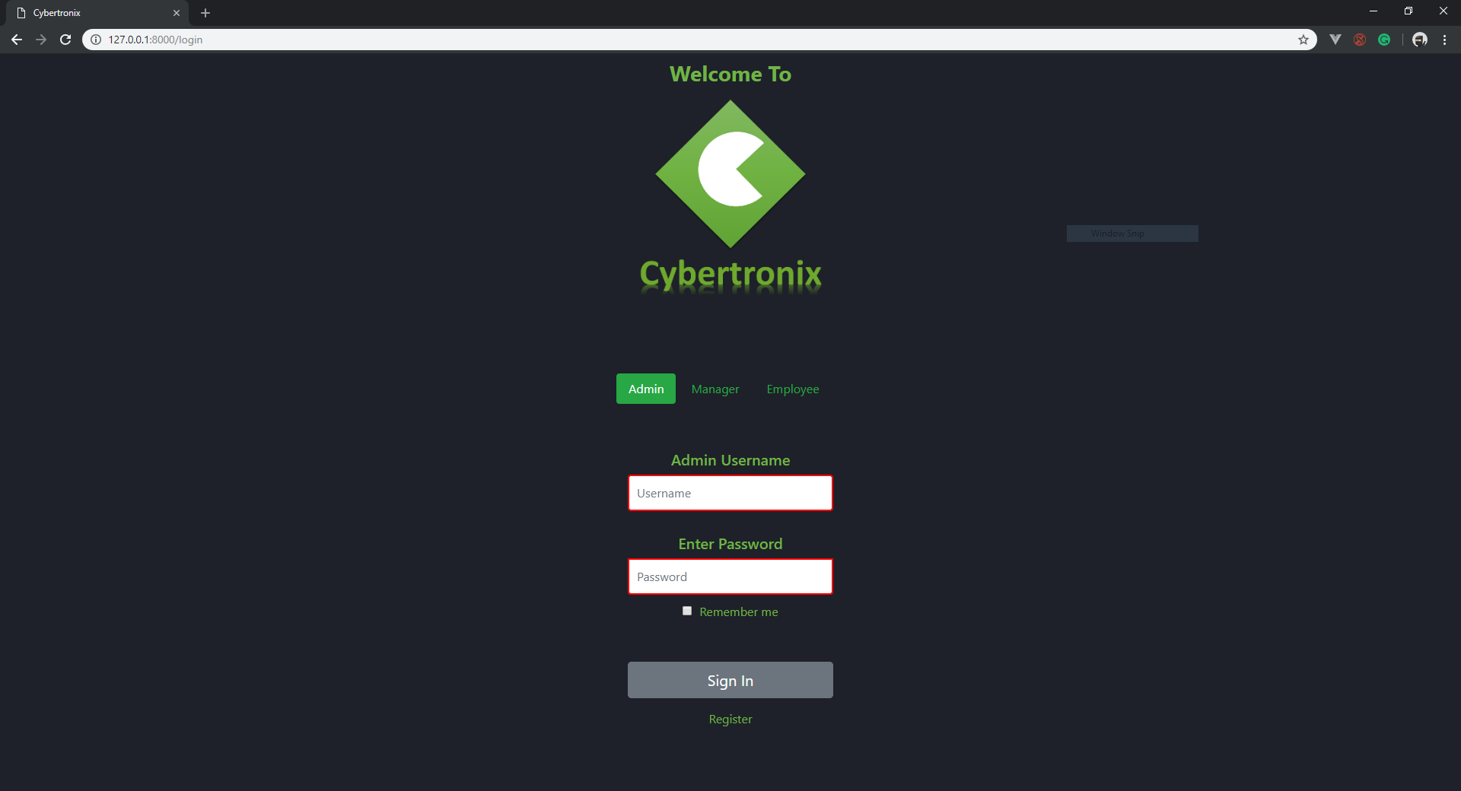

1. Employee login:

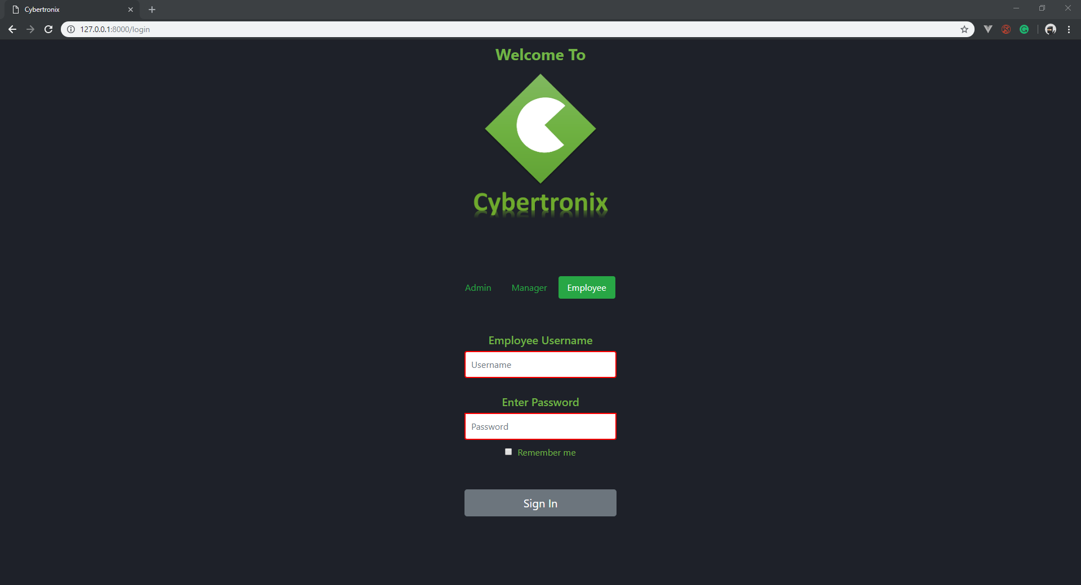

1. Manager login:

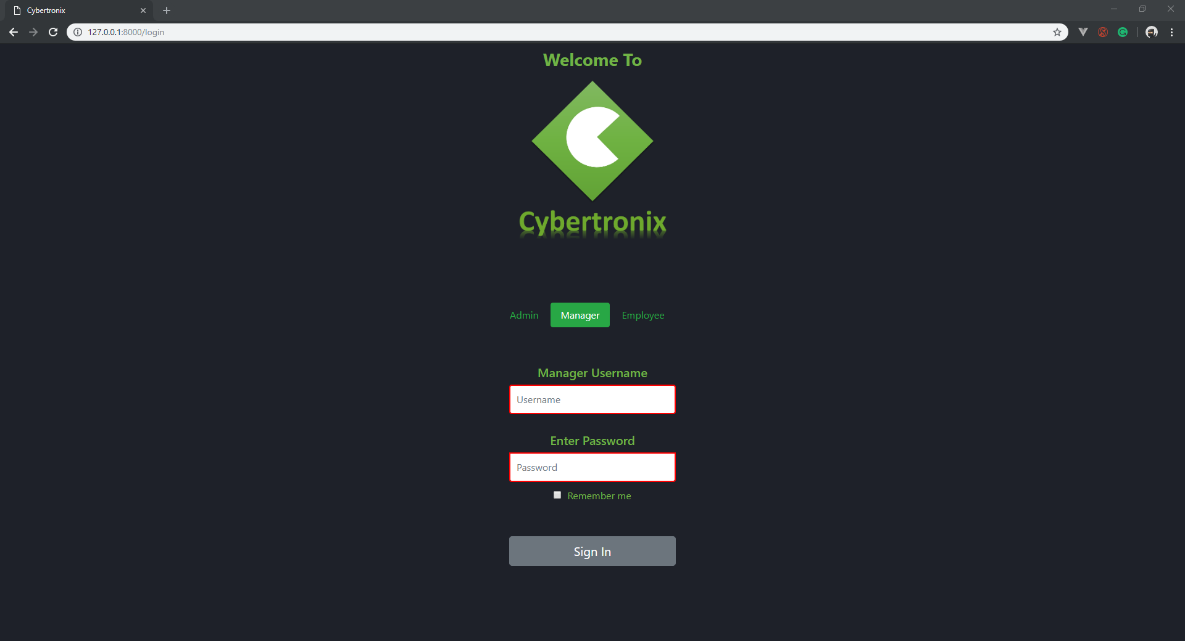

### **Admin**

1. Admin registration page:

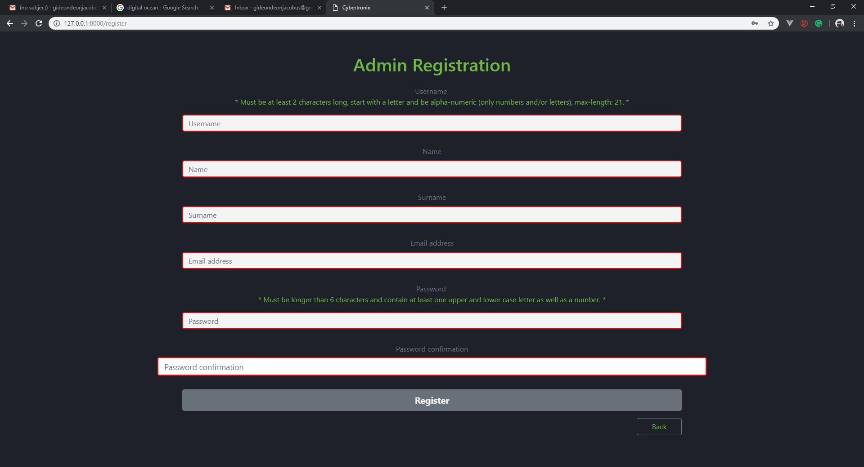

1. Admin home page:

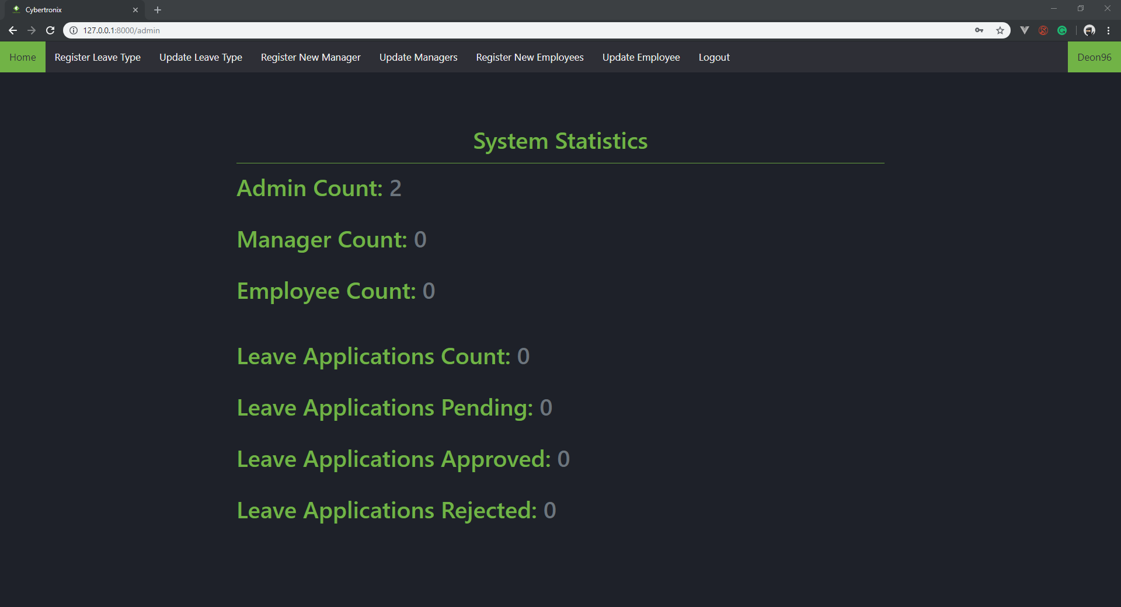

1. Admin register manager:

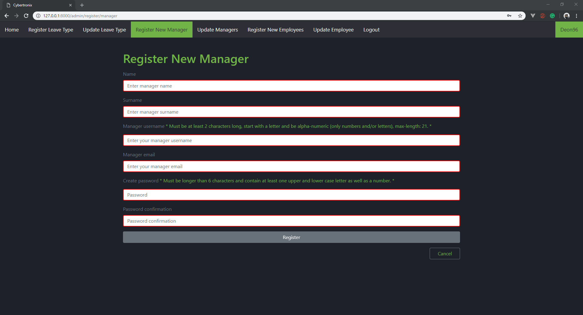

1. Admin update manager:

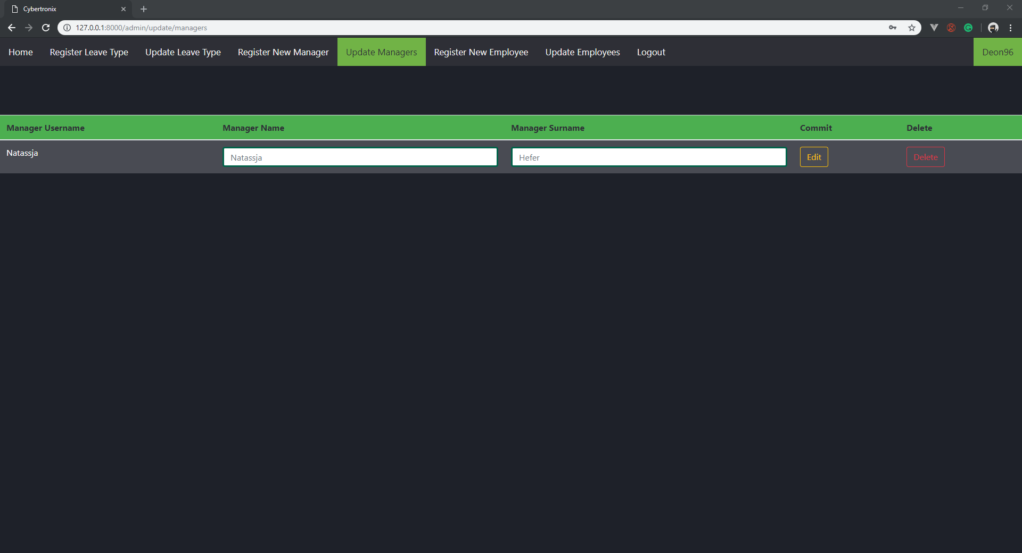

1. Admin register employee:

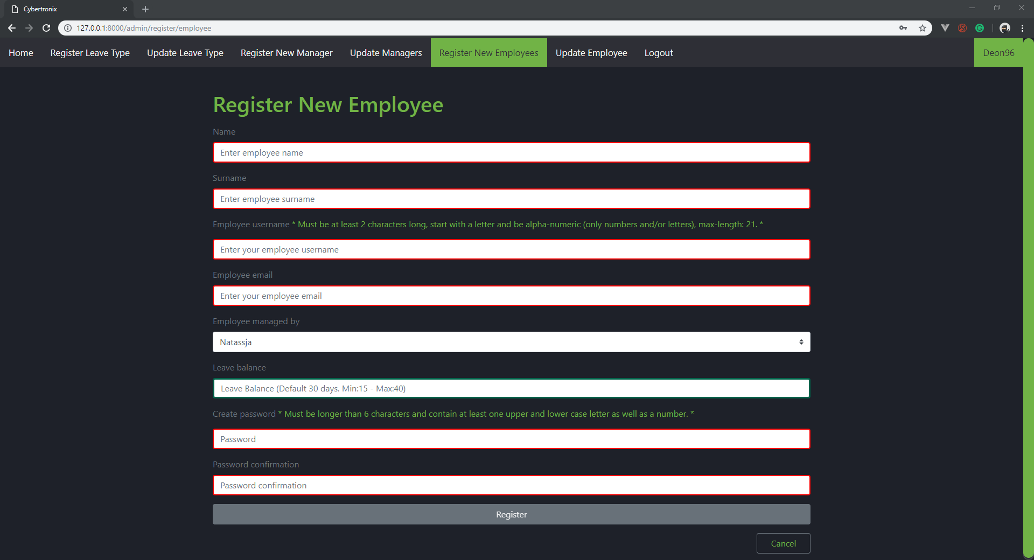

1. Admin update employee:

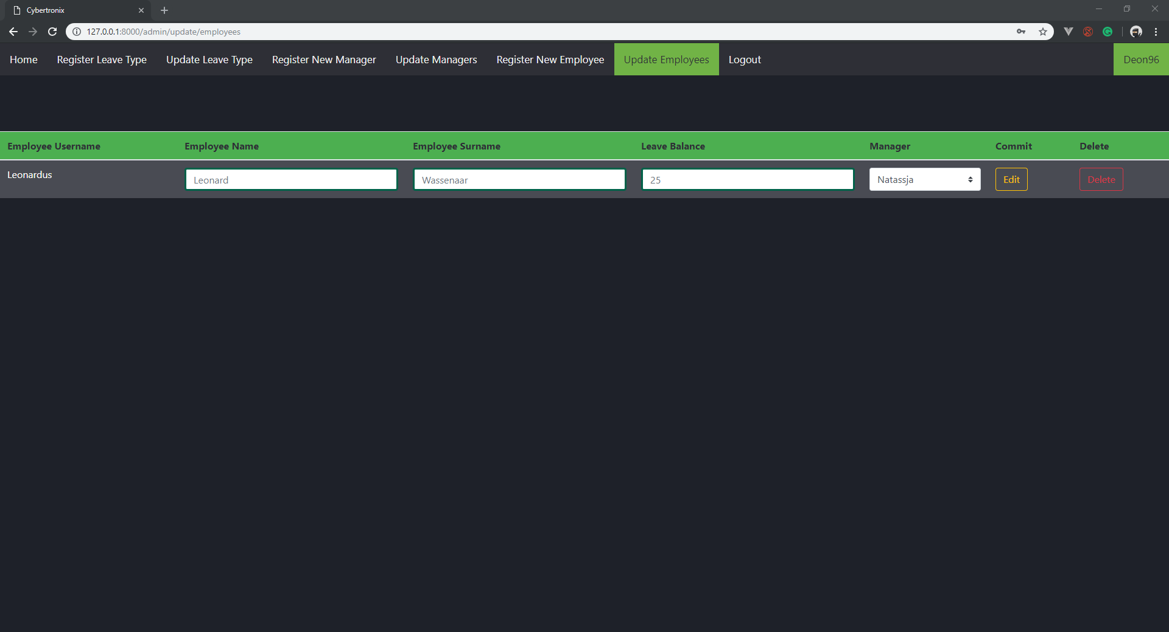

1. Admin create new leave type:

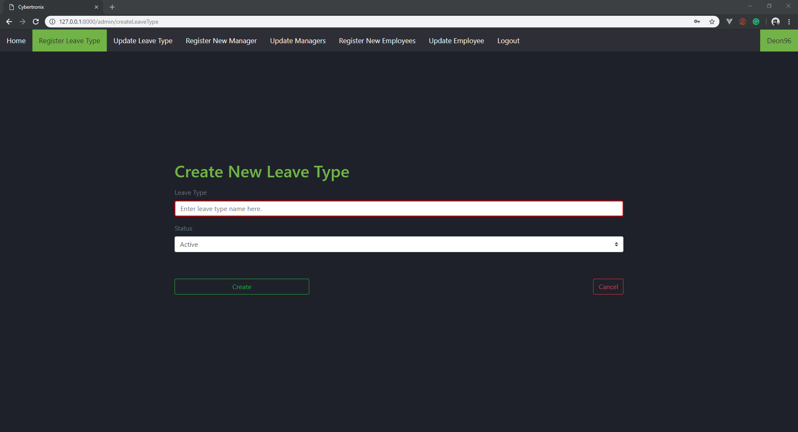

1. Admin update leave type:

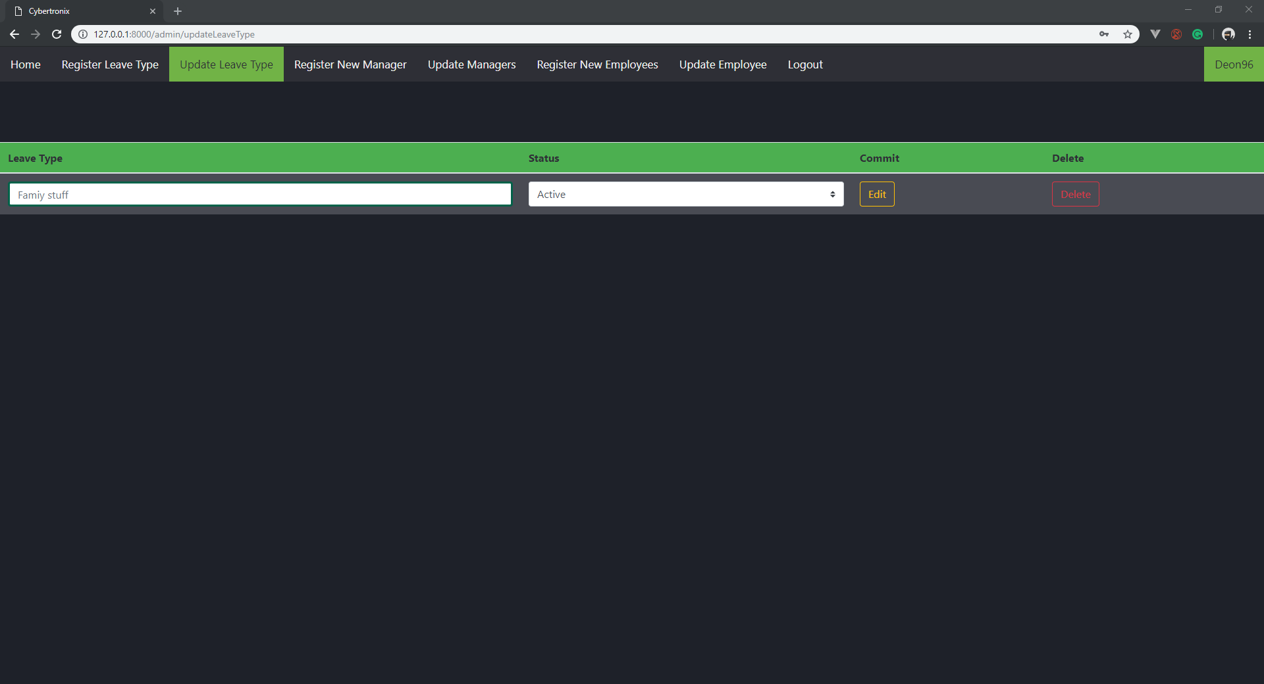

### **Manager**

1. Manager home page:

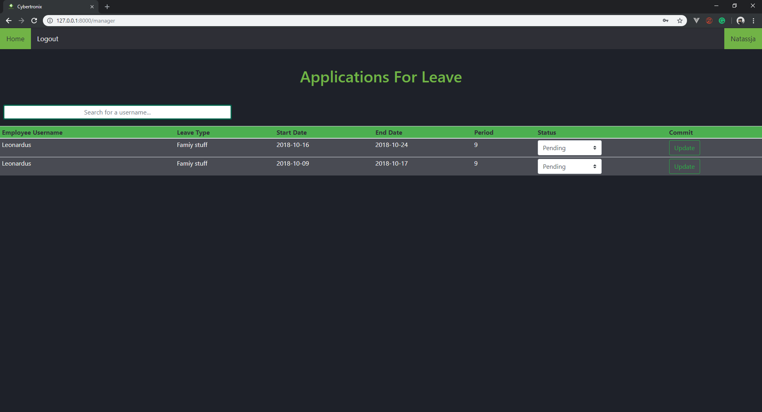

1. Manager view employee history:

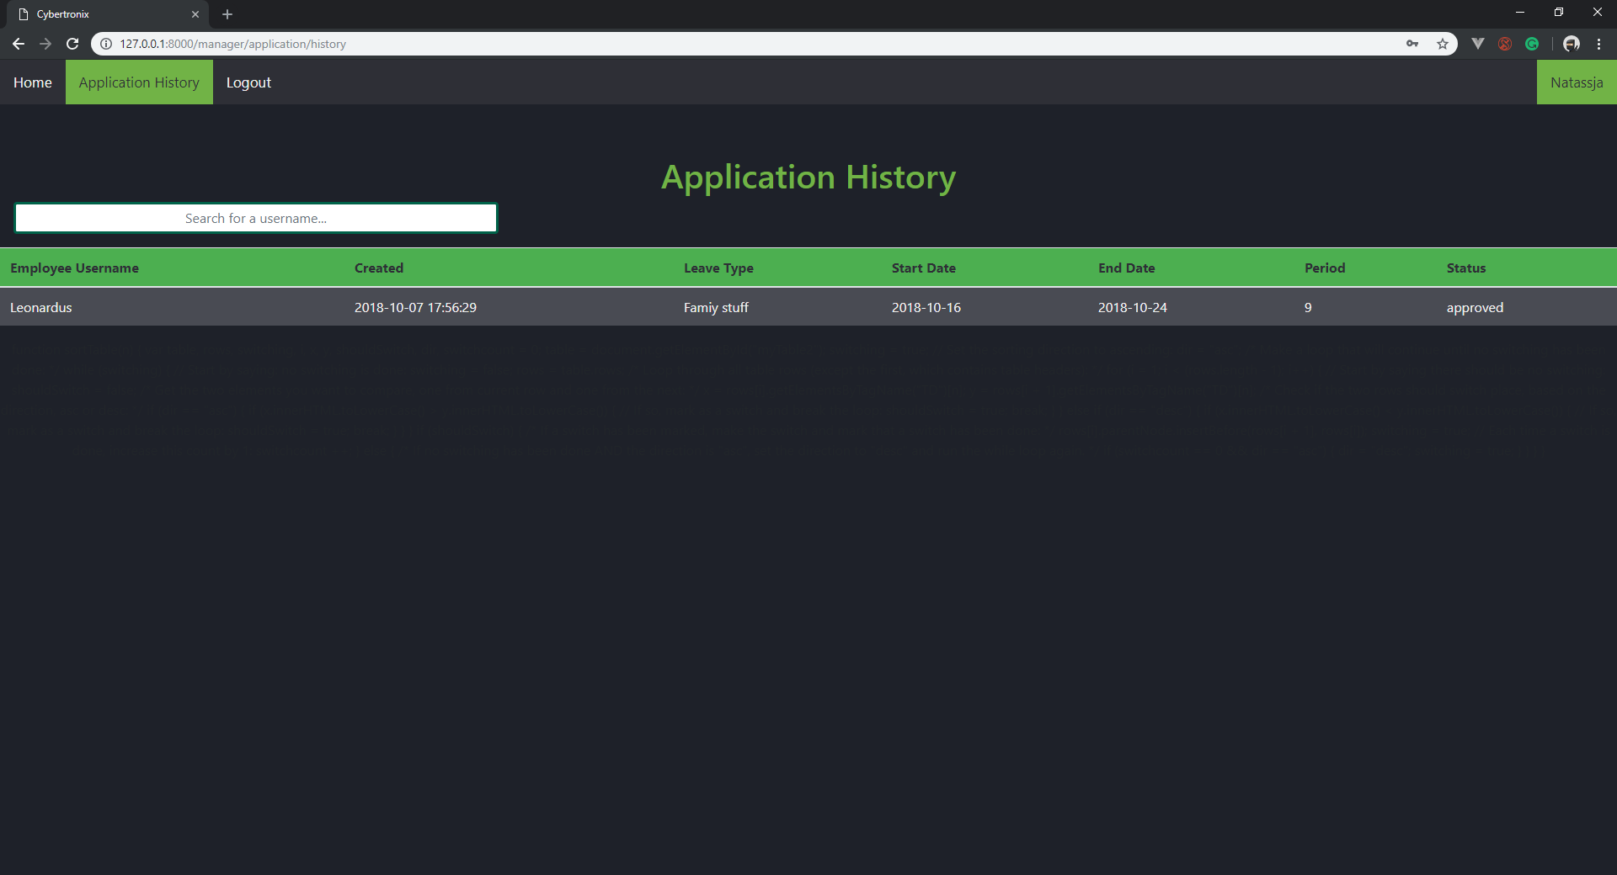

### **Employee**

1. Employee home page:

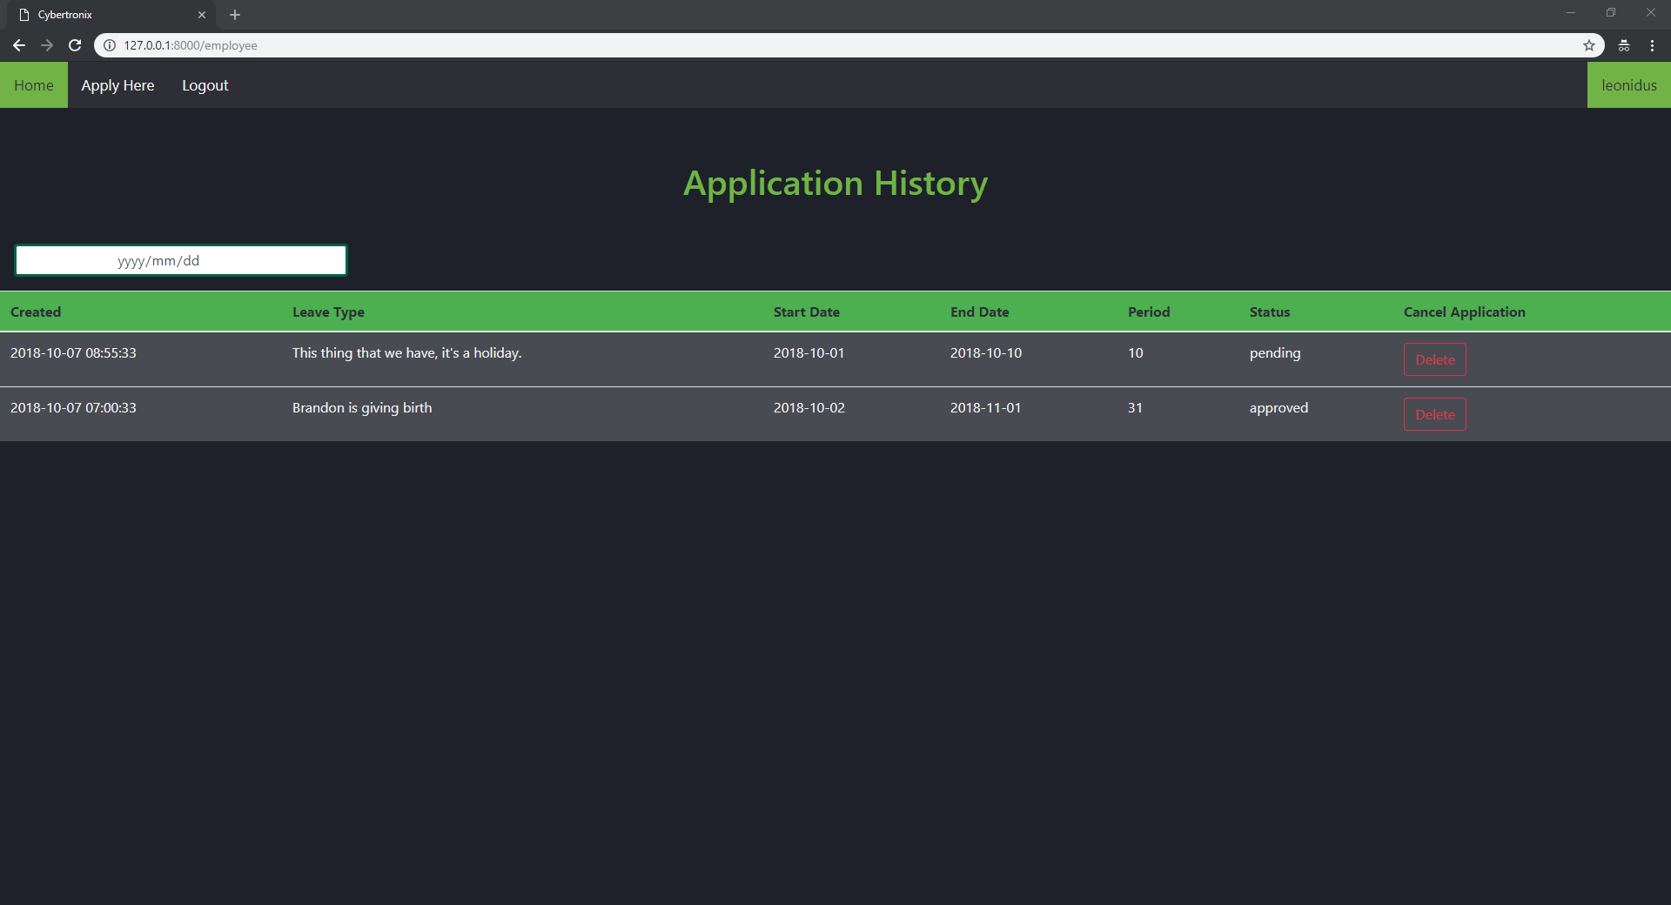

1. Employee Apply for leave:

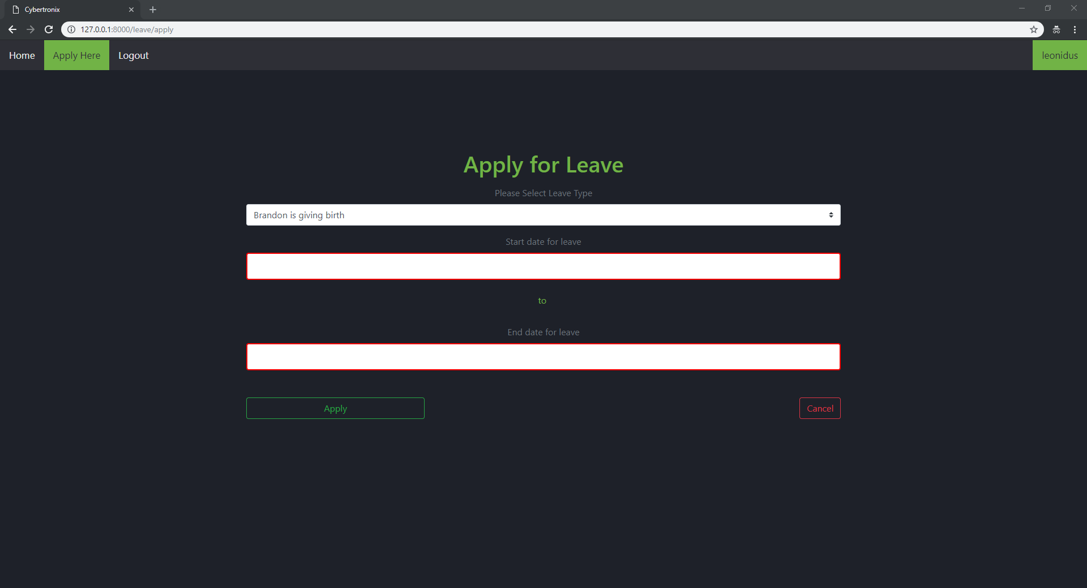

1. Employee application calendar:

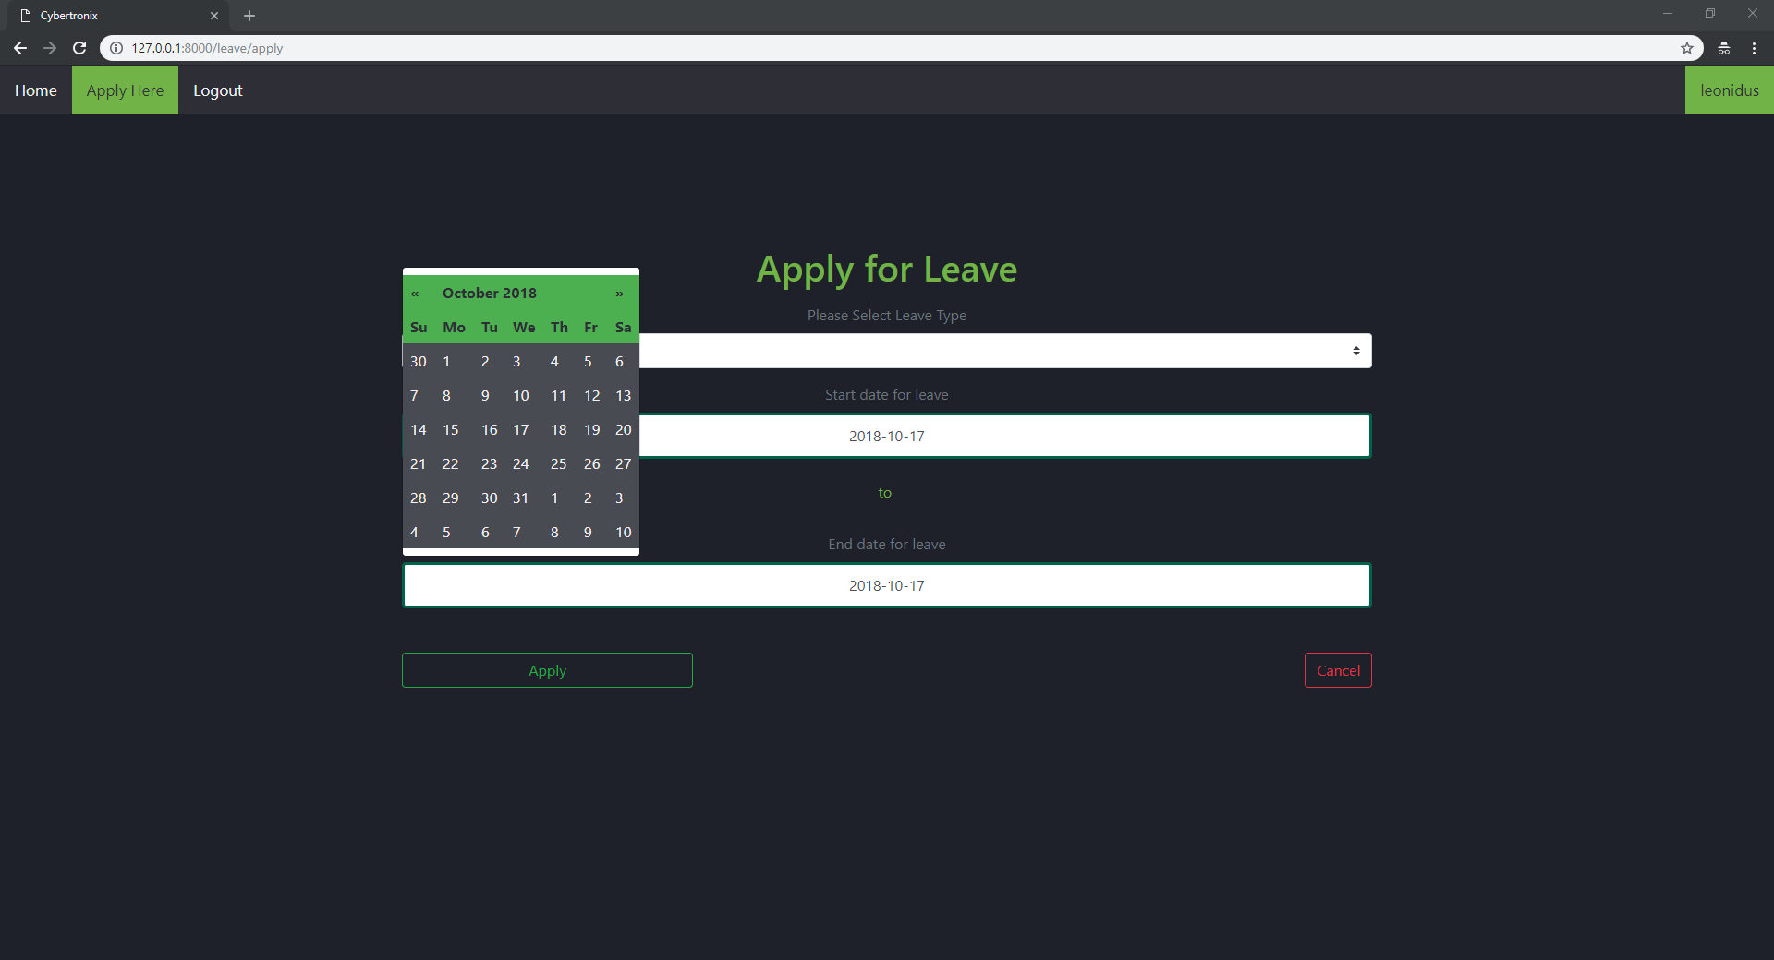

### **Validation**

1. Example of validation:

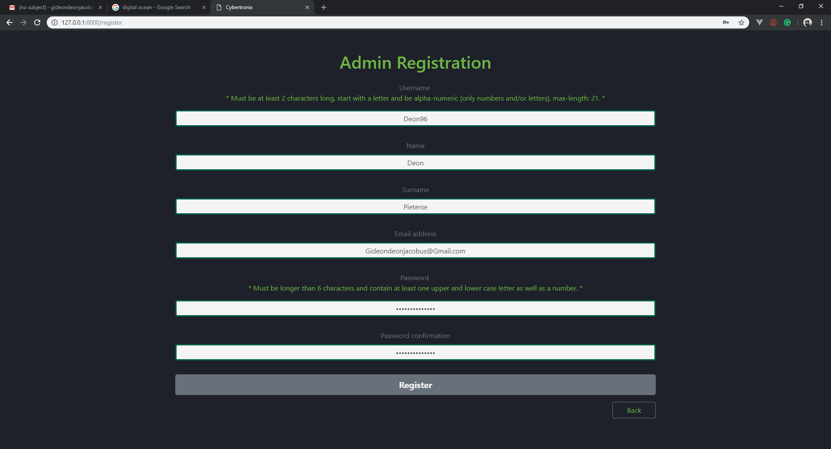

## Aesthetic design

According to David and Janson (2008) a website’s first impressions is met within the first view seconds. These first impressions often lead to the decision to leave or stay on the website, one factor that influences a user’s decision is the aesthetics of the web page.

The aesthetic design in the web application is strong in the sense that it is a clean and easy to use design that is both attractive and professional to the user. A dark theme with the color green to complement the darkness of the theme is used and gives an appealing look. Consistent colors for validation to avoid confusion for the user is being used for example red for fields that are needed to be filled and green for fields that are filled in correctly.

The darker back ground and the darker green we used for the writing is softer on the eyes of the user which helps when users have to spend long hours looking at the screen. The application’s features were kept to the necessary functions needed for the completeness of this web application to avoid unnecessary clutter and confusion on the web site for the user.

## Content design

As mentioned by Richards (2016) the content design is usually followed by the following question: “what is the best way to fulfil a user’s needs?”. Which implies that the content design is linked to the user requirements for a web application.

The user needs for this web application is as follows:

Administrator:

* Should be able to create employees (CRUD).
* Be able to create new leave types (CRUD).

Manager and Employees:

* Should be able to view their own leave balances.
* Apply for specific leave types with a date range.
* View pending leave approvals.

The following is screenshots with explanations on how these requirements mentioned above is implemented in this web application:

1. Admin creating a new employee. This application makes use of validation text boxes to receive input from the admin and saves the information entered to the database to add the new employee to the system. The admins can use the navigation bar at the top to navigate between form depending on what he/she wants to do.



1. Admin creating new leave types. This application again makes use of validation textboxes to receive input from the admin for detail regarding the new leave type. The information is captured by the create button and stored in the database.



1. Managers and employees should be able to view their own leave balances. The application uses a table to display the history of applications and weather they have been approved or not. This example is the manager side the employee side can be seen above in the interface design.



1. The managers and employees should be able to apply for a leave type and provide the range of date they want to take leave. Here we can see the calendar the application uses to capture the date range for the employees to choose when they want the leave. As well as the text boxes to capture details regarding the application for the leave.



1. Managers should be able to view pending applications to be approved. Here the application makes use of a table to display the pending applications and a drop down list to approve or disapprove the application.

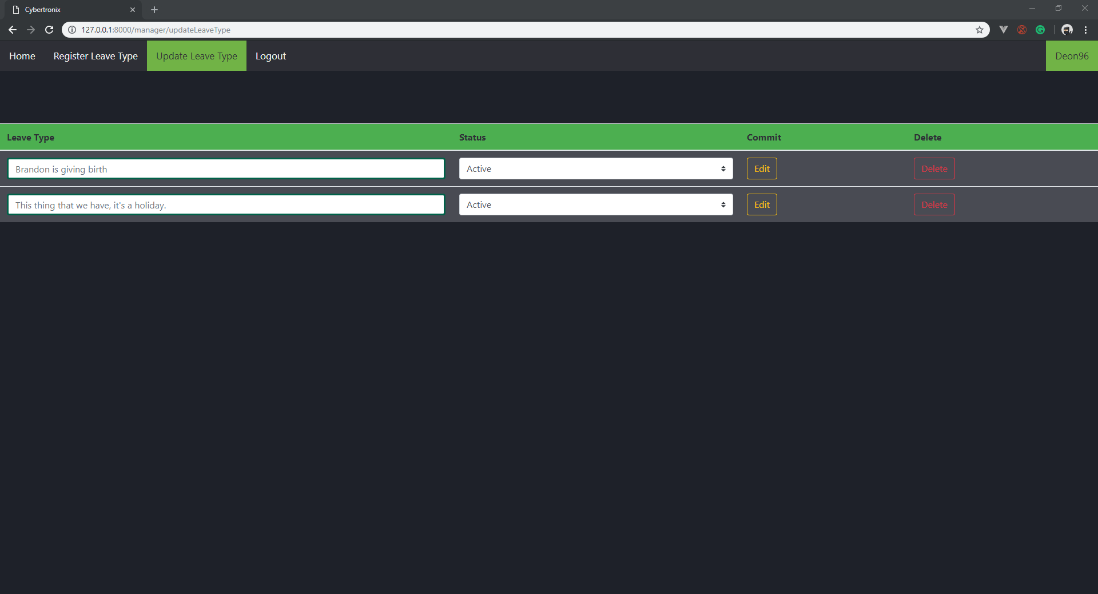

More forms can be seen at the interface design above that helps the application divide the requirements for the different employees to perform their individual roles.

## Navigation design component-level design

According to Anon (2018) the navigation of a web application should be simple to use and be consistent. The end-user should be able to understand how to navigate from page to page without the need to search for instructions how to navigate through the application.

The following are examples of this web applications navigation components:

1. In this figure the login screen can be seen. The user must choose the button whether they are a admin, manager or employee to be able to login with their specific details. If a admin chooses the manager tab they won’t be allowed to login due to their admin details.

Once the details have been entered the sign in button can be clicked to proceed. If a user is not on the system yet they can be added by clicking the register link that will navigate them to the register page.



1. All the forms use a navigation bar at the top of the screen to navigate between pages. Depending on the employee type is what the end user will see in their navigation bar and depending what the user wants to do depends on what tab in the navigation bar they will click.

In this example the admin clicks the home tab in the navigation bar then he/she s redirected to the home page for the admins. Each form also has a logout tab in the navigation bar that will link the user back to the login screen of the application.



References

Robins, D. and Holmes, J., 2008. Aesthetics and credibility in web site design. *Information Processing & Management*, *44*(1), pp.386-399.

Anon (2018). "WebApp Design." Retrieved 7 October 2018, 2018, from https://[www.suranacollege.edu.in/surana-pg/pdf/mca/Webapp-design.pdf](http://www.suranacollege.edu.in/surana-pg/pdf/mca/Webapp-design.pdf).

Richards, S. (2016). "Content design vs editorial." Retrieved 7 October 2018, 2018, from https://contentdesign.london/content-design/content-design-vs-editorial/.