Leonard Wassenaar

25948084

ITRW 322

Go-back-n Assignment

Host 1 and Host 2 simultaneously types messages and is display on the labels of each other

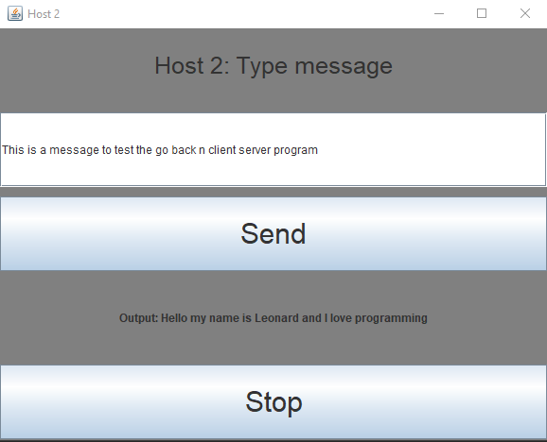

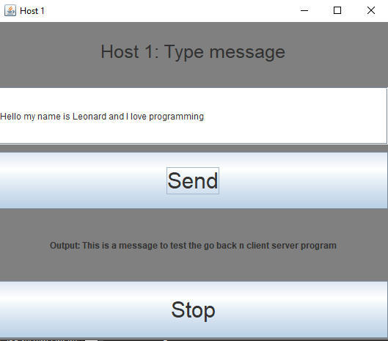

* One host writes a phrase(word) to the other host

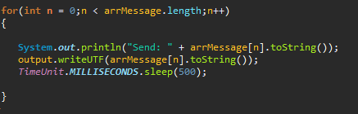

* Read incoming phrases(words)
* A probability of 14% that one host will successfully receive a phrase(word) of the message
* If val = 1, meaning 14% probability of an error, it will receive an error

