User Story 1: Storing customer details for different type of complaints (CRM)
- Functionality
Web application
Create / Modify below fields except Customer ID
- Wireframes
- Business logic and
Validate Email Address, SSN Number and Phone Number
- Database fields
  - Customer ID (Primary)
  - First Name
  - Last Name
  - Address
  - Zip Code
  - Email Address
  - SSN Number
  - Phone Number
  - Status (Active / Inactive / etc.,)
As per industry standards we will define the field lengths.

User Story 2: Create service Request (SO)
- Functionality: Based on the Request raised by the Customer a Service Order will be created.
Web application
Create / Modify below fields except SO Number
- Wireframes
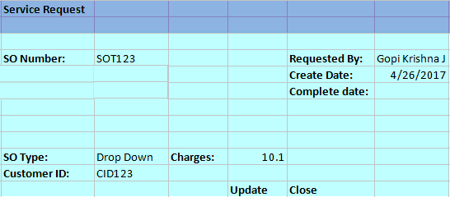
- Database fields
  - Service Order Number (Non editable Text Field Auto generated)
  - SO Create Date(Calendar Text Field)
  - Requested BY(Text Field)
  - Service Type
    - Water, Gas, Electricity
  - Request Type (Service Order) (C, R, D, M)(Drop down)
    - Connect, Reconnect, Disconnect, Miscellaneous
  - Customer ID(Text Field)
  - Fees/Charges(Text Field)
  - SO Complete date(Calendar Text Field)
  - Update & Close Buttons
As per industry standards we will define the field lengths.
User Story 3: Feasibility check for meter and location (Provisioning system)
- Functionality: Based on the Service Order type Meter and location will be Assigned to the SO.
Web application
Create / Modify all the below fields
- Wireframes
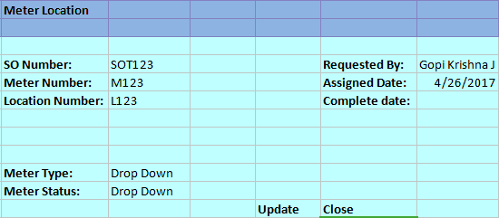
- Database fields
  - Service Order Number(Text Field)
  - Meter Number(Text Field)
  - Meter type(Drop down)
  - Meter Status(Drop down)
  - Location Number(Text Field)
  - Requested By(Text Field)
  - Assigned Date(Calender Text Field)
  - Complete Date(Calender Text Field)
  - Update & Close Buttons
As per industry standards we will define the field lengths.
User Story 4: Create work request (WM)
- Functionality: Based on the Request raised by the Customer a Work Request will be Created.
Web application
Create / Modify below fields except WR Number
- Wireframes
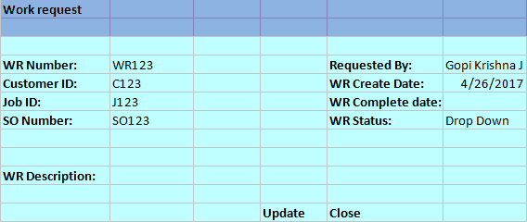
- Database fields
  - Work Request Number(Non Editable Text Field)
  - Work Request Description(Text Field)
  - Customer ID(Text Field)
  - Job ID(Text Field)
  - SO Number(Text Field)
  - WR Create date(Calender Text Field)
  - Requested BY(Text Field)
  - WR Status9Drop down)
  - WR Complete Date(Calender Text Field)
As per industry standards we will define the field lengths.
User Story 5: Verify stock availability (MM)
Verify stock availability (WM)
- Functionality: As a User, I want to verify the availability of the stock in the warehouse. (Web application)
- Wire Frames:
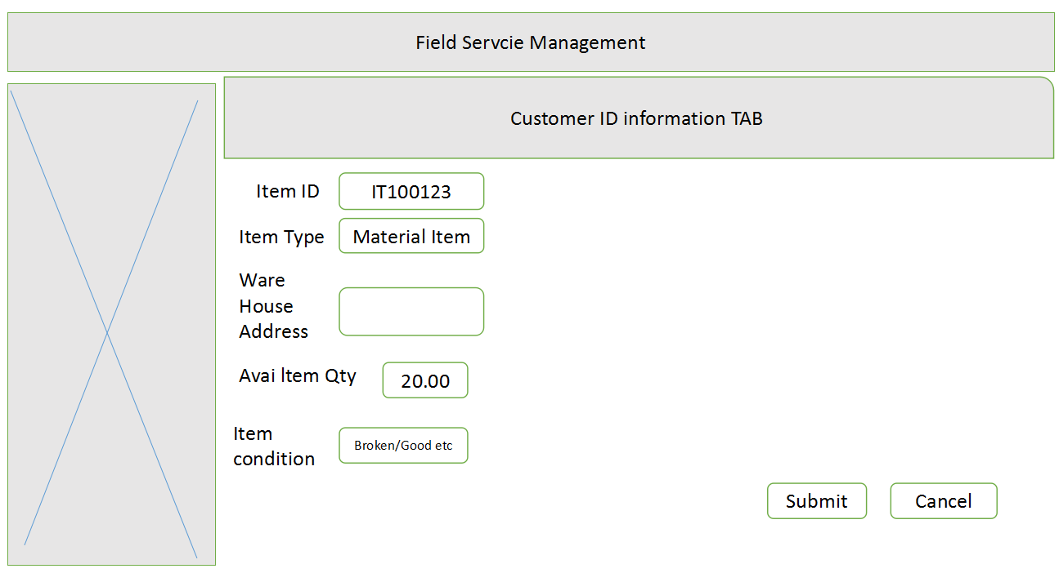
- Priority: Medium
- Estimation :
- Database Fields: Create/Modify the below fields except Item ID
  - Item ID (Primary)
  - Item name/Item Type
  - Warehouse
  - Available Item Quantity
  - Item condition
**As per industry standards we will define the field lengths.**

User Story 6: Use purchase order system to get the new stock (VMS)
- Functionality: As a User, I want to use Purchase Order System to get the new stock in the warehouse. (Web application)
- Wire Frames :
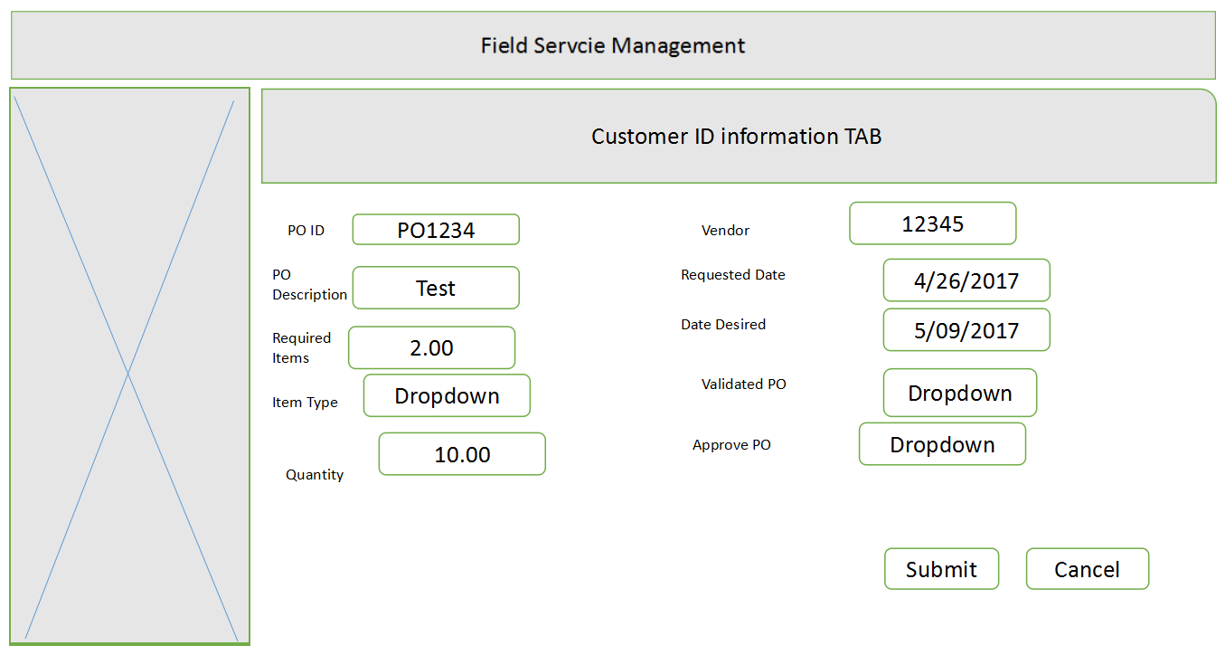

- Priority: Medium
- Estimation :
- Database fields:Create/Modify below fields except Purchase Order ID
  - PO ID(Primary)
  - PO Description
  - Required Items
  - Item Name/Item Type
  - Quantity
  - Vendor
  - Requested Date
  - Date Desired
  - Validate PO
  - Approve PO

**As per industry standards we will define the field lengths. **

User Story 7: Creating jobs for a work request (WM)
- Functionality: As a User, I want to create a Job for Work Request. (Web application)
- Wire Frames:

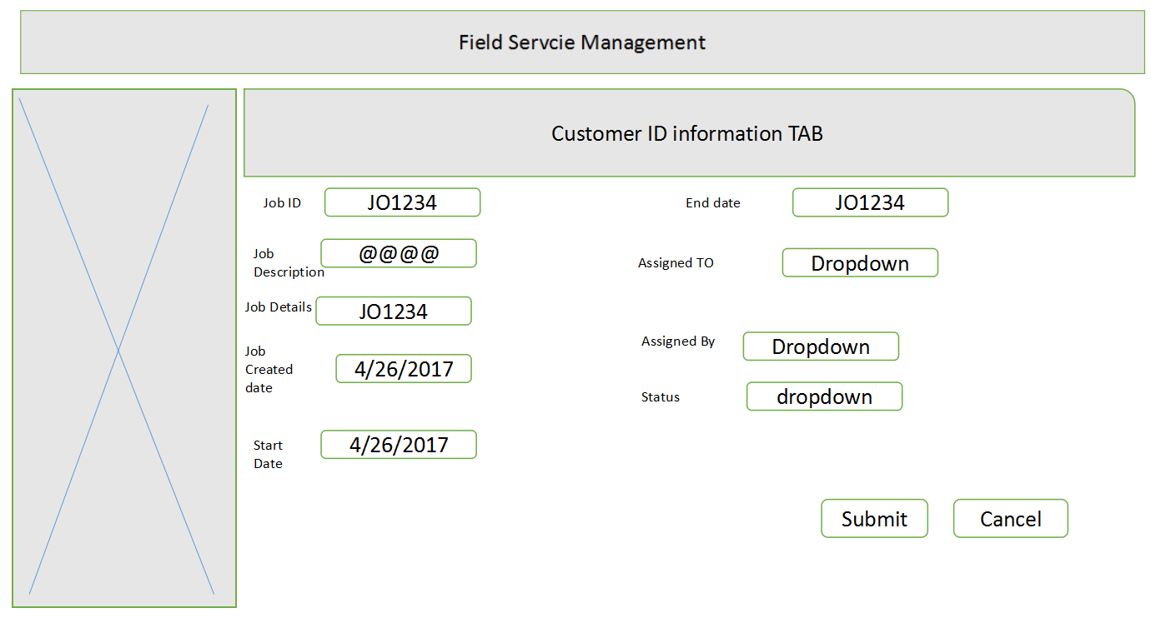

- Priority: Medium
- Estimation :
- Database fields: Create/Modify below fields except Job ID
  - Job ID(Primary)
  - Job Description
  - Job Details
  - Job Created Date
  - Start Date
  - End Date
  - Assigned To
  - Assigned By
  - Status

**As per industry standards we will define the field lengths. **

User Story 8: Mapping Service request to jobs under a work request
- Functionality: Implemented in Web
Coop/ Org mappes the service request to a job under work request. Create a new Service Request and Job. Associate the Job to Service Request
Pre Requisite: Work Request should be created by the Coop/ Org
- Database fields
Effects Work Request details, Service Request, Job details tables
  - Customer ID
  - Work Request ID
  - Work Request Desc
  - Service Request ID
  - Service Order Number
  - Service Order Desc
  - Job ID
  - Job details
  - Job Owner
  - Customer Details
  - Address
  - Crew Details
- Validations: Service Order Number, Job ID

User Story 9: Assigning the jobs to a field person
- Functionality: Implemented in Web
Coop/ Org assign the Job to field person for the raised Work Request, Finding the crew to assign the job (nearby location)
Pre Requisite: Service Request should be created by the Coop/ Org
- Database fields
  - Job ID
  - Job Desc
  - Job details
  - Job Owner
  - Service Request ID
  - Work Request ID
  - Address
  - Crew Details

User Story 10: Scheduling the work request (WM)
- Functionality: Implemented in Web
Coop/ Org schedules the Job to field person for the raised Work Request, On scheduling the job, calendar should be blocked to the field man (this is based on the crew availability)
- Database fields
  - Customer ID
  - Work Request ID
  - Job ID
  - Job Desc
  - Job Owner
  - Address
  - Crew Details
  - Dates
  - Status

User Story 11: Notification to the customer with job and field person details
- Functionality
Web application(CRM)

- Wireframes.
- Business logic and
Validate customer ID and Customer name,Field person name and Mobile no job id,dates.
- Database fields
  - Customer ID (Primary)
  - Field person Name
  - Phone Number
  - Timings/Dates
  - Job ID
  - Date
  - Employee id

User Story 12: Notification to the field person with job and customer details
- Functionality
Web application (CRM)
- Wireframes.
- Validate customer ID and Customer name, Field person name and Mobile no, JOBID, Job details, location.
- Database fields
  - Customer ID (Primary)
  - Field person Name
  - Phone Number
  - Timings
  - Job ID
  - Customer address
  - Zip code
  - Location map
  - Job description
  - Device id-model

User Story 13: Get device history and analyze (CMS)
- Functionality
Web application(CRM)

- Wireframes
- Validate customer ID , Customer name,Field person name and Mobile no,JOB ID,Job details,location.
- Database fields

Device ID
Model no
Year of purchase
Device name
Manufacturer details
Device past history

User Story 14: Create 3D models for devices (CMS)
- Functionality
  - User should be able to upload 2D & 3D models.
  - View the Uploaded Images ( Unity )
  - Delete the images.
  - Modify the Existing Details.
  - Web application & Unity & Mobile
- Wire-frames
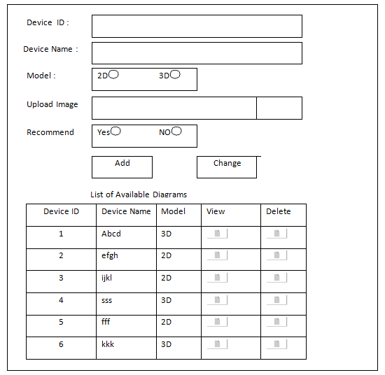

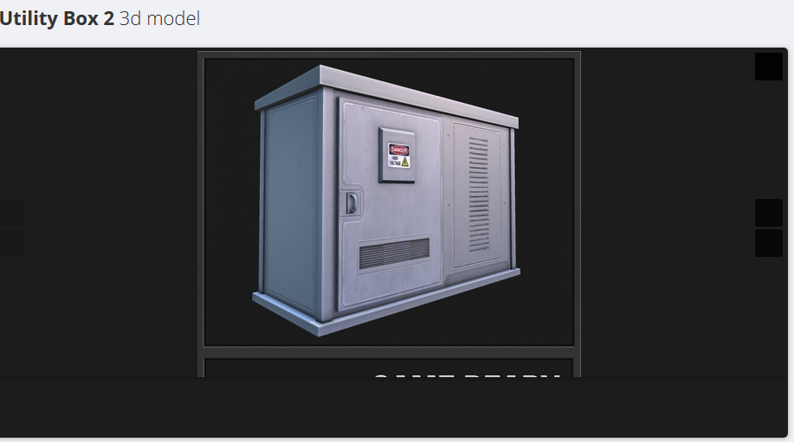
Show Image on selection of View button in the list
- Business logic
  - Validate Device ID.
  - Validate Image Type.
  - Confirmation on Delete.

- Database fields
  - Device ID
  - Name
  - Model
  - Image
  - Recommend

As per industry standards we will define the field lengths.
User Story 15: Rendering 3D models of devices (CMS)
- Functionality
  - Display available images based on Recommend & Models.
  - Provide Search functionality.
  - Field person should be in a position to view the Uploaded images.
Web application & Unity & Mobile
- Wireframes
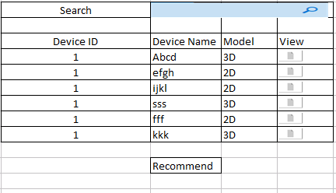
When field person clicks on View from the list we should open a new window and display the 2D or 3 D model in that.

- Business logic
- Database fields ( Not Required)

User Story 16: AI will recommend appropriate videos, links, and manual about the device (CMS)
AI will recommend appropriate videos, links, and manual about the device (CMS)
- Functionality
  - We can give an option to Recommend while upload the Videos & Diagrams.
  - Even Field person also can Recommend.
Web application , Mobile app, Unity
- Wireframes : User Story 14 and 15 will cover this
- Business logic ( Not Required)
- Database fields ( Not Required)
As per industry standards we will define the field lengths.

User Story 17: Field person shall take the snap and annotate it and upload before fixing the issue
- Functionality
Mobile application
Take snap and upload it before fixing the issue.
After fixing issue take snap and annotate workmen’s observations and upload it.

- Wireframes
- Business logic
Field person can add annotate snap with Sticky Note, Text can be highlighted, Freehand, Rotate Clockwise.
- Database fields
Employee ID
Job ID
BeforeIssueFixImgPath
AfterIssueFixImgPath
Notes
User Story 18: Field person shall be able to view the video to fix the device
- Functionality
Mobile application
The workmen can find the videos in categories based on the present work and open the video and the video need to be rendered in mobile.
- Wireframes
- Business logic
- Database fields
Employee ID
Job ID
Video path / name
Notes

User Story 19: As field person, I shall get auto connected to available SME using phone call / video call / VR Device if I need assistance.
- Functionality
Mobile application
The workmen can click on Connect SME, and automatically the available SME will be called over voice call / video call / VR device.
- Wireframes
- Business logic
- Database fields
Employee ID
Job ID
SME ID
Notes

User Story 20: If all SMEs are occupied I shall be given option to choose the SME to connect manually
- Functionality
Mobile, VR App
Should list the SMEs in List or grid format.
Should also give option for Skype, Video call or just a phone call.
UI/3D model should be user friendly
All the necessary details like, Name, Number and Photo and brief description should be available as display item.

- Wireframes
  - 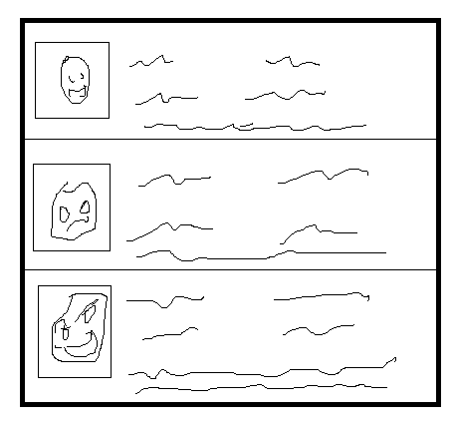
- Business logic
Verify if the SME are available or not based on their calendar
Manual Dial option for Video/Skype/Phone call depending on mode of availability
- Database fields
  - Employee ID
  - First Name
  - Last Name
  - Email Address
  - Phone Number
  - Status (Available / Busy / etc.,)
  - VR connectivity ID / Skype ID
As per industry standards we will define the field lengths.

User Story 21: As workmen, I shall have an option for phone call / video call / VR Device from Multipartite SMEs
- Functionality
  - Mobile, VR App
  - Should provide conference call depending on mode.

- Wireframes: will display parties involved and their names.

- Business logic
  - Verify if we can conference people required based on mode.

- Database fields
  - Similar to US -20
As per industry standards we will define the field lengths.

User Story 22: Field person shall create associated job
- Functionality
Mobile, VR App
Should be able to create new job for associated WO/SO
Should capture all details required for JOB and created by, created time.
- Wireframes:
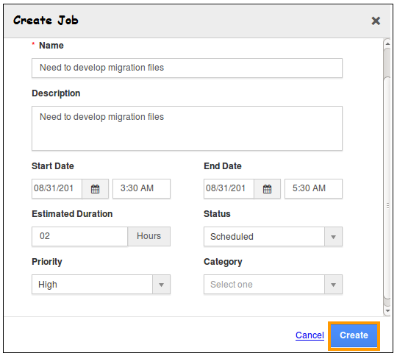
- Business logic
Validate Name of Job
Description should be minimum 50 chars
Start Date and End Date Validations

- Database fields
  - Name
  - Description
  - Start Date
  - End Date
  - Estimated Duration
  - Status
  - Priority
  - Category
As per industry standards we will define the field lengths.

User Story 23: Field person will update his time sheet and observation
- Functionality
Web application
  - Create / Modify below fields except JobId
- Wireframes
- Business logic and
Update the status of the job
- Database fields
  - JobId
  - CustomerId
  - Status
  - JobDescription
  - Comments
User Story 24: Communicate the customer with job status details (push notification)
- Functionality
Web application
Create / Modify below fields except Customer ID
- Wireframes
- Business logic and
Update the status of the job
- Database fields
  - JobId
  - CustomerId
  - Status
  - JobDescription

User Story 25: Customer shall provide his feedback
- Functionality
Web application
Create / Modify below fields except Customer ID
- Wireframes
- Business logic and
Validate Email Address, SSN Number and Phone Number
- Database fields
  - JobId
  - Customer ID
  - Status
  - JobDescription
  - Comments

User Story 26: Closing the Job
- Functionality
Web/Mobile application
Modify and update created job request
- Wireframes
- Business logic
Validate job id and crew id

- Database fields
Depends on the Job and crew table

User Story 27: Close the work request based on closer of jobs.
- Functionality
Web application
Modify and update created work request
- Wireframes
- Business logic
Validate work id, job id and job request status
- Database fields
Depends on the Job and work request order table

User Story 28: Close service request based on closer of work requests.
- Functionality
Web application
Modify and update created service order request
- Wireframes
- Business logic
Validate work id, job id and job and work order request status

- Database fields
Depends on the Job, work and service request order table

