User Story 1: Get device history and analyze (CMS)
- Functionality
Web application (CRM)
- Wireframes
- Validate customer ID , Customer name, Field person name and Mobile no, JOB ID,Job details, location.
- Database fields
Device ID
Model no
Year of purchase
Device name
Manufacturer details
Device past history
User Story 2: Create 3D models for devices (CMS)
- Functionality
  - User should be able to upload 2D & 3D models.
  - View the Uploaded Images ( Unity )
  - Delete the images.
  - Modify the Existing Details.
  - Web application & Unity & Mobile
- Wire-frames
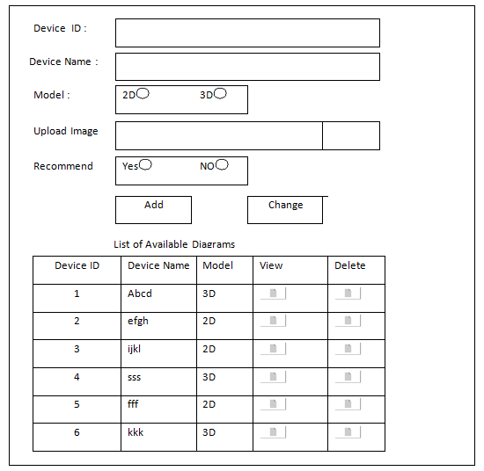
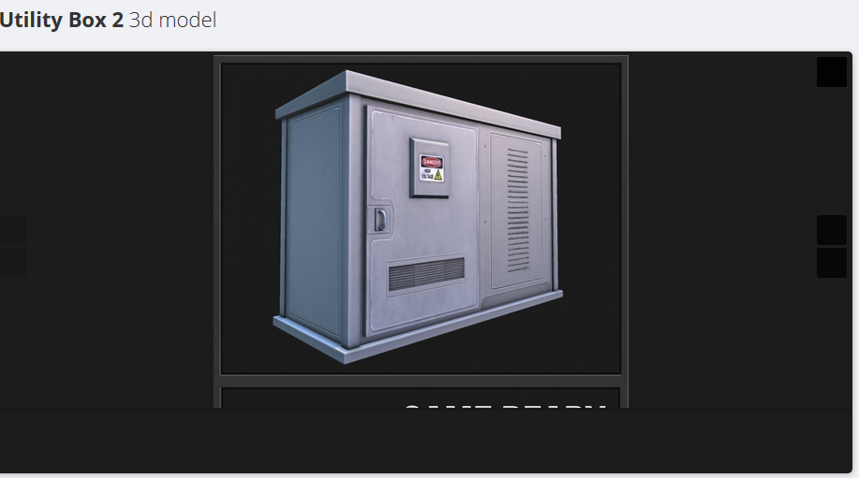
Show Image on selection of View button in the list
- Business logic
  - Validate Device ID.
  - Validate Image Type.
  - Confirmation on Delete.

- Database fields
  - Device ID
  - Name
  - Model
  - Image
  - Recommend
As per industry standards we will define the field lengths.

User Story 3: Rendering 3D models of devices (CMS)
- Functionality
  - Display available images based on Recommend & Models.
  - Provide Search functionality.
  - Field person should be in a position to view the Uploaded images.
Web application & Unity & Mobile
- Wireframes
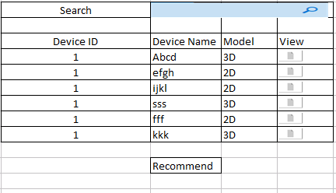
When field person clicks on View from the list we should open a new window and display the 2D or 3 D model in that.

- Business logic
- Database fields ( Not Required)

User Story 4: AI will recommend appropriate videos, links, and manual about the device (CMS)
AI will recommend appropriate videos, links, and manual about the device (CMS)
- Functionality
  - We can give an option to Recommend while upload the Videos & Diagrams.
  - Even Field person also can Recommend.
Web application , Mobile app, Unity
- Wireframes : User Story 14 and 15 will cover this
- Business logic ( Not Required)
- Database fields ( Not Required)
As per industry standards we will define the field lengths.
User Story 5: Field person shall take the snap and annotate it and upload before fixing the issue
- Functionality
Mobile application
Take snap and upload it before fixing the issue.
After fixing issue take snap and annotate workmen’s observations and upload it.

- Wireframes
- Business logic
Field person can add annotate snap with Sticky Note, Text can be highlighted, Freehand, Rotate Clockwise.
- Database fields
Employee ID
Job ID
BeforeIssueFixImgPath
AfterIssueFixImgPath
Notes
User Story 6: Field person shall be able to view the video to fix the device
- Functionality
Mobile application
The workmen can find the videos in categories based on the present work and open the video and the video need to be rendered in mobile.
- Wireframes
- Business logic
- Database fields
Employee ID
Job ID
Video path / name
Notes

User Story 7: As field person, I shall get auto connected to available SME using phone call / video call / VR Device if I need assistance.
- Functionality
Mobile application
The workmen can click on Connect SME, and automatically the available SME will be called over voice call / video call / VR device.
- Wireframes
- Business logic
- Database fields
Employee ID
Job ID
SME ID
Notes
User Story 8: If all SMEs are occupied I shall be given option to choose the SME to connect manually
- Functionality
Mobile, VR App
Should list the SMEs in List or grid format.
Should also give option for Skype, Video call or just a phone call.
UI/3D model should be user friendly
All the necessary details like, Name, Number and Photo and brief description should be available as display item.
- Wireframes
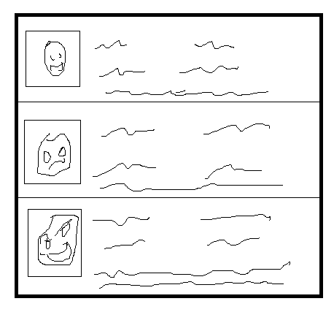
- Business logic
Verify if the SME are available or not based on their calendar
Manual Dial option for Video/Skype/Phone call depending on mode of availability
- Database fields
  - Employee ID
  - First Name
  - Last Name
  - Email Address
  - Phone Number
  - Status (Available / Busy / etc.,)
  - VR connectivity ID / Skype ID
As per industry standards we will define the field lengths.

User Story 9: As workmen, I shall have an option for Multipartite SMEs phone call / video call / VR Device.
- Functionality
  - Mobile, VR App
  - Should provide conference call depending on mode.

- Wireframes: will display parties involved and their names.

- Business logic
  - Verify if we can conference people required based on mode.

- Database fields
  - Similar to US -20
As per industry standards we will define the field lengths.

User Story 10: Field person shall create associated job
- Functionality
Mobile, VR App
Should be able to create new job for associated WO/SO
Should capture all details required for JOB and created by, created time.
- Wireframes:
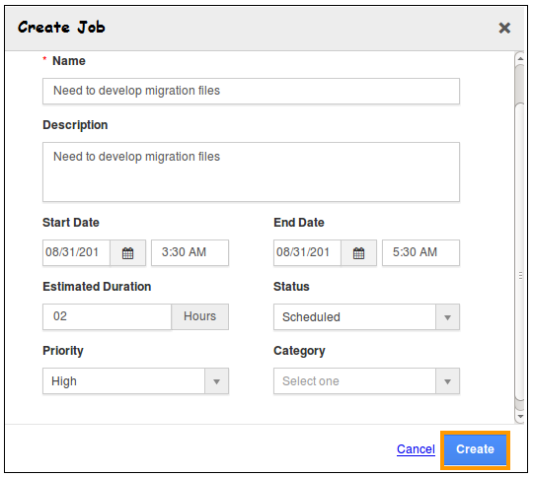
- Business logic
Validate Name of Job
Description should be minimum 50 chars
Start Date and End Date Validations
- Database fields
  - Name
  - Description
  - Start Date
  - End Date
  - Estimated Duration
  - Status
  - Priority
  - Category
As per industry standards we will define the field lengths.
User Story 11: Field person will update his time sheet and observation
- Functionality
Web application
  - Create / Modify below fields except JobId
- Wireframes
- Business logic and
Update the status of the job
- Database fields
  - JobId
  - CustomerId
  - Status
  - JobDescription
  - Comments

