User Story 1: Create Service Request (Service Request Mgt)
- Functionality: Based on the Request raised by the Customer a Service Request will be created.
Web application
Create / Modify below fields except SR Number
- Wireframes
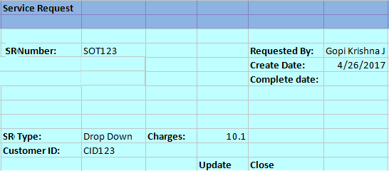
- Database fields
  - Service Request Number (Non editable Text Field Auto generated)
  - SR Create Date(Calendar Text Field)
  - Requested BY(Text Field)
  - Service Type
    - Water, Gas, Electricity
  - Request Type (Service Request) (C, R, D, M)(Drop down)
    - Connect, Reconnect, Disconnect, Miscellaneous
  - Customer ID(Text Field)
  - Fees/Charges(Text Field)
  - SR Complete date(Calendar Text Field)
  - Update & Close Buttons
As per industry standards we will define the field lengths.
User Story 2: Create work request (WM)
- Functionality: Based on the Request raised by the Customer a Work Request will be Created.
Web application
Create / Modify below fields except WR Number

- Wireframes
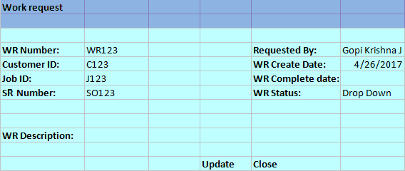
- Database fields
  - Work Request Number(Non Editable Text Field)
  - Work Request Description(Text Field)
  - Customer ID(Text Field)
  - Job ID(Text Field)
  - SR Number(Text Field)
  - WR Create date(Calender Text Field)
  - Requested BY(Text Field)
  - WR Status9Drop down)
  - WR Complete Date(Calender Text Field)
As per industry standards we will define the field lengths.
User Story 3: Get device history and analyze (AM)
- Functionality
Web application (Removed)
- Wireframes
- Validate customer ID, Customer name, Field person name and Mobile no, JOB ID, Job details, location.
- Database fields
Device ID
Model no
Year of purchase
Device name
Manufacturer details
Device past history
User Story 4: Create 3D models for devices (CMS)
- Functionality
  - User should be able to upload 2D & 3D models.
  - View the Uploaded Images ( Unity )
  - Delete the images.
  - Modify the Existing Details.
  - Web application & Unity & Mobile
- Wire-frames
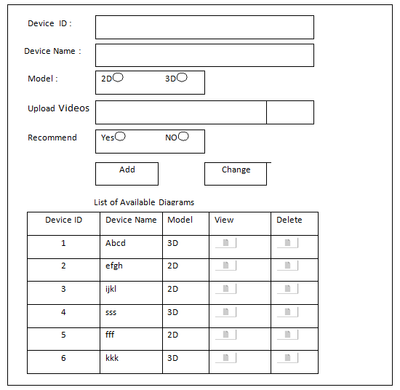

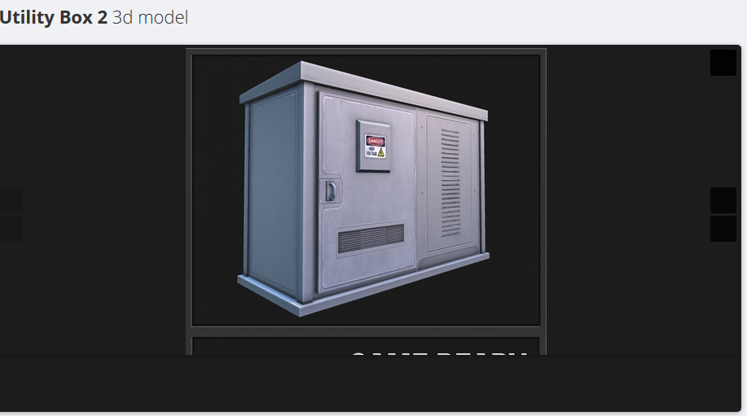
Show Image on selection of View button in the list
- Business logic
  - Validate Device ID.
  - Validate Image Type.
  - Confirmation on Delete.

- Database fields
  - Device ID
  - Name
  - Model
  - Path
  - Type( PDF or Video or 2D Image or 3D image)
  - Recommend
As per industry standards we will define the field lengths.

User Story 5: Rendering 3D models of devices (CMS)
- Functionality
  - Display available images based on Recommend & Models.
  - Provide Search functionality.
  - Field person should be in a position to view the Uploaded images.
Web application & Unity & Mobile
- Wireframes
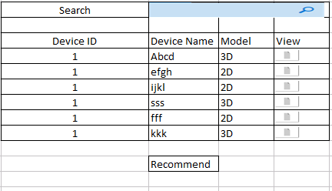
When field person clicks on View from the list we should open a new window and display the 2D or 3 D model in that.

- Business logic
- Database fields
  - Device ID
  - Name
  - Model
  - Path
  - Type( PDF or Video or 2D Image or 3D image)
  - Recommend
User Story 6: AI will recommend appropriate videos, links, and manual about the device (CMS)
AI will recommend appropriate videos, links, and manual about the device (CMS)
- Functionality
  - We can give an option to Recommend while upload the Videos & Diagrams.
  - Even Field person also can Recommend.
Web application , Mobile app, Unity
- Wireframes : User Story 4 and 5 will cover this
- Business logic ( Not Required)
- Database fields ( Not Required)
As per industry standards we will define the field lengths.
User Story 7: Field person shall be able to take the snap and annotate it and upload before fixing the issue (CMS)
- Functionality
Mobile application
Take snap and upload it before fixing the issue.
After fixing issue take snap and annotate workmen’s observations and upload it.

- Wireframes

After successful log in, Field person is going to see his jobs calendar for that week or month with below screen.
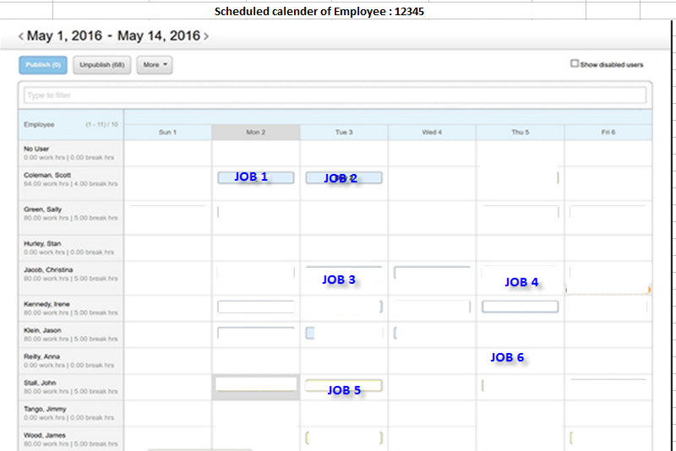

Screen 2 : On selection of a specific job he should view the job details.
Given a provision to upload the image before & after fixing the issue.

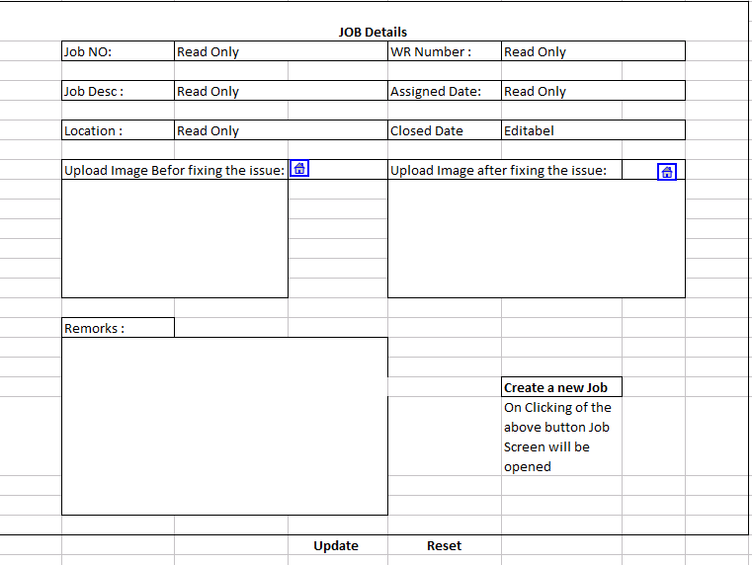
- Business logic
Field person can add annotate snap with Sticky Note, Text can be highlighted, Freehand, Rotate Clockwise.
- Database fields
JobDetail( Table 1 )
  - Job ID(Primary)
  - Job Description
  - Requested Date
  - Scheduled Date
  - Completed Date
  - Image Before Upload
  - Image after upload
  - Comments
  - Status

- Business logic
Field person can add annotate snap with Sticky Note, Text can be highlighted, Freehand, Rotate Clockwise.

User Story 8: Field person shall be able to view the video to fix the device
- Functionality
Mobile application, AR/ VR
The workmen can find the videos in categories based on the present work and open the video and the video need to be rendered in mobile.
- Wireframes
- Business logic
- Database fields ( Not Required, we can use the table created to store the image paths for this)

User Story 9: As field person, I shall get auto connected to available SME using phone call / video call / VR Device if I need assistance.
- Functionality
Mobile application, AR/VR
The workmen can click on Connect SME, and automatically the available SME will be called over voice call / video call / VR device.
- Wireframes
- Business logic
- Database fields
Employee ID
Job ID
SME ID
Notes
User Story 10: If all SMEs are occupied I shall be given option to choose the SME to connect manually and also I shall have an option to connect for Multipartite SMEs
- Functionality
Mobile, VR App
Should list the SMEs in List or grid format.
Should also give option for Skype, Video call or just a phone call.
Should provide conference call depending on mode.
UI/3D model should be user friendly
All the necessary details like, Name, Number and Photo and brief description should be available as display item.
- Wireframes : will display parties involved and their names
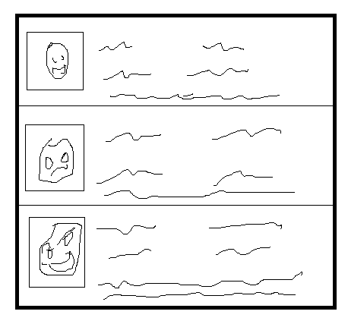

- Business logic
Verify if the SME are available or not based on their calendar
Verify if we can conference people required based on mode
Manual Dial option for Video/Skype/Phone call depending on mode of availability
- Database fields
  - Employee ID
  - First Name
  - Last Name
  - Email Address
  - Phone Number
  - Status (Available / Busy / etc.,)
  - VR connectivity ID / Skype ID
As per industry standards we will define the field lengths.

User Story 11: As workmen I shall be able to create a new job.
- Functionality
Mobile, VR App
Should be able to create new job for associated WO/SO
Should capture all details required for JOB and created by, created time.
- Wireframes:
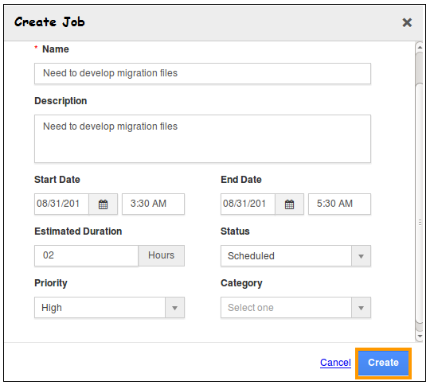

- Business logic
Validate Name of Job
Description should be minimum 50 chars
Start Date and End Date Validations
- Database fields
  - Name
  - Description
  - Start Date
  - JobID (readonly)
  - WorkRequestID (readonly)
  - End Date
  - Estimated Duration
  - Status
  - Priority
  - Category
As per industry standards we will define the field lengths.
User Story 12: Field person will update his time sheet and Comments
- Functionality
Web application, Mobile
  - Create / Modify below fields except JobId
- Wireframes
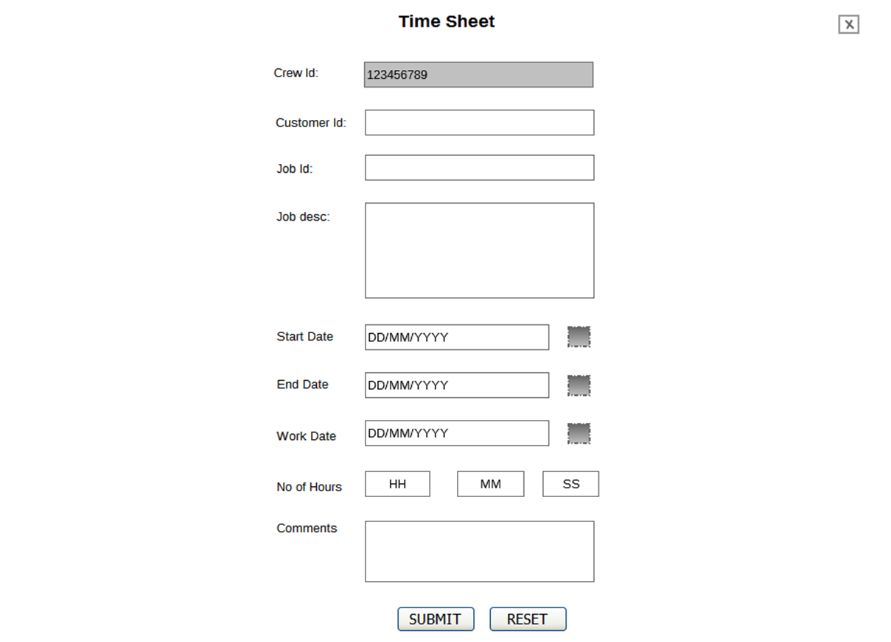
- Business logic and
Update the status of the job
- Database fields
  - JobId
  - CustomerId
  - Start time
  - End time
  - Status
  - JobDescription
  - Comments

