Design Document

31.03.2015  
Version 1

**Group B**

Stoyan Staynov  
Dan Velev  
Boris Mihailovic  
Sophia Njenga  
Veselin Kichukov  
Nikolay Polyanov

Contents

Class Diagram 3

Sequence diagrams 4

1. Save File 4

2. Increase Traffic 4

3. Insert Crossing 5

4. Remove Crossing 6

# Introduction

The traffic control program is going to help the User simulate a real time simulation of a crossroad with cars passing through it. The User is going to be able to adjust several parameters of the simulation e.g. car count.

# Class Diagram

Below you will find the first version of the class diagram for the application. It represents the classes along with their operations, attributes and relations. *This class diagram will be changing during the development of the application. Note: keep in mind that this is still the first version so the class diagram might look simple.*

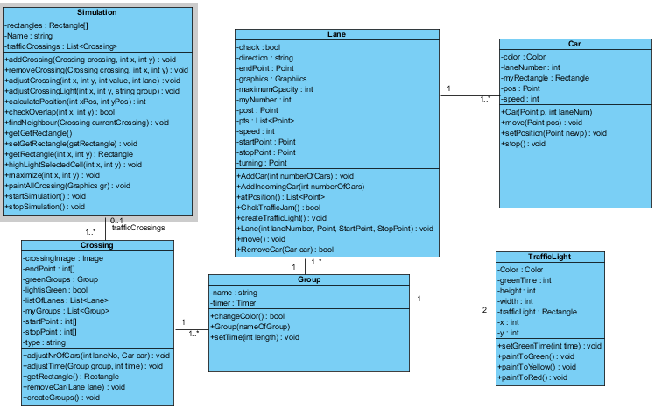

# Sequence diagrams

## Save File

Represents the methods and classes used when saving the file

## Increase Traffic

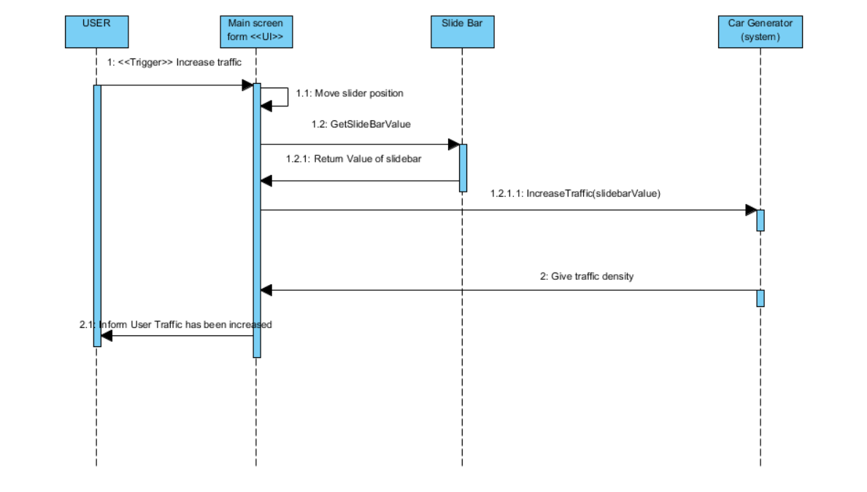

## Insert Crossing

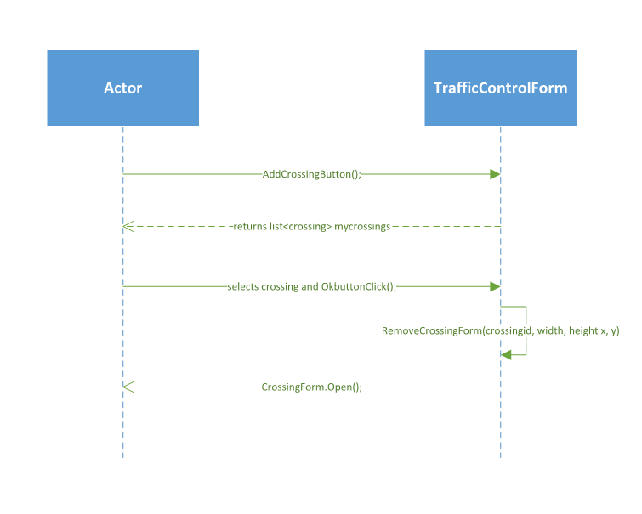

## Remove Crossing

