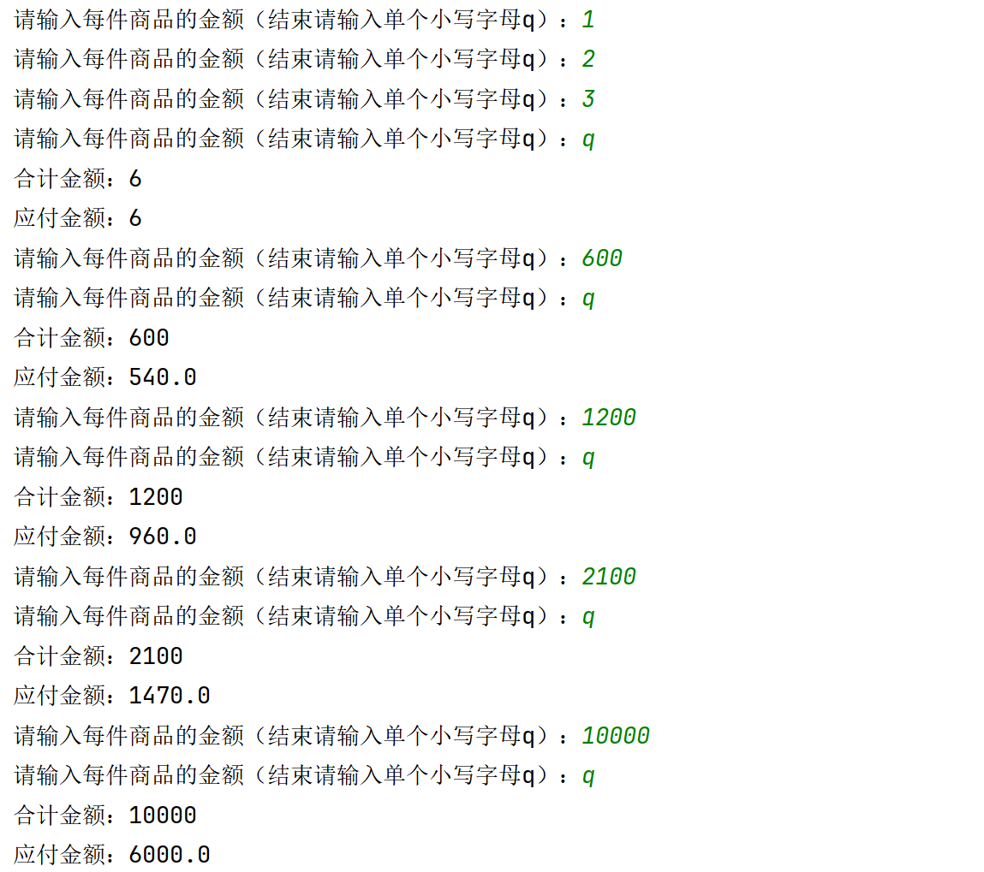
def fun(money=[]):
count=0
count_final=0
for i in money:
i=int(i)
count+=i
if count>=3000:
count_final=0.6*count
elif count>=2000:
count_final=0.7*count
elif count>=1000:
count_final=0.8*count
elif count>=500:
count_final=0.9*count
else:
count_final=count
return count,count_final
def getmoney(list01=[]):
while True:
price = input('请输入每件商品的金额（结束请输入单个小写字母q）：')
if price == 'q':
break
else:
list01.append(price)
return list01
def main():
while (1):
list01 = []
getmoney(list01)
result1, result2 = fun(list01)
print(f'合计金额：{result1}')
print(f'应付金额：{result2}')
main()

