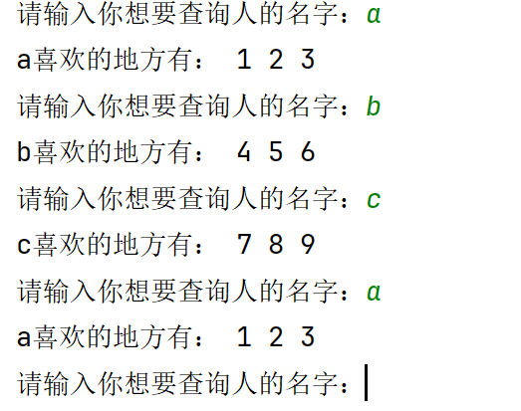
dict={
'a':[1,2,3],
'b':[4,5,6],
'c':[7,8,9]
}
while True:
information=input('\n请输入你想要查询人的名字：')
if information in dict:
b=dict[information]
print(f'{information}喜欢的地方有：', end=' ')
for i in b:
print(f'{i}',end=' ')

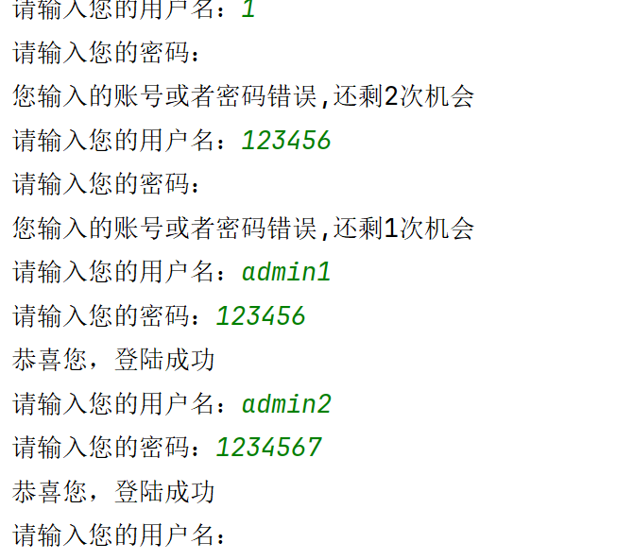
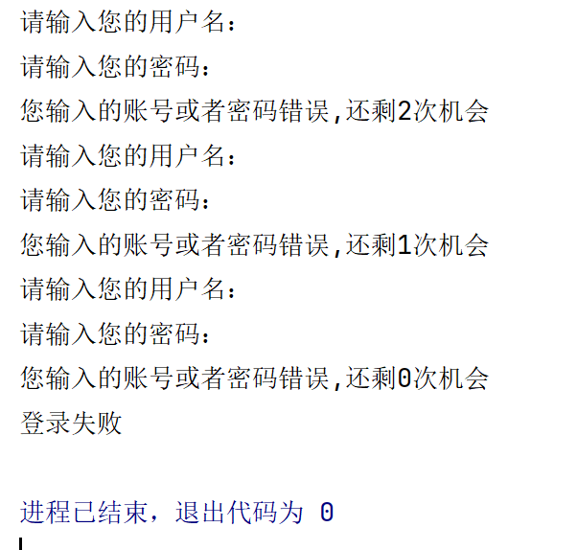
dict={
'admin1':'123456',
'admin2':'1234567',
'user1':'12345678',
'user2':'123456789',
'user3':'12345678910',
}
while True:
again=False
for i in range(3):
name=input('请输入您的用户名：')
password=input('请输入您的密码：')
if name in dict:
if dict[name]==password:
again=True
print('恭喜您，登陆成功')
if again==False:
print(f'您输入的账号或者密码错误,还剩{2-i}次机会')
if again==False:
print('登录失败')
break

names = ['Tom','Billy','Jefferson','Andrew','Wesley','Steven','Joe',
'Alice','Jill','Ana','Wendy','Jennifer','Sherry','Eva']
a=[]
b=[]
for i in names:
length=len(i)
if length>4:
a.append(i)
for i in names:
length=len(i)
if length<5:
c=i.upper()
b.append(c)
print(a)
print(b)

