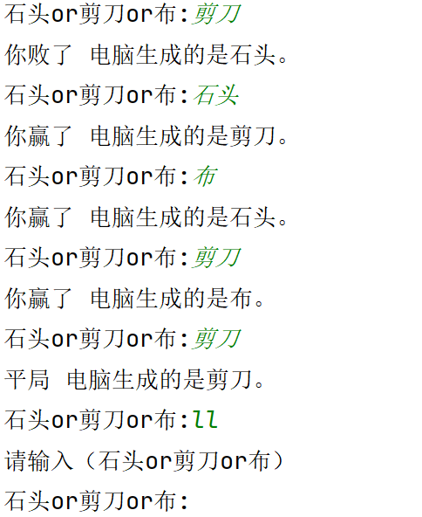
import random
while True:
info1=input('石头or剪刀or布:')
if info1!='石头' and info1!='剪刀' and info1!='布':
print('请输入（石头or剪刀or布）')
continue
c=random.randint(0,2)
if c==0:
info2='石头'
elif c==1:
info2='剪刀'
elif c==2:
info2='布'
def compare(randomstr,comparestr):
if randomstr=='石头':
if randomstr==comparestr:
print('平局',end=' ')
elif comparestr=='剪刀':
print('你败了',end=' ')
else:
print('你赢了',end=' ')
elif randomstr=='剪刀':
if randomstr==comparestr:
print('平局',end=' ')
elif comparestr=='布':
print('你败了',end=' ')
else:
print('你赢了',end=' ')
elif randomstr=='布':
if randomstr==comparestr:
print('平局',end=' ')
elif comparestr=='石头':
print('你败了',end=' ')
else:
print('你赢了',end=' ')
compare(randomstr=info2,comparestr=info1)
print(f'电脑生成的是{info2}。')

