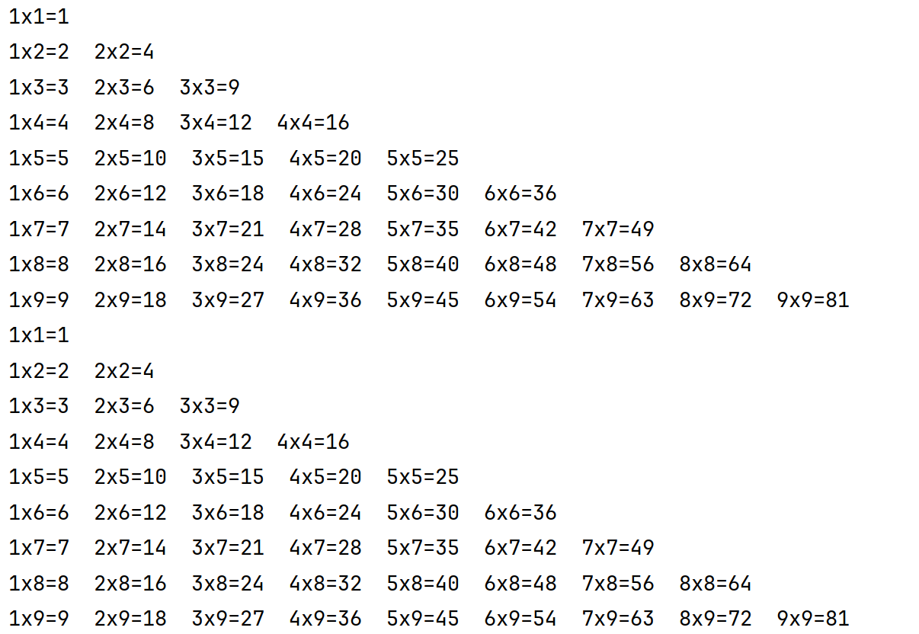
for i in range(1,10):
for j in range(1,10):
if i>=j:
print(f'{j}x{i}={i*j}',end=' ')
print()
k=0
while k<9 :
k+=1
h = 0
while h<k :
h += 1
print(f'{h}x{k}={k*h}',end=' ')
print()

