Social influencing in die Ultimatum Game

Introduction
In a social context, individuals are influenced by social stimuli from others, and they actively try to influence others in pursuing their goals (Argyle, 1969). A special form of social influence is the reaction to norm violating behavior of others, i.e. behavior that goes against prevailing norms, such as fairness or equity. In groups, it has been shown that norm-violating behavior is often penalized by other group members to re-establish the group norm, even if this comes at one’s own expenses. Such a behavior has been termed as altruistic or, more recently, costly punishment (Bowles & Gintis, 2004; Fehr & Gächter, 2002; Heinrich et al., 2006; Rodrigues, Nagowski, Mussel, & Hewig, 2018).

Costly punishment has often been investigated in the Ultimatum game (Güth, Schmittberger, & Schwarze, 1982). Here, a proposer divides an amount of money into two shares, one for him/herself, one for the receiver. If the receiver accepts, both get the assigned amount of money. If the receiver rejects, both get nothing. Rational Choice theory predicts that proposers always offer the least amount of money, and receivers always accept, as little money is better than no money (Neumann & Morgenstern, 1944). However, receivers usually reject offers of less than 20%, which has been interpreted as costly punishment.

We recently developed an extended version of the Ultimatum game (Mussel, Hewig, & Weiß, 2018). After the decision of the receiver, proposers had the option to react towards the decision with an emotional facial expression (smiling, neutral, sad, angry). By recording the neural reaction of the receiver via EEG we could show that a sad or angry facial expression, compared to a neutral facial expression, elicited a reward positivity in the EEG which is usually observed after positive, compared to negative feedback stimuli. We interpreted this effect as indicating successful costly punishment.
Here, by using a further modification of the Ultimatum game, we extend this line of research by investigating whether successful, compared to non-successful costly punishment also impacts upcoming decisions.

Methods
A sample size of N=59 was estimated for a medium effect of partial ƞ² =.06, α =.05, and β = .95.
EEG (analog band-pass: 0.1–80 Hz, sampling rate: 250 Hz) will be recorded from 31 scalp sites according to the 10–20 system using Ag/AgCl electrodes and a BrainAmp DC amplifier (Brain Products GmbH, Gilching, Germany). Electrodes will be referenced to the vertex (Cz) and re-referenced offline to average. Channels will be inspected automatically using the z value-based channel rejection for probability, kurtosis and frequency range, using the outlier criterion of z = 3.29 (see Tabachnick & Fidell, 2007) and bad channels will be spherical interpolated automatically. Data will be epoched from -1.5 s to 2.5 s the relevant marker and filtered with a 1 Hz - 40 Hz Butterworth bandpass filter. Trials will be rejected if the absolute amplitude exceedes the criterion of 300 μV within a segment or the joint probability of 4 standard deviations. After ICA analyses, bad components will be automatically removed with the tool MARA. The N170 will be quantified as the mean amplitude in the interval +/-20 ms around the negative peak in time window between 130 and 210 ms at electrodes TP9 and TP10. The N2 will be quantified as the mean amplitude in the interval +/-20 ms around the negative peak in time window between 200 and 350 ms at electrode FCz. The P3 will be quantified as the mean amplitude in the interval +/-20 ms around the positive peak in time window between 400 and 800 ms at electrode Pz. For theta band activation, a time frequency analysis will be performed and theta band activation will be extracted from 3.5 – 8.5 Hz +/- 300 ms around the peak power.

Tasks
We use three different tasks:
First, we use a reinforcement learning task as a reference task to measure neural responses to facial stimuli in a non-costly-punishment setting. The task of the participant is to offer each of four partners (2 male, 2 female) a fruit that he or she likes, as indicated by a smiling facial expression of the partner, and to avoid offering fruits that he or she does not like, as indicated by a sad facial expression. On each trial, the participant sees a picture of the partner with a neutral facial expression (see figure 1A). Next, five different fruits are shown. The participant chooses one of them. Next, the facial expression of the partner (smile, neutral, sad) signals how she or he likes the chosen fruit. Thereby, only one fruit is mainly associated with a smiling facial expression (80%, compared to 10% for sad and neutral facial expression, respectively); the other fruits mainly associated with either a neutral or sad facial expression. In total, there are 120 trials (appr. 5 minutes), 30 with each of four partners (2 male, 2 female). There will be between 18 (in case the participant always chooses the correct fruit) and 31 (if decisions are at random) trials per condition. We investigate neural responses (N170, FRN, P3) following the facial expression. Neural responses to smiling, neutral, and sad facial expressions in this task can be compared to and controlled for (as co-variate) with regards to the analog responses in task 3, see below.
 | Smile | Neutral | Sad
Apple | 80 | 10 | 10
Pear | 20 | 40 | 40
Grapes | 20 | 40 | 40
Orange | 20 | 40 | 40
Banana | 20 | 40 | 40

The purpose of the second task is mainly to familiarize the participant with the main experiment and to enhance the plausibility of the cover story. The participant plays a modified Ultimatum game in the role of the proposer. On each trial, the participant makes a decision on how many Cents (0 to 5 from a total of 10) to offer to his or her partner (see Figure 1B). The decision is then visualized as a pie chart. Next, the partner makes a decision to accept or reject the offer. The participant is told that decisions were made by former participants. Unknown to the participant, decisions are predefined with a 100% probability to accept for an offer of 5 Cent, continually decreasing to 0% for an offer of 0 Cent. Next, the participant has the option to react to the decision of the partner by sending a smiling, sad, or neutral facial expression. The pictures contain images of the participant that were made prior to the experiment. The chosen facial expression is briefly shown as a confirmation. In total, the participant plays 10 rounds. The average amount of money kept for one-self may be used as an indicator of selfish decision making.
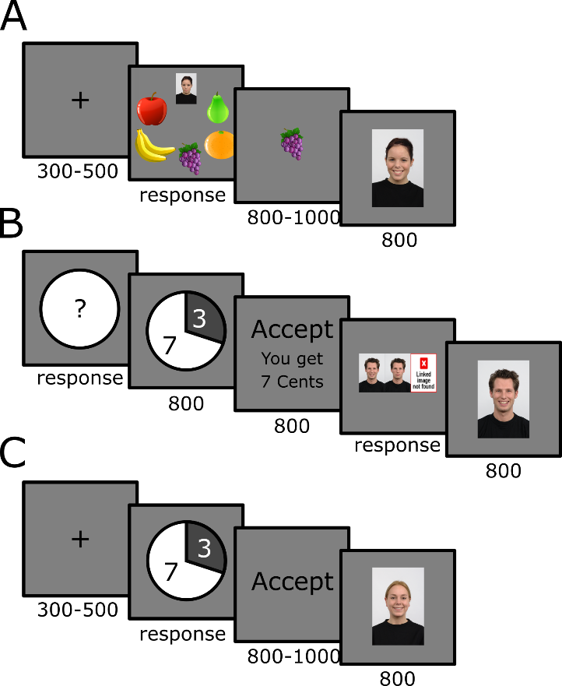
Figure 1: Time line of the three experimental tasks
In the third and main task, participants play the modified Ultimatum game, as explained above, in the role of the receiver. Participants are told that offers and facial expressions in response to the decision were collected from other participants who played the Ultimatum game earlier (as the participant did in task 2). There are 8 blocks with 48 trials each (appr. 35 minutes). Each block is played against a different proposer, but under the same conditions. Each trial starts with the offer of the proposer, ranging from 0 to 5 cents from a total of 10 cents. The offer is displayed as a pie chart, see Figure 1C. The participant decides to either accept or reject the offer, and the decision is briefly confirmed. Next, the participant sees a facial expression in response to his or her decision. After an accepted offer, either a neutral or a smiling facial expression is shown with a probability of 50% each, respectively. After a rejected offer, either a neutral or a sad facial expression is shown with a probability of 50% each, respectively.
Participants are informed that five trials per block will be chosen randomly; the money received in these trials will actually be paid to the participant. Due to the deception (offers are predefined, rather than from other participants) the maximum of 2 Euro is given to the participants.
After the experiment participants complete questionnaires to account for individual differences in anger and altruism. Therefore, the German version of the State-Trait-Anger-Expression-Inventory (STAXI; Schwenkmezger and Hodapp, 1991; Spielberger, 1988; 10 items) and the German version of the Prosocial Tendencies Measure Revised (PTM-R; Carlo and Randall, 2002, Carlo et al., 2003, Rodrigues et al., 2017; 25 items) are being used.
Neural responses are investigated following the presentation of the offer (FRN, P3) and the presentation of the facial expression (N170, FRN, P3). Behavioral data are analyzed with a mixed model on a trial-by-trial level, with the decision to accept or reject an offer in trial n+1 predicted by offer in trial n+1, offer in trial n, facial expression (four levels, neutral after accept, smiling after accept, neutral after reject, sad after reject) in trial n, and neural response (N170, FRN, P3) to the facial expression in trial n.

Hypotheses:
For the reference task 1 we expect:
- Smiling compared to neutral facial expressions elicit a stronger N170 response; a stronger reward positivity (reduced negativity) in the FRN, less theta power and more positive amplitudes in the P3 component.
- Sad compared to neutral facial expressions elicit a stronger N170 response; a stronger reward negativity (reduced positivity) in the FRN and more theta power. Effects regarding amplitudes of the P3 component are investigated exploratorily as different theories (valence hypothesis; motivational salience hypothesis) make contradictory hypotheses.

Regarding our main task 3 we expect:
- Lower compared to higher offers in trial n are followed by lower acceptance rates in trial n
- Lower compared to higher offers in trial n elicit a stronger feedback-related negativity in trial n
- Smiling compared to neutral facial expressions following acceptance elicit a stronger N170 response; a stronger reward positivity (reduced negativity) in the FRN, less theta power, and more positive amplitudes in the P3 component in trial n.
- Sad compared to neutral facial expressions following rejection in trial n elicit a stronger N170 response; a stronger reward positivity (reduced negativity) in the FRN, less theta power and more positive amplitudes in the P3 component in trial n.
- Higher (compared to lower) acceptance rates in trial n+1 are expected
  - for higher compared to lower offers in trial n+1
  - when offers in trial n+1 are higher (rather than lower) compared to offers in trial n (positive reinforcement)
  - after smiling compared to neutral facial expression after acceptance in trial n (positive reinforcement)
  - after sad compared to neutral facial expressions after rejection in trial n (successful punishment)
  - following a stronger (compared to lower) reward positivity in the FRN, less (compared to more) theta power and more positive (compared to negative) amplitudes in the P3 component after sad facial expression following rejection in trial n (neural indicator of successful punishment)

Literature
Argyle, M. (1969). Social interaction. London, UK: Tavistock
Bowles, S., & Gintis, H. (2004). The evolution of strong reciprocity:Cooperation in heterogeneous populations. Theoretical Population Biology, 65, 17–28. https://doi.org/10.1016/j.tpb.2003.07.001Publications.
Carlo, G., Randall, B.A., (2002). The development of a measure of prosocial behaviors for late adolescents. Journal of Youth and Adolescence, 31 (1), 31-44.
Carlo, G., Hausmann, A., Christiansen, S., Randall, B.A., (2003). Sociocognitive and behavioral correlates of a measure of prosocial tendencies for adolescents. The Journal of Early Adolescence, 23(1), 107–134.
Fehr, E., & Gächter, S. (2002). Altruistic punishment in humans. Nature, 415(6868), 137–140. https://doi.org/10.1038/415137a
Güth, W., Schmittberger, R., & Schwarze, B. (1982). An experimental analysis of ultimatum bargaining. Journal of Economic Behaviour and Organization, 3, 367–388.
Henrich, J., McElreath, R., Barr, A., Ensminger, J., Barrett, C., Bolyanatz, A., … Ziker, J. (2006). Costly punishment across human societies. Science, 312(5781), 1767–1770. https://doi.org/10.1126/science.1127333
Mussel, P., Hewig, J., & Weiß, M. (2018). The reward-like nature of social cues that indicate successful altruistic punishment. Psychophysiology, 55(9). doi:10.1111/psyp.13093
Neumann, J., & Morgenstern, O. (1944). Theory of games and economic behavior. Princeton, NJ, US: Princeton University Press.
Rodrigues, J., Nagowski, N., Mussel, P., & Hewig, J. (2018). Altruistic punishment is connected to trait anger, not trait altruism, if compensation is available. Heliyon, 4(11), e00962. https://doi.org/10.1016/J.HELIYON.2018.E00962
Rodrigues, J., Ulrich, N., Mussel, P., Carlo, G., Hewig, J. (2017). Measuring prosocial tendencies in Germany: sources of validity and reliability of the revised prosocial tendency measure. Frontiers in Psychology, 8, 2119.
Schwenkmezger, P., Hodapp, V. (1991). A questionnaire for assessing anger and expression of anger. Zeitschrift für Klinische Psychologie, Psychopathologie und Psychotherapie, 39, 63e68.
Spielberger, C.D. (1988). Manual for the State Train Anger Expression Inventory. Psychological Assessment Resources, Odessa FL (P.O. Box 998 Odessa 33556).
Tabachnick, B. G. & Fidell, L. S. (2007). Using multivariate statistics (5th edition). Boston: Allyn & Bacon.

