Document Management System

Project Assignment Requirement

Contents

1) Introduction 3

2) Functional Requirements 3

a) Overall description 3

b) Guest feature 4

c) Common feature 4

d) Admin feature 4

e) Staff feature 4

f) Employee feature 5

3. Other Requirements 5

a) User Input data formats 5

b) Admin account creation 5

## Introduction

This project is aimed at developing a Document Management System which supports as a platform for operations related to managing physical and digital documents in businesses. This system support for the bellow type of user

* Guest: user who have not logged into the system
* Admin: administrator department’s employee, in charge of managing system users and documents; is the entry of importing documents into the physical storage; managing the organization’s digital storage
* Employee: employee of the company
* Staff: employee that in charge of a physical document storage room

## Functional Requirements

### Overall description

This to-be-developed includes the 6 features with the functions for each feature listed in the beneath sections. It needs to provide 32 user screens with the flow as the following diagram

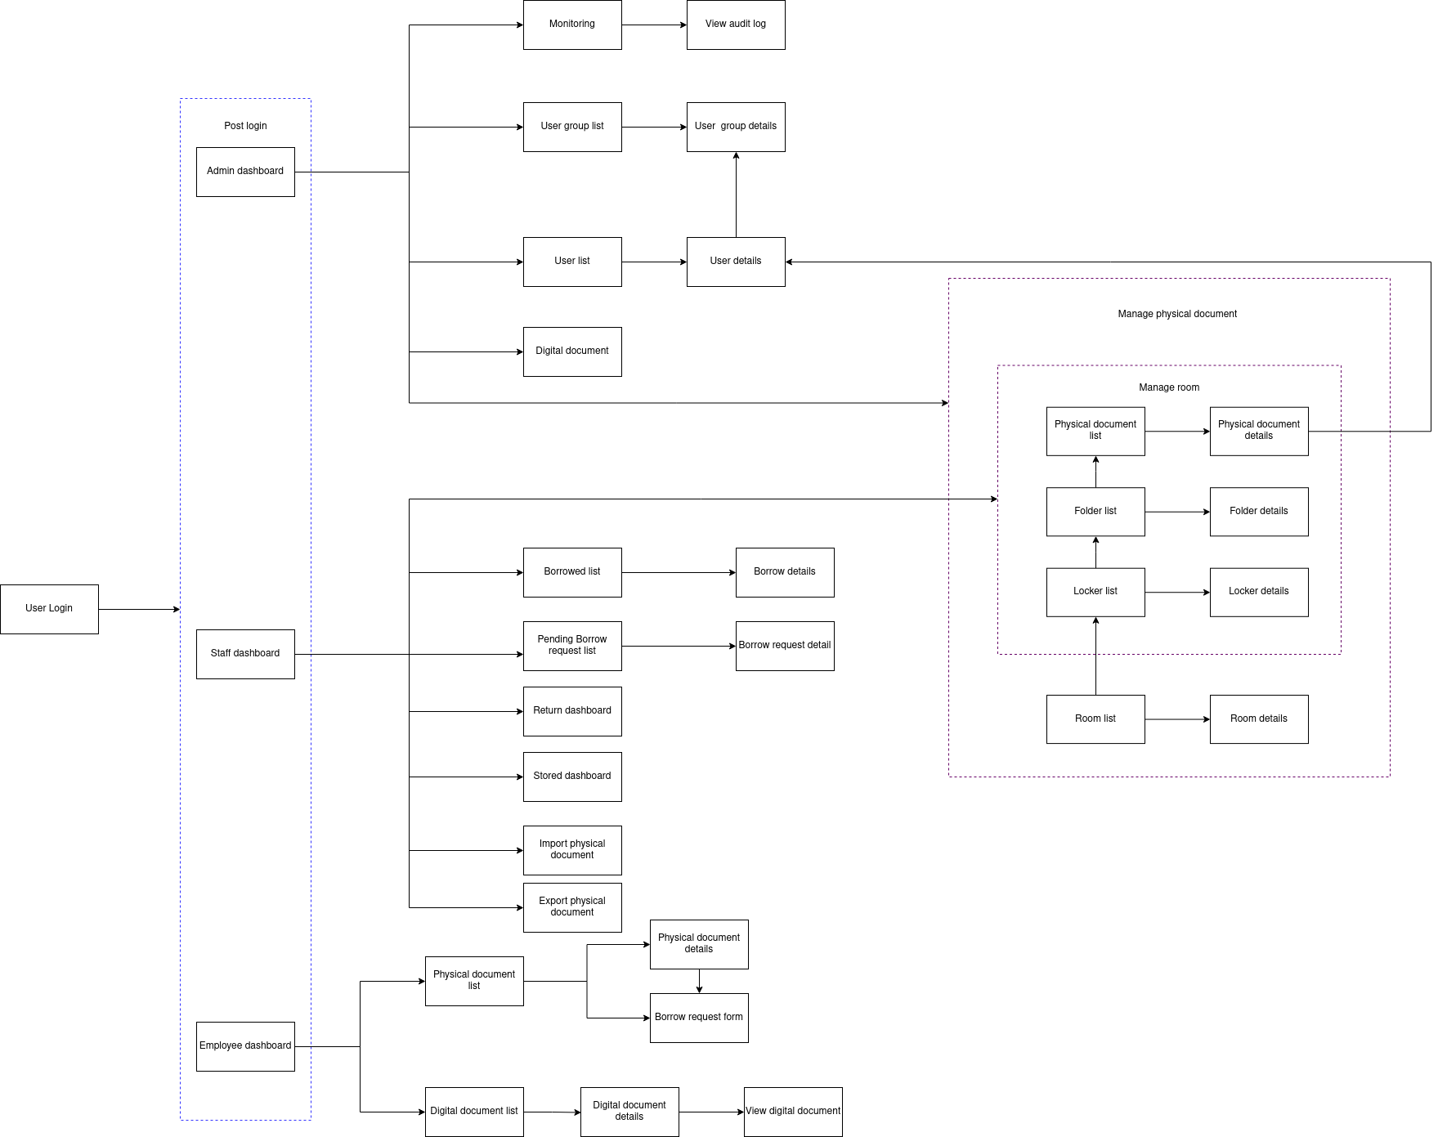

### Guest feature

This feature include the screen for Guests

* User Login: authenticate the user to give him/her to access authorized features later on

### Common feature

This feature include the screens use for Admin and Staff

* Locker list: list, search, view existing lockers with add, delete for admin
* Locker details: list, search, view list of folders within a specific locker and have add, delete function for admin
* Folder list: list, search, view list of folders and have add, delete functionality for admin
* Folder details: list, search, view, list of documents within a specific folder and have add delete function for admin
* Physical document list: list search, view, list of documents with import function for staff
* Physical document details: view details and edit metadata of a specific physical document.

### Admin feature

This includes the screens for Admin

* Admin dashboard: View general statistics about user, user groups,
* Monitoring: View metrics of the system
* View audit log: list, search, view the log of every activities in the system
* User group list: list, search, view, add, delete, edit existing groups
* User group details: list, view, add ,delete, search, user in a specific user group
* User list: list, search, view, add, delete, edit existing user in the system
* User details: View, edit details, delete, add to user group of a specific user
* Digital documents: a File-Explorer like view about the digital documents
* Room list: list, search, view, add, remove, edit existing rooms
* Room details: list, search, view, add, removals of lockers in a specific room

### Staff feature

This includes the screens for Staff

* Staff dashboard: View general statistics about lockers, folder, documents of a room
* Import physical document dashboard: A form that takes input about metadata of the document, Locker/Folder suggestion, QR that identifies after the document has been imported.
* Borrow list: list, search,view, track existing borrows
* Borrow details: view & edit details of a specific borrow
* Pending borrow request list: list, search, view, existing borrow requests
* Borrow request details: view, accept, deny a specific borrow request
* Return dashboard: view metadata and QR of the return document
* Stored dashboard:
* Export physical document dashboard:

### Employee feature

This includes the screens for Employee

* Employee dashboard: list, search, view list of their user group
* Physical document list: list, search, view existing physical document in a user group
* Physical document details: view metadata of a physical documents and have options for borrow
* Borrow request form: a form for inputting details of borrow request
* Digital document list: list view, search view existing digital documents in a user and can add their file
* Digital document details: view digital document information and have option to request for view
* View digital document: view the content

## Other Requirements

### User Input data formats

The types & format (length, validation, etc) of the input data are suggested by the project team and need to be mentioned clearly in the analyzing & designing documents.

- Those must be agreed by the supervisor (teacher) before implementing.

- Once agreed, those must be implemented accordingly in the software input validating, data showing and in the system database.

### Admin account creation

After deployment, admin will have temporary account and after login must changed the account password