Arduino IDE
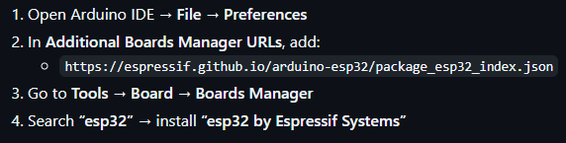
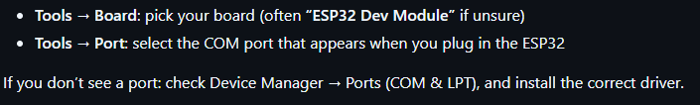
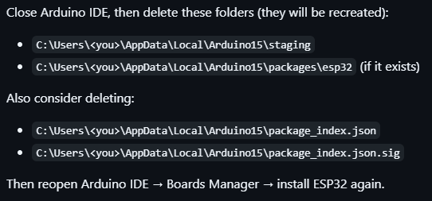
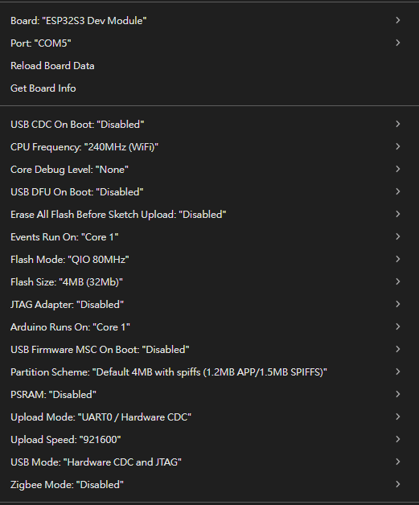

TGAM to PC read
Program: read_tgam.py
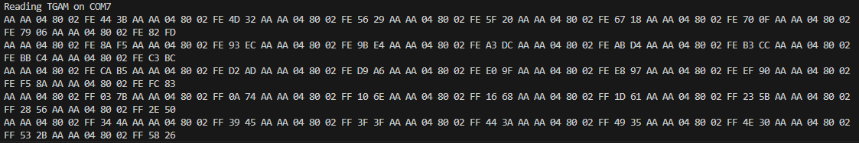

Logger
Program: tgam_logger.py, raw_to_brainwave.py
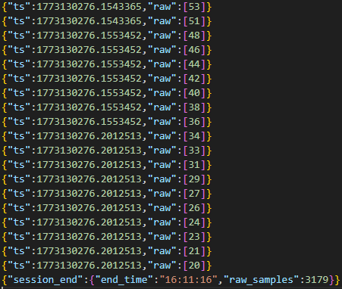
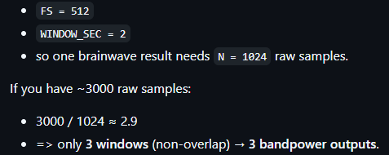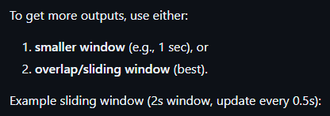
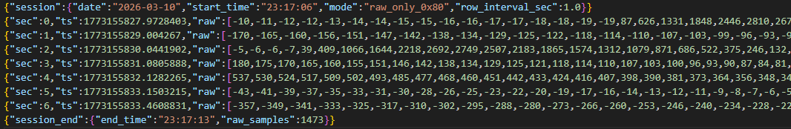
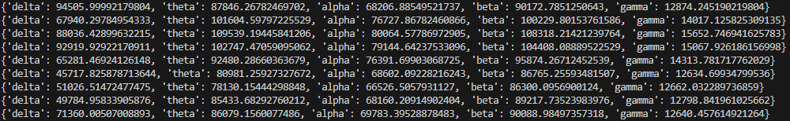

PC to ESP32, ESP32 to PC
In VS-code terminal: python -m pip install pyserial
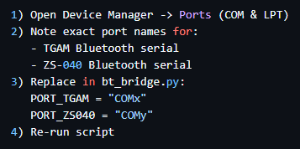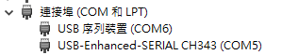

Program: bluetooth.py, bluetooth.ino
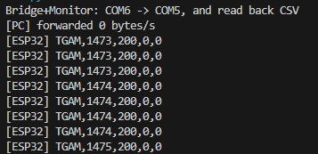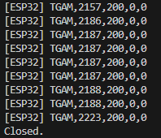
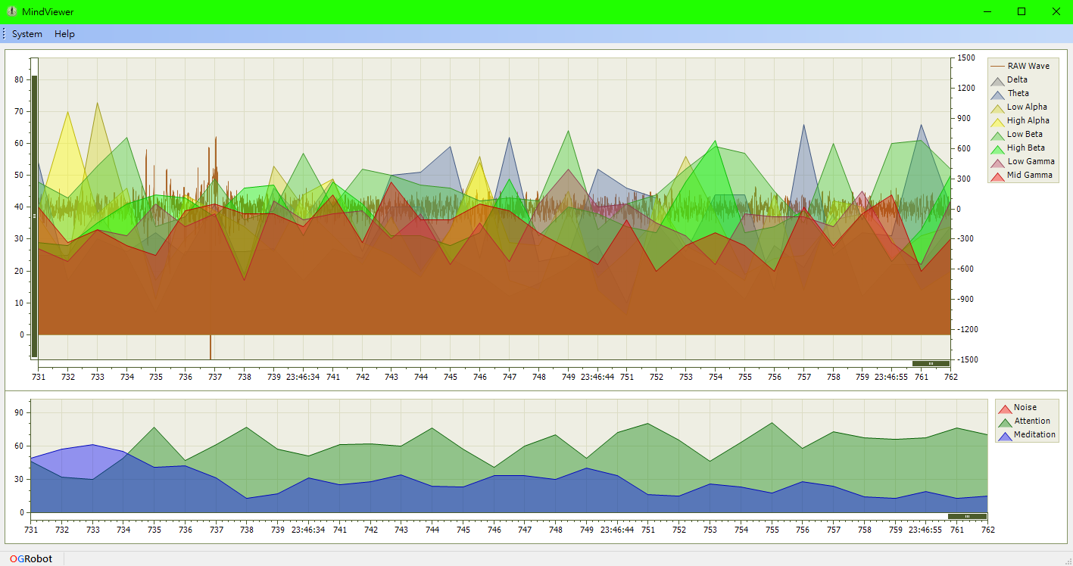

TGAM to New ESP32
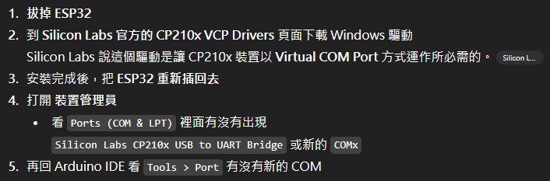
https://docs.espressif.com/projects/esp-idf/en/v4.2.1/esp32/get-started/establish-serial-connection.html
https://www.silabs.com/software-and-tools/usb-to-uart-bridge-vcp-drivers
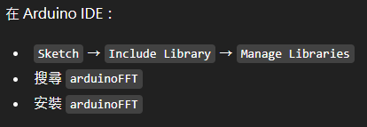

ESP32 to FPGA
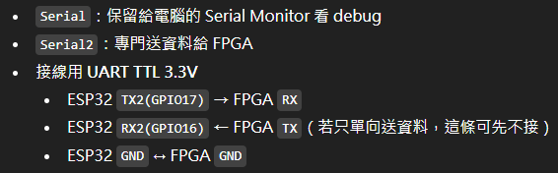
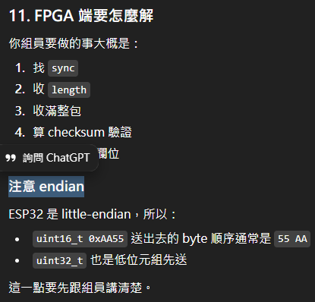

Arduino to ESP32 to FPGA
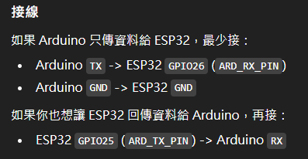
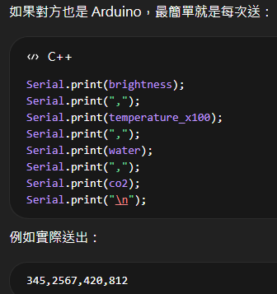

HW827 to ESP32
