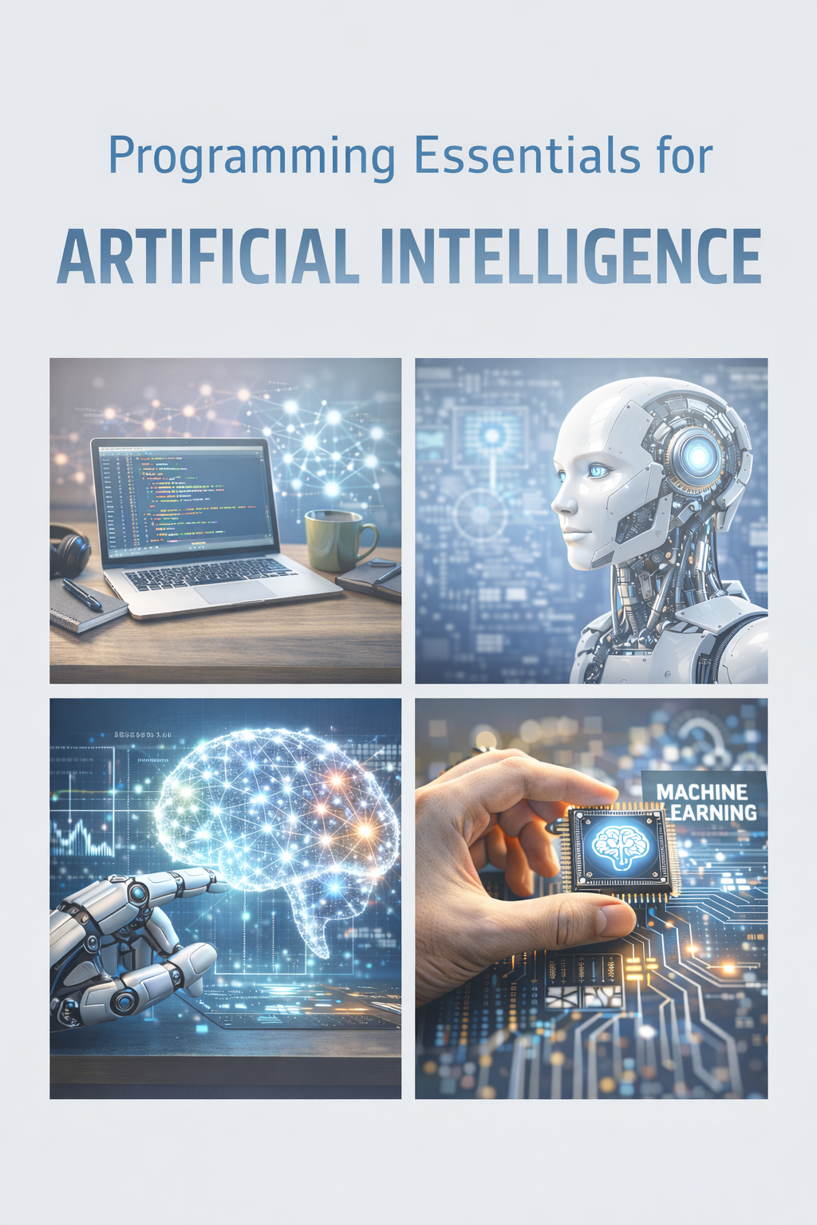
JavaScript Edition: Node.js + Browser + Modern ML/LLM Workflows
Part:1
A practical mini-eBook focused on building AI systems using JavaScript, without Python.
Author: David Donovan
Released: January 23, 2026
What you’ll learn | How to structure AI projects in JavaScript, handle data, run models (TensorFlow.js / ONNX Runtime), and ship reliable LLM apps.
Who it’s for | Developers who prefer JavaScript/TypeScript and want to build real AI features for web apps, services, and automation.
What it is not | A math textbook or a framework deep-dive. The goal is practical competence and a solid foundation.
License: You may copy and adapt this document for personal or internal team use.

Table of Contents
- What “AI Programming” Means in JavaScript
- Toolchain and Project Workflow (Node, TypeScript, Notebooks)
- JavaScript Essentials You Actually Use for AI
- Data Handling: Files, Streams, JSON/CSV, and Schemas
- Math & Vectors: TypedArrays, Linear Algebra, and Numerical Stability
Glossary + Next Steps

What “AI Programming” Means in JavaScript
AI programming is a pipeline: problem definition, data/inputs, representation, model or rules, evaluation, and shipping with monitoring.
In JavaScript, you typically build AI features in one of three places: (1) a Node.js service, (2) a browser app, or (3) a hybrid where the browser handles UX and the server handles heavy compute or data access.
Your advantage as a programmer is not picking a model. It’s building a system that is measurable, testable, and safe under real user behavior.
Rule of thumb: treat model outputs as untrusted input. Validate and constrain them the same way you would validate user input.

Toolchain and Project Workflow (Node, TypeScript,Notebooks)
Recommended baseline: Node.js 18+ (or 20+), TypeScript, ESLint, Prettier, and a test runner (Vitest or Jest).
For experimentation, you can use plain scripts with small datasets, observable notebooks, or Jupyter with a JavaScript kernel. Promote working experiments into versioned modules.
Use a simple project layout that separates data ingestion, model/inference, evaluation, and serving.
Non-negotiables: track dataset versions, log evaluation metrics, and keep a reproducible config for any model behavior you ship.
# Example layout ai_js_project/
data/ # raw/processed data OR pointers src/ config.ts ingest/ features/ inference/ eval/ server/ tests/ scripts/ package.json tsconfig.json README.md

JavaScript Essentials You Actually Use for AI
Most AI code is data transformation. You want clean functions, predictable types, and explicit boundaries.
Prefer TypeScript for anything you’ll maintain. Inference code gets complicated quickly (inputs, outputs, versions, fallbacks).
Master: async/await, error handling, working with streams, JSON schema validation, and performance profiling basics.
Avoid hidden state. AI systems fail quietly; make the state (inputs, versions, thresholds) explicit in code and logs.
// Prefer explicit types and pure functions. export function mean(xs: number[]): number {
if (xs.length === 0) throw new Error("mean() needs at least one value"); let s = 0;
for (const x of xs) s += x; return s / xs.length; }

Data Handling: Files, Streams, JSON/CSV, andSchemas
Real-world AI work starts with messy data. In Node.js, you’ll often parse JSONL, CSV, or pull from a database or object store.
Use streaming I/O for large files; don’t read multi-GB datasets into memory. Normalize text and enforce schemas early.
Validation prevents silent corruption: check required fields, types, ranges, and label distributions.
If you can’t explain your dataset in one page (fields, sources, leakage risks, known biases), you’re not ready to trust the model.
import fs from "node:fs"; import readline from "node:readline";
// JSONL streaming reader
export async function* readJsonl(path: string) { const rl = readline.createInterface({
input: fs.createReadStream(path, { encoding: "utf8" }), crlfDelay: Infinity,
});
for await (const line of rl) { if (!line.trim()) continue; yield JSON.parse(line);
}
}
export function normalizeText(s: string): string { return s.toLowerCase().trim().replace(/\s+/g, " ");
}

Math & Vectors: TypedArrays, Linear Algebra, andNumerical Stability
Even if you don’t implement backprop by hand, you need vector thinking: dot products, cosine similarity, and stable softmax.
In JavaScript, TypedArrays (Float32Array) are key for performance and interoperability with ML runtimes.
Numerical stability matters: subtract max before softmax; clamp probabilities; avoid overflow in exp.
For embeddings and similarity search, store vectors as Float32Array and avoid converting to plain arrays in hot paths.
export function dot(a: Float32Array, b: Float32Array): number { if (a.length !== b.length) throw new Error("Length mismatch"); let s = 0;
for (let i = 0; i < a.length; i++) s += a[i] * b[i]; return s; }
export function cosineSim(a: Float32Array, b: Float32Array): number { const ab = dot(a, b); const aa = Math.sqrt(dot(a, a)); const bb = Math.sqrt(dot(b, b)); return ab / (aa * bb + 1e-12); }
export function softmax(z: number[]): number[] { const m = Math.max(...z);
const exps = z.map(v => Math.exp(v - m)); const sum = exps.reduce((a, b) => a + b, 0); return exps.map(e => e / sum); }

