Manual

Picking Exercise
On the left corner of the GUI exercise panel can be found. In order to start the program user should select desired exercise. If exercise is a babystep exercise, then the countdown will begin immediately.
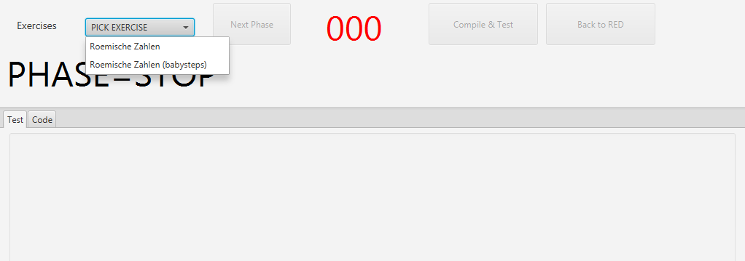
Writing a Test
First stage is the test stage. In this stage user need to write a failing test. With “Compile & Test” button user can compile user’s code and see the result at the console screen.
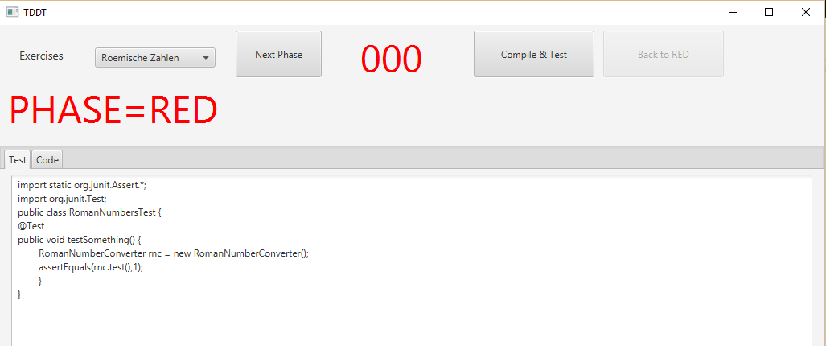

Writing a Code
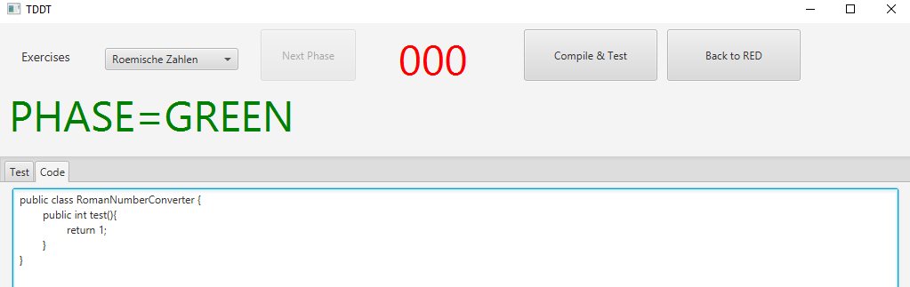
After successfully completing the “Phase Red”, user will be able to write the code in the second tab. The goal is making the test pass. User can go back to “Phase Red” anytime he wants.
After passing all of the tests user is able to do refactor with tests and code. Once the refactoring is done. User can see statics and analytics by finishing the project.
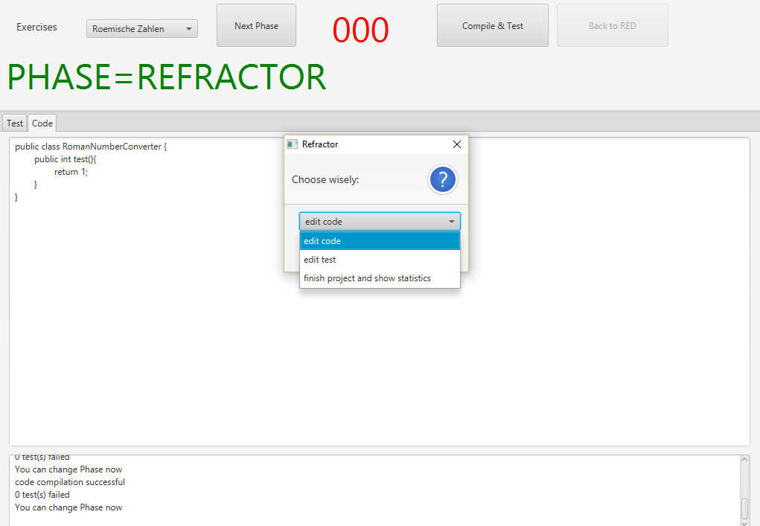

Statistics
In this section, user can see all the analytics. User can travel through phases to see time spent or analyze all the code differences. This option is viable in the refactor phase.
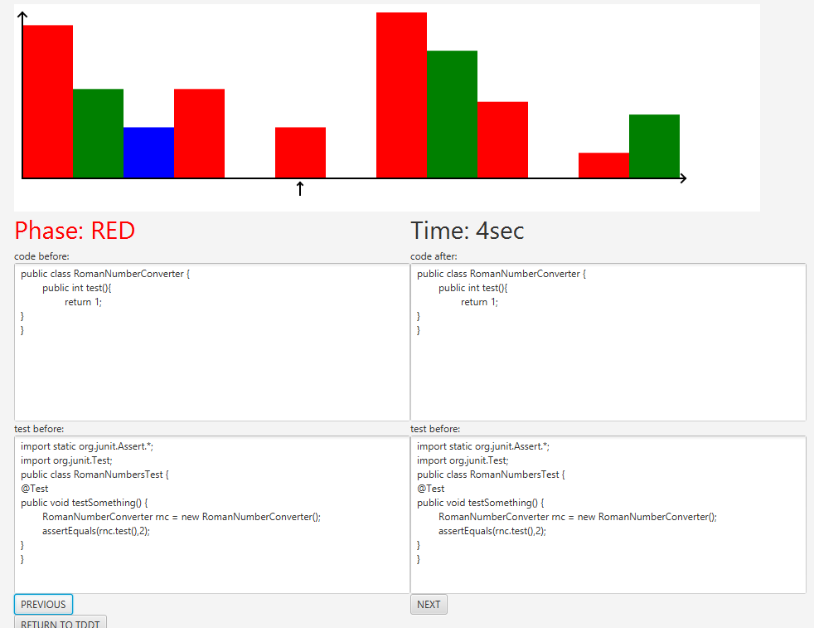
The x axis shows the phase and the y axis the time. In the fields the code and tests are visable with and without changes for this phase.

Babysteps
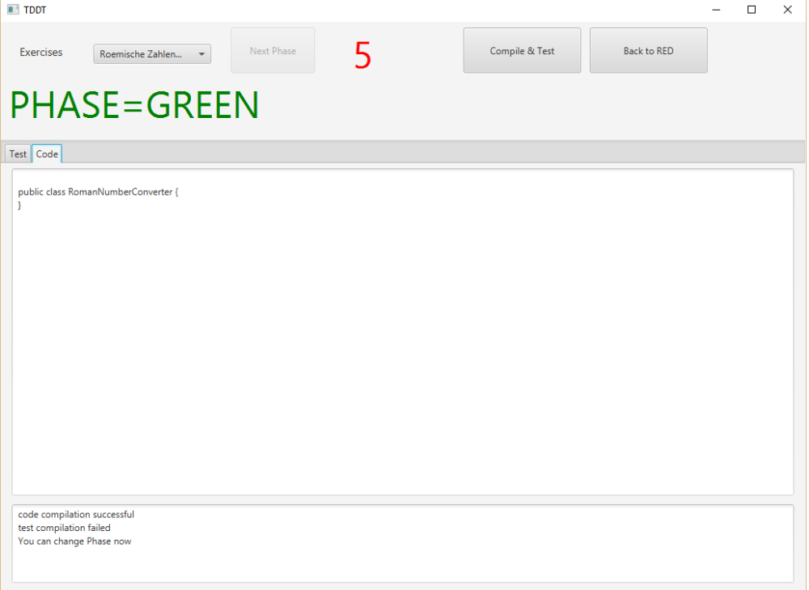
If Babysteps is activated the time is limited for each phase. When the user dont make it in the given time frame the code is deleted. The time in Refactoring isnt limited

