**GRAPHIC ERA DEEMED TO BE UNIVERSITY**



SESSION 2022-23

WEB DEVELOPMENT LAB

( PCS 693 )

Submitted To: Submitted By:

Mr. Pranav Moore Prakhar Mamgain

Department of CSE CST

35

2015394

VIth Sem

B.Tech (CST)

1. **Design a form for Employee registration which includes all elements of form tags.**

<!DOCTYPE html>

<html lang="en">

<head>

<meta charset="UTF-8">

<meta http-equiv="X-UA-Compatible" content="IE=edge">

<meta name="viewport" content="width=device-width, initial-scale=1.0">

<title>Employee Registration Form</title>

</head>

<style>

body {

margin: 0px;

padding: 10px;

text-align: start;

}

input {

margin: 10px;

}

.abhi {

text-align: center;

}

.content

{margin-left: 33%;

}

</style>

<body>

<h1 class="abhi">Employee Registration Form</h1>

<div class="content">

<label for="name">Full Name:</label>

<input type="text">

<br>

<label for="name">Father's Name:</label>

<input type="text">

<br>

<label for="name">Mother's Name:</label>

<input type="text">

<br>

<label for="dob">DOB:</label>

<input type="date" name="dob" id="dob">

<br>

<label for="name">Email:</label>

<input type="text">

<br>

<label for="name">Contact Number:</label>

<input type="text">

<br>

<label for="name">Address:</label>

<input type="text">

<br>

<label for="gender">Gender:</label>

<input type="radio" name="gender"> Male

<input type="radio" name="gender"> Female

<input type="radio" name="gender"> Other

<br><br>

<label for="Department">Department:</label>

<select name="dep" id="dep">

<option value="accounts">Accounts</option>

<option value="admin">Administration</option>

<option value="it">IT</option>

<option value="management">Management</option>

</select>

<br><br>

<label for="image">Photo:</label>

<input type="file">

<br>

<input type="submit" value="Register">

<br><br><br><br>

</div>

</body>

</html>

**Output:-**

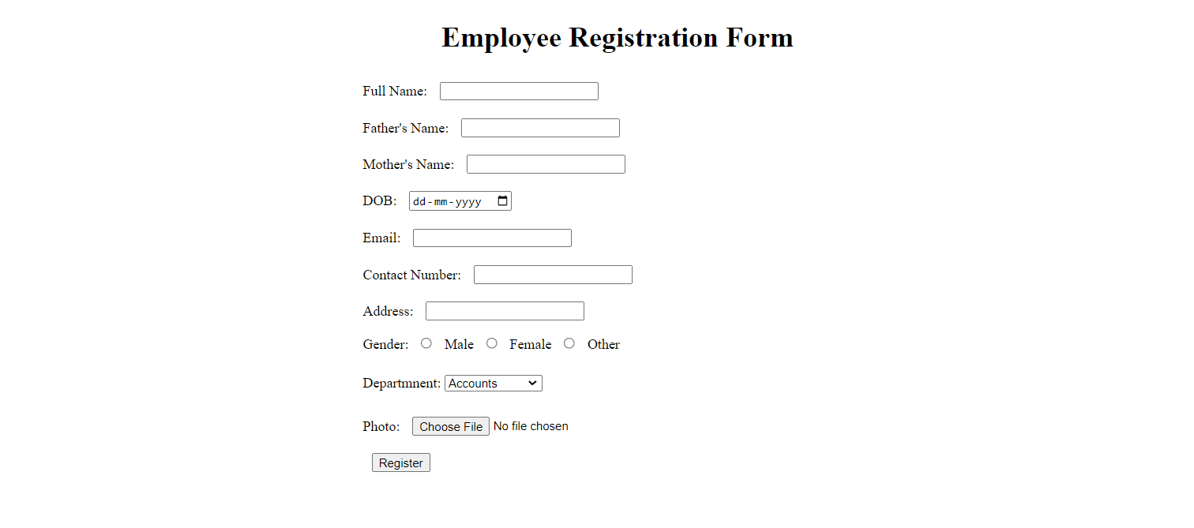

1. **Write a HTML code to generate a class timetable and add external CSS to customize the properties of the font, background etc. (color, bold and font size)**

<!DOCTYPE html>

<html lang="en">

<head>

<meta charset="UTF-8">

<meta http-equiv="X-UA-Compatible" content="IE=edge">

<meta name="viewport" content="width=device-width, initial-scale=1.0">

<title>Time Table</title>

<link rel="stylesheet" type="text/css" href="../CSS/abhi.css">

<script src="../Javascript/first.js"></script>

</head>

<body>

<h1 class="heading" style="text-align: center;">GRAPHIC ERA DEEMED TO BE UNIVERSITY</h1>

<h2 class="sub-heading" style="text-align: center;">ONLINE TIME TABLE OF B. TECH. VIth SEMESTER “ COMPUTER SCIENCE & ENGG.-H"</h2>

<h2 class="sub-heading-2" style="text-align: center;">ACADEMIC YEAR 2021- 22</h2> <p style="text-align: center;"> <b>W.E.F:25th February 2022</b></p>

<div style="display: flex; justify-content: center; align-items: center;"> <table style="border: 2px solid black;">

<thead>

<tr>

<th></th>

<th>9:00-9:55</th>

<th>9:55-10:50</th>

<th>11:10-12:05</th>

<th>12:05-1:00</th>

<th>1:00-1:55</th>

<th>1:55-2:50</th>

<th>3:10-4:05</th>

<th>4:05-5:00</th>

</tr>

</thead>

<tbody>

<tr>

<th>MON</th>

<td>TCS-602</td>

<td>TCS 693</td>

<td>TCS-601</td>

<td>TCS-691/TCS-651/TCS-619</td>

<td>Lunch</td>

<td>XCS-601 (PDP)</td>

<td colspan="2">Career Excellence Classes (CEC)</td>

</tr>

<tr>

<th>TUE</th>

<td>TCS-602</td>

<td>TCS 693</td>

<td>TCS-601</td>

<td>TCS-691/TCS-651/TCS-619</td>

<td>Lunch</td>

<td>XCS-601 (QAR)</td>

<td>TCS-604</td>

<td>TCS-604</td>

</tr>

<tr>

<th>WED</th>

<td>TCS-602</td>

<td>TCS 693</td>

<td>TCS-601</td>

<td>TCS-691/TCS-651/TCS-619</td>

<td>Lunch</td>

<td>LIB</td>

<td>TCS-604</td>

<td>TCS-604 (Discussion Class)</td>

</tr>

<tr>

<th>THU</th>

<td>TCS-602</td>

<td>TCS 693</td>

<td>TCS-601</td>

<td>TCS-691/TCS-651/TCS-619 <br> (Discussion Class)</td> <td>Lunch</td>

<td colspan="3">SWAYAM/Training/Extra-Curricular Activities/LIB</td>

</tr>

<tr>

<th>FRI</th>

<td colspan="2">Software Engineering Lab</td>

<td colspan="2">Compiler Design Lab</td>

<td>Lunch</td>

<td>LIB</td>

<td colspan="2">Web Development Lab</td>

</tr>

</tbody>

</table>

</div>

<br><br><br><br>

</div>

</body>

</html>

**Output:-**

1. **Use frames such that page is divided into 3 frames 20% on left to show contents of pages, 60% in center to show body of page, remaining on right to show remarks.**

(Frame.html)

<!DOCTYPE html>

<html>

<head>

<title>Frames</title>

</head>

<frameset cols="20%,80%" noresize="noresize" border="10">

<frame src="../HTML/frames/menu.html" name="menu_page">

<frame src="../HTML/frames/main.html" name="main_page">

</frameset>

</html> (main.html)

<!DOCTYPE html>

<html>

<body>

<h1>

<marquee Scrollamount=20>Select any planet </marquee>

</h1>

</body>

</html> (menu.html)

<!DOCTYPE html>

<html>

<head>

<style> body {

background-color: #fee7c1;

}

h1 {

color: #81130f;

text-align: center;

font-family: sans-serif; font-size: 35px;

}

a:link { color: blue;

background-color: transparent;

}

a:visited { color: purple;

background-color: transparent;

}

a:hover { color: red;

background-color: transparent;

}

</style>

</head>

<body>

<h1> Selected Planets</h1>

<p style="font-size: 20px"> Read essential details about following planets.

<p>

<ul style="font-size: 20px">

<li><u> <a href="https://en.wikipedia.org/wiki/Venus" target="main_page">Venus</a></u></li>

<br>

<li><u> <a href="https://en.wikipedia.org/wiki/Earth" target="main_page">Earth</a></u></li>

<br>

<li><u> <a href="https://en.wikipedia.org/wiki/Jupiter" target="main_page">Jupiter</a></u></li>

</ul>

</body>

</html>

Output:-

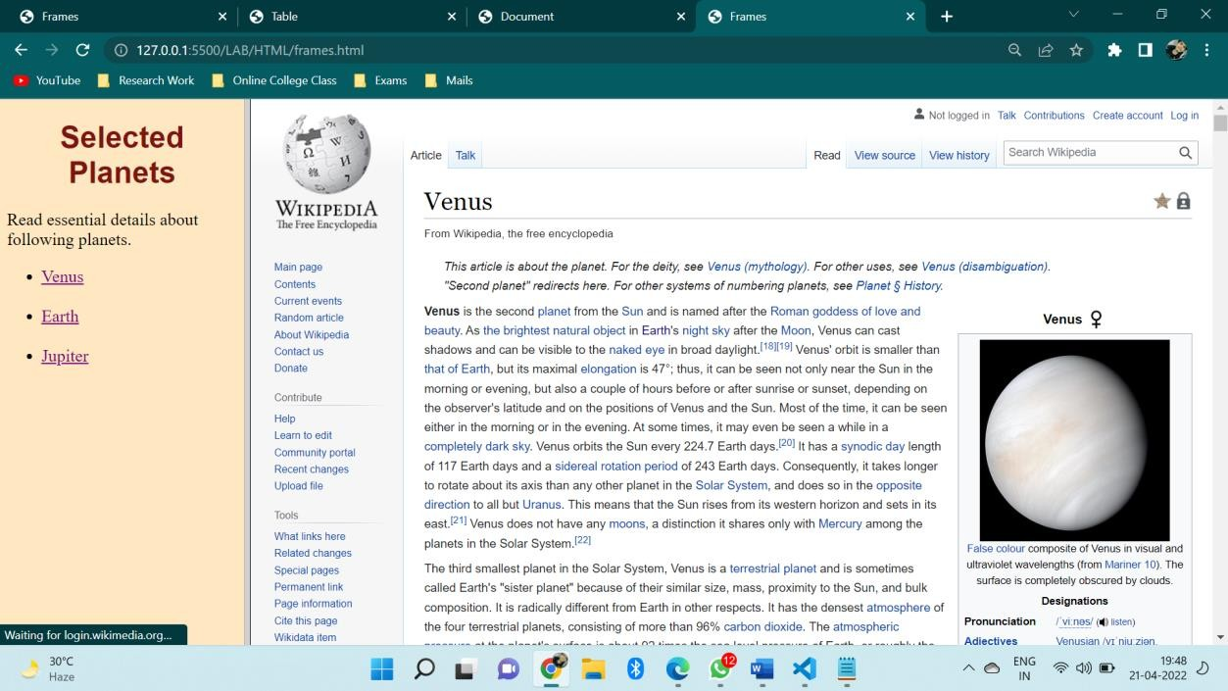

1. **Write an HTML page that contains a selection box with a list of 5 countries, when the user selects a country, its capital should be printed next to the list; Add CSS to customize the properties of the font of the capital (color, bold and font size).**

<html>

<head>

<title>capitals of countries</title>

<style>

p {

color: red;

font-weight: bold;

font-size: 50;

}

</style>

<script language="javascript">

function capital() {

var cunt = document.forms["frm1"].country.value;

var capital = " Please select any country ";

if (cunt == "india") {

capital = "NEW DELHI";

}

if (cunt == "china") {

capital = "BEIJING";

}

if (cunt == "pakistan") {

capital = "ISLAMABAD";

}

if (cunt == "bangladesh") {

capital = "DHAKA";

}

if (cunt == "japan") {

capital = "TOKYO";

}

if (cunt == "select") {

capital = "Please select any country";

}

document.getElementById("capt").innerHTML = capital;

}

</script>

</head>

<body>

<form name="frm1">

<br />

<center>

Select a Country : <select name="country" onchange="capital()">

<option value="select">--SELECT--</option>

<option value="india">INDIA</option>

<option value="china">CHINA</option>

<option value="pakistan">PAKISTAN</option>

<option value="bangladesh">BANGLADESH</option>

<option value="japan">JAPAN</option>

</select>

<br />

<br />

<font color="green" size="6">Capital is :</font>

<p id="capt"></p>

</center>

</form>

</body>

</html>

**Output:-**

  

1. **Develop and demonstrate the usage of inline, internal and external style sheet using CSS.**

**Index.html**

<!DOCTYPE html>

<head>

<meta name="viewport" content="width=device-width, initial-scale=1.0" />

<title>CSS internal,external and inline</title>

<link rel="stylesheet" href="style.css" />

<style>

body {

background-color: linen;

}

.first {

background-color: blue;

height: 100px;

width: 100px;

}

</style>

</head>

<body>

<div class="first">BOX</div>

<div class="second">BOX</div>

<div style="background-color: red; height: 100px; width: 100px">BOX</div>

</body>

</html>

**Style.css**

.second{

background-color: green;

height:100px;

width:100px;

}

**Output:-**

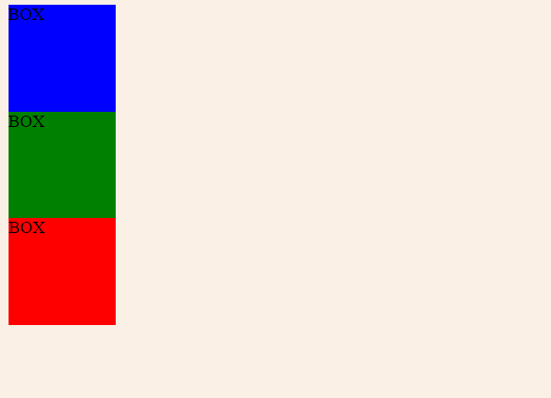

1. **Create a student registration system page using HTML tags and apply box model using external CSS.**

**Index.html**

<!DOCTYPE html>

<head>

<meta name="viewport" content="width=device-width, initial-scale=1.0">

<title>Student Registration Form</title>

<link rel="stylesheet" href="style.css">

</head>

<body>

<form class="signup-form" action="/register" method="post">

<div class="form-header">

<h1>Registration</h1>

</div>

<div class="form-body">

<div class="horizontal-group">

<div class="form-group left">

<label for="firstname" class="label-title">First name *</label>

<input type="text" id="firstname" class="form-input" placeholder="enter your first name" required="required" />

</div>

<div class="form-group right">

<label for="lastname" class="label-title">Last name</label>

<input type="text" id="lastname" class="form-input" placeholder="enter your last name" />

</div>

</div>

<div class="form-group">

<label for="email" class="label-title">Email*</label>

<input type="email" id="email" class="form-input" placeholder="enter your email" required="required">

</div>

<div class="horizontal-group">

<div class="form-group left">

<label for="password" class="label-title">Password *</label>

<input type="password" id="password" class="form-input" placeholder="enter your password" required="required">

</div>

<div class="form-group right">

<label for="confirm-password" class="label-title">Confirm Password *</label>

<input type="password" class="form-input" id="confirm-password" placeholder="enter your password again" required="required">

</div>

</div>

<div class="horizontal-group">

<div class="form-group left">

<label class="label-title">Gender:</label>

<div class="input-group">

<label for="male">

<input type="radio" name="gender" value="male" id="male"> Male</label>

<label for="female">

<input type="radio" name="gender" value="female" id="female"> Female</label>

</div>

</div>

<div class="form-group right">

<label class="label-title">Hobbies</label>

<div>

<label>

<input type="checkbox" value="Web">Music</label>

<label>

<input type="checkbox" value="iOS">Sports</label>

<label>

<input type="checkbox" value="Andriod">Travel</label>

<label>

<input type="checkbox" value="Game">Movies</label>

</div>

</div>

</div>

<div class="horizontal-group">

<div class="form-group left" >

<label class="label-title">Source of Income</label>

<select class="form-input" id="level" >

<option value="B">Employed</option>

<option value="I">Self-employed</option>

<option value="A">Unemployed</option>

</select>

</div>

<div class="form-group right">

<label for="experience" class="label-title">Income</label>

<input type="range" min="20" max="100" step="5" value="0" id="experience" class="form-input" onChange="change();" style="height:28px;width:78%;padding:0;">

<span id="range-label">20K</span>

</div>

</div>

<div class="horizontal-group">

<div class="form-group left" >

<label for="choose-file" class="label-title">Upload Profile Picture</label>

<input type="file" id="choose-file" size="80">

</div>

<div class="form-group right">

<label for="experience" class="label-title">Age</label>

<input type="number" min="18" max="80" value="18" class="form-input">

</div>

</div>

<div class="form-group">

<label for="choose-file" class="label-title">Bio</label>

<textarea class="form-input" rows="4" cols="50" style="height:auto"></textarea>

</div>

</div>

<div class="form-footer">

<!-- form footer -->

<div class="form-footer">

<span>* required</span>

<button type="submit" class="btn">Create</button>

</div>

</div>

</form>

<script>

var rangeLabel = document.getElementById("range-label");

var experience = document.getElementById("experience");

function change() {

rangeLabel.innerText = experience.value + "K";

}

</script>

</body>

</html>

**Style.css**

@import url('httpss://fonts.googleapis.com/css?family=Roboto');

body {

background:linear-gradient(to right, #78a7ba 0%, #385D6C 50%, #78a7ba 99%);

}

.signup-form {

font-family: "Roboto", sans-serif;

width:650px;

margin:30px auto;

background:linear-gradient(to right, #ffffff 0%, #fafafa 50%, #ffffff 99%);

border-radius: 10px;

}

.form-header {

background-color: #EFF0F1;

border-top-left-radius: 10px;

border-top-right-radius: 10px;

}

.form-header h1 {

font-size: 30px;

text-align:center;

color:#666;

padding:20px 0;

border-bottom:1px solid #cccccc;

}

.form-body {

padding:10px 40px;

color:#666;

}

.form-group{

margin-bottom:20px;

}

.form-body .label-title {

color:#1BBA93;

font-size: 17px;

font-weight: bold;

}

.form-body .form-input {

font-size: 17px;

box-sizing: border-box;

width: 100%;

height: 34px;

padding-left: 10px;

padding-right: 10px;

color: #333333;

text-align: left;

border: 1px solid #d6d6d6;

border-radius: 4px;

background: white;

outline: none;

}

.horizontal-group .left{

float:left;

width:49%;

}

.horizontal-group .right{

float:right;

width:49%;

}

input[type="file"] {

outline: none;

cursor:pointer;

font-size: 17px;

}

#range-label {

width:15%;

padding:5px;

background-color: #1BBA93;

color:white;

border-radius: 5px;

font-size: 17px;

position: relative;

top:-8px;

}

::-webkit-input-placeholder {

color:#d9d9d9;

}

.form-footer {

clear:both;

}

.signup-form .form-footer {

background-color: #EFF0F1;

border-bottom-left-radius: 10px;

border-bottom-right-radius: 10px;

padding:10px 40px;

text-align: right;

border-top: 1px solid #cccccc;

}

.form-footer span {

float:left;

margin-top: 10px;

color:#999;

font-style: italic;

font-weight: thin;

}

.btn {

display:inline-block;

padding:10px 20px;

background-color: #1BBA93;

font-size:17px;

border:none;

border-radius:5px;

color:#bcf5e7;

cursor:pointer;

}

.btn:hover {

background-color: #169c7b;

color:white;

}

**Output:-**

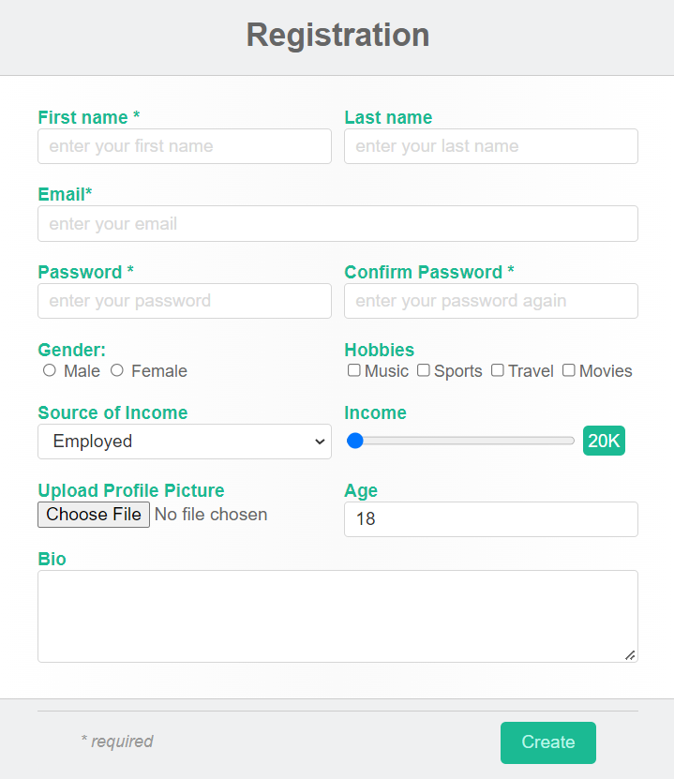

1. **Write a JavaScript program to test the first character of a string is uppercase or not.**

function upper_case(str)

{

regexp = /^[A-Z]/;

if (regexp.test(str))

{

console.log("String's first character is uppercase");

}

else

{

console.log("String's first character is not uppercase");

}

}

upper_case('Abcd');

upper_case('abcd');

1. **Write a JavaScript code to take color from user and apply that color to Div tag.**

<html>

<head>

<style>

#Myelement {

width: 500px;

height: 100px;

}

</style>

</head>

<body>

<div id="Myelement"

onclick="changeColor()">

</div>

<input name="MyColorPicker"

type="color"

id="MyColorPicker" />

</body>

</html>

<script>

function changeColor() {

document.getElementById(

"Myelement").style.backgroundColor =

document.getElementById(

"MyColorPicker").value;

}

</script>

**Output:-**

 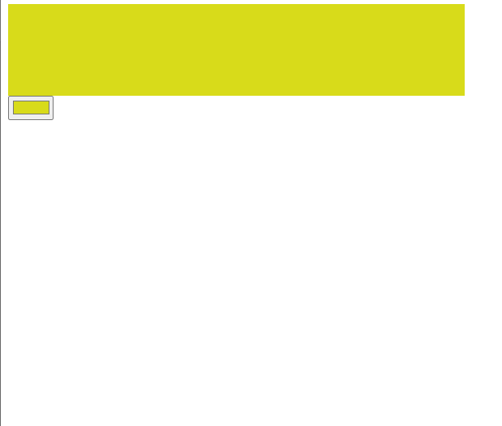

1. **Write JavaScript to validate the following fields of the Registration page. 1. First Name (Name should be min 4 characters and max 8 characters) 2. Password & Confirm Password (Password should not be less than 8 characters length). 3. Email id (should not contain any invalid mail) 4. Mobile Number (Phone number should be 8 digits only) 5. Last Name and Address (should not be Empty).**

**Index.html**

<html>

<head>

<style>

.content

{

padding: 50px;

margin-left: 25%;

}

input

{

padding: 10px;

}

</style>

</head>

<body>

<h1 class="abhi">Login</h1>

<div class="content">

<label for="name">Full Name:</label>

<input type="text" onblur="nameCheck()" value="" id="fname"><br>

<label for="name">Password:</label>

<input type="password" onblur="passCheck()" value="" id="pass"><br>

<label for="name"> Confirm Password:</label>

<input type="password" onblur="conPassCheck()" value="" id="cpass"> <br>

<label for="name">E-mail</label>

<input type="email" onblur="eCheck()" value="" id="mail"><br>

<label for="mob">Mobile:</label>

<input type="text" onblur="mCheck()" value="" id="phone"> <br>

<label for="lname">Last Name:</label>

<input type="text" onblur="lnCheck()" value="" id="lname"><br>

<label for="Address">Address:</label>

<input type="text" onblur="addCheck()" value="" id="add">

</div>

</body>

<script src="app.js"></script>

</html>

**App.js**

function nameCheck() {

var x = document.getElementById("fname");

if (!(x.value.length >= 4 && x.value.length <= 8)) {

alert("Name should be at least 4 char and max 8 char long");

x.value="";

}

}

function passCheck() {

var paswd = /^(?=.*[0-9])(?=.*[!@#$%^&*])[a-zA-Z0-9!@#$%^&*]{8,}$/;

var x = document.getElementById("pass");

if (!(x.value.match(paswd))) {

alert("Enter Valid password");

}

}

function conPassCheck() {

var x = document.getElementById("pass");

var y = document.getElementById("cpass");

if (!(x.value==y.value)) {

alert("Confirm password should be same as the password");

}

}

function eCheck() {

var email = document.getElementById("pass");

if(email.value=="")

{

alert('Please fill this field');

}

var filter = /^([a-zA-Z0-9_\.\-])+\@(([a-zA-Z0-9\-])+\.)+([a-zA-Z0-9]{2,4})+$/;

if (!filter.test(email.value)) {

alert("Please provide a valid email address");

}

}

function mCheck() {

var x = document.getElementById("phone");

if (!(x.value.length == 8)) {

alert("Phone Number should be 8 char long");

}

}

function lnCheck() {

var x = document.getElementById("lname");

if (x.value == "") {

alert("Please fill this field");

}

}

function addCheck() {

var x = document.getElementById("add");

if (x.value == "") {

alert("Please fill this field");

}

}

**Output:-**

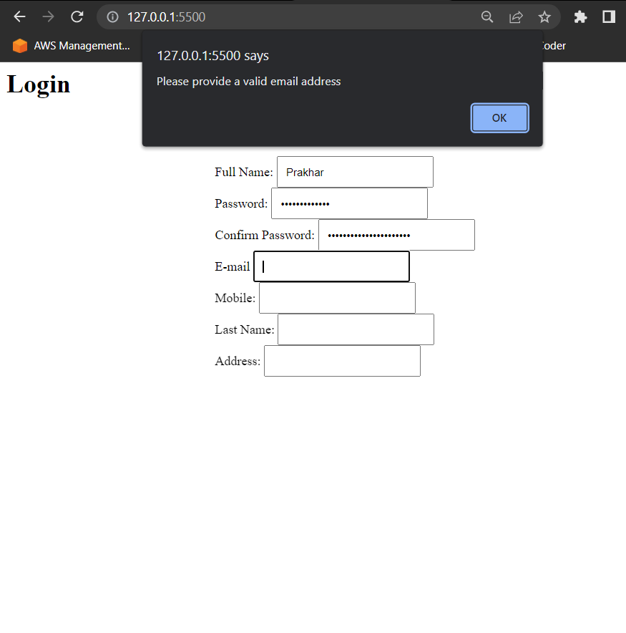

1. **Create a HTML form and write JavaScript to generate the invoice with one click of GENERATE INVOICE button. Take any 5 product with rate and quantity and display total for every product. Calculate Grand Total by including 18% GST.**

<!DOCTYPE html>

<head>

<meta name="viewport" content="width=device-width, initial-scale=1.0">

<title>Document</title>

<style>

table{

border: 2px solid black;

border-collapse: collapse;

}

input{

margin: 5px;

}

th,td{

border-bottom: 1px solid black;

}

</style>

</head>

<body>

<table>

<tr>

<th>particulars</th>

<th>rate</th>

<th>quantity</th>

<th>total</th>

</tr><tr>

<td>Product 1</td>

<td><input type="text" id="rate1"></td>

<td><input type="text" id="quantity1"></td>

<td><input type="text" id="total1"></td>

</tr><tr>

<td>Product 2</td>

<td><input type="text" id="rate2"></td>

<td><input type="text" id="quantity2"></td>

<td><input type="text" id="total2"></td>

</tr><tr>

<td>Product 3</td>

<td><input type="text" id="rate3"></td>

<td><input type="text" id="quantity3"></td>

<td><input type="text" id="total3"></td>

</tr><tr>

<td>Product 4</td>

<td><input type="text" id="rate4"></td>

<td><input type="text" id="quantity4"></td>

<td><input type="text" id="total4"></td>

</tr><tr>

<td>Product 5</td>

<td><input type="text" id="rate5"></td>

<td><input type="text" id="quantity5"></td>

<td><input type="text" id="total5"></td>

</tr><tr>

<td colspan="4" style="text-align:center"> Tax : <input type="text" id="tax"> Based on a 18% GST</td>

</tr><tr>

<td colspan="4" style="text-align:center"> Grandtotal : <input type="text" id="grandtotal"> Vat included</td>

</tr>

</table>

<script>

let total1 = document.getElementById('total1');

let total2 = document.getElementById('total2');

let total3 = document.getElementById('total3');

let total4 = document.getElementById('total4');

let total5 = document.getElementById('total5');

let p1total = 0;

let p2total = 0;

let p3total = 0;

let p4total = 0;

let p5total = 0;

total1.addEventListener('click', function fun() {

let rate1 =parseInt(document.getElementById('rate1').value);

let quantity1 = parseInt(document.getElementById('quantity1').value);

p1total = rate1 * quantity1;

total1.value = p1total;

});

total2.addEventListener('click', function fun() {

let rate2 = parseInt(document.getElementById('rate2').value);

let quantity2 = parseInt(document.getElementById('quantity2').value);

p2total = rate2 * quantity2;

total2.value = p2total;

});

total3.addEventListener('click', function fun() {

let rate3 = parseInt(document.getElementById('rate3').value);

let quantity3 = parseInt(document.getElementById('quantity3').value);

p3total = rate3 * quantity3;

total3.value = p3total;

});

total4.addEventListener('click', function fun() {

let rate4 = parseInt(document.getElementById('rate4').value);

let quantity4 = parseInt(document.getElementById('quantity4').value);

p4total = rate4 * quantity4;

total4.value = p4total;

});

total5.addEventListener('click', function fun() {

let rate5 = parseInt(document.getElementById('rate5').value);

let quantity5 = parseInt(document.getElementById('quantity5').value);

p5total = rate5 * quantity5;

total5.value = p5total;

});

let tax = 0;

let taxinpt = document.getElementById('tax');

taxinpt.addEventListener('click', ()=>{

tax = (p1total+p2total+p3total+p4total+p5total)*0.18;

taxinpt.value = tax;

});

let gt = document.getElementById('grandtotal');

gt.addEventListener('click', ()=>{

gt.value = p1total+p2total+p3total+p4total+p5total+tax;

})

</script>

</body>

</html>

**Output:-**

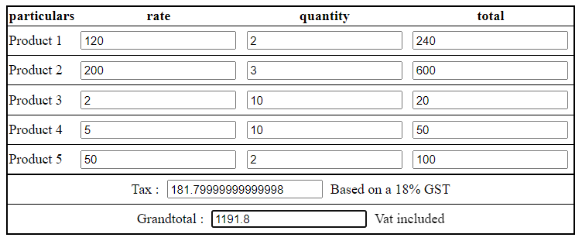

1. **Write a JQuery code to give animation to div on click of button.**

<!DOCTYPE html>

<html>

<head>

<script src="https://ajax.googleapis.com/ajax/libs/jquery/3.6.0/jquery.min.js"></script>

<script>

$(document).ready(function(){

$("button").click(function(){

$("div").animate({

left: '250px',

opacity: '0.5',

height: '150px',

width: '150px'

});

});

});

</script>

</head>

<body>

<button>Start Animation</button>

<div style="background:#98bf21;height:100px;width:100px;position:absolute;"></div>

</body>

</html>

**Output:-**

 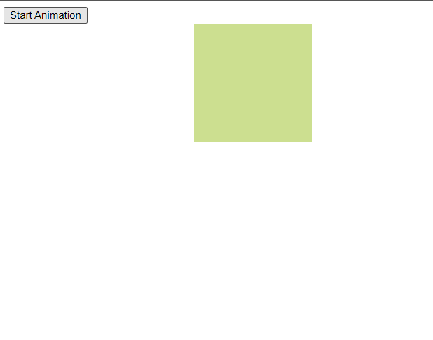

1. **Write a JQuery code to add dynamic element on page on click of button.**

<!DOCTYPE html>

<html lang="en">

<head>

<meta charset="utf-8">

<title>jQuery Bind Click Event to Dynamically added Elements</title>

<script src="https://code.jquery.com/jquery-3.5.1.min.js"></script>

<script>

$(document).ready(function () {

$("button").click(function () {

$("ol").append("<li>Milk <a href='javascript:void(0);' class='remove'>&times;</a></li>");

});

$(document).on("click", "a.remove", function () {

$(this).parent().remove();

});

});

</script>

</head>

<body>

<button>Add Milk</button>

<p>Click the above button to add milk. <p>

<ol>

<li>Milk</li><li>Milk</li><li>Milk</li>

</ol>

</body>

</html>

**Output:-**

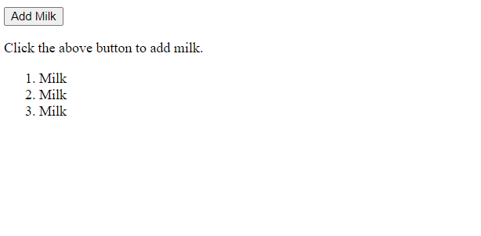 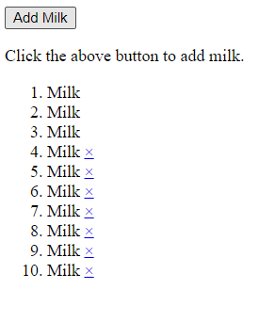

1. **Write a jQuery program to demonstrate the use of mouse event, keyboard event and form event.**

<!DOCTYPE html>

<head>

<meta name="viewport" content="width=device-width, initial-scale=1.0">

<title>Program 11</title>

<script src="https://ajax.googleapis.com/ajax/libs/jquery/3.6.0/jquery.min.js"></script>

<script>

let i = 0;

$(document).ready(function () {

//Mouse Event

$("p").click(function () {

$(this).hide();

})

$("#p1").hover(function () {

alert("You entered p1!");

},

function () {

alert("Bye! You now leave p1!");

})

//Keyboard event

$("input").keypress(function () {

$("span").text(i += 1);

});

//Form event

$("#target").blur(function () {

alert("Handler for .blur() called.");

});

});

</script>

</head>

<body>

<p>Click me first</p>

<p>Click me second</p>

<p id="p1" style="display: inline; border: 2px solid red">This is text</p><br><br>

Enter your name: <input type="text">

<p>Keypresses: <span>0</span></p>

<form>

<input id="target" type="text" value="Field 1">

</form>

</body>

</html>

**Output:-**

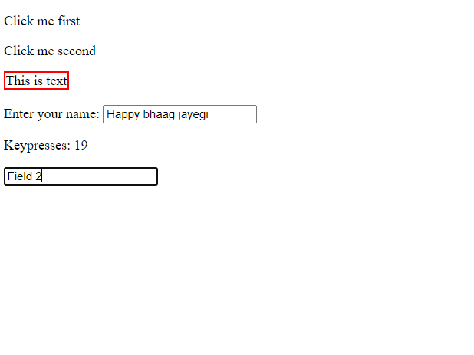

1. **Write a jQuery program to demonstrate the use of display effect, fade effect and slide effect.**

<!DOCTYPE html>

<html>

<head>

<script src="https://ajax.googleapis.com/ajax/libs/jquery/3.6.0/jquery.min.js"></script>

<script>

$(document).ready(function () {

//Display Effect

$(".btn1").click(function () {

$("p").hide();

});

$(".btn2").click(function () {

$("p").show();

});

//Fade Effect

$("button").click(function () {

$("#div1").fadeToggle();

$("#div2").fadeToggle("slow");

$("#div3").fadeToggle(3000);

})

//Side Effect

$("#flip").click(function () {

$("#panel").slideToggle("slow");

});

});

</script>

<style>

#panel,

#flip {

padding: 5px;

text-align: center;

width: 50%;

background-color: rgb(83, 219, 83);

border: solid 1px #c3c3c3;

margin: auto;

}

#panel {

padding: 50px;

display: none;

}

</style>

</head>

<body>

<p>This is a paragraph.</p>

<button class="btn1">Hide</button>

<button class="btn2">Show</button>

<br><br>

<button>Click to fade in/out boxes</button><br><br>

<div id="div1" style="width:80px;height:80px;background-color:red;"></div>

<br>

<div id="div2" style="width:80px;height:80px;background-color:green;"></div>

<br>

<div id="div3" style="width:80px;height:80px;background-color:blue;"></div>

<br><br>

<div id="flip">Click to slide the panel down or up</div>

<div id="panel">Hello world!</div>

</body>

</html>

**Output:-**

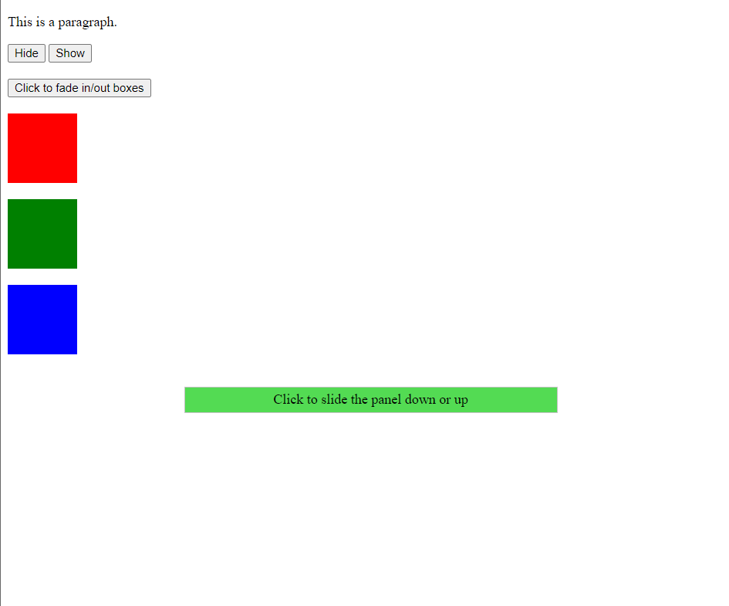 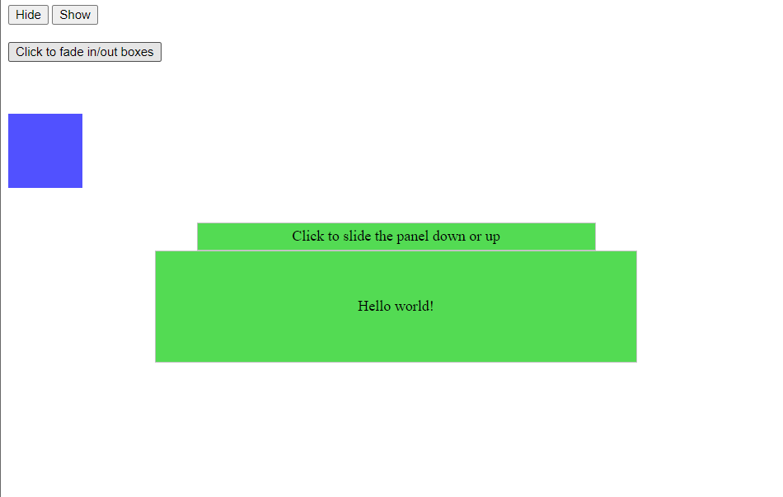

1. **A simple calculator web application that takes two numbers and an operator (+, -, /,*and %) from an HTML page and returns the result page with the operation performed on the operands.**

<!DOCTYPE html>

<html lang="en">

<head>

<meta charset="UTF-8">

<meta http-equiv="X-UA-Compatible" content="IE=edge">

<meta name="viewport" content="width=device-width, initial-scale=1.0">

<title>Document</title>

</head>

<body>

<form>

<label for="num1">Number1</label>

<input type="number" id="num1" name="num1"><br>

<label for="num2">Number2</label>

<input type="number" id="num2" name="num2"><br>

<br>

<label for="opr">Choose Operation : </label>

<select name="opr" id="opr">

<option value="add">Add</option>

<option value="sub">Subtract</option>

<option value="div">Divide</option>

<option value="mul">Multiply</option>

</select>

<br>

<input type="button" onClick="submit()" id="submit" value="Submit"><br>

<p>Result : </p>

<p id="res"></p>

</form>

<script>

but = document.getElementById('submit');

but.addEventListener("click" , function()

{

num1 = parseInt(document.getElementById("num1").value);

num2 = parseInt(document.getElementById("num2").value)

opr = document.getElementById('opr');

select = opr.options[opr.selectedIndex].value;

if(select == 'add')

{

cal = num1+num2;

document.getElementById('res').innerHTML = cal;

}

else if(select == 'sub')

{

cal = num1-num2;

document.getElementById('res').innerHTML = cal;

}

else if(select == 'div')

{

cal = num1/num2;

document.getElementById('res').innerHTML = cal;

}

else if(select == 'mul')

{

cal = num1*num2;

document.getElementById('res').innerHTML = cal;

}

});

</script>

</body>

</html>

**Output:-**

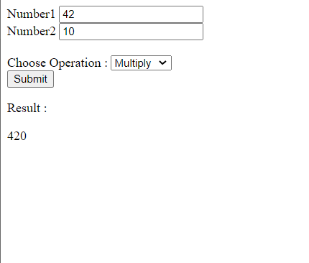

1. **Write PHP program for student registration. Perform insert, display, update and delete operations from database. (use any database).**

**_db_connect.php**

<?php

$server = "localhost ";

$username = 'root';

$password = '';

$database = "student";

$conn = mysqli_connect($server, $username, $password, $database);

if(!$conn)

die("Error " . mysqli_connect_error());

else

echo 'Connection made successfully!!'

?>

**Output:-**

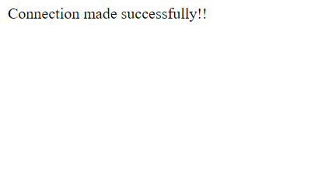

**welcome.php**

<!DOCTYPE html>

<html lang="en">

<head>

<meta charset="UTF-8">

<meta http-equiv="X-UA-Compatible" content="IE=edge">

<meta name="viewport" content="width=device-width, initial-scale=1.0">

<title>Welcome</title>

<style>

div{

display: flex;

justify-content: center;

align-items: center;

margin-top: 210px;

}

li{

font-size:30px;

}

</style>

</head>

<body>

<div>

<ul>

<li><a class="nav-link" href="insert.php">Insert</a></li>

<li><a class="nav-link" href="display.php">Display</a></li>

<li><a class="nav-link" href="update.php">Update</a></li>

<li><a class="nav-link" href="delete.php">Delete</a></li>

</ul>

</div>

</body>

</html>

**Output:**

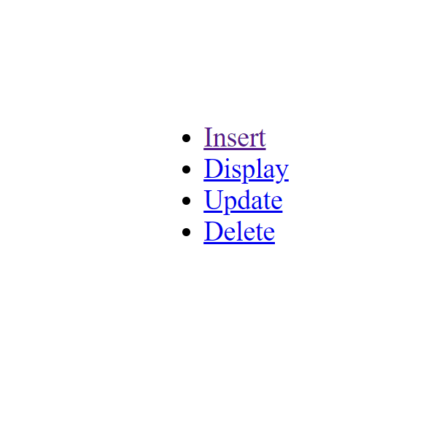

**insert.php**

<?php

if($_SERVER['REQUEST_METHOD'] == 'POST') {

$name = $_POST['name'];

$email = $_POST['email'];

$gender = $_POST['gender'];

if($gender == 'male') {

$gender = 'm';

}else $gender = 'f';

require '_db_connect.php';

$sql = "INSERT INTO student(`name`, `email`, `gender`) values('$name', '$email', '$gender')";

$result = mysqli_query($conn, $sql);

if($result) {

echo "<script>

alert('Regitration Successful');

</script>";

}else {

echo "<script>

alert('Not Registered');

</script>";

}

}

?>

<!DOCTYPE html>

<html lang="en">

<head>

<meta charset="UTF-8">

<meta http-equiv="X-UA-Compatible" content="IE=edge">

<meta name="viewport" content="width=device-width, initial-scale=1.0">

<title>Insert</title>

<style>

#container{

display: flex;

justify-content: center;

align-items: center;

margin-top:210px;

}

a{

font-size:25px;

}

</style>

</head>

<body>

<h2>

<a href="welcome.php">Home</a>

</h2>

<div id="container">

<form action="insert.php" method="post">

<label for="name">Name : </label>

<input type="text" name="name" id="name"><br><br>

<label for="email">Email : </label>

<input type="email" name="email" id="email">

<h3>Gender</h3>

<input type="radio" name="gender" id="male" value="male">

<label for="male">Male</label>

<input type="radio" name="gender" id="female" value="female">

<label for="female">Female</label><br><br>

<button type="submit" id="btn">Submit</button>

</form>

</div>

</body>

</html>

**Output:**

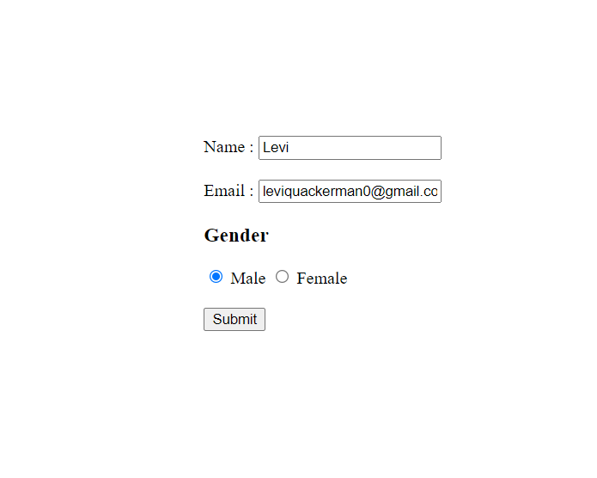

**display.php**

<?php

echo '<title>Display</title>';

echo '

<h2>

<a style="font-size:25px;" href="Welcome.php">Home</a>

</h2>';

require '_db_connect.php';

$sql = 'SELECT * FROM student';

$result = mysqli_query($conn, $sql);

if($result) {

$num = mysqli_num_rows($result);

if($num > 0) {

echo '<table border="2" cellspacing="3" cellpadding="2">

<tr>

<th>Name</td>

<th>Email</td>

<th>Gender</td>

</tr>';

while($row = mysqli_fetch_assoc($result)) {

$gen = "Male";

if($row['gender'] == 'f') $gen = 'Female';

echo

'<tr>

<td>'.$row['name'].'</td>

<td>'.$row['email'].'</td>

<td>'.$gen.'</td>

</tr>';

}

echo '</table>';

}

}

?>

**Output:**

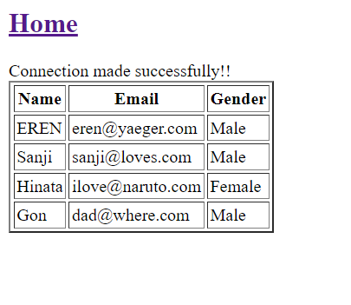

**update.php**

<?php

if($_SERVER['REQUEST_METHOD'] == 'POST') {

$name = $_POST['name'];

$email = $_POST['email'];

require '_db_connect.php';

$sql = "update student set `email` = '$email' where `name` = '$name'";

$result = mysqli_query($conn, $sql);

if($result) {

echo "<script>

alert('Updation Successful');

</script>";

}else {

echo "<script>

alert('User Not Found');

</script>";

}

}

?>

<!DOCTYPE html>

<html lang="en">

<head>

<meta charset="UTF-8">

<meta http-equiv="X-UA-Compatible" content="IE=edge">

<meta name="viewport" content="width=device-width, initial-scale=1.0">

<title>Update</title>

<style>

a{

font-size:25px;

}

</style>

</head>

<body>

<h2>

<a href="Welcome.php">Home</a>

</h2>

<form action="update.php" method="post">

<label for="name">Name:</label>

<input type="text" placeholder="Enter Name" name="name"><br><br>

<label for="email">Enter your New Email:</label>

<input type="email" placeholder="Enter new Email" name="email">

<button type="submit">Update</button>

</form>

</body>

</html>

**Output:**

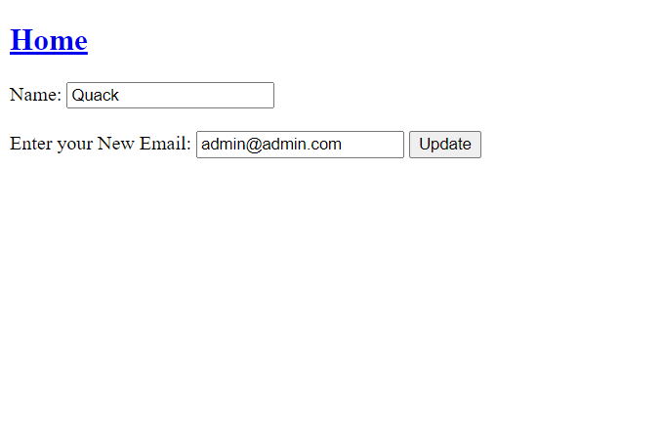

**delete.php**

<?php

if($_SERVER['REQUEST_METHOD'] == 'POST') {

$name = $_POST['name'];

require '_db_connect.php';

$sql = "delete from `student` where `name`='$name'";

$result = mysqli_query($conn, $sql);

if($result) {

echo "<script>

alert('Deletion Successful');

</script>";

}else {

echo "<script>

alert('User Not Found');

</script>";

}

}

?>

<!DOCTYPE html>

<html lang="en">

<head>

<meta charset="UTF-8">

<meta http-equiv="X-UA-Compatible" content="IE=edge">

<meta name="viewport" content="width=device-width, initial-scale=1.0">

<title>Delete</title>

<style>

a{

font-size:25px;

}

</style>

</head>

<body>

<h2>

<a href="Welcome.php">Home</a>

</h2>

<form action="delete.php" method="post">

<label for="name">Name:</label>

<input type="text" placeholder="Enter Name" name="name">

<button type="submit">Delete</button>

</form>

</body>

</html>

**Output:**

**Before deletion:- Deletion command:- After deletion:-**

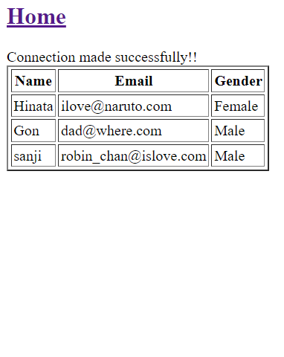 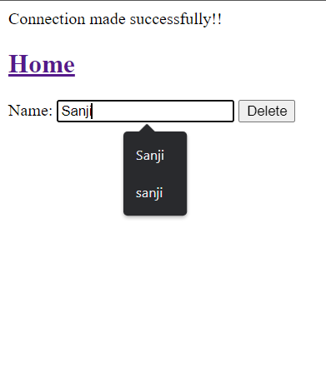 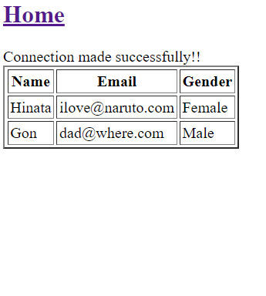

1. **Write a PHP program to store current date-time in a COOKIE and display the ‘Last visited on’ date-time on the web page upon reopening of the same page.**

<?php

// time for 60 days in future

$cookie_value = time() + 60*60*60*24;

setcookie('lastvisit' , date("G:i , m/d/y") , $cookie_value , )

?>

<?php

if(isset($_COOKIE['lastvisit']))

{

echo "Your last visit time and date are : " . $_COOKIE['lastvisit'] . "<br>";

setcookie('lastvisit',"",time()-3600);

}

else{

echo "This is your first visit <br>";

}

?>

**Output:-**

