**Assignment-1**

**How to install Web Server on Windows Machine?**

**Step 1:** Sign in to AWS Management Console either by root or IAM user.

* Open website aws.amazon.com
* Click on **Log Back In** it will redirect you to the sign in page.
* After Signing in, make the default AWS Region as **Asia Pacific (Mumbai) ap-south-1.**

**Step 2:** Launching an Instance.

* Click on **Services** on the top-left corner of the dashboard >> open **Compute** section >> click on **EC2**.
* Click on **Instances** in dashboard and click on **Launch Instances** option.
* A new page named **Launch an instance** will be opened.
* Give a name to the newly created instance and select the desired OS for the instance. Select **t2.micro** as the Instance type.
* Create new key pair of .pem and the file will be downloaded.
* Leave all setting as it is and hit **Launch Instance.**
* After which an instance will be created. You can check its running status by going to **Instances** section.

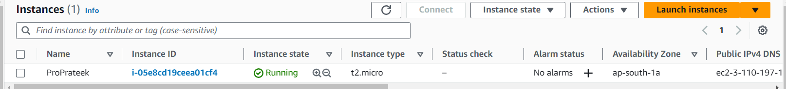

**Step 3:** Connecting the instance**.**

* Select the Instance, click on **Connect** and switch the tab to **RDP client**.
* Click on **Download Remote Desktop file** option and the file will be downloaded.
* Click on **Get password** >> **upload primary key file**.
* Select the key pair file (previously downloaded) >> click **Decrypt password**.
* After that copy the password displayed >> open the remote desktop file >> click Connect >> paste the password >> press ok.

The instance with the desired Windows OS will be working successfully in few moments.

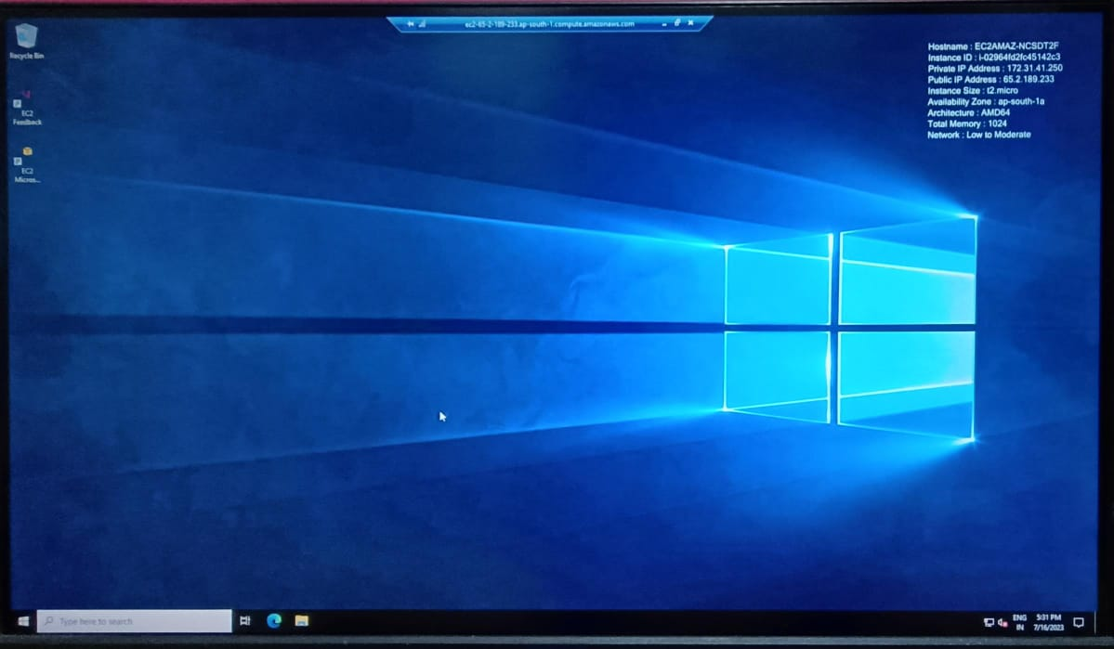

**Step 4:** Installing the Apache Web Server**.**

* Open Microsoft Edge >> search Apache Install for Windows >> go to the official website >> download the zip file >> extract the contents of the zip file.
* Select the **Apache24** folder and move it to the **C drive**.
* Copy the path of the **bin** folder inside the Apache24 folder.
* Open **Command Prompt** >> type **cd** and paste the path copied >> press enter key.
* Type **httpd -k install** >> press enter key.

Apache web server will be installed successfully.