**PRN**: 2020BTEIT00041

**Name**: Om Vivek Gharge

**Batch**: S2

**LAB ESE**

**Problem Statement:** To divide the network into three parts using routers and perform packet transferring between network

**Platform:** Cisco packet tracer

**Devices Required:** PC, Switch and Router

**Topology:**

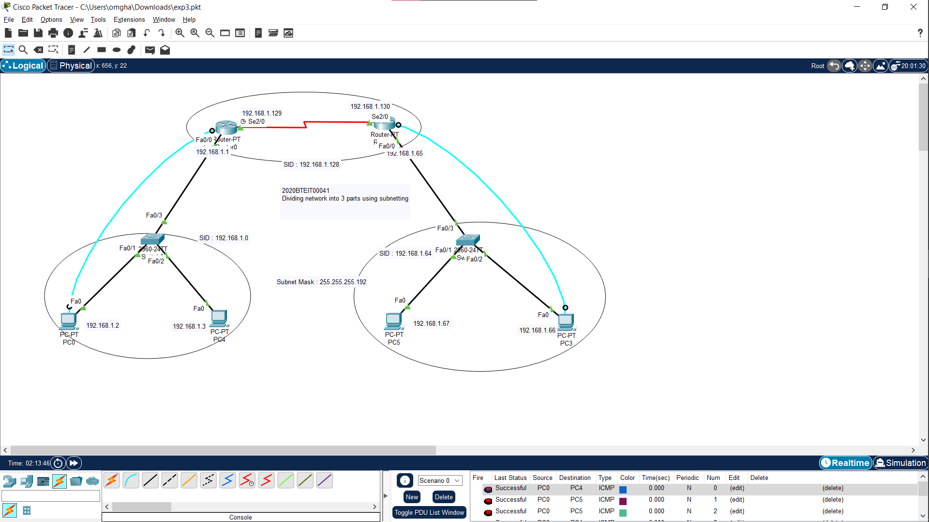

**CONCLUSION:**

Communication between two networks present in the different subnets is possible using routers. Subnetting using router done successfully.

Dr. P. K. Kharat

(Course Teacher)