

**PLATINUM JUBLEE**

**Celebrating 75 years of WCE & 20 years of Department**



**Walchand College of Engineering, Sangli**

***(Government Aided Autonomous Institute)***

Department of Information Technology

Computer Networks Lab

EVEN SEMESTER AY 2021-22

*Submitted by*

Name: Om Vivek Gharge

PRN: 2020BTEIT00041

Batch: S2

Course Code: 5IT272

Date: 19/03/2022

Contact Number: 9730369761

**LA-1 Performance**

**Experiment Name:** Implement and execute VLAN 1 & 2 in CISCO packet tracer on switch to split the network and observe VLAN table.

**Platform:** CISCO packet tracer

**Devices Required:** Switches, PC.

**Design:** LAN consisting of sixteen PCs and one Switch.

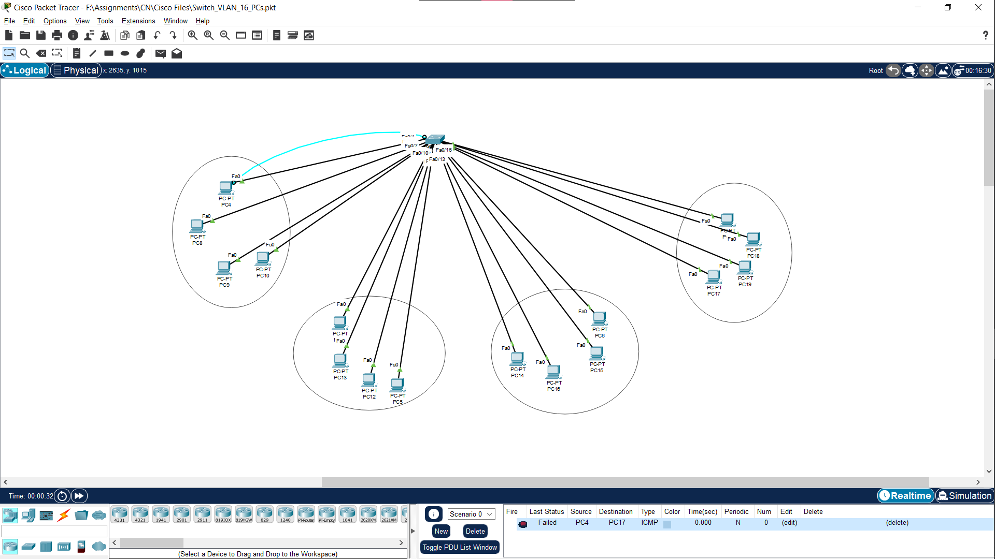

**Procedure:**

1. Arrange the devices in above given topology.
2. Allocate IP address to the PCs and configure the switch

Commands:

Enable switch

Config t

1. Create VLANS using these commands

Vlan 1

Exit

Vlan 2

Exit

Vlan 3

Exit

Vlan 4

Exit

1. Place the PCs in the VLANs by using commands:

Int fa 0/1

Switchport mode access

Switchport access vlan 1

No shutdown

Exit

Similarly Use these commands to place each PC in vlan.

1. Check if the PCs are present in the VLAN by checking out the vlan table by using command:

“do show vlan”

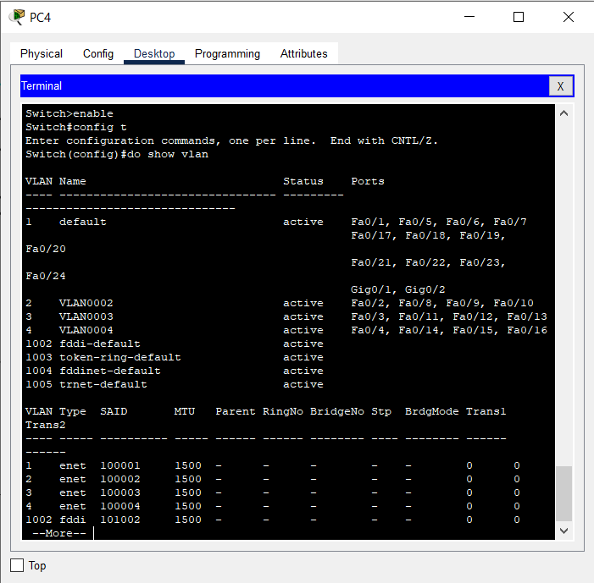

Conclusion:

VLAN has been implemented and PCs in different VLANs cannot communicate as they are isolated.

Questions:

Q1. Which switch is being used and why?

Ans: Switch used is 2960 and it is used because of the requirement of the ports

Q2. Can we use any other switch instead if we want a certain number of ports?

Ans: Yes, we can use any other switch of ports as per our requirement as the switches can have ethernet ports from 5 to 50.

Q3. How many ports of the switch are in use and how many ports are there in the switch?

Ans: 16 FastEthernet ports of the switch are in use. The total number of ports present on the switch are 24 FastEthernet ports and 2 GigabitEthernet ports.

Q4. Can PC4 send any packets to PC17?

Ans: No, in this topology it cannot send packets or ping, as they are present in different VLANs and are isolated.

