**Walchand College of Engineering, Sangli**

(An Autonomous Institute)

Department of Information Technology

Name: Om Vivek Gharge

PRN: 2020BTEIT00041

Batch: S2

Subject: Computer Networking

**Experiment No: 1**

**Title:** To implement a VLAN in a switch and splitting the network

**Devices:** Switch, PC

**Topology** **Design:**

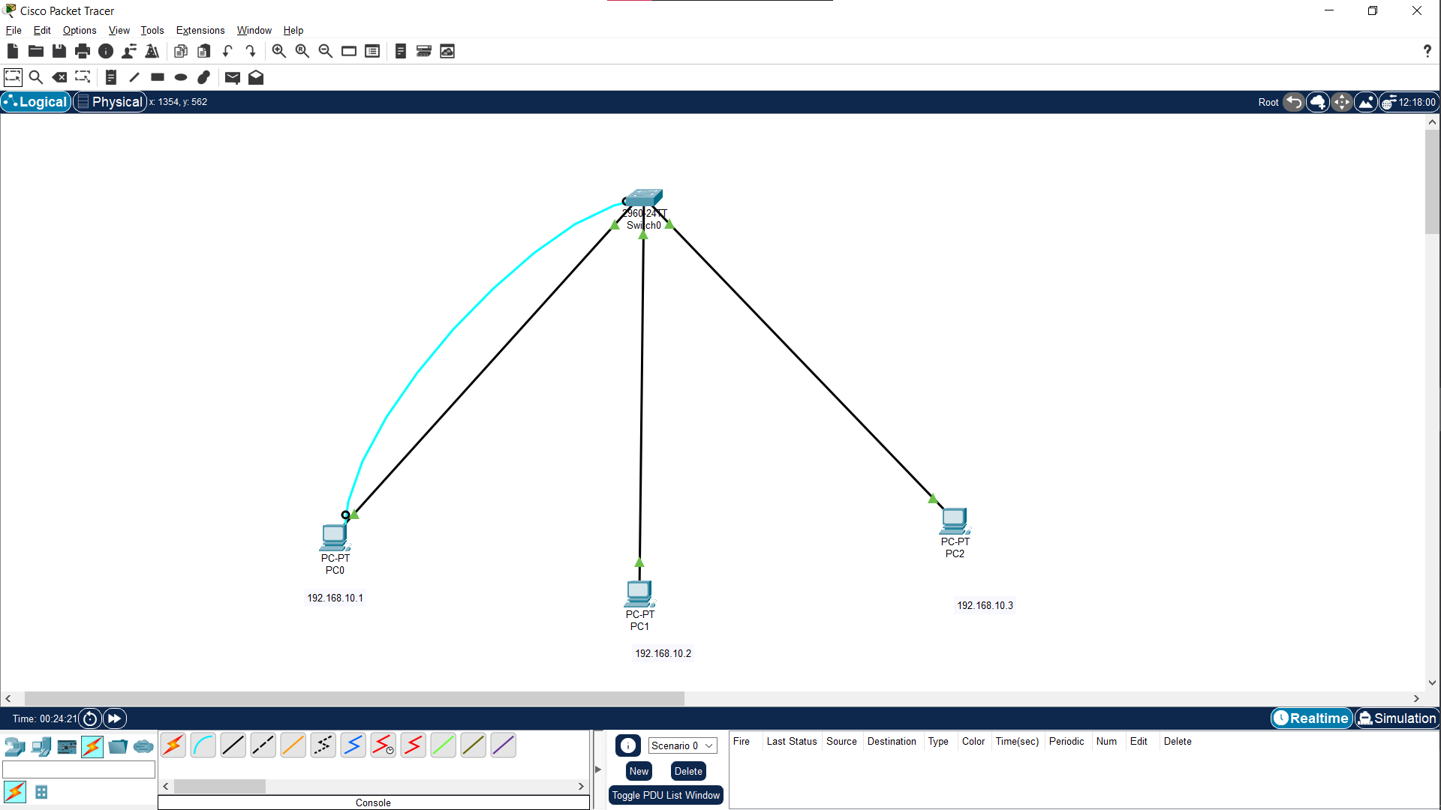

**Procedure:**

1. Connect the devices as shown in above diagram.
2. Assign IP address to each PC.
3. Open terminal and enable switch and use command

“show mac-address-table” to see all the connected PCs with the switch.

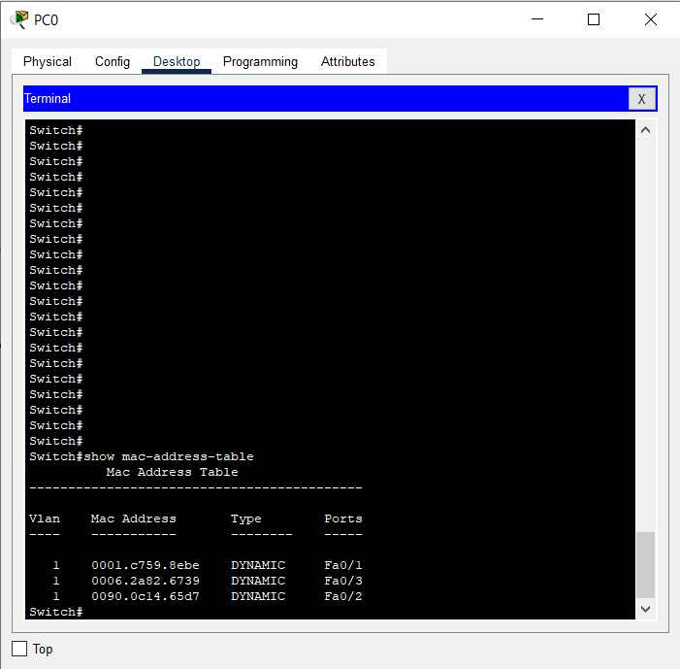

1. In order to check if all the PCs are connected in a VLAN we will send packets between them by using the command “ping 192.168.10.3” (i.e. IP of receiver’s PC).

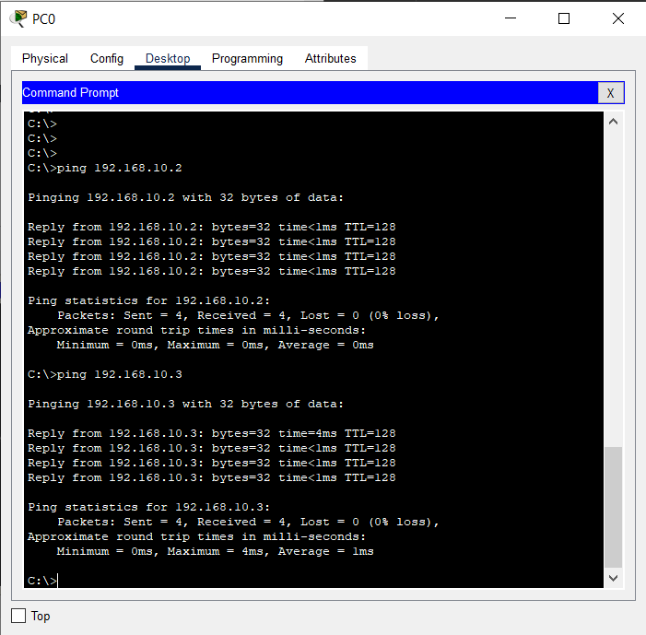

1. The packet has been transferred successfully via switch
2. Go to terminal and configure the switch using command “config t”
3. Use command “do show vlan” to see how many VLAN are present.

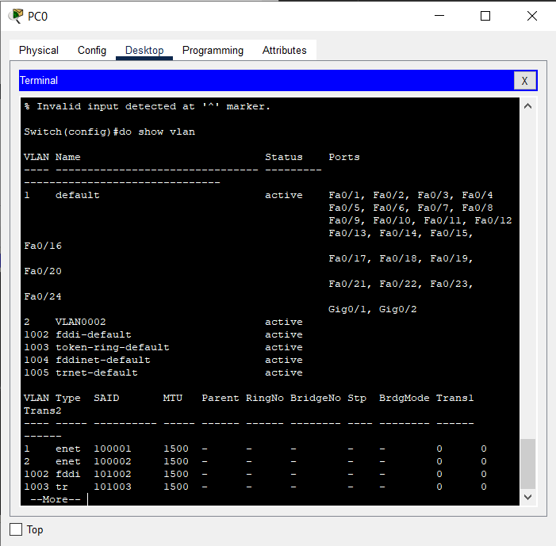

1. We have only one VLAN
2. Configure terminal and use “vlan 2” command to create a VLAN.
3. Exit and use command “do show vlan” to see newly

created VLAN. 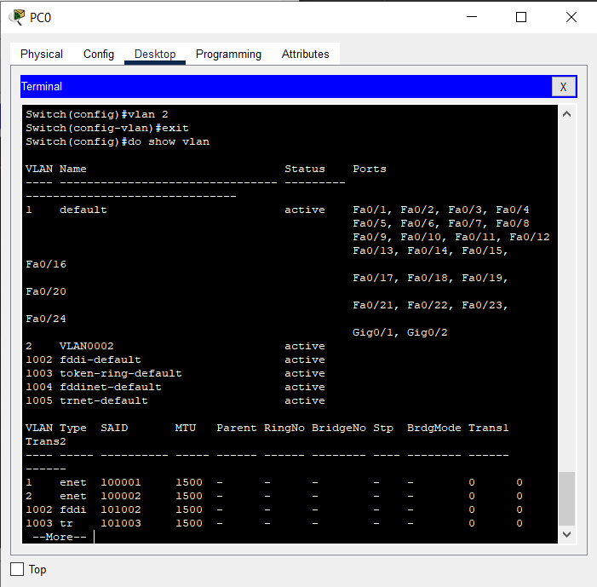

1. Add the host connected to Fa 0/3 to VLAN 2 . 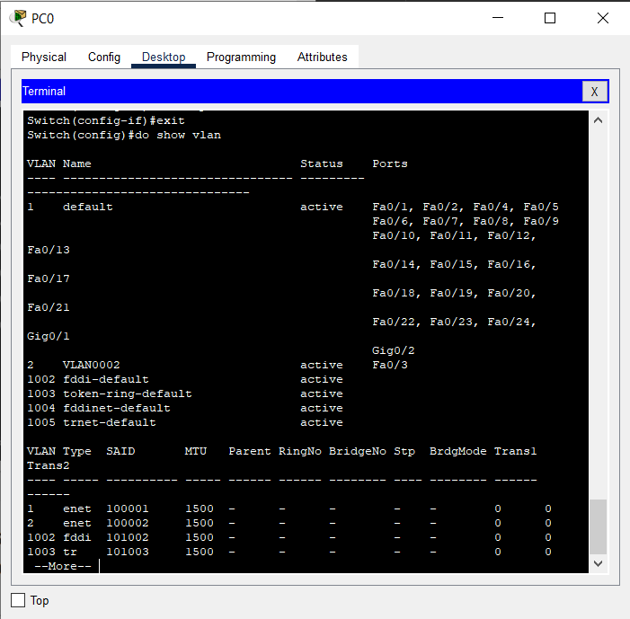
2. After adding host to VLAN 2 , try sending data packet from host in VLAN 1 to host in VLAN 2, it will fail 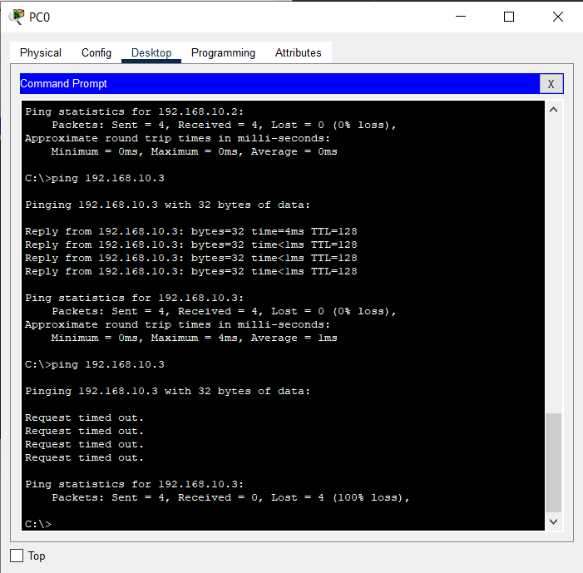

**Conclusion:**

We implemented VLAN in a switch and created a logical partition in it.