

**PLATINUM JUBLEE**

**Celebrating 75 years of WCE & 20 years of Department**



**Walchand College of Engineering, Sangli**

***(Government Aided Autonomous Institute)***

Department of Information Technology

Computer Networks Lab

EVEN SEMESTER AY 2021-22

*Submitted by*

Name: Om Vivek Gharge

PRN: 2020BTEIT00041

Batch: S2

Course Code: 5IT272

Date: 19/03/2022

Contact Number: 9730369761

**Department of Information Technology**

2021-22

**Experiment Number:** 1

**Experiment Name:** Implement and execute VLAN 1 & 2 in CISCO packet tracer on switch to split the network and

observe VLAN table.

**Contents:**

**Problem Statement:**

Implement and execute VLAN 1 & 2 in CISCO packet tracer on switch to split the network and observe VLAN table

**Platform:** CISCO packet tracer

**Devices Required:** Switches, PC.

**Design:** LAN consisting of three PCs and one Switch.

**Implementation:**

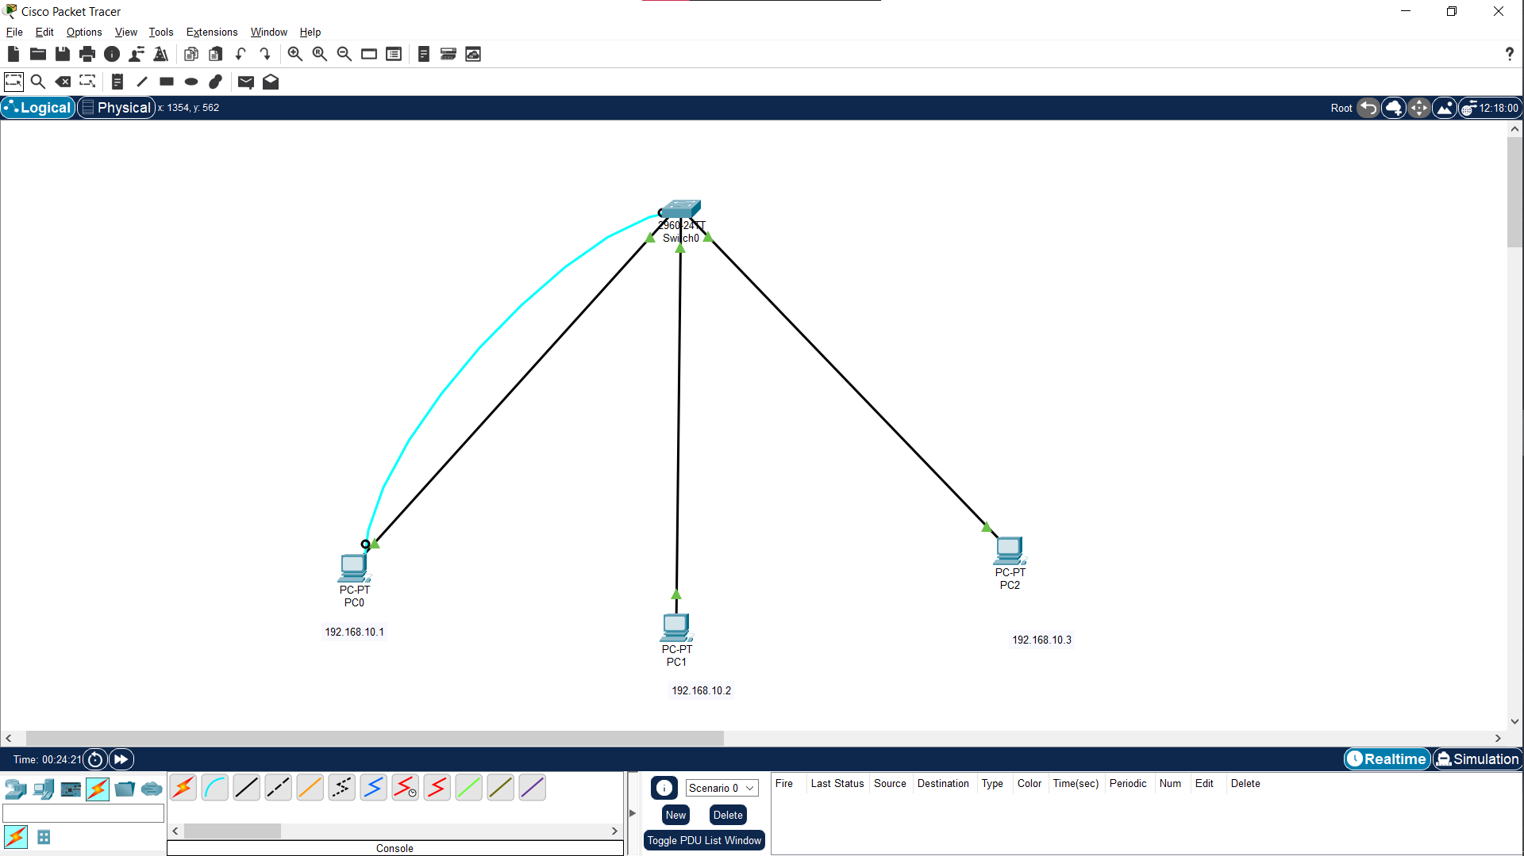

1. Connect the devices as shown in above diagram.
2. Assign IP address to each PC.
3. Open terminal and enable switch and use command

“show mac-address-table” to see all the connected PCs with the switch.

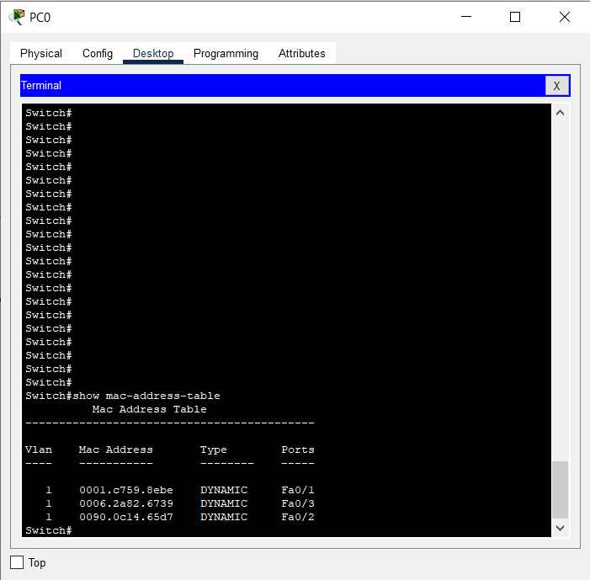

1. In order to check if all the PCs are connected in a VLAN we will send packets between them by using the command “ping 192.168.10.3” (i.e. IP of receiver’s PC).

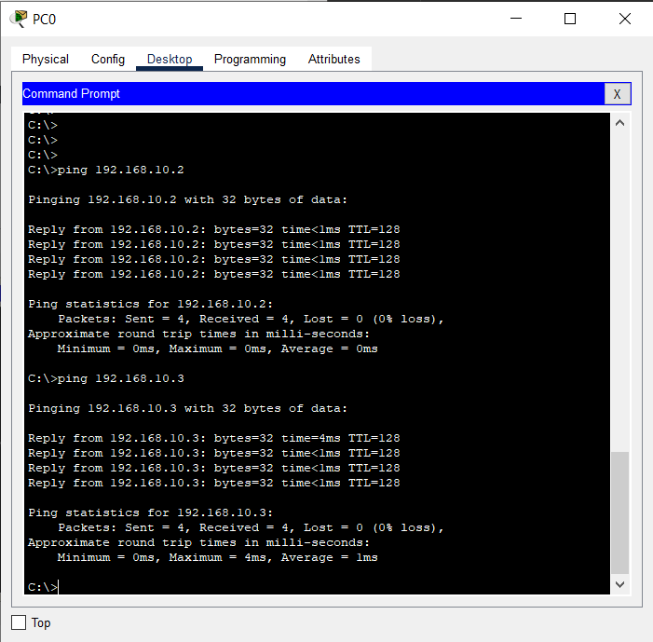

1. The packet has been transferred successfully via switch
2. Go to terminal and configure the switch using command “config t”
3. Use command “do show vlan” to see how many VLAN are present.

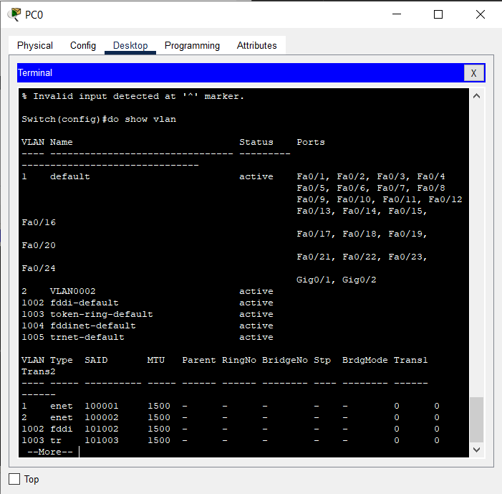

1. We have only one VLAN
2. Configure terminal and use “vlan 2” command to create a VLAN.
3. Exit and use command “do show vlan” to see newly

created VLAN. 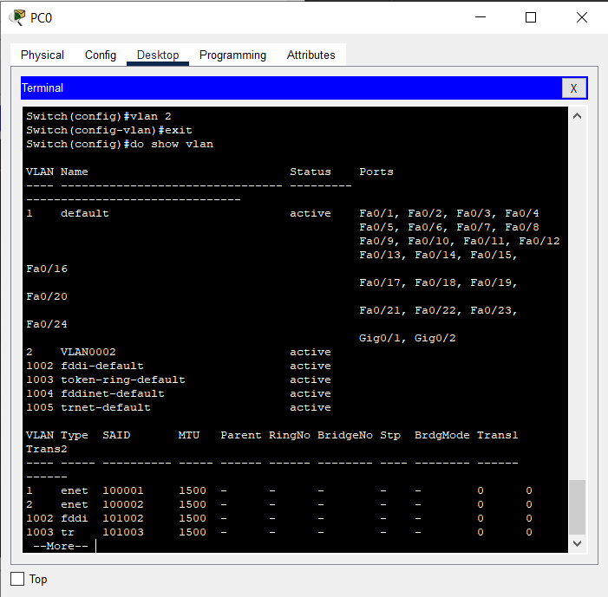

1. Add the host connected to Fa 0/3 to VLAN 2 . 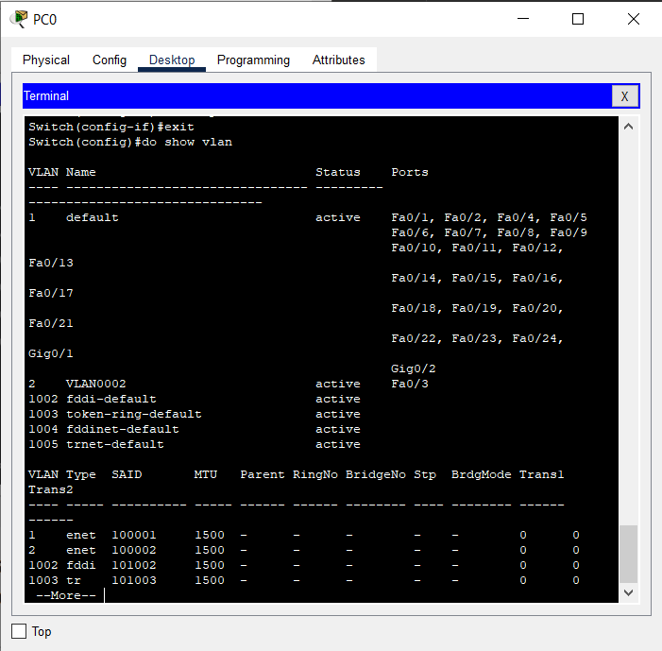
2. After adding host to VLAN 2 , try sending data packet from host in VLAN 1 to host in VLAN 2, it will fail 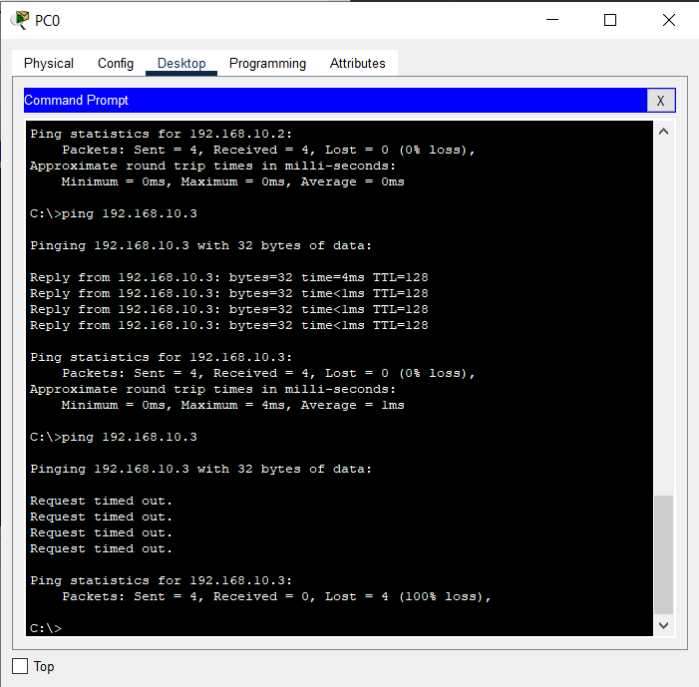

**Results:**

VLAN between PC 1 and PC 2 is successfully created and the packet transfer between PC 1 and PC 2 is failed.

**Conclusion:**

We implemented VLAN in a switch and created a logical partition in it therefore PC’s in different VLAN couldn’t transfer any packet between one another.

Dr. P. K. Kharat

(Course Teacher)