

**PLATINUM JUBLEE**

**Celebrating 75 years of WCE & 20 years of Department**



**Walchand College of Engineering, Sangli**

***(Government Aided Autonomous Institute)***

Department of Information Technology

Computer Networks Lab

EVEN SEMESTER AY 2021-22

*Submitted by*

Name: Om Vivek Gharge

PRN: 2020BTEIT00041

Batch: S2

Course Code: 5IT272

Date: 19/04/2022

Contact Number: 9730369761

**Department of Information Technology**

2021-22

**Experiment Number:** 2

**Experiment Name:** Implement and execute VLAN 1 & 2 in CISCO packet tracer on router to connect two different networks, and observe route tables and VLAN databases.

**Contents:**

**Problem Statement:**

Implement and execute VLAN 1 & 2 in CISCO packet tracer on router to connect two different networks, and observe route tables and VLAN databases.

**Devices Required:** PC, Switch, Router

**Design**:

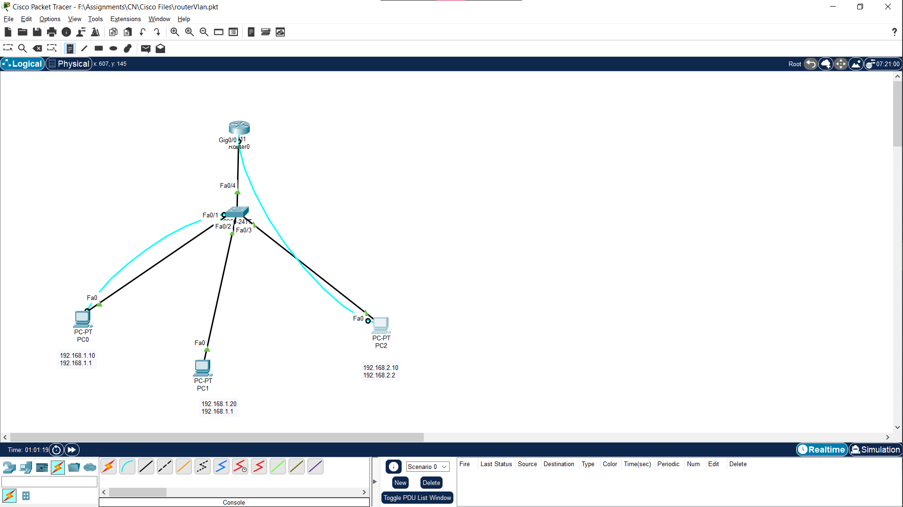

**Implementation:**

1. Arrange components as shown in above diagram and assign IP to each PC and default gateway.
2. Create a LAN and Create two VLANs, One VLAN consisting of two PCs and One consisting of another one, using switch.

Commands:

Enable switch

config t

vlan 10

exit

vlan 20

exit

1. Add devices to the VLAN 10 and 20, make port Fa0/4 in trunk mode.

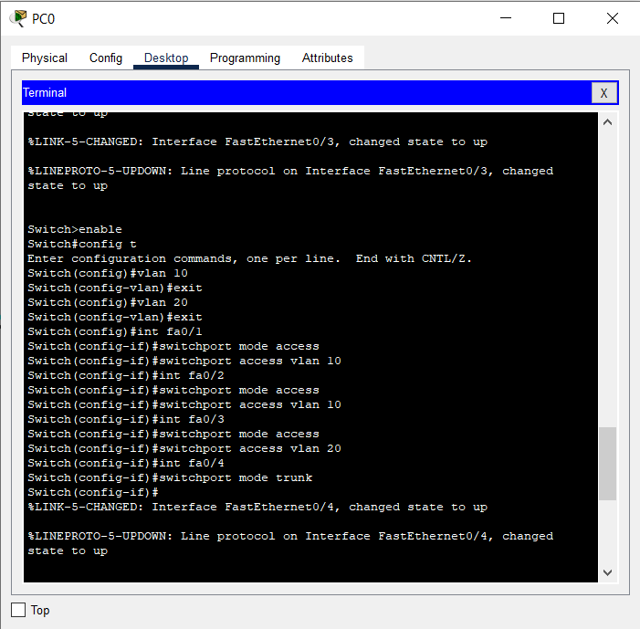

1. Enable and configure the router through terminal
2. Configure VLAN 10 and VLAN 20 with following commands:

interface gigabitEthernet 0/0.10

encapsulation dot1Q 10

ip address 192.168.1.1 255.255.255.0

No shutdown

Exit

Similarly configure VLAN 10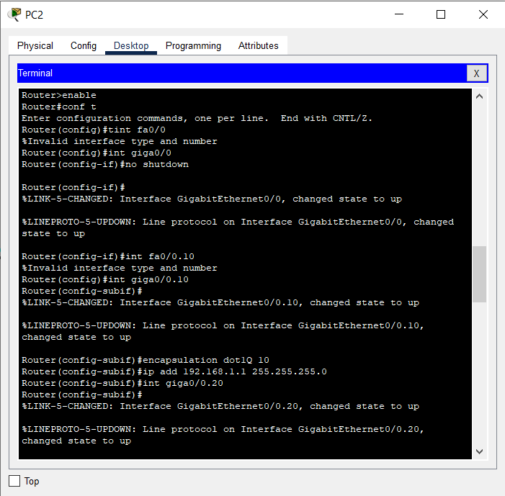

1. Router is now configured, now ping pc0 and pc2 to check if packet transfer is possible in other VLAN

**Results:**

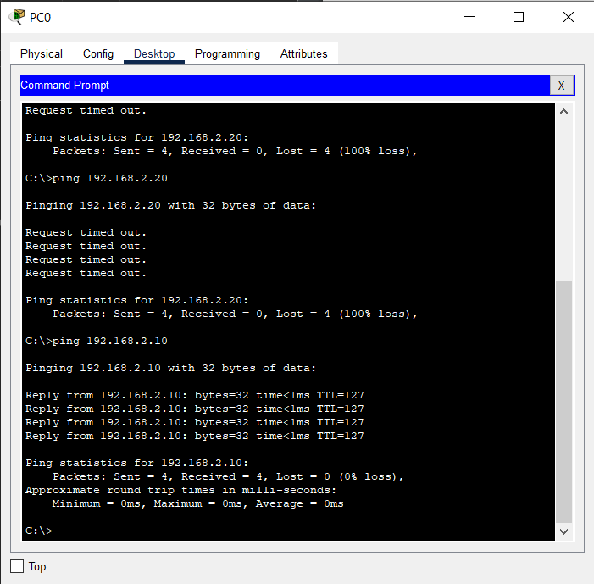

**Conclusion:**

Here PC 0 & PC1 have a successful packet transfer, thus router is successfully configured.

Dr. P. K. Kharat

(Course Teacher)