

**PLATINUM JUBLEE**

**Celebrating 75 years of WCE & 20 years of Department**



**Walchand College of Engineering, Sangli**

***(Government Aided Autonomous Institute)***

Department of Information Technology

Computer Networks Lab

EVEN SEMESTER AY 2021-22

*Submitted by*

Name: Om Vivek Gharge

PRN: 2020BTEIT00041

Batch: S2

Course Code: 5IT272

Date: 19/04/2022

Contact Number: 9730369761

**Department of Information Technology**

2021-22

**Experiment Number:** 3

**Experiment Name:** Subnetting

**Contents:**

**Problem Statement:**

To divide the network into three parts and perform packet transferring.

**Devices Required:** PC, Switch, Router

**Design**:

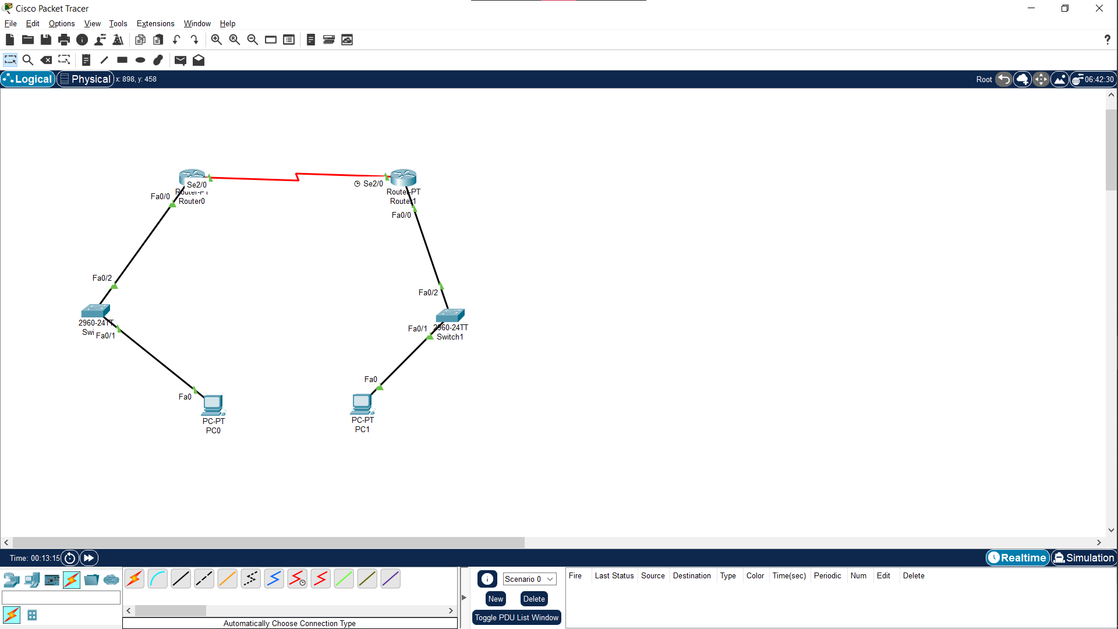

**Implementation:**

1. Arrange components as shown in above diagram and assign IP to each PC
2. Configure the router and the switch

Commands:

enable

config t

interface fastEthernet 0/1

switchport mode trunk

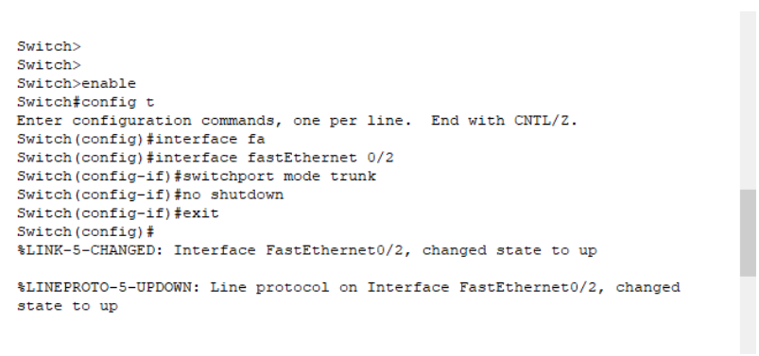

Similarly do the same for other

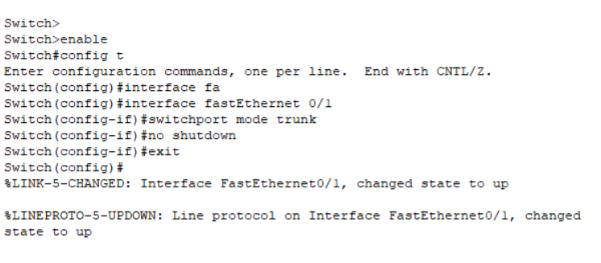

1. For configuring router use command “ip address ip_to_be_set”

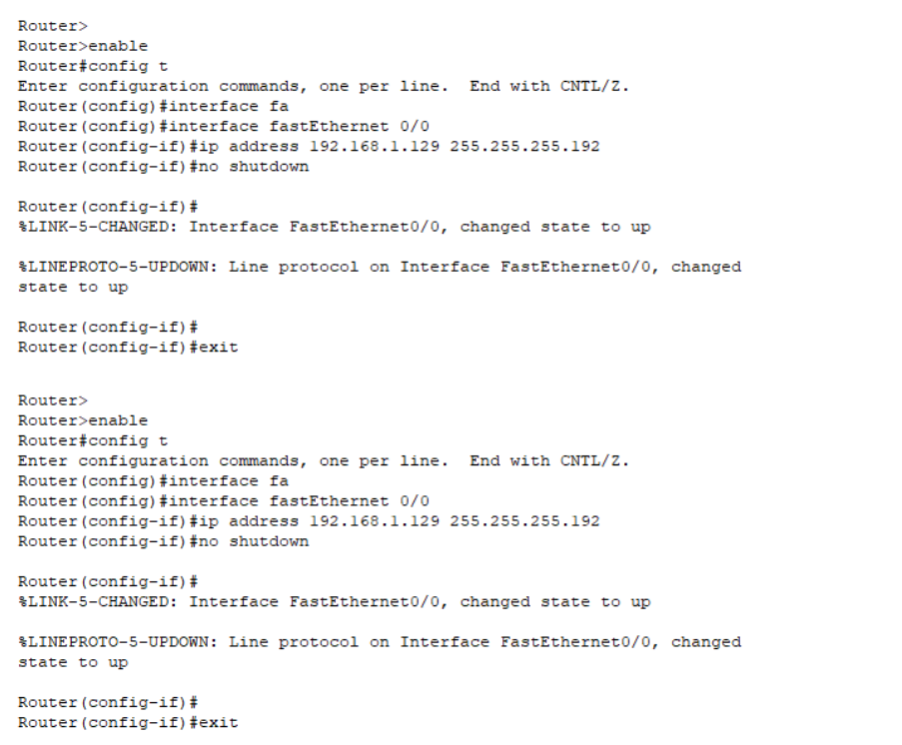

1. Next step is to interface the serial port using the command ● “interface serial 2/0” > “ip address new_ip_of_router subnet_Mask” 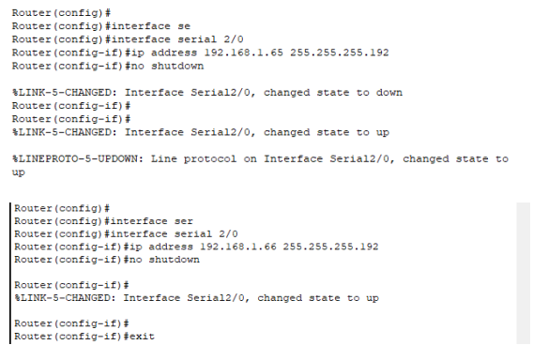
2. To set the ip route between both the networks use the command “ip route dest_net_id subnet_mask ip_next_hop”

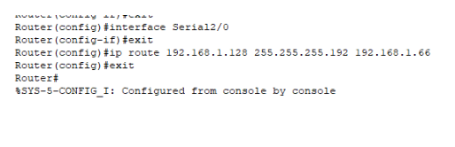

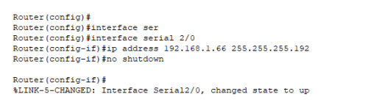

1. Subnetting is completed

**Results:**

Communication between two systems present in the different subnets is possible using routers

Dr. P. K. Kharat

(Course Teacher)