PRN: 2020BTEIT00041

File Handling CPP:

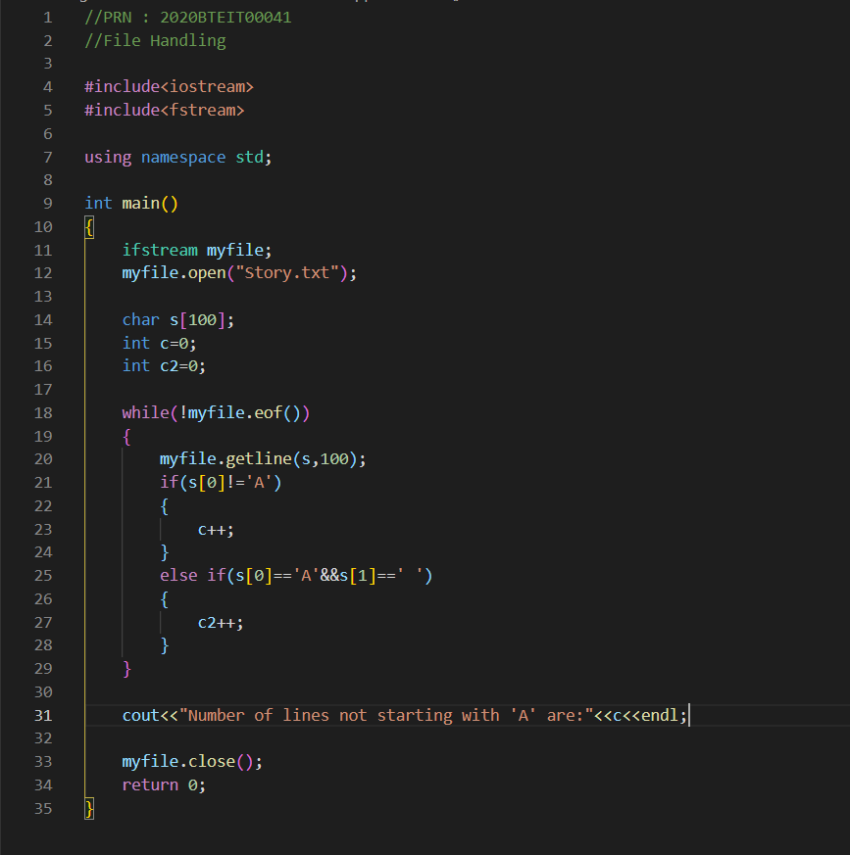

OUTPUT:

