PRN:2020BTEIT00041

Name: Om Vivek Gharge

Hybrid Inheritance

CODE: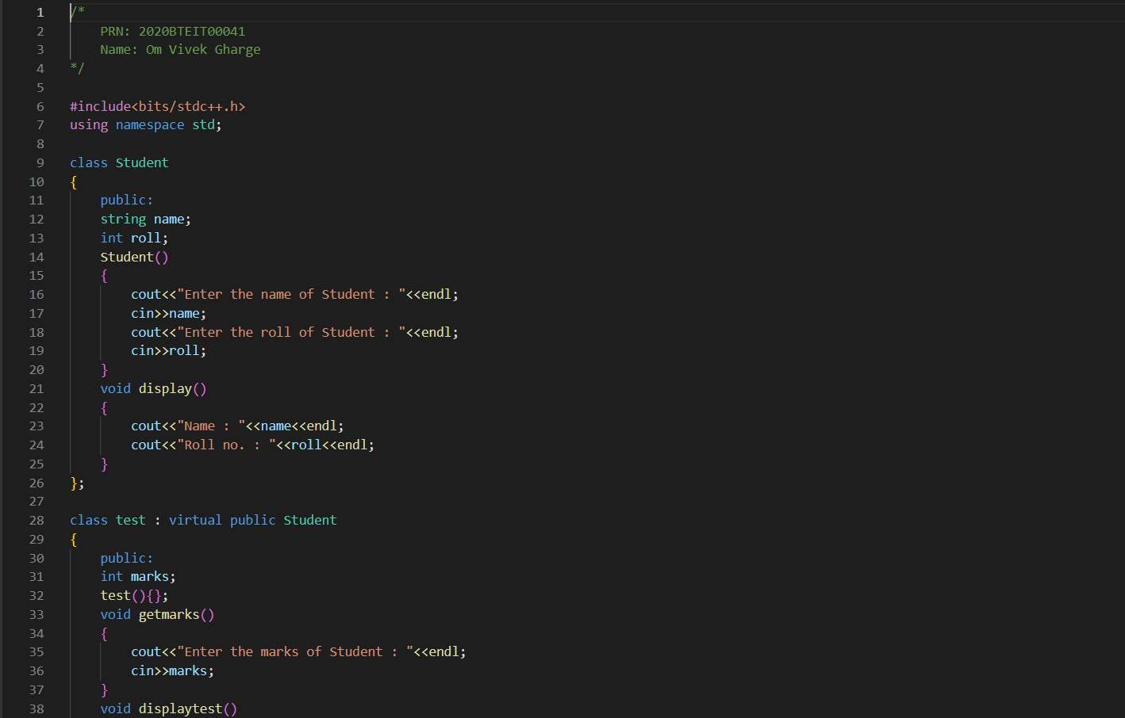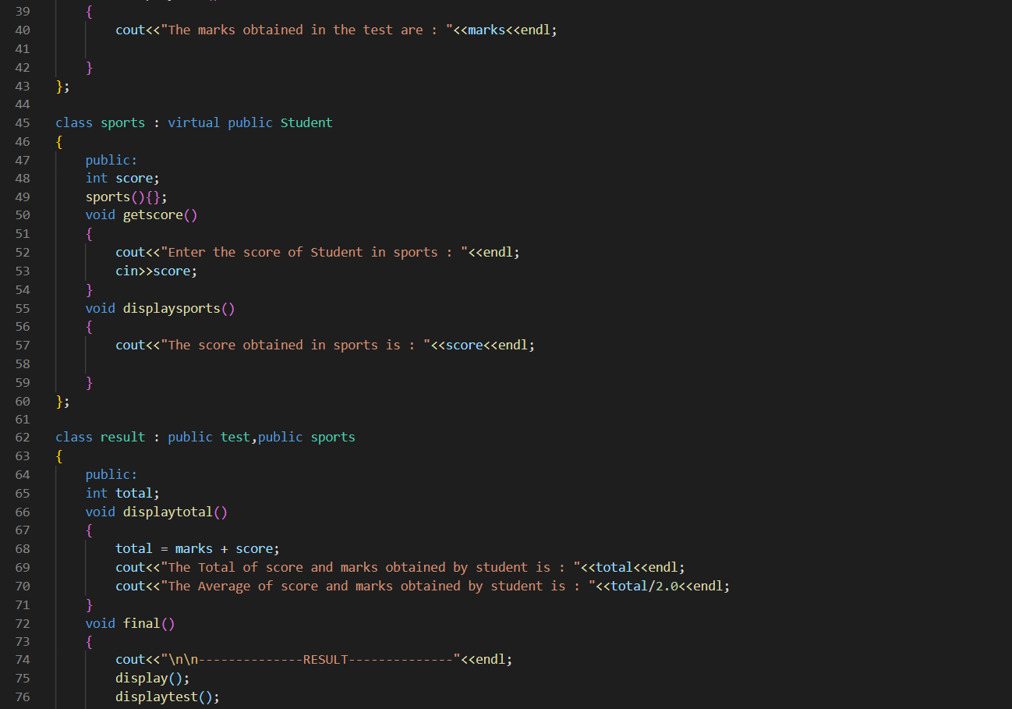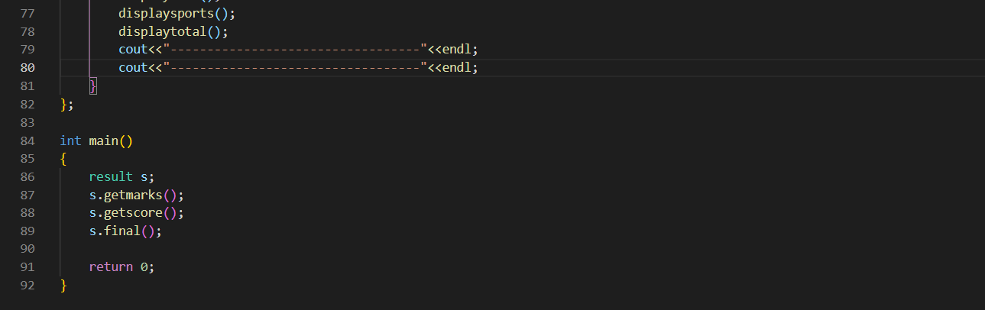

OUTPUT:

