**NAME**: Om Vivek Gharge

**PRN**: 2020BTEIT00041

**SQL DATABASE:**

**Tables**:

1. Tables in school:

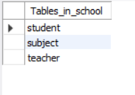

1. Student table:

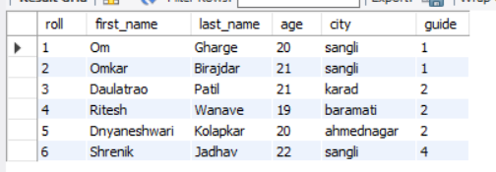

1. Teachers table:

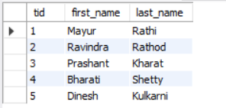

1. Subject table:

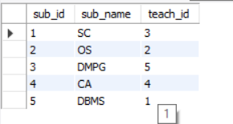

**Queries:**

1. **Logical Operator**

query = SELECT * FROM student WHERE age >20 AND age<22

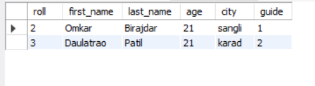

1. **Aggregation queries**

query =SELECT first_name,MAX(age) FROM student;

To select tuple from student table with maximum age

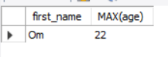

1. **Range operators**

query = SELECT * FROM student WHERE roll IN(2,4);

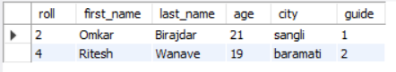

1. **Group by clause**

query = SELECT COUNT(age),age FROM student GROUP BY age;

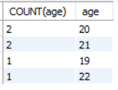

1. **Order by clause**

query = SELECT * FROM student ORDER BY age;

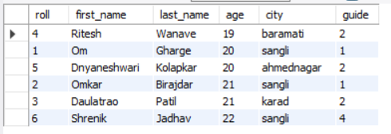

query = SELECT * FROM student ORDER BY age DESC;

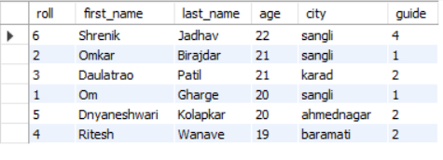

1. **Having clause**

SELECT * FROM student HAVING city="sangli";



1. **Queries based on patterns**

query = SELECT * FROM student WHERE first_name LIKE “O%”;

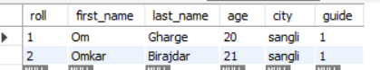

1. **Nested Queries**

query = SELECT * FROM student WHERE age >(SELECT AVG(age) FROM student);

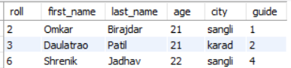

(

Printing AVG:

Query = SELECT avg(age) as avg FROM student ;



)