PRN: 2020BTEIT00041

Name: Om Vivek Gharge

Q.) Circular Linked List

CODE: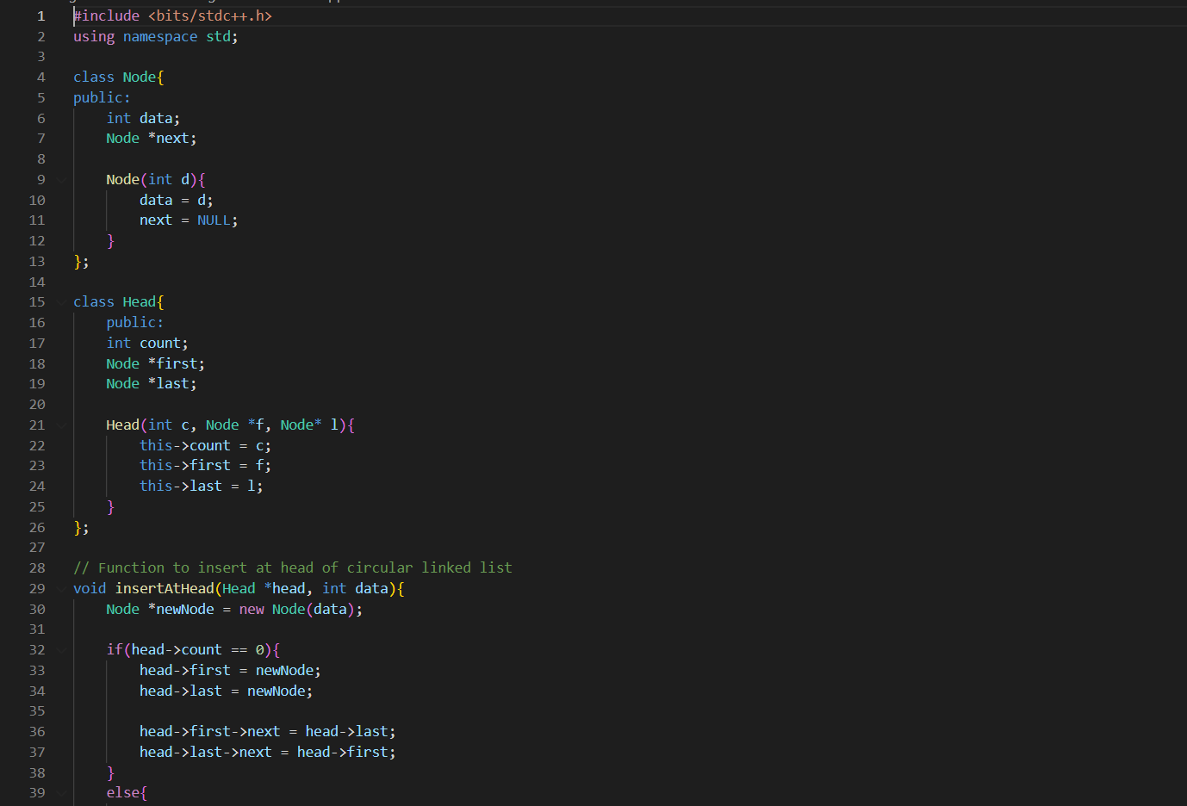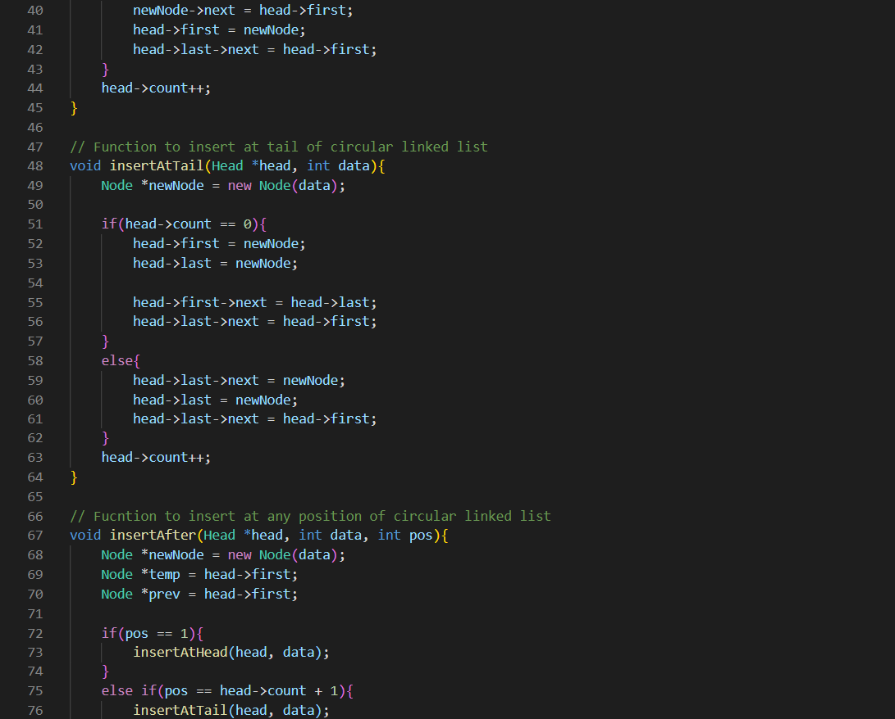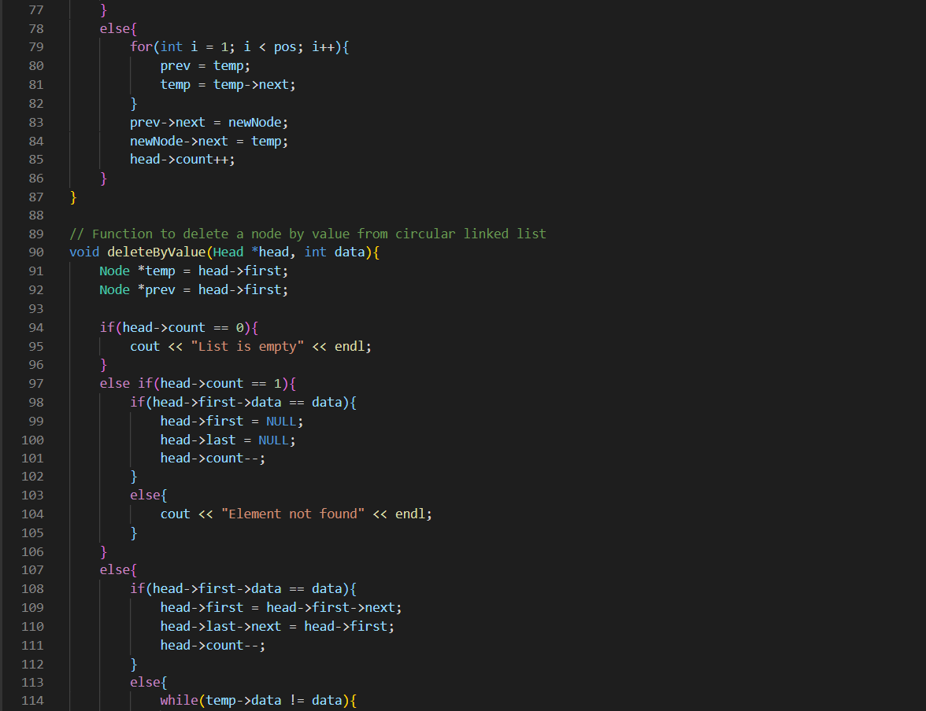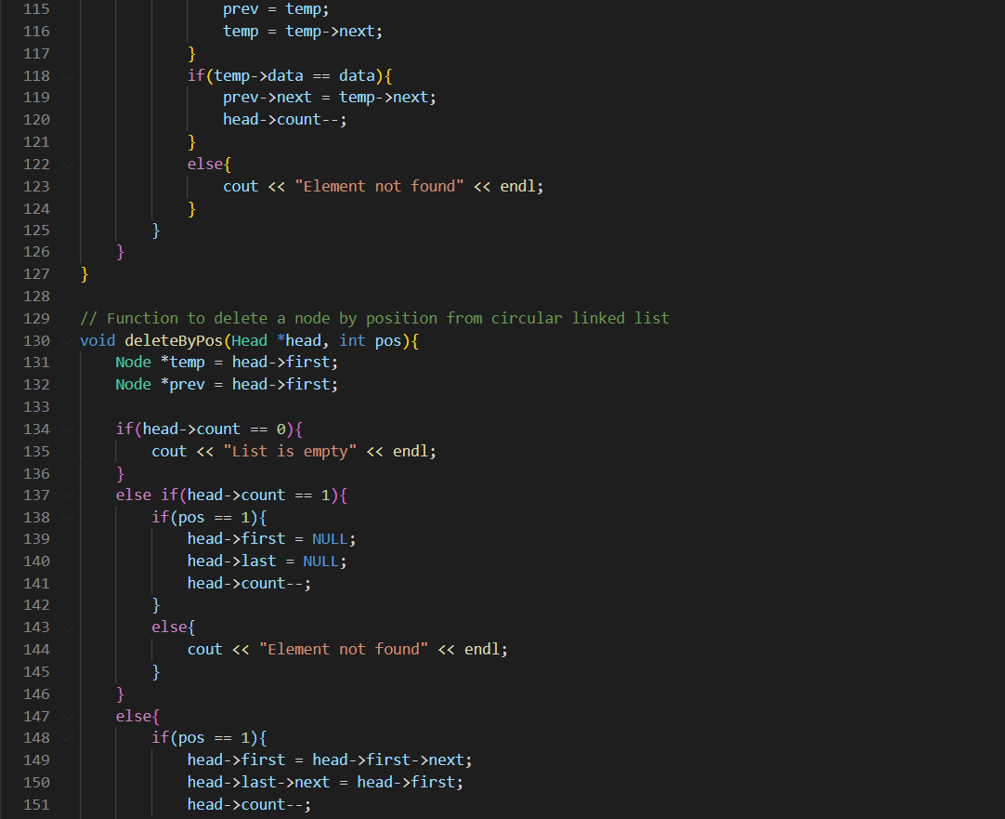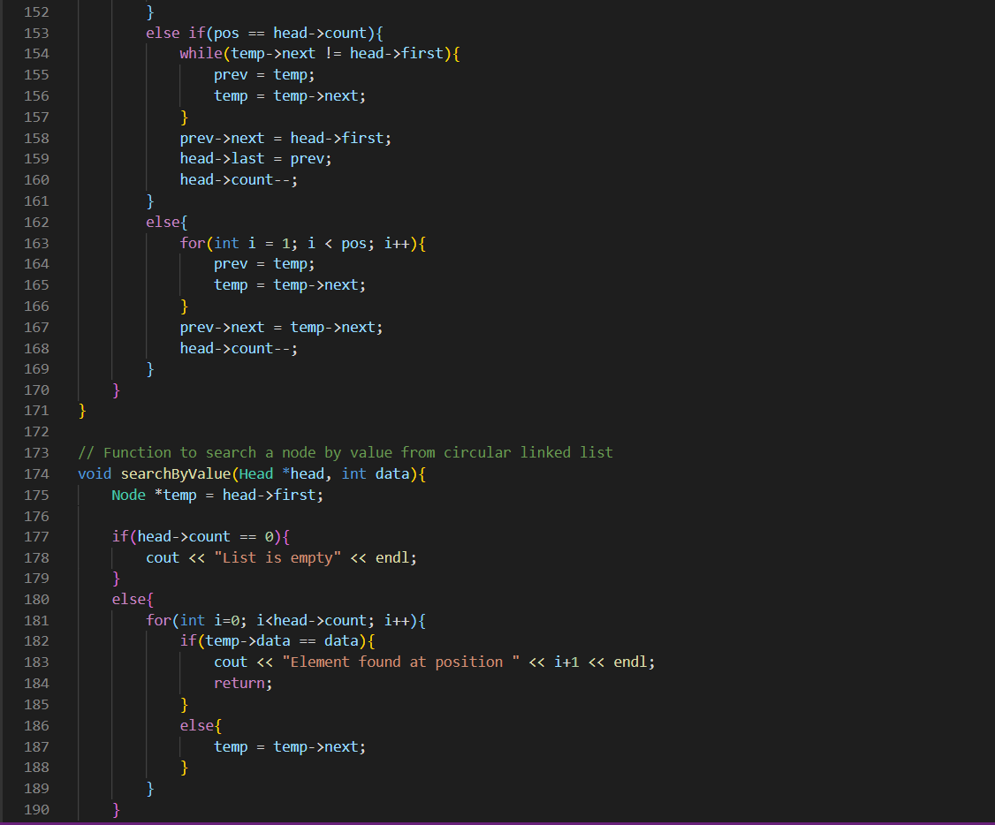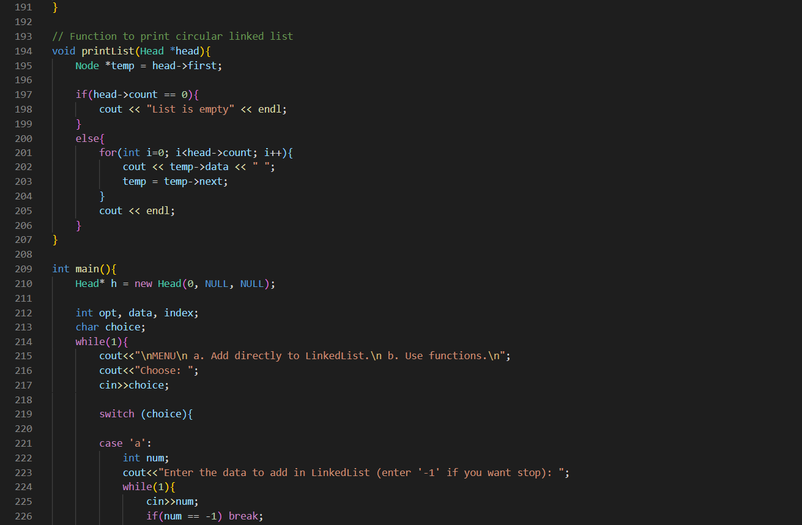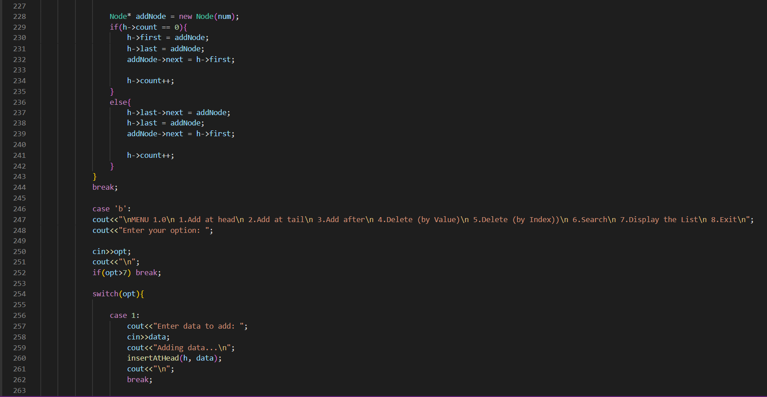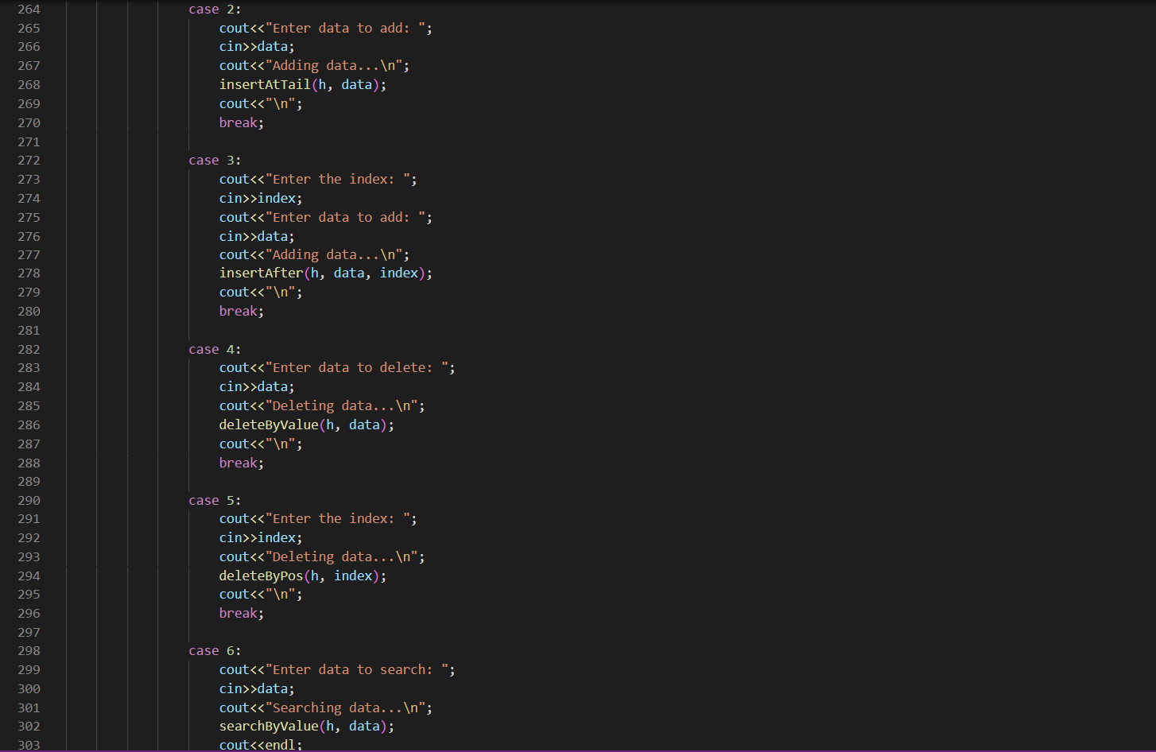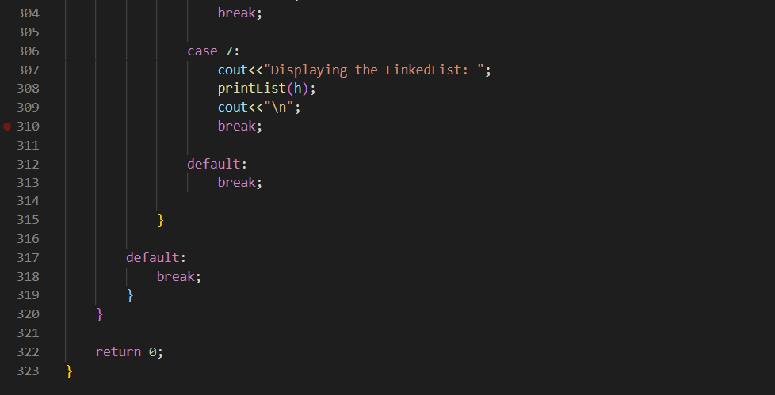

OUTPUT: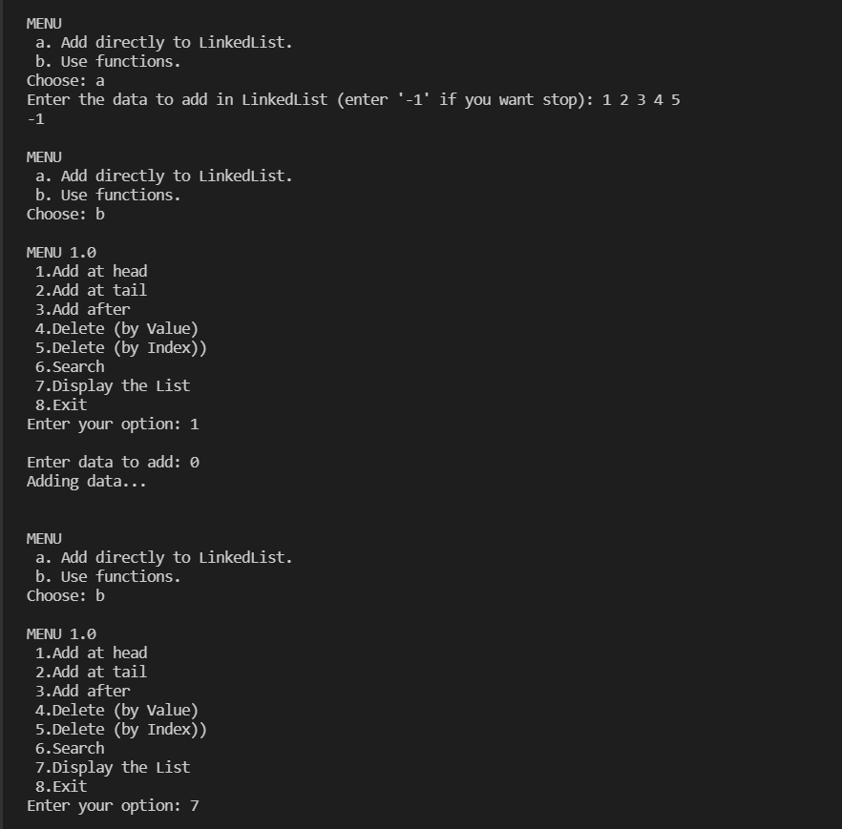 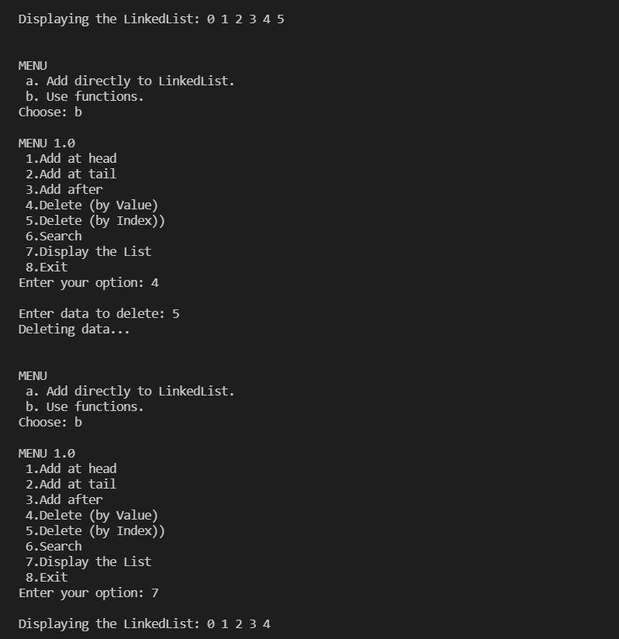

ALGORITHM:

Circular Linked List

ALGORITHMS:

1.Insertion of node in the circular linked list at the beginning

Step 1:

IF PTR = NULL

Write OVERFLOW

Go to Step 11

[END OF IF]

Step 2: SET NEW_NODE = PTR

Step 3: SET PTR = PTR -> NEXT

Step 4: SET NEW_NODE -> DATA = VAL

Step 5: SET TEMP = HEAD

Step 6: Repeat Step 8 while TEMP -> NEXT != HEAD

Step 7: SET TEMP = TEMP -> NEXT

[END OF LOOP]

Step 8: SET NEW_NODE -> NEXT = HEAD

Step 9: SET TEMP → NEXT = NEW_NODE

Step 10: SET HEAD = NEW_NODE

Step 11: EXIT

2.Insertion of node in the circular linked list at the end

Step 1: IF PTR = NULL

Write OVERFLOW

Go to Step 1

[END OF IF]

Step 2: SET NEW_NODE = PTR

Step 3: SET PTR = PTR -> NEXT

Step 4: SET NEW_NODE -> DATA = VAL

Step 5: SET NEW_NODE -> NEXT = HEAD

Step 6: SET TEMP = HEAD

Step 7: Repeat Step 8 while TEMP -> NEXT != HEAD

Step 8: SET TEMP = TEMP -> NEXT

[END OF LOOP]

Step 9: SET TEMP -> NEXT = NEW_NODE

Step 10: EXIT

3.Deletion of node in the circular linked list at the beginning

Step 1: IF HEAD = NULL

Write UNDERFLOW

Go to Step 8

[END OF IF]

Step 2: SET PTR = HEAD

Step 3: Repeat Step 4 while PTR → NEXT != HEAD

Step 4: SET PTR = PTR → next

[END OF LOOP]

Step 5: SET PTR → NEXT = HEAD → NEXT

Step 6: FREE HEAD

Step 7: SET HEAD = PTR → NEXT

Step 8: EXIT

4.Deletion of node in the circular linked list at the end

Step 1: IF HEAD = NULL

Write UNDERFLOW

Go to Step 8

[END OF IF]

Step 2: SET PTR = HEAD

Step 3: Repeat Steps 4 and 5 while PTR -> NEXT != HEAD

Step 4: SET PREPTR = PTR

Step 5: SET PTR = PTR -> NEXT

[END OF LOOP]

Step 6: SET PREPTR -> NEXT = HEAD

Step 7: FREE PTR

Step 8: EXIT

5.Searching in circular linked list

Step 1: SET PTR = HEAD

Step 2: Set I = 0

STEP 3: IF PTR = NULL

WRITE "EMPTY LIST"

GOTO STEP 8

END OF IF

STEP 4: IF HEAD → DATA = ITEM

WRITE i+1 RETURN [END OF IF]

STEP 5: REPEAT STEP 5 TO 7 UNTIL PTR->next != head

STEP 6: if ptr → data = item

write i+1

RETURN

End of IF

STEP 7: I = I + 1

STEP 8: PTR = PTR → NEXT

[END OF LOOP]

STEP 9: EXIT

6.Traversing in circular linked list

STEP 1: SET PTR = HEAD

STEP 2: IF PTR = NULL

WRITE "EMPTY LIST"

GOTO STEP 8

END OF IF

STEP 4: REPEAT STEP 5 AND 6 UNTIL PTR → NEXT != HEAD

STEP 5: PRINT PTR → DATA

STEP 6: PTR = PTR → NEXT

[END OF LOOP]

STEP 7: PRINT PTR→ DATA

STEP 8: EXIT