PRN: 2020BTEIT00041

NAME: Om Vivek Gharge

Q.) Evaluating value of Polynomial by adding the value of variable x

CODE:

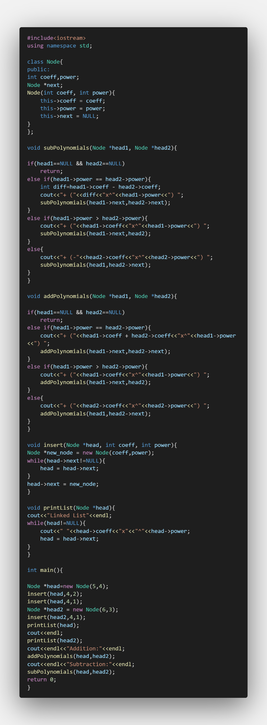

OUTPUT:

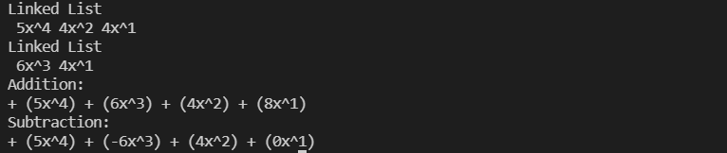

ALGORITHM:

Step 1: Algorithm to add two polynomials using linked list: Let p and q be the two polynomials represented by linked lists.

Step 1. while p and q are not null, repeat step 2.

Step 2. If powers of the two terms are equal then if the terms do not cancel then insert the sum of the terms into the sum Polynomial Advance p Advance q Else if the power of the first polynomial> power of second Then insert the term from first polynomial into sum polynomial Advance p Else insert the term from second polynomial into sum polynomial Advance q.

Step 3. Copy the remaining terms from the non-empty polynomial into the sum polynomial. step 3 of the algorithm is to be processed till the end of the polynomials has not been reached.

Step 2: Algorithm to subtract two polynomials using linked list: Let p and q be the two polynomials represented by linked lists.

Step 1. while p and q are not null, repeat step 2.

Step 2. If powers of the two terms are equal then if the terms do not cancel then insert the difference of the terms into the difference Polynomial Advance p Advance q Else if the power of the first polynomial> power of second Then insert the term from first polynomial into difference polynomial Advance p Else insert the term from second polynomial into difference polynomial Advance q.

Step 3. Copy the remaining terms from the non-empty polynomial into the difference polynomial. Step 3 of the algorithm is to be processed till the end of the polynomials has not been reached.