Q. A

CODE:

class DefData{

static int a;

static float b;

static char c;

static double d;

public static void main(String []args){

System.out.println("Default value of int is "+ a);

System.out.println("Default value of float is "+ b);

System.out.println("Default value of char is "+ c);

System.out.println("Default value of double is "+ d);

}

}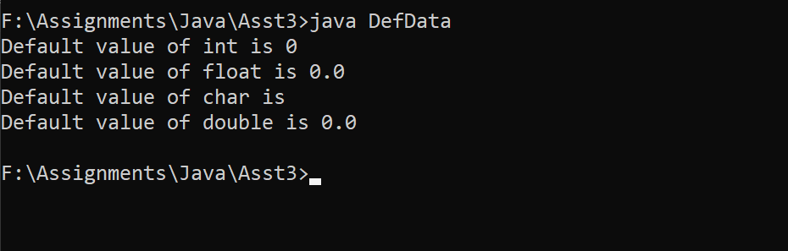

Q. B

CODE:

import java.util.\*;

class Gradesheet{

public static void main(String[] args){

Scanner sc = new Scanner(System.in);

System.out.println("Enter marks of PCM");

int phy = sc.nextInt();

int chem = sc.nextInt();

int math = sc.nextInt();

float total = 0,percentage=0;

total = phy + chem + math;

percentage = (total/300)\*100;

System.out.println("Percentage obtained : " + percentage);

if(percentage>=90)

System.out.println("Grade A");

else if(percentage>=80)

System.out.println("Grade B");

else if(percentage>=70)

System.out.println("Grade C");

else if(percentage>=60)

System.out.println("Grade D");

else

System.out.println("Grade Fail");

}

}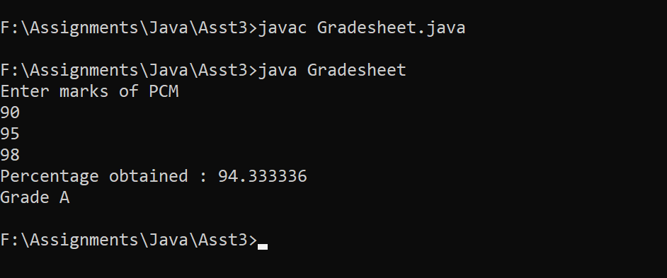

Q. C

CODE:

import java.util.\*;

class MathOp {

public static void main(String[] args) {

Scanner sc = new Scanner(System.in);

int a, b;

double ans = 0;

while (true) {

System.out.println("1. Add");

System.out.println("2. Subtract");

System.out.println("3. Multiply");

System.out.println("4. Divide");

System.out.println("5. Square");

System.out.println("6. Squareroot");

System.out.println("7. Exit");

System.out.println("Enter your choice: ");

int x = sc.nextInt();

switch (x) {

case 1:

System.out.println("Enter two integers");

a = sc.nextInt();

b = sc.nextInt();

ans = a + b;

System.out.println("Addition: " + ans);

break;

case 2:

System.out.println("Enter two integers");

a = sc.nextInt();

b = sc.nextInt();

ans = a - b;

System.out.println("Substraction: " + ans);

break;

case 3:

System.out.println("Enter two integers");

a = sc.nextInt();

b = sc.nextInt();

ans = a \* b;

System.out.println("Multiplication: " + ans);

break;

case 4:

System.out.println("Enter two integers");

a = sc.nextInt();

b = sc.nextInt();

ans = a / b;

System.out.println("Division: " + ans);

break;

case 5:

System.out.println("Enter integer");

a = sc.nextInt();

ans = a \* a;

System.out.println("Square: " + ans);

break;

case 6:

System.out.println("Enter integer");

a = sc.nextInt();

ans = Math.sqrt(a);

System.out.println("Squareroot: " + ans);

break;

case 7:

System.exit(0);

System.out.println("Exiting...");

break;

}

}

}

}