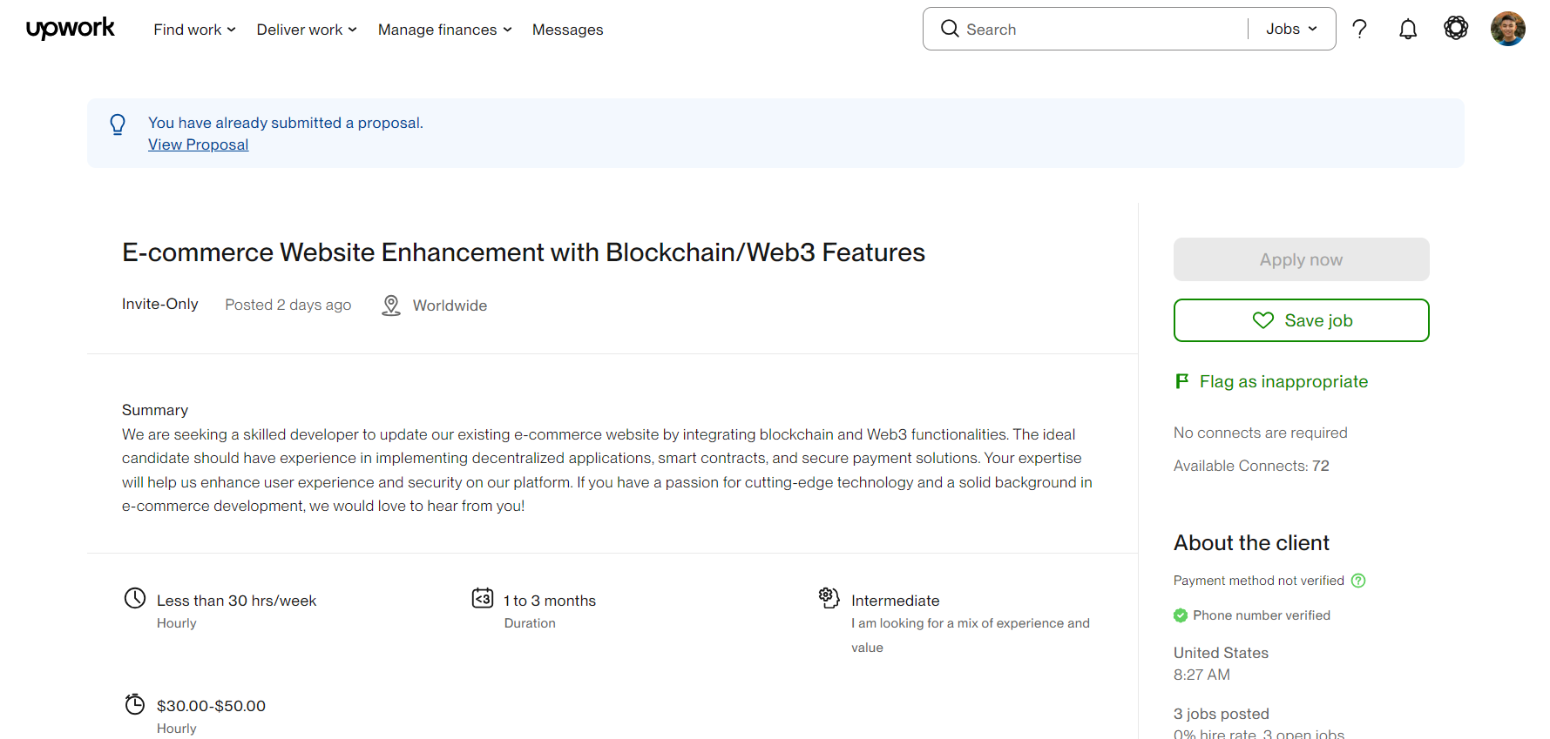

**Cover letter**

Hello there, I am happy to have received your invitation, and I’m even more delighted—and a bit incredulous—that the job posting corresponding to your invitation is such a perfect fit for me. As you can see on my profile, I have extensive experience developing blockchain systems as a full-time developer at the FPT Digital Banking Division. Decentralized applications, smart contracts, and secure payment solutions are precisely my areas of expertise. In particular, I received recognition from my team for developing sophisticated smart contracts. The secret lies in writing secure, gas-efficient, and well-tested code. I focus on preventing vulnerabilities, optimizing performance, designing modular and upgradeable contracts, and ensuring clear documentation so that smart contracts remain reliable and maintainable long-term. As you may have already seen on my profile, I also participated in developing an e-commerce platform. Initially, I wrote the code in PHP, but later migrated the system to the MERN stack. I have long believed that we should introduce blockchain technology into commercial sites, and I feel I’ve finally met the right person to help make this vision a reality. Integrating blockchain and Web3 into e-commerce offers significant advantages: stronger security through immutable records and smart contracts; lower payment fees and global reach via crypto transactions; innovative loyalty programs using tokens or NFTs; supply chain transparency; and new business models like decentralized marketplaces. These features enhance trust, user engagement, and competitiveness in a digital-first world.

A few months ago, I collaborated with a colleague to develop a Telegram-based crypto trading bot that interacts with the Solana blockchain. The bot integrated the Jupiter Aggregator API for optimal token swap execution and included advanced features such as sniping newly launched tokens and monitoring wallet activity in real time. In my experience, using modern, lightweight modules instead of traditional Web3 libraries significantly improved performance—enhancing transaction speed by over 30% and ensuring a smoother, more reliable user experience. I’m confident that I can bring both technical skill and creative problem-solving to your project and would love the opportunity to contribute. Best regards, Tuan Le

