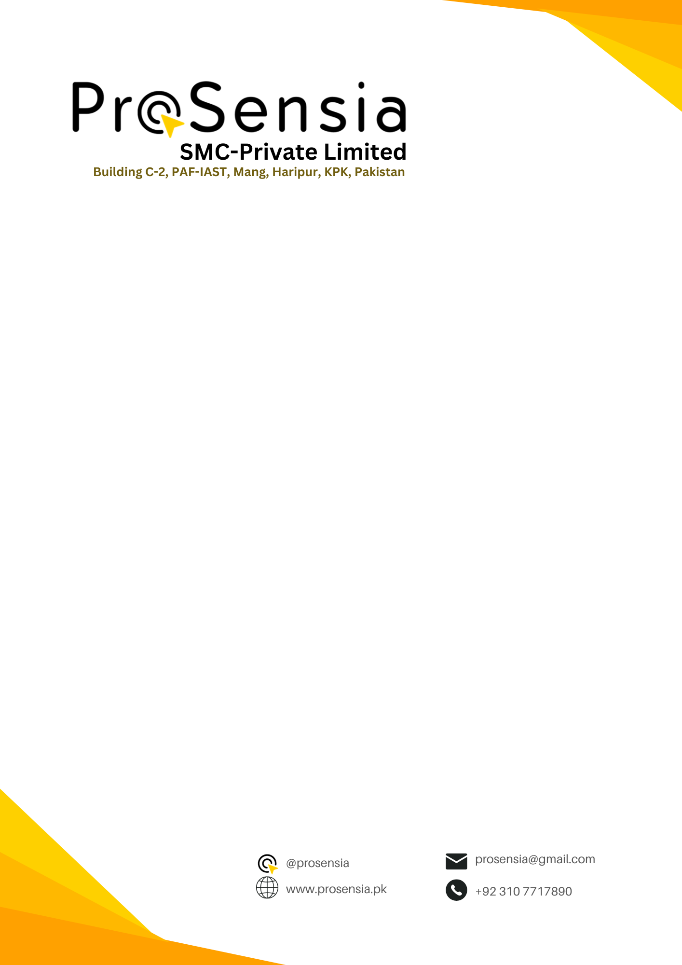
September 3, 2026

TO WHOM IT MAY CONCERN
EXPERIENCE LETTER
This is to certify that Ms. Hira Malik, D/O Malik Amjad Haider, bearing CNIC No. 42201-1247760-8, worked with ProSensia (SMC Private Limited) as a Media Manager & Team Lead from 10 January 2025 to 22 December 2025. He also contribute as a Volunteer Member.
During this period, he/she worked with us on a part-time basis alongside university studies and actively contributed to our media and event-related activities. Her responsibilities primarily included videography, event coverage, photography, video recording, and supporting the media team in organizing and documenting company events and activities.
Throughout the internship, she demonstrated dedication, professionalism, creativity, and a strong sense of responsibility. Her contribution to our media-related work was highly appreciated, particularly during events and organizational activities.
For verification, please contact us at: prosensia@gmail.com
ProSensia (SMC Private Limited) 