**Leeward Islands Federal Elections Commission -Voting System**

**How To Run??**

*After Starting Apache and MySQL in XAMPP, follow the following steps*

***1st Step****:* Extract file  
***2nd Step:*** Copy the main project folder  
***3rd Step:*** Paste in xampp/htdocs/

***Now Connecting Database***

***4th Step:*** Open a browser and go to URL “http://localhost/phpmyadmin/”  
***5th Step:*** Then, click on databases tab  
***6th Step:*** Create database naming “votingsystem” and then click on import tab  
***7th Step:*** Click on browse file and select “votingsystem.sql” file which is inside “database” folder  
***8th Step:*** Click on go.

***After Creating Database***,

***9th Step:*** Open a browser and go to URL <http://localhost/votingSys/>

**For Admin Panel**  
***Final Step:*** Login from the User’s login side. Just provide the Admin’s login detail, it will redirect you to Admin panel.

**Login Credentials**

Username: admin

Password:password

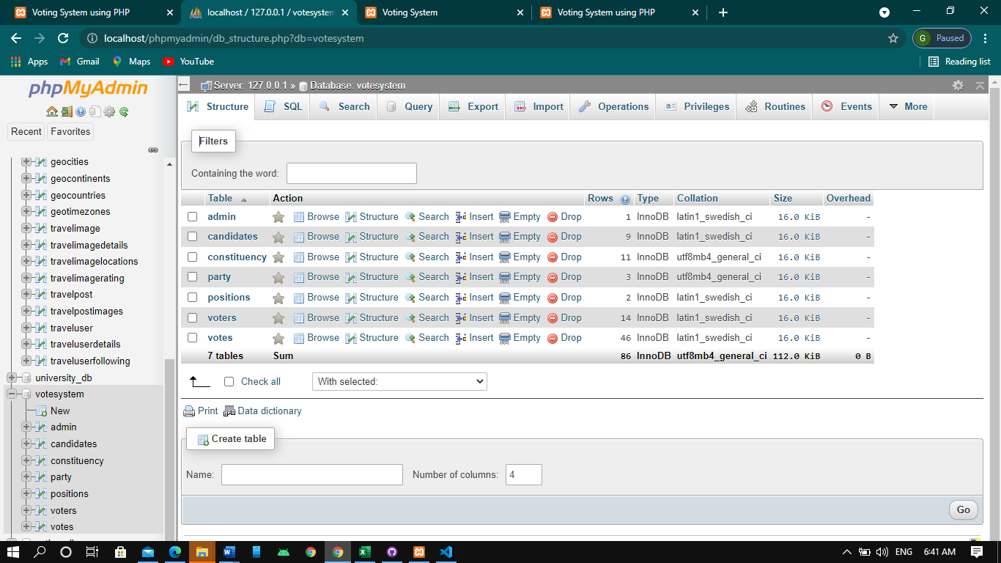  
Provide the username and password which is provided above

**Admin panel**

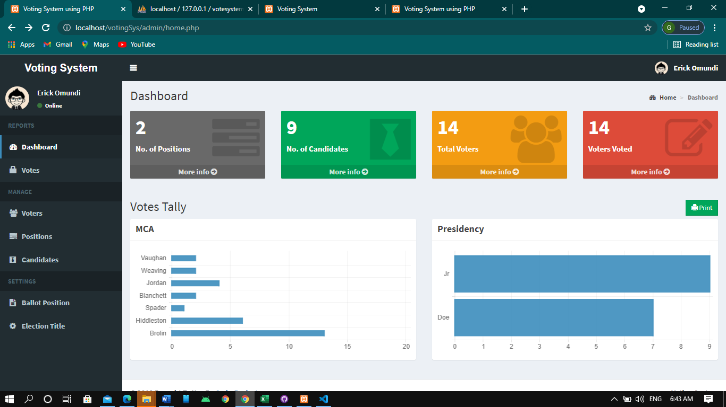

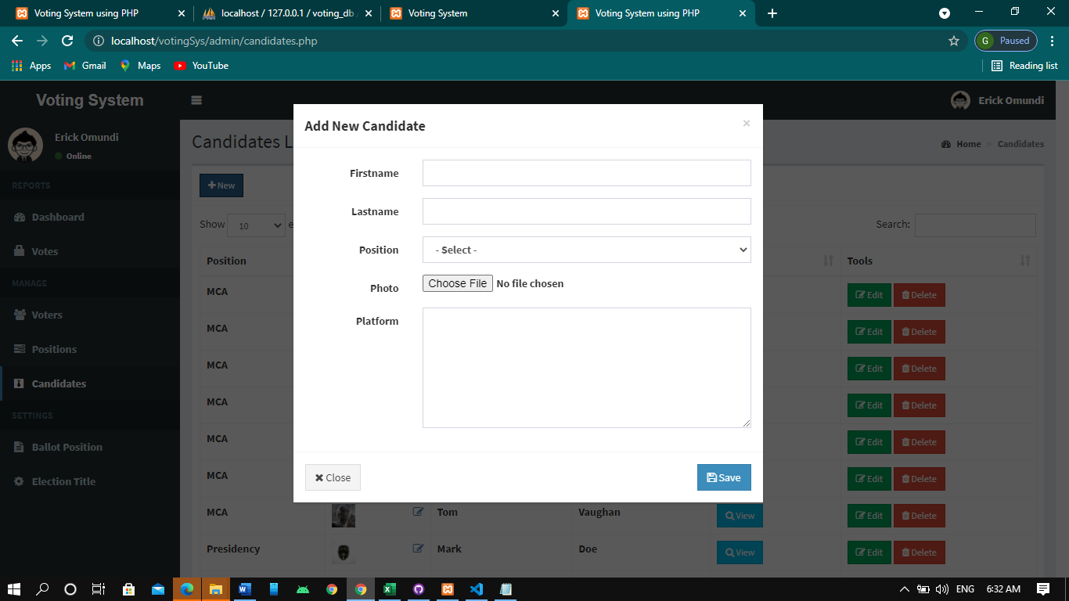

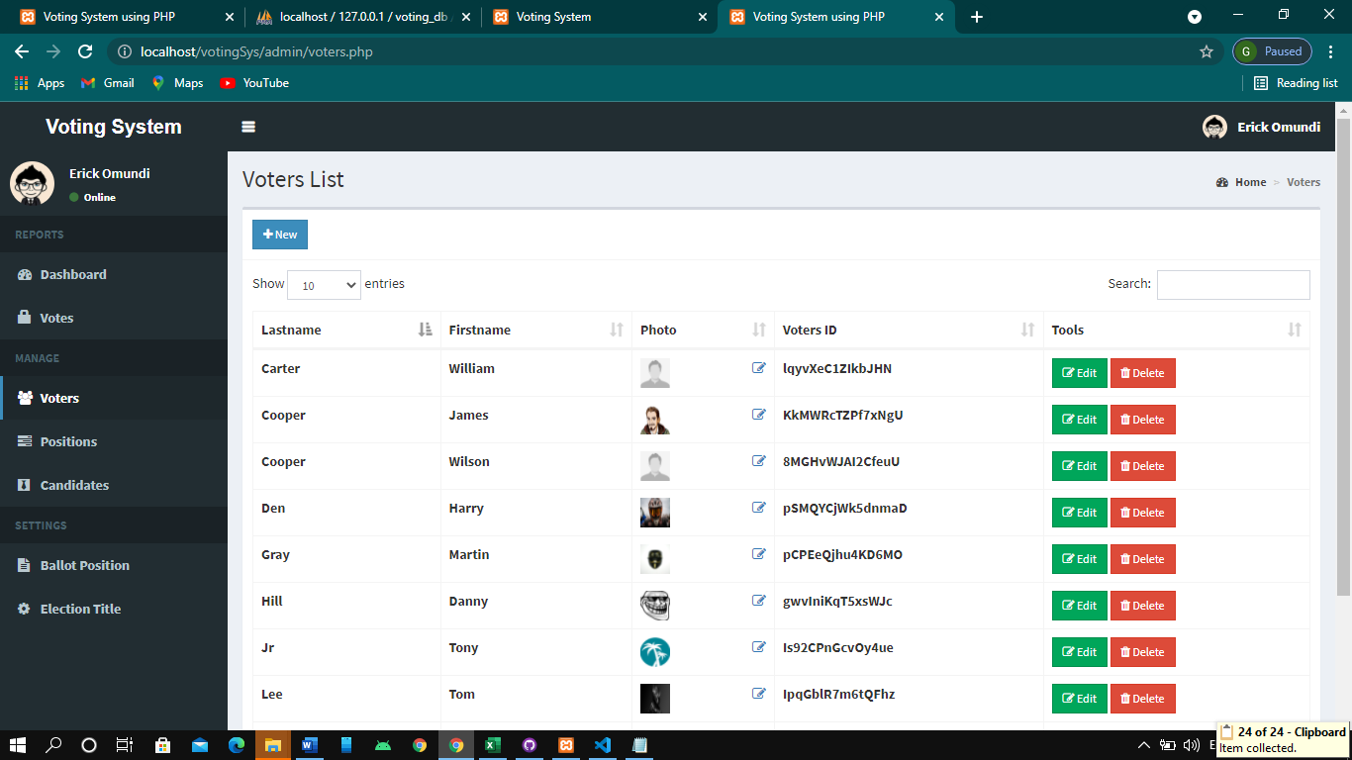

**Voters Pannel**

