**Vertical Search Engine**

**How To Run??**

***1st Step****:* Extract file  
***2nd Step:*** Copy the main project folder  
***3rd Step:*** Open the project directory through the terminal

***4th Step:*** Move to the app folder directory  
***5th Step:*** Then, type “python app.py” as shown below  
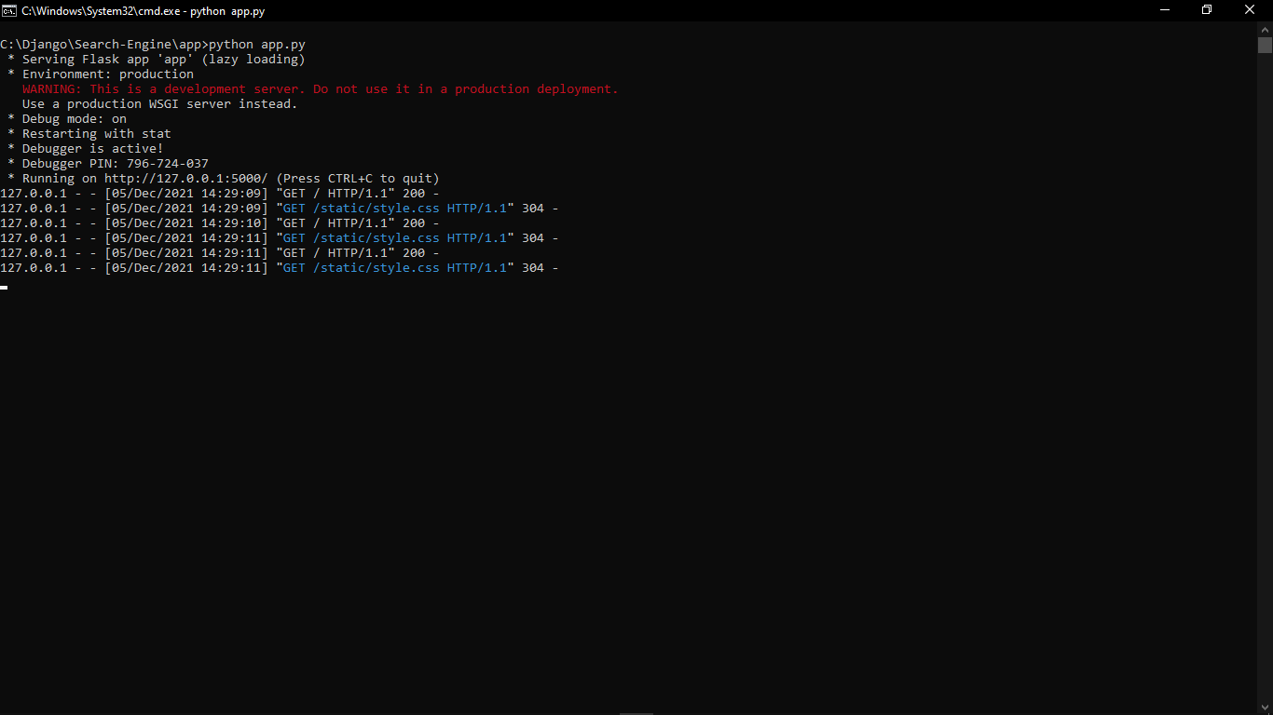  
***6th Step:*** Click Enter and go on

***After Completing the above steps***,

***7th Step:*** Open a browser and go to URL 127.0.0.01:5000