A picture containing clipart

Description generated with high confidence

DTC Restore – Meriplex Only

Puneet Vijayvergi

VER No. (ex. Ver. 1.0)

iNITIAL DRAFT / Review Date (Ex. Review Date 15 June 2021)

Contents

Recovering Files………………………………………………………………………………………………………………………………3

Monitoring Restore…………………………………………………………………………………………………………………………6

***Unitrends DTC Restore***

Recovering Files:

**Recovery considerations**

*Consider the following before recovering files*:

* You can recover files from any backup to any asset that has been added to your Unitrends Cloud Backup environment.
* File data is recovered. Other file attributes, such as Access Control Lists (ACLs), are not recovered.
* Recovery requires a stable connection. Recovery can resume if there is a brief disconnection. If the connection is interrupted for more than a few minutes, the recovery fails.

**Recovering files and folders from a backup**

Use this procedure to recover selected files and folders from a backup.

To recover files

1. On the Restore > Recover Files page, select the customer whose files you will recover.
2. Select an asset and the backup to recover.

**Notes:**

* *You can filter the asset list by entering text in the Choose Asset field. Only assets containing the string you entered display in the list.*
* *If the asset has been decommissioned, displays next to the asset name. You can recover backups of this asset by selecting it in the list, but you must recover the backup to another asset (one that has not been decommissioned).*

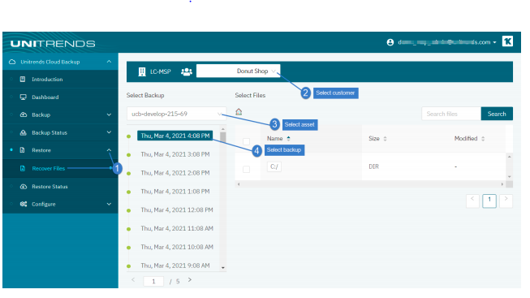

1. Select one or more items to recover, then click Restore Selections:

* You can recover all files by selecting the root directory's checkbox.

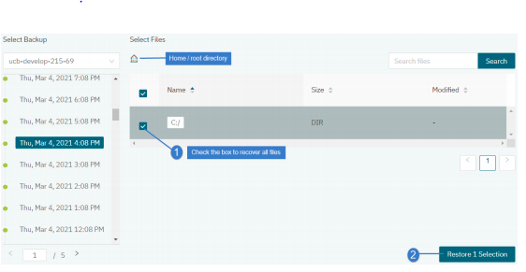

* You can recover the contents of an entire drive or folder by selecting its checkbox.

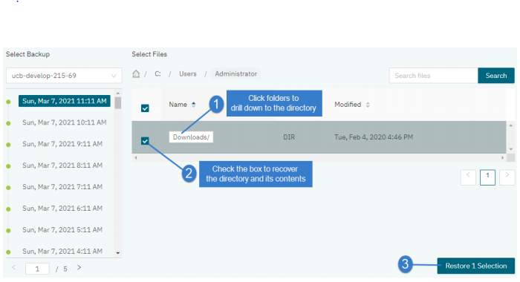

* You can search for and recover individual files/folders. Enter a text string in the Search Files field, then click Search. Files and directory names containing the string you entered display in a list. Check boxes to select items to recover.

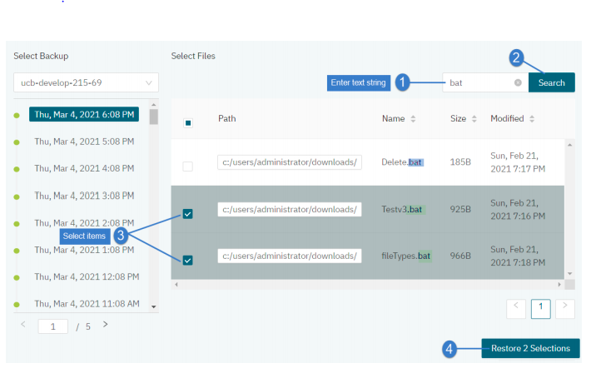

* You can recover individual files by browsing the backup contents and selecting one or more files

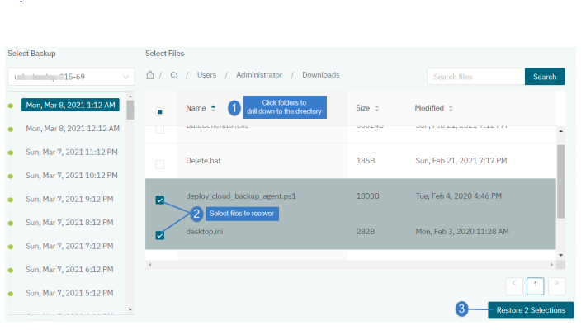

1. Select these Advanced Options for the recovery:

* Target Asset – Select the asset where files will be recovered.
* Alternate Path – Enter the recovery path on the target asset. Use the default location, C:/recover, or enter an alternate path.
* Conflict Resolution – Choose how to handle existing files of the same name in the target directory: select Overwrite to replace the file with the one you are recovering or Preserve Newer to keep the existing file only if
* it is newer than the one selected for recovery (otherwise overwrite the existing file).
* Folder Structure – Choose Preserve to recover the existing folder structure under the target directory or Flatten to recover only the files to the target directory.

1. Click Confirm Restore.

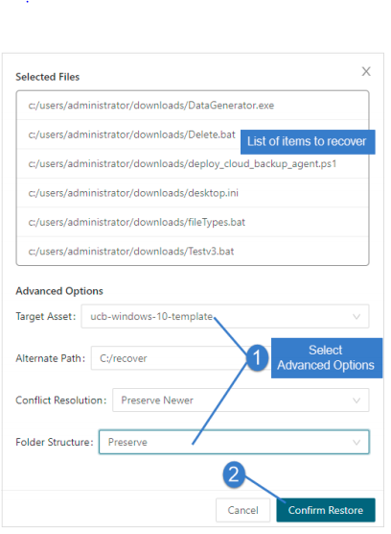

**Monitoring Restore**

The job is added to the queue and displays on the Restore Status page. Files are recovered to the destination asset.

* If the recovery path directory does not exist, the job creates it during the recovery.
* If the destination asset is not online, the job runs upon the next asset check-in.

